Supplementary materials

Locally Applied Stem Cell Exosome-Scaffold Attenuates Nerve Injury-induced Pain in Rats

Jong-Ming Hsu,^{1,2,3,#} Sheng-Jie Shiue,^{4,#} Kuender D. Yang,^{5,6,7,#} Han-Shiang Shiue,⁸ Yi-Wei Hung,⁴ Pavani Pannuru,⁴ Raju Poongodi,⁴ Hsin-Yi Lin,^{9,10,+} Jen-Kun Cheng^{3,4,11,+}

¹ Department of Urology, Mackay Memorial Hospital, Taipei, 10449, Taiwan
² Mackay Junior College of Medicine, Nursing, and Management, Taipei, 11260, Taiwan
³ Department of Medicine, Mackay Medical College, New Taipei City, 252, Taiwan
⁴ Department of Medical Research, Mackay Memorial Hospital, Taipei, 10449, Taiwan
⁵ Institute of Biomedical Science, Mackay Medical College, New Taipei City, 252, Taiwan
⁶ Department of Pediatrics, Mackay Memorial Hospital, Taipei, 10449, Taiwan
⁷ Institute of Clinical Medicine, National Yang-Ming University, Taipei, 11221, Taiwan
⁸ Institute of Neuroscience, National Yang-Ming University, Taipei, 11221, Taiwan
⁹ Department of Chemical Engineering and Biotechnology, National Taipei University of Technology, Taipei, 106, Taiwan
¹⁰ Graduate Institute of Biochemical and Biomedical Engineering, National Taipei University of Technology, Taipei, 106, Taiwan
¹¹ Department of Anesthesiology, Mackay Memorial Hospital, Taipei, 10449, Taiwan

#These authors contributed equally to the work.

⁺Corresponding authors:
Hsin-Yi Lin, No. 1, Sec 3, Zhongxiao E. Rd., Taipei, 106, Taiwan. Department of Chemical Engineering and Biotechnology, National Taipei University of Technology, E-mail: hsinyibrunken@gmail.com
Jen-Kun Cheng, No. 92, Sec. 2, Zhongshan N. Rd., Taipei City 10449, Taiwan. Department of Anesthesiology, Mackay Memorial Hospital, E-mail: jkcheng@usa.net

Supplementary Materials and Methods

Mesenchymal stem cell exosome isolation
UCMSC exosomes were isolated and purified from the supernatant of human UCMSC culture. Briefly, for the UCMSC exosome production, the cells at passages 3-8 were cultured in serum-free medium at 37 °C in a humidified atmosphere of 5% CO₂ for 48 h before harvesting the medium. After cell debris removing, the cell free medium was passed through a 0.22 μm filter and a 100 kDa centrifugal filter tube (Millipore, CA, USA). Finally, the UCMSC exosomes were transferred into saline buffer by a new centrifugal filter tube. Total top layer was transferred to a micro-centrifuge tube and homogenized. The final protein concentration of exosomes was about 1.0 - 1.4 mg/ml and stored at −80 °C for later use.

Cell culture
UCMSCs were cultured in complete DMEM (low glucose, Invitrogen, CA, USA) containing 10% foetal bovine serum (FBS, Gibco, CA, USA) and 1% penicillin/streptomycin (Invitrogen, CA, USA) at 37°C in humid air with 5% CO₂. HEK293 cells were purchased from Bioresource Collection and Research Centre (BCRC, No. 60019, Taiwan) and maintained in DMEM medium (Corning, NY, USA) supplemented with 2 mM L-glutamine, 1.5 g/l sodium bicarbonate, 0.1 mM non-essential amino acids (Corning, NY, USA) and 10% FBS. PC12 cells were purchased from BCRC (No. 60048, Taiwan) and maintained in RPMI 1640 medium (Corning, NY, USA) supplemented with 2 mM L-glutamine, 1.5 g/l sodium bicarbonate, 5% FBS and 10% heat-inactivated horse serum (Gibco, CA, USA).

Cell viability assay
The cell viability was analysed by alamarBlue® reagent (Thermo, CA, USA). PC12 and HEK293 cells were seeded 1×10⁵ cells/well in 24 well cell culture plate with or without alginate scaffold and cultured for 24 h at 37°C in humid air with 5% CO₂. AlamarBlue® reagent as 10% of the medium volume was added into each well and kept 4 h culturing at 37°C for viable cells to convert resazurin to fluorescent resorufin. The resulting fluorescence is read on the fluorescence spectrophotometer (SpectraMax Gemini XS, Molecular Devices, CA, USA). For FA treatment assay in 24 well plate, PC12 cells were seeded on collagen IV coating plate (Corning, NY, USA). After 24 h for cell adhesion well on the plates, 1×10⁵ cells/well PC12 and HEK293 cells were incubated with or without 100 μg/ml exosome for 1 h, then FA was added into FA treatment groups (final concentration: 120 μM) and alamarBlue reagent as 10% of the medium volume was added into each well for 4 h. The resulting fluorescence is read on fluorescence spectrophotometer. Cells were visualized using an inverted microscope (Eclipse TiS, Nikon, Tokyo, Japan) and cell images were captured using NIS-Elements software (Nikon, Tokyo, Japan).

PC12 cell neurite outgrowth assay
PC12 cells were plated on 24 well culture plates coated with collagen IV (Corning, NY, USA) at a density of 1 × 10⁴ cells/well at 37°C in humid air with 5% CO₂. After 24 h for cell adhesion well on the plates, the cells were incubated with or without exosome (final concentration: 100 μg/ml) in RPMI 1640 medium (Corning, NY, USA) supplemented with 2 mM L-glutamine, 1.5 g/l sodium bicarbonate, 5% FBS and 10% heat-inactivated horse serum (Gibco, CA, USA) for 24 h. The percentage of cells bearing neurites at least two cell bodies in length was determined and counted at least 500 single cells by ImageJ software (NIH, Maryland, USA). Cells were visualized using an inverted microscope (Eclipse TiS, Nikon, Tokyo, Japan) and cell images were captured using NIS-Elements software (Nikon, Tokyo, Japan).

Alginate scaffold preparation and characterization
For scaffold implantation on the ligated L5/6 nerves, we prepared tubular alginate scaffolds. Sodium alginate (MW=500 kDa, ACORS) was dissolved in deionized water to make a 4 w/v% alginate solution. The outer cylindrical tube (ID=2 mm) was placed on a fixed base and the inner cylinder (OD=0.8 mm) was inserted inside the tube before pouring the 4% sodium alginate into the space in between the module parts. The module was placed at -20°C for 30 min. The base was removed and put in a freeze dryer (FDS-5, Paymo, Taiwan) for 24 h. The tubes were immersed in 5 w/v% CaCl₂ solution for 10 min after freeze-drying. The porous scaffold was removed from the module and the scaffold was rinsed with deionized water for 5 min twice. The scaffold was dehydrated by the following steps: they were sequentially immersed in 15%, 35% and 50% ethanol solutions for 1 h each and then in 70%, 95% and 99.5% ethanol for 30 min each. The scaffold was then air-dried and stored at room temperature before use. For sterilization process, the dried scaffold was placed in 75% ethanol for 12 h. For cell culture purpose, they were rinsed with Ca²⁺ and Mg²⁺-containing PBS twice to remove the ethanol and then with cell culture medium twice before cell seeding.

Scaffold porosity assay
Dry specimens (n=3) were submerged in 99.5% ethanol overnight. The volume (V1) and weight (W1) of specimens saturated with ethanol were recorded. The specimens were then placed in a 15 ml centrifuge tube with tissue paper at the bottom and spun for 5 min at 3000 rpm to remove ethanol from the pores. After centrifugation, the weight of the scaffold was recorded (W2). The porosity of the scaffold was calculated as [(W1–W2)/ρ_{ethanol}]/V1 × 100%, where the density of ethanol (ρ_{ethanol}) was 0.83 g/cm³.

Tensile test of scaffold
The alginate scaffold films (30 cm x 20 cm, thickness 1.2 mm) were prepared for tensile test. Dog-bone-shaped specimens were punched out of the film with gauge length of 9.51 mm and width 3.18 mm. The samples were dehydrated using a series of ethanol solutions (15, 35, 50, 70, 95 and 99.5%) and air dried. Before the test, the samples were rehydrated in PBS containing Ca²⁺ and Mg²⁺ (pH = 7.4) for 3 h. The specimens (n=5) were fixed between the two grips of a tensile tester (Kotsao, Taiwan), which were 15 mm apart. The crosshead traveled at 6 mm/min until the sample broke. The Young’s modulus (MPa) and ultimate tensile strength (MPa) were obtained according to the regulations in ASTM D 638-10.

Morphology and pore size of scaffold
Dry samples (n=3, inner diameter=0.8 mm, outside diameter=2 mm, 10 mm length) were sliced perpendicularly to their length to expose the cross sections. The slices were sputter-coated with gold (E1010, Ion Sputter, Hitachi, Japan) before being examined by scanning electron microscopy (SEM, S-3000H, Hitachi, Tokyo, Japan). Pores size (diameter) was measured based on the micrographs taken using the built-in software of the SEM apparatus. The diameters of 30 randomly selected pores on three cross-sections were measured and averaged for each sample.

UCMSC exosome release from alginate scaffold
The alginate tubular scaffolds were placed into 1 mg/ml exosome solution and centrifuged at 3000g for 10 min at 4 °C to remove bubbles in scaffolds. For exosome adsorption, scaffold tubes (n=6) were incubated with 1 mg/ml exosome solution under agitation at 37 °C overnight. Scaffolds were transferred into a new dish and then immersed in 300 µl of sterilized saline incubated at 37 °C overnight under gentle agitation. Supernatants were retrieved on day 1, 2, 3, 4, 5, 6 and 7. Subsequently, 300 µl of new sterilized saline was added. Protein concentration of each supernatant was analysed by BCA Protein Assay Kit. The total exosome protein level of each sample was conversed from the net weight of dried scaffolds before and after incubating with 1 mg/ml exosome solution. CD81 antibody (BD Biosciences NJ, USA) was used in flow cytometry assay for exosome checking.

Supplementary Figures and Legends
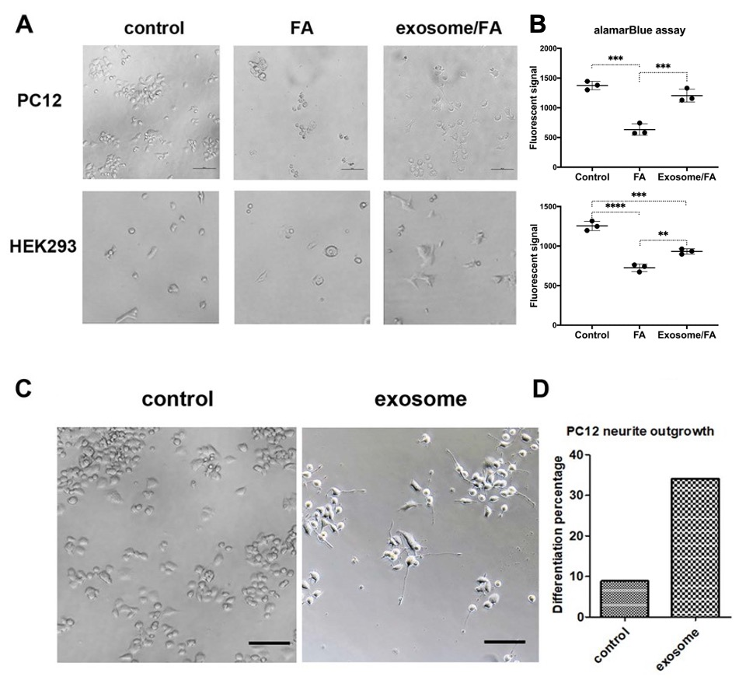Figure S1. Human umbilical cord mesenchymal stem cell exosomes protect PC12 and HEK293 cells from formaldehyde acid (FA) treatment and induce neurite outgrowth of PC12 cells. (A) Representative microscopic images showing morphology of PC12 cells on collagen IV coating plate and HEK293 cells on tissue plate in control, FA treatment and exosome/FA treatment groups. Scale bar: 100 μm. (B) Cell viability of PC12 and HEK293 cells in control, FA treatment and exosome/FA treatment groups, analysed by alamarBlue assay. Fluorescent signals are presented as mean (standard deviation) (**P<0.01, ***P<0.001, ****P<0.0001, one-way analysis of variance with post hoc Tukey test, n=3 in each group). (C) Microscopic image showing morphology of PC12 cells with or without exosome treatment on the collagen IV coating plate. Scale bar: 100 μm. (D) Summarized bar graph depicting the differentiation percentage of PC12 cells with or without exosome treatment, taking total cells as 100%.
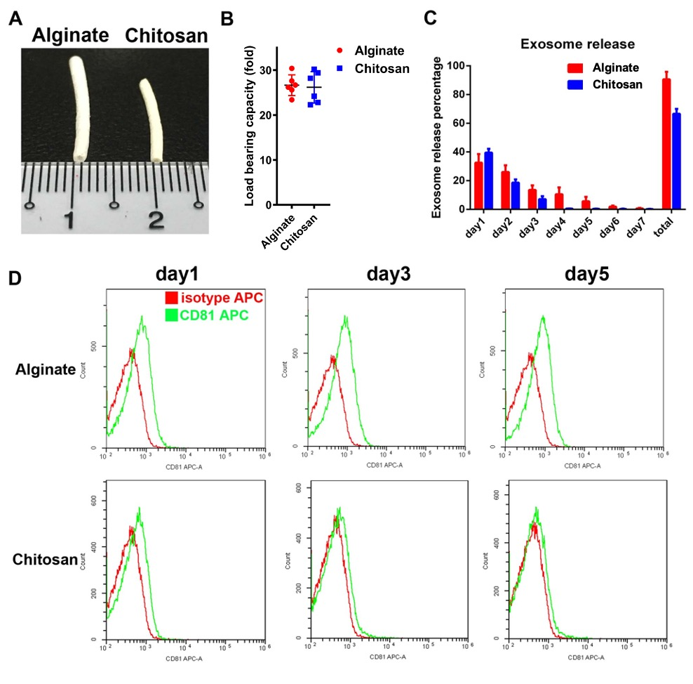
Figure S2. Comparing appearance and efficiency of exosome absorption and release between alginate and chitosan scaffold. (A) Freeze-dried alginate and chitosan tubes. (B) The exosome absorption ability of alginate and chitosan scaffolds. For swelling ratio detection, the wet weight minus dry weight then average to dry weight. Data are presented as mean (standard deviation), taking dry weight of scaffold as 100% (n=6 in each group). (C, D) Exosome release ability of alginate and chitosan scaffolds (C, n=6 in each group) and exosome marker CD81 was tracked from day 1, 3 and 5 by flow cytometry (D).

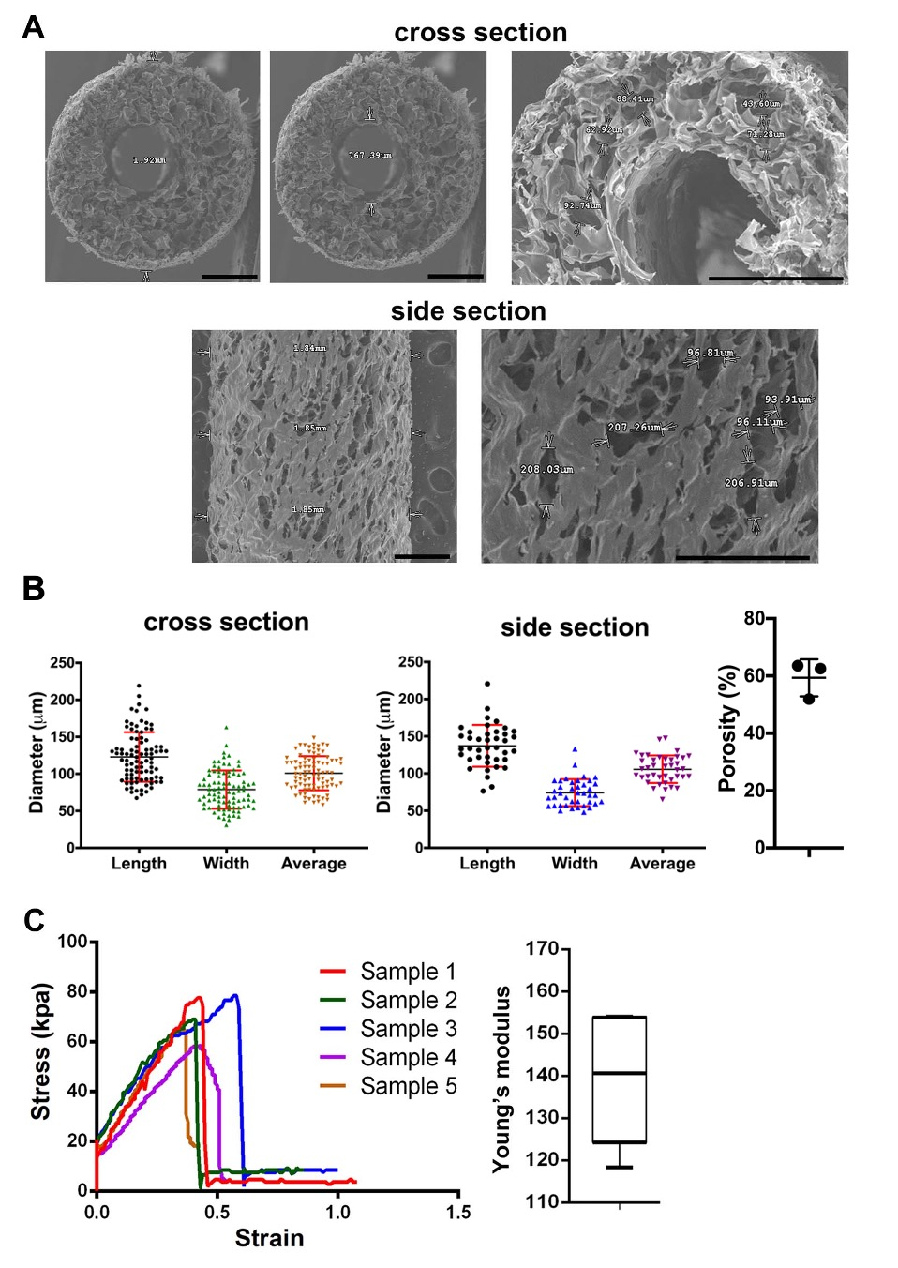Figure S3. Characterization of alginate scaffold tube. (A) The morphology and pore size of alginate scaffold tube. The cross and side sections of alginate scaffold tube showed sponge-like multi-pore structure. Scale bar: 500 μm. (B) The total pore size scatter plots (Mean ± SD) depict the pore size range and average of cross and side sections of alginate scaffold tube. The porosity was 59.3 ± 6.5 % (Mean ± SD, n=3). (C) Tensile mechanical test of alginate scaffold. The average Young’s modulus of alginate scaffold was 139.6 ± 15.5 kPa (Mean ± SD, n=5).

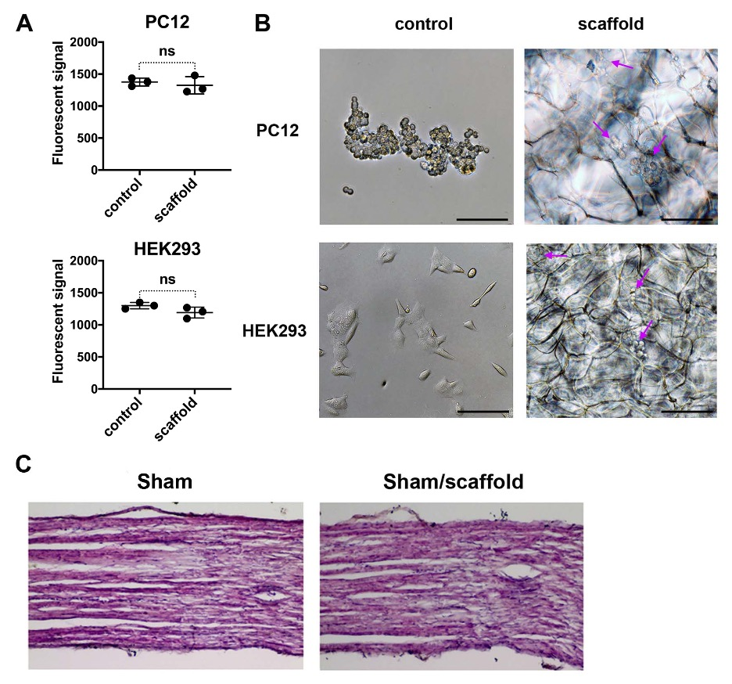Figure S4. The alginate scaffold shows good cytocompatibility and biocompatibility for PC12, HEK293 cells and L5 spinal nerve of rats, respectively. (A) AlamarBlue cell viability assay of PC12 and HEK293 cells on tissue plate (control) and alginate scaffold. Fluorescent signals are presented as Mean ± SD. The cell viability of PC12 or HEK293 cells shows no significant (ns) difference between tissue plate (control) and scaffold groups (Student’s t-test, n=3 in each group). (B) Microscopic morphology of PC12 and HEK293 cells on tissue plate (control) and alginate scaffold. Arrow indicates the cell. Scale bar: 100 μm. (C) Biocompatibility of alginate scaffold for rat L5 spinal nerve. Haematoxylin-eosin staining of L5 spinal nerve with or without scaffold was performed for biocompatibility test 21 days after scaffold implantation, no obvious histopathological change was noted in the Sham/scaffold group (n=6).

