Supplemental Tables

Table S1. ICD diagnoses codes.
Disease | ICD-8 codes | ICD-10 codes
DM | 249* Diabetes mellitus  250* Diabetes mellitus | DE1* Diabetes mellitus
RA | 712* Rheumatoid arthritis and allied conditions  715* Arthritis, unspecified UD | DM05* Rheumatoid arthritis  DM06* Rheumatoid arthritis  DM08* Juvenile rheumatoid arthritis
COE | 269* Other nutritional deficiency | DK900* Celiac disease
CD | 563.00; 563.01; 563.02; 563.08; 563.09 Mb. Crohn | DK50* Crohn’s sygdom
UC | 563.19 Ulcerosa, proctocolitis, haemorrhagic  569.04 Proctitis haemorrhagic | DK51* Colitis ulcerosa
Abbreviations: ICD-8 was used until the end of 1993 and ICD-10 from 1994 in Denmark. Both primary (A) and secondary (B) diagnoses were used.

Table S2. The number of offspring that developed a CID dependent on the CID status of the parents.
Parents Disease |  | Child
 |  | Disease- (n=2639753) | Disease+ (n=59696)
CID |  | 419175 (16%) | 19641 (33%)
DM |  | 302248 (12%) | 15171 (25%)
RA |  | 55304 (2%) | 2,509 (4%)
COE |  | 10670 (0.4%) | 744 (1%)
CD |  | 27956 (1%) | 1215 (2%)
UC |  | 56420 (2%) | 2247 (4%)
CID Multi |  | 22667 (0.9%) | 1475 (3%)
The % signify the percentages of children without and with CID that have at least one parent with the condition.
Abbreviations: at least one chronic inflammatory disease (CID), diabetes mellitus (DM), rheumatoid arthritis (RA), coeliac disease (COE), Crohn’s disease (CD), ulcerativ colitis (UC), and more than one chronic inflammatory diseases (CID Multi).
1

Table S3. The fully adjusted hazard ratios for developing diabetes mellitus, rheumatoid arthritis, coeliac disease, Crohn’s disease, ulcerative colitis and at least one chronic inflammatory disease among girls (A), boys (B), and children (C) dependent on the specific CID of the affected parent compared with children with unaffected parents.
A.
Girls |  | Diabetes Melitus |  |  | Rheumatoid Arthritis |  |  | Coeliac Disease |  |  | Ulcerative Colitis |  |  | Crohn's Disease |  |  | Chronic Inflammatory Disease
 |  | (HR 95% CI) | p-value |  | (HR 95% CI) | p-value |  | (HR 95% CI) | p-value |  | (HR 95% CI) | p-value |  | (HR 95% CI) | p-value |  | (HR 95% CI) | p-value
Parents
DM |  | 3.04(2.93,3.15) | <0.001 |  | 1.13(1.06,1.21) | <0.001 |  | 1.26(1.15,1.37) | <0.001 |  | 1.05(0.99,1.12) | 0.089 |  | 1.06(0.99,1.14) | 0.119 |  | 1.73(1.68,1.77) | <0.001
RA |  | 1.22(1.12,1.34) | <0.001 |  | 3.16(2.89,3.46) | <0.001 |  | 1.39(1.17,1.65) | <0.001 |  | 1.14(1.01,1.30) | 0.038 |  | 1.22(1.05,1.41) | 0.008 |  | 1.55(1.47,1.63) | <0.001
COE |  | 1.52(1.22,1.90) | <0.001 |  | 1.23(0.88,1.74) | 0.229 |  | 23.31(20.89,26.02) | <0.001 |  | 0.80(0.53,1.20) | 0.278 |  | 1.04(0.69,1.57) | 0.846 |  | 3.72(3.40,4.07) | <0.001
CD |  | 1.16(0.99,1.36) | 0.064 |  | 1.32(1.07,1.62) | 0.009 |  | 0.99(0.76,1.29) | 0.939 |  | 1.86(1.60,2.15) | <0.001 |  | 4.26(3.73,4.88) | <0.001 |  | 1.70(1.57,1.84) | <0.001
UC |  | 0.92(0.82,1.04) | 0.171 |  | 0.98(0.84,1.16) | 0.847 |  | 1.19(1.00,1.43) | 0.055 |  | 3.31(3.01,3.63) | <0.001 |  | 1.98(1.74,2.24) | <0.001 |  | 1.52(1.43,1.61) | <0.001
CID |  | 2.63(2.54,2.73) | <0.001 |  | 1.42(1.34,1.50) | <0.001 |  | 1.91(1.78,2.04) | <0.001 |  | 1.41(1.34,1.49) | <0.001 |  | 1.45(1.36,1.54) | <0.001 |  | 1.88(1.84,1.93) | <0.001
CID Multi |  | 2.83(2.53,3.17) | <0.001 |  | 2.28(1.93,2.68) | <0.001 |  | 3.03(2.49,3.69) | <0.001 |  | 2.86(2.5,3.28) | <0.001 |  | 3.29(2.83,3.83) | <0.001 |  | 2.79(2.61,2.99) | <0.001
Abbreviations: at least one chronic inflammatory disease (CID), diabetes mellitus (DM), rheumatoid arthritis (RA), coeliac disease (COE), Crohn’s disease (CD), ulcerativ colitis (UC), Hazard ratio (HR) and Confidence interval (CI).
*The risk is calculated as the number of children with a specific outcome among children with CID affected parents compared to the number of children with the outcome among children with non CID affected parents. For example, DM among children
B.
Boys |  | Diabetes Melitus |  |  | Rheumatoid Arthritis |  |  | Coeliac Disease |  |  | Ulcerative Colitis |  |  | Crohn's Disease |  |  | Chronic Inflammatory Disease
 |  | (HR 95% CI) | p-value |  | (HR 95% CI) | p-value |  | (HR 95% CI) | p-value |  | (HR 95% CI) | p-value |  | (HR 95% CI) | p-value |  | (HR 95% CI) | p-value
Parents disease
DM |  | 3.09(2.97,3.22) | <0.001 |  | 1.18(1.08,1.29) | <0.001 |  | 1.33(1.21,1.46) | <0.001 |  | 1.02(0.95,1.09) | 0.601 |  | 1.05(0.97,1.14) | 0.237 |  | 1.79(1.74,1.84) | <0.001
RA |  | 1.33(1.21,1.46) | <0.001 |  | 2.52(2.20,2.89) | <0.001 |  | 1.28(1.05,1.57) | 0.016 |  | 1.02(0.88,1.18) | 0.775 |  | 1.13(0.95,1.35) | 0.152 |  | 1.37(1.28,1.45) | <0.001
COE |  | 1.37(1.05,1.78) | 0.018 |  | 1.02(0.61,1.70) | 0.937 |  | 14.93(12.73,17.51) | <0.001 |  | 0.75(0.47,1.21) | 0.242 |  | 1.18(0.76,1.83) | 0.46 |  | 2.59(2.29,2.93) | <0.001
CD |  | 1.02(0.85,1.22) | 0,861 |  | 1.00(0.73,1.36) | 1 |  | 1.18(0.88,1.59) | 0.262 |  | 1.48(1.24,1.77) | <0.001 |  | 4.28(3.68,4.96) | <0.001 |  | 1.57(1.43,1.72) | <0.001
UC |  | 0.89(0.78,1.02) | 0.091 |  | 1.00(0.81,1.24) | 0.987 |  | 1.22(0.99,1.52) | 0.066 |  | 2.86(2.57,3.18) | <0.001 |  | 1.79(1.55,2.07) | <0.001 |  | 1.48(1.38,1.58) | <0.001
CID |  | 2.68(2.57,2.78) | <0.001 |  | 1.35(1.25,1.46) | <0.001 |  | 1.74(1.60,1.88) | <0.001 |  | 1.26(1.19,1.34) | <0.001 |  | 1.43(1.34,1.53) | <0.001 |  | 1.85(1.81,1.9) | <0.001
CID Multi |  | 2.72(2.4,3.09) | <0.001 |  | 1.74(1.35,2.23) | <0.001 |  | 2.54(1.99,3.24) | <0.001 |  | 2.18(1.85,2.56) | <0.001 |  | 2.91(2.43,3.48) | <0.001 |  | 2.45(2.26,2.66) | <0.001
Abbreviations: at least one chronic inflammatory disease (CID), diabetes mellitus (DM), rheumatoid arthritis (RA), coeliac disease (COE), Crohn’s disease (CD), ulcerativ colitis (UC), Hazard ratio (HR) and Confidence interval (CI).
*The risk is calculated as the number of children with a specific outcome among children with CID affected parents compared to the number of children with the outcome among children with non CID affected parents. For example, DM among children

C.
Child |  | Diabetes Melitus |  |  | Rheumatoid Arthritis |  |  | Coeliac Disease |  |  | Ulcerative Colitis |  |  | Crohn's Disease |  |  | Chronic Inflammatory Disease
 |  | (HR 95% CI) | p-value |  | (HR 95% CI) | p-value |  | (HR 95% CI) | p-value |  | (HR 95% CI) | p-value |  | (HR 95% CI) | p-value |  | (HR 95% CI) | p-value
Parents disease
DM |  | 3.06(2.98,3.14) | <0.001 |  | 1.15(1.09,1.21) | <0.001 |  | 1.29(1.21,1.37) | <0.001 |  | 1.04(0.99,1.08) | 0.113 |  | 1.06(1.00,1.11) | 0.053 |  | 1.75(1.72,1.79) | <0.001
RA |  | 1.27(1.19,1.36) | <0.001 |  | 2.94(2.73,3.17) | <0.001 |  | 1.34(1.18,1.53) | <0.001 |  | 1.09(0.99,1.20) | 0.084 |  | 1.18(1.06,1.32) | 0.003 |  | 1.47(1.41,1.53) | <0.001
COE |  | 1.46(1.23,1.73) | <0.001 |  | 1.17(0.88,1.55) | 0.288 |  | 19.86(18.15,21.74) | <0.001 |  | 0.78(0.57,1.06) | 0.117 |  | 1.11(0.82,1.49) | 0.507 |  | 3.24(3.01,3.49) | <0.001
CD |  | 1.09(0.97,1.23) | 0.149 |  | 1.20(1.01,1.42) | 0.04 |  | 1.06(0.87,1.29) | 0.545 |  | 1.68(1.50,1.88) | <0.001 |  | 4.26(3.85,4.71) | <0.001 |  | 1.64(1.54,1.74) | <0.001
UC |  | 0.91(0.83,0.99) | 0.032 |  | 0.99(0.87,1.13) | 0.897 |  | 1.21(1.05,1.39) | 0.007 |  | 3.10(2.89,3.32) | <0.001 |  | 1.89(1.72,2.08) | <0.001 |  | 1.50(1.44,1.57) | <0.001
CID |  | 2.65(2.58,2.72) | <0.001 |  | 1.39(1.33,1.46) | <0.001 |  | 1.83(1.74,1.93) | <0.001 |  | 1.34(1.29,1.39) | <0.001 |  | 1.44(1.38,1.51) | <0.001 |  | 1.87(1.84,1.90) | <0.001
CID Multi |  | 2.78(2.56,3.02) | <0.001 |  | 2.08(1.82,2.39) | <0.001 |  | 2.82(2.42,3.29) | <0.001 |  | 2.54(2.28,2.81) | <0.001 |  | 3.12(2.77,3.5) | <0.001 |  | 2.64(2.5,2.78) | <0.001
Abbreviations: at least one chronic inflammatory disease (CID), diabetes mellitus (DM), rheumatoid arthritis (RA), coeliac disease (COE), Crohn’s disease (CD), ulcerativ colitis (UC), Hazard ratio (HR) and Confidence interval (CI).
*The risk is calculated as the number of children with a specific outcome among children with CID affected parents compared to the number of children with the outcome among children with non CID affected parents. For example, DM among children

Table S4. The fully adjusted hazard ratios for developing diabetes mellitus, rheumatoid arthritis, coeliac disease, Crohn’s disease, ulcerative colitis and at least one chronic inflammatory disease among children dependent on the specific CID of affected mothers and fathers or both compared with children with unaffected parents.
Child |  | Diabetes Melitus |  |  | Rheumatoid Arthritis |  |  | Coeliac Disease |  |  | Crohn's Disease |  |  | Ulcerative Colitis |  |  | Chronic Inflammatory Disease
 |  | (HR 95% CI) | p-value |  | (HR 95% CI) | p-value |  | (HR 95% CI) | p-value |  | (HR 95% CI) | p-value |  | (HR 95% CI) | p-value |  | (HR 95% CI) | p-value
Father
DM |  | 2.29(2.20,2.37) | <0.001 |  | 1.14(1.06,1.22) | <0.001 |  | 1.15(1.06,1.26) | 0.001 |  | 1.05(0.98,1.13) | 0.151 |  | 1.05(0.99,1.11) | 0.124 |  | 1.48(1.45,1.52) | <0.001
RA |  | 1.15(1.03,1.29) | 0.015 |  | 2.78(2.46,3.15) | <0.001 |  | 1.13(0.90,1.43) | 0.296 |  | 1.31(1.10,1.56) | 0.003 |  | 1.02(0.87,1.20) | 0.773 |  | 1.38(1.29,1.48) | <0.001
COE |  | 1.44(1.08,1.91) | 0.012 |  | 0.83(0.47,1.46) | 0.512 |  | 13.13(11.02,15.64) | <0.001 |  | 1.40(0.89,2.19) | 0.146 |  | 0.82(0.49,1.35) | 0.431 |  | 2.55(2.22,2.92) | <0.001
CD |  | 1.13(0.94,1.35) | 0.186 |  | 1.12(0.86,1.47) | 0.396 |  | 1.06(0.78,1.44) | 0.715 |  | 4.13(3.56,4.80) | <0.001 |  | 1.65(1.39,1.96) | <0.001 |  | 1.62(1.48,1.78) | <0.001
UC |  | 0.96(0.84,1.08) | 0.481 |  | 0.99(0.82,1.19) | 0.896 |  | 1.23(1.00, 1.51) | 0.048 |  | 1.84(1.60,2.11) | <0.001 |  | 3.04(2.75,3.36) | <0.001 |  | 1.51(1.41,1.61) | <0.001
CID |  | 2.07(1.99,2.14) | <0.001 |  | 1.27(1.20,1.36) | <0.001 |  | 1.43(1.32,1.54) | <0.001 |  | 1.36(1.28,1.45) | <0.001 |  | 1.29(1.22,1.36) | <0.001 |  | 1.58(1.54,1.62) | <0.001
CID Multi |  | 1.96(1.72,2.24) | <0.001 |  | 1.80(1.45,2.22) | <0.001 |  | 1.92(1.49,2.48) | <0.001 |  | 2.96(2.50,3.51) | <0.001 |  | 2.38(2.04,2.77) | <0.001 |  | 2.13(1.97,2.31) | <0.001
Mother
DM |  | 3.40(3.28,3.52) | <0.001 |  | 1.13(1.05,1.23) | 0.002 |  | 1.39(1.27,1.53) | <0.001 |  | 1.04(0.96,1.13) | 0.363 |  | 1.04(0.97,1.11) | 0.323 |  | 1.87(1.82,1.92) | <0.001
RA |  | 1.29(1.20,1.40) | <0.001 |  | 2.92(2.67,3.20) | <0.001 |  | 1.42(1.21,1.65) | <0.001 |  | 1.11(0.96,1.28) | 0.147 |  | 1.12(0.99,1.26) | 0.061 |  | 1.48(1.41,1.55) | <0.001
COE |  | 1.46(1.19,1.80) | <0.001 |  | 1.34(0.97,1.86) | 0.077 |  | 22.9(20.67,25.37) | <0.001 |  | 0.94(0.63,1.41) | 0.781 |  | 0.76(0.51,1.12) | 0.164 |  | 3.64(3.35,3.97) | <0.001
CD |  | 1.05(0.89,1.23) | 0.564 |  | 1.26(1.02,1.58) | 0.036 |  | 1.07(0.83,1.38) | 0.594 |  | 4.27(3.75,4.86) | <0.001 |  | 1.66(1.43,1.92) | <0.001 |  | 1.64(1.51,1.77) | <0.001
UC |  | 0.86(0.76,0.97) | 0.014 |  | 1.01(0.85,1.20) | 0.892 |  | 1.19(0.99,1.43) | 0.071 |  | 1.90(1.68,2.16) | <0.001 |  | 3.14(2.86,3.45) | <0.001 |  | 1.49(1.41,1.58) | <0.001
CID |  | 2.71(2.62,2.81) | <0.001 |  | 1.46(1.37,1.55) | <0.001 |  | 2.19(2.05,2.35) | <0.001 |  | 1.49(1.40,1.59) | <0.001 |  | 1.40(1.32,1.48) | <0.001 |  | 1.96(1.92,2.01) | <0.001
CID Multi |  | 2.57(2.31,2.86) | <0.001 |  | 2.15(1.80,2.56) | <0.001 |  | 3.09(2.56,3.73) | <0.001 |  | 2.90(2.49,3.39) | <0.001 |  | 2.43(2.11,2.79) | <0.001 |  | 2.55(2.39,2.73) | <0.001
Both Parents
CID |  | 1.02(0.96,1.09) | 0.548 |  | 0.93(0.81,1.08) | 0.351 |  | 0.74(0.63,0.87) | <0.001 |  | 0.83(0.72,0.97) | 0.015 |  | 0.76(0.67,0.87) | <0.001 |  | 1.00(0.95,1.05) | 0.893
DM |  | 0.89(0.83,0.95) | 0.001 |  | 0.99(0.82,1.20) | 0.954 |  | 1.00(0.81,1.25) | 0.965 |  | 1.04(0.86,1.26) | 0.674 |  | 0.91(0.77,1.07) | 0.241 |  | 1.10(1.04,1.16) | 0.001
Abbreviations: at least one chronic inflammatory disease (CID), diabetes mellitus (DM), rheumatoid arthritis (RA), coeliac disease (COE), Crohn’s disease (CD), ulcerativ colitis (UC), and more than one chronic inflammatory diseases (CID Multi), Hazard ratio (HR), Confidence interval (CI).
*The risk is calculated as the number of children with a specific outcome among children with CID affected parents compared to the number of children with the outcome among children with non CID affected parents. For eksample, DM among children

Table S5. The fully, partial and unadjusted hazard ratios (HR and 95% confidence interval (CI)) for the association between the parents CID and the incidence of a. DM for boys b. DM for girls c. RA for boys d. RA for girls e. COE for boys f. COE for girls g. CD for boys h. CD for girls i. UC for boys j. UC for girls k. CID for boys l. CID for girls, with sequential adjustment for potential confounding variables stratified on the age of the child where the given CID was diagnosed.

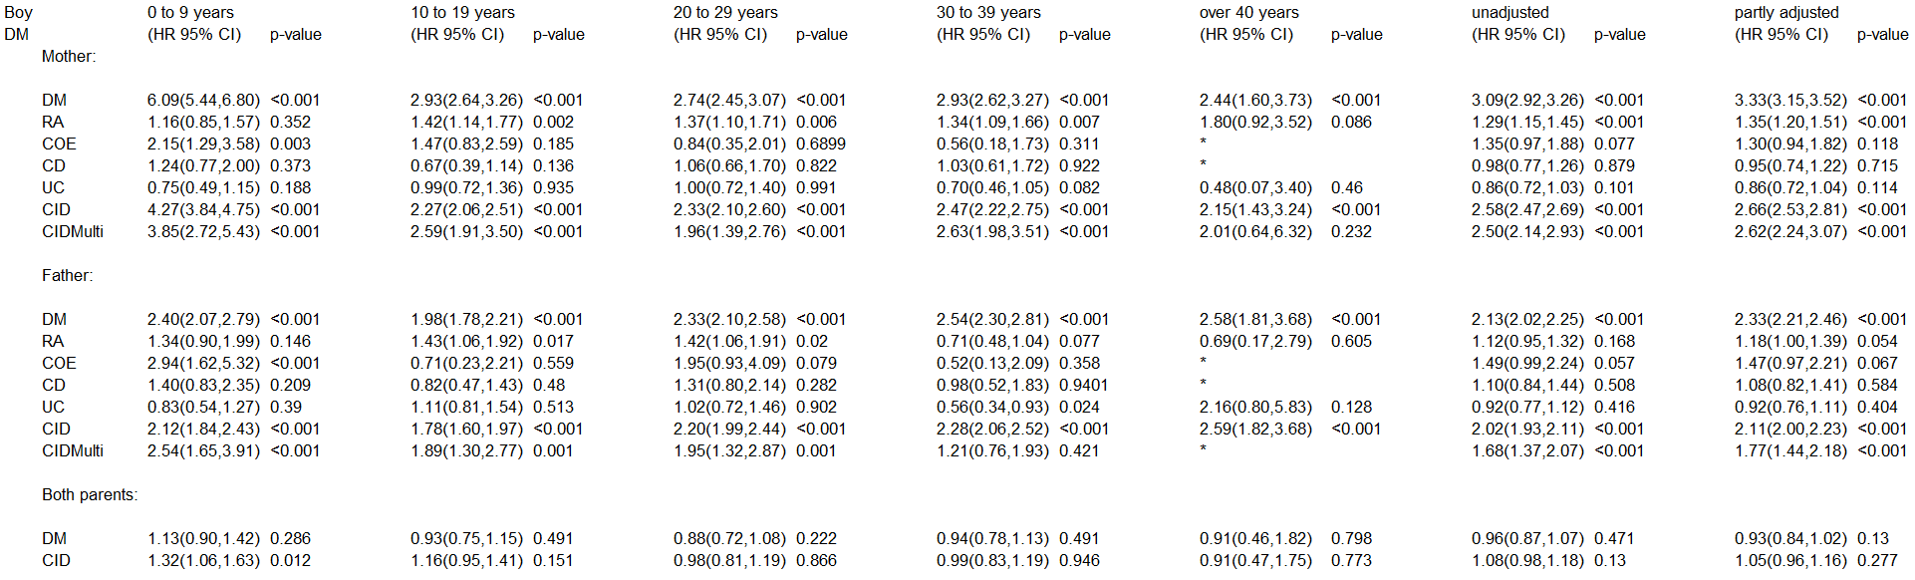
The partly adjusted model is adjusted for decade of birth, child’s sex, mother’s and father’s age.
The fully adjusted model is adjusted for decade of birth, child’s sex, mother’s and father’s age and mother’s and father’s diabetes, arthritis, coeliac disease and IBD and stratified on the age when the child got the diagnosis.
Abbreviations: DM: diabetes mellitus; RA: rheumatoid arthritis; COE: coeliac disease; CD: Crohn’s disease; UC: ulcerative colitis; CID: the parent has at least one chronic inflammatory disease; CIDMulti: the parent has more than one CID.
The asterix (*) is placed if there were too few observation to estimate the hazard ratio and the confidence interval.

b.
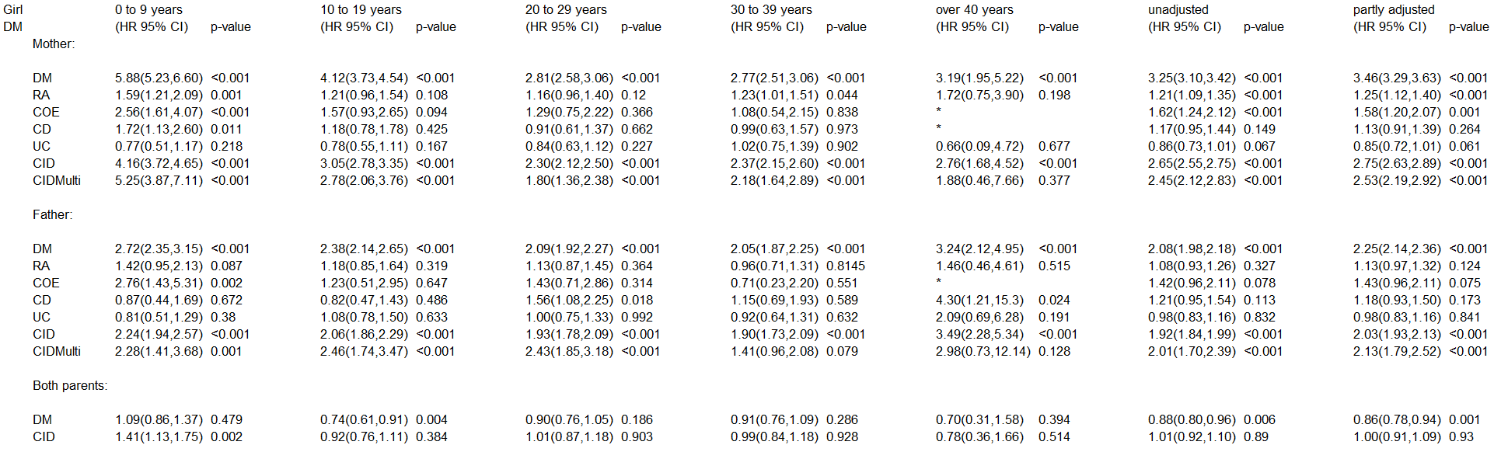
The partly adjusted model is adjusted for decade of birth, child’s sex, mother’s and father’s age.
The fully adjusted model is adjusted for decade of birth, child’s sex, mother’s and father’s age and mother’s and father’s diabetes, arthritis, coeliac disease and IBD and stratified on the age when the child got the diagnosis.
Abbreviations: DM: diabetes mellitus; RA: rheumatoid arthritis; COE: coeliac disease; CD: Crohn’s disease; UC: ulcerative colitis; CID: the parent has at least one chronic inflammatory disease; CIDMulti: the parent has more than one CID.
The asterix (*) is placed if there were too few observation to estimate the hazard ratio and the confidence interval.

c.
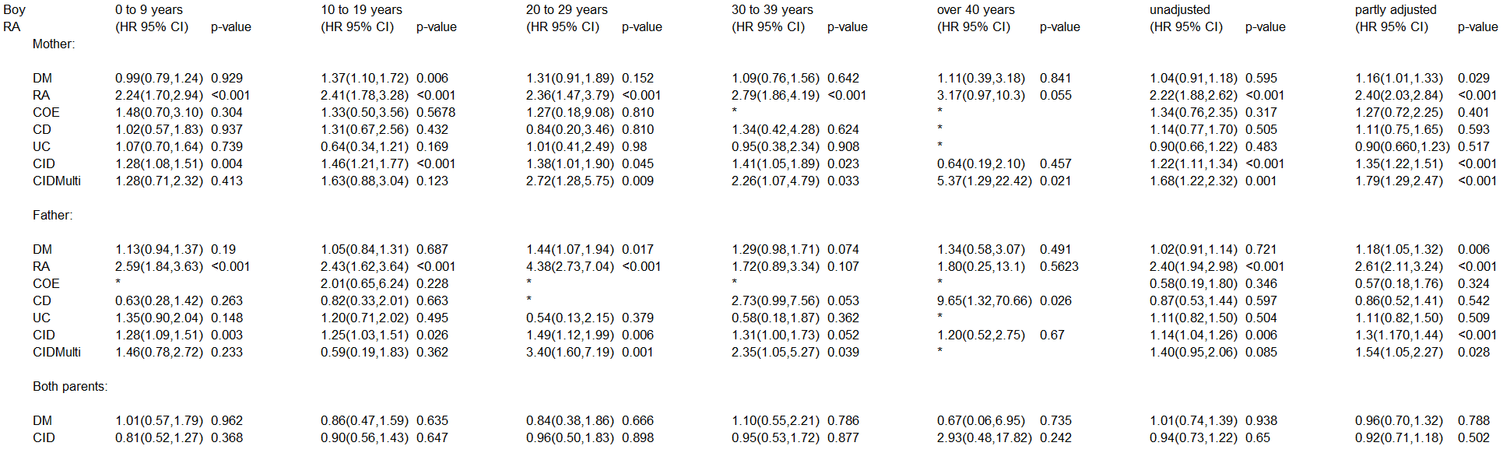
The partly adjusted model is adjusted for decade of birth, child’s sex, mother’s and father’s age.
The fully adjusted model is adjusted for decade of birth, child’s sex, mother’s and father’s age and mother’s and father’s diabetes, arthritis, coeliac disease and IBD and stratified on the age when the child got the diagnosis.
Abbreviations: DM: diabetes mellitus; RA: rheumatoid arthritis; COE: coeliac disease; CD: Crohn’s disease; UC: ulcerative colitis; CID: the parent has at least one chronic inflammatory disease; CIDMulti: the parent has more than one CID.
The asterix (*) is placed if there were too few observation to estimate the hazard ratio and the confidence interval.

d.
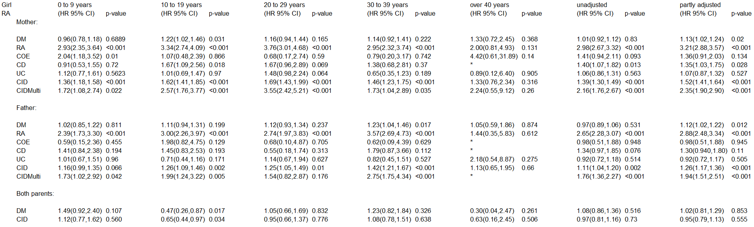
The partly adjusted model is adjusted for decade of birth, child’s sex, mother’s and father’s age.
The fully adjusted model is adjusted for decade of birth, child’s sex, mother’s and father’s age and mother’s and father’s diabetes, arthritis, coeliac disease and IBD and stratified on the age when the child got the diagnosis.
Abbreviations: DM: diabetes mellitus; RA: rheumatoid arthritis; COE: coeliac disease; CD: Crohn’s disease; UC: ulcerative colitis; CID: the parent has at least one chronic inflammatory disease; CIDMulti: the parent has more than one CID.
The asterix (*) is placed if there were too few observation to estimate the hazard ratio and the confidence interval.

e.
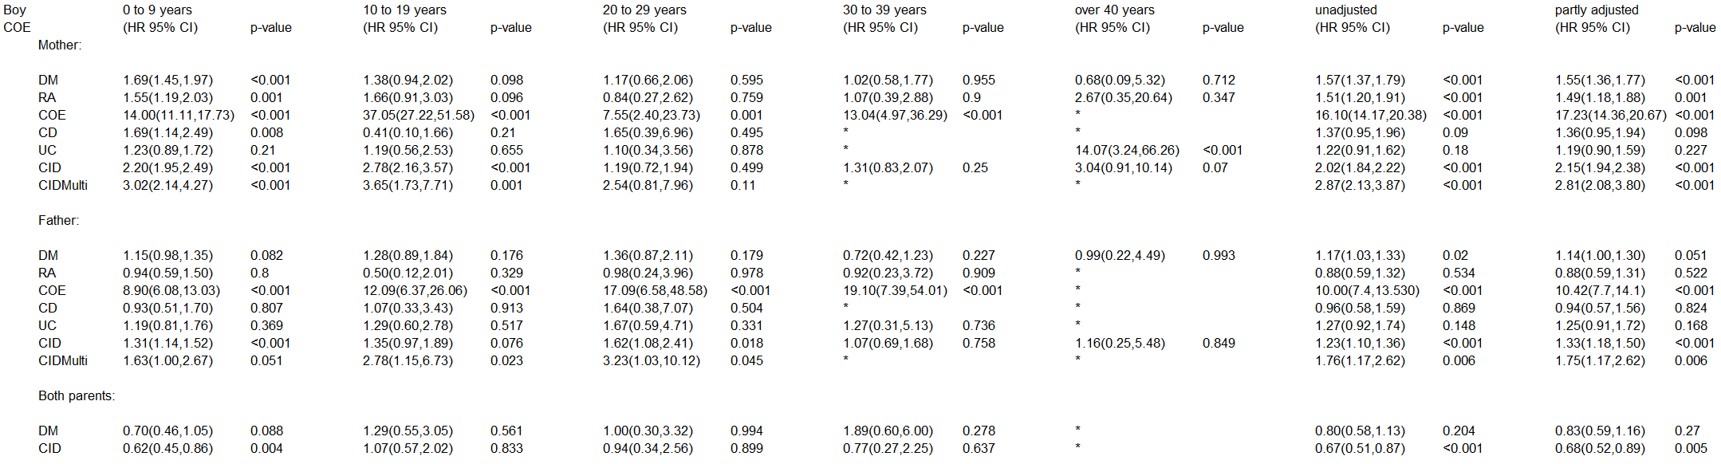
The partly adjusted model is adjusted for decade of birth, child’s sex, mother’s and father’s age.
The fully adjusted model is adjusted for decade of birth, child’s sex, mother’s and father’s age and mother’s and father’s diabetes, arthritis, coeliac disease and IBD and stratified on the age when the child got the diagnosis.
Abbreviations: DM: diabetes mellitus; RA: rheumatoid arthritis; COE: coeliac disease; CD: Crohn’s disease; UC: ulcerative colitis; CID: the parent has at least one chronic inflammatory disease; CIDMulti: the parent has more than one CID.
The asterix (*) is placed if there were too few observation to estimate the hazard ratio and the confidence interval.

f.
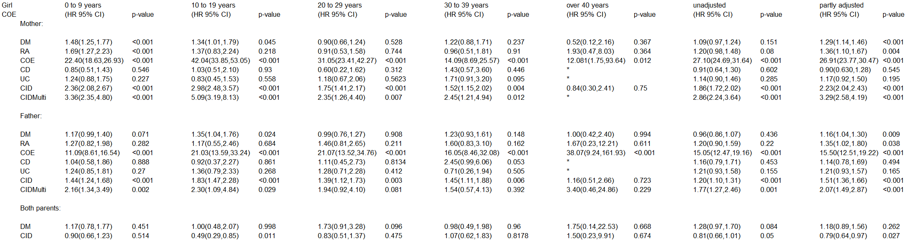
The partly adjusted model is adjusted for decade of birth, child’s sex, mother’s and father’s age.
The fully adjusted model is adjusted for decade of birth, child’s sex, mother’s and father’s age and mother’s and father’s diabetes, arthritis, coeliac disease and IBD and stratified on the age when the child got the diagnosis.
Abbreviations: DM: diabetes mellitus; RA: rheumatoid arthritis; COE: coeliac disease; CD: Crohn’s disease; UC: ulcerative colitis; CID: the parent has at least one chronic inflammatory disease; CIDMulti: the parent has more than one CID.
The asterix (*) is placed if there were too few observation to estimate the hazard ratio and the confidence interval.

g.
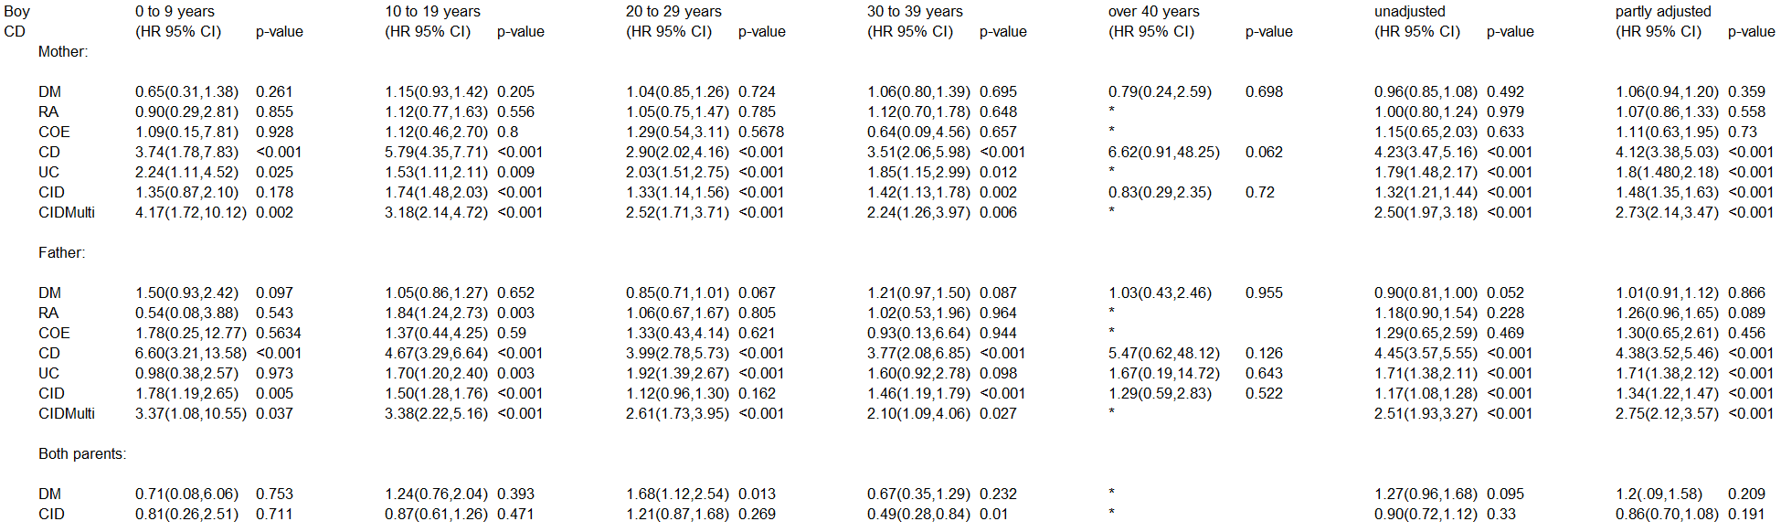
The partly adjusted model is adjusted for decade of birth, child’s sex, mother’s and father’s age.
The fully adjusted model is adjusted for decade of birth, child’s sex, mother’s and father’s age and mother’s and father’s diabetes, arthritis, coeliac disease and IBD and stratified on the age when the child got the diagnosis.
Abbreviations: DM: diabetes mellitus; RA: rheumatoid arthritis; COE: coeliac disease; CD: Crohn’s disease; UC: ulcerative colitis; CID: the parent has at least one chronic inflammatory disease; CIDMulti: the parent has more than one CID.
The asterix (*) is placed if there were too few observation to estimate the hazard ratio and the confidence interval.

h.
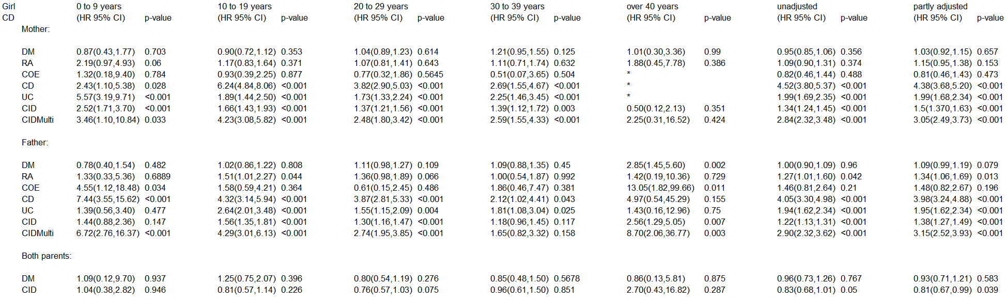
The partly adjusted model is adjusted for decade of birth, child’s sex, mother’s and father’s age.
The fully adjusted model is adjusted for decade of birth, child’s sex, mother’s and father’s age and mother’s and father’s diabetes, arthritis, coeliac disease and IBD and stratified on the age when the child got the diagnosis.
Abbreviations: DM: diabetes mellitus; RA: rheumatoid arthritis; COE: coeliac disease; CD: Crohn’s disease; UC: ulcerative colitis; CID: the parent has at least one chronic inflammatory disease; CIDMulti: the parent has more than one CID.
The asterix (*) is placed if there were too few observation to estimate the hazard ratio and the confidence interval.

i.
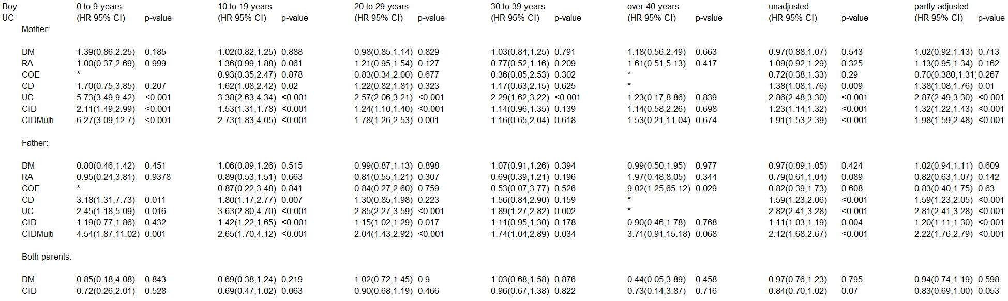
The partly adjusted model is adjusted for decade of birth, child’s sex, mother’s and father’s age.
The fully adjusted model is adjusted for decade of birth, child’s sex, mother’s and father’s age and mother’s and father’s diabetes, arthritis, coeliac disease and IBD and stratified on the age when the child got the diagnosis.
Abbreviations: DM: diabetes mellitus; RA: rheumatoid arthritis; COE: coeliac disease; CD: Crohn’s disease; UC: ulcerative colitis; CID: the parent has at least one chronic inflammatory disease; CIDMulti: the parent has more than one CID.
The asterix (*) is placed if there were too few observation to estimate the hazard ratio and the confidence interval.

j.
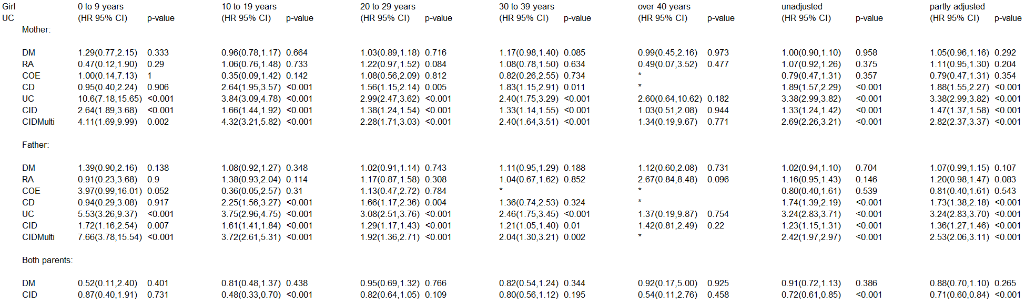
The partly adjusted model is adjusted for decade of birth, child’s sex, mother’s and father’s age.
The fully adjusted model is adjusted for decade of birth, child’s sex, mother’s and father’s age and mother’s and father’s diabetes, arthritis, coeliac disease and IBD and stratified on the age when the child got the diagnosis.
Abbreviations: DM: diabetes mellitus; RA: rheumatoid arthritis; COE: coeliac disease; CD: Crohn’s disease; UC: ulcerative colitis; CID: the parent has at least one chronic inflammatory disease; CIDMulti: the parent has more than one CID.
The asterix (*) is placed if there were too few observation to estimate the hazard ratio and the confidence interval.

k.
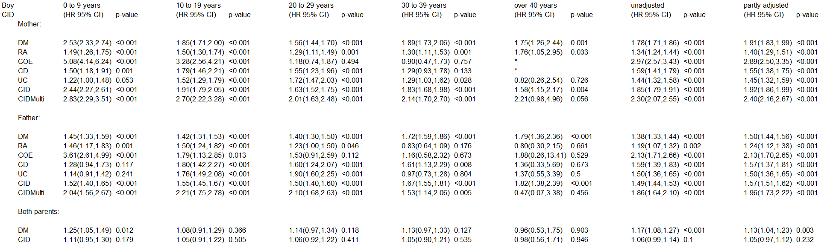
The partly adjusted model is adjusted for decade of birth, child’s sex, mother’s and father’s age.
The fully adjusted model is adjusted for decade of birth, child’s sex, mother’s and father’s age and mother’s and father’s diabetes, arthritis, coeliac disease and IBD and stratified on the age when the child got the diagnosis.
Abbreviations: DM: diabetes mellitus; RA: rheumatoid arthritis; COE: coeliac disease; CD: Crohn’s disease; UC: ulcerative colitis; CID: the parent has at least one chronic inflammatory disease; CIDMulti: the parent has more than one CID.
The asterix (*) is placed if there were too few observation to estimate the hazard ratio and the confidence interval.

l.
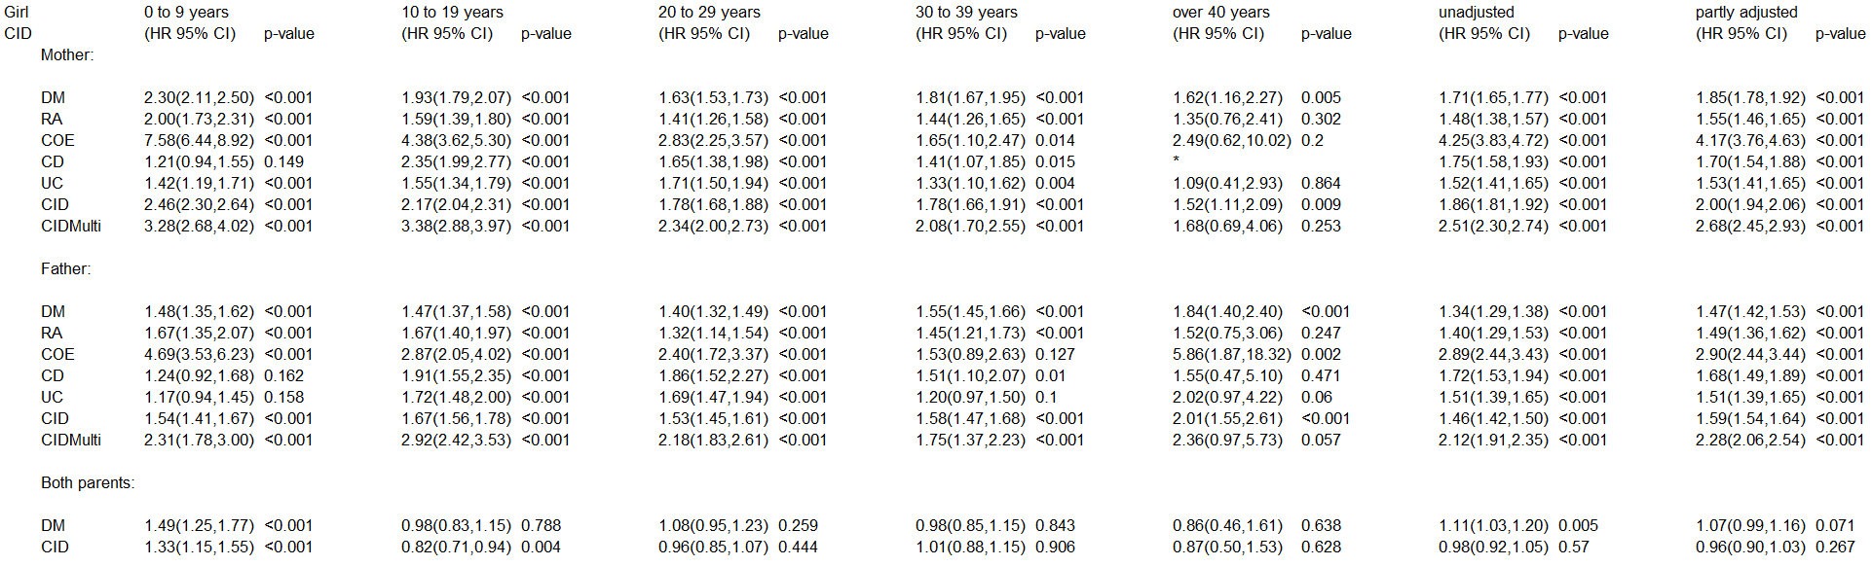
The partly adjusted model is adjusted for decade of birth, child’s sex, mother’s and father’s age.
The fully adjusted model is adjusted for decade of birth, child’s sex, mother’s and father’s age and mother’s and father’s diabetes, arthritis, coeliac disease and IBD and stratified on the age when the child got the diagnosis.
Abbreviations: DM: diabetes mellitus; RA: rheumatoid arthritis; COE: coeliac disease; CD: Crohn’s disease; UC: ulcerative colitis; CID: the parent has at least one chronic inflammatory disease; CIDMulti: the parent has more than one CID.
The asterix (*) is placed if there were too few observation to estimate the hazard ratio and the confidence interval.

