Figure S1 Diagram of study training cohort selection step.
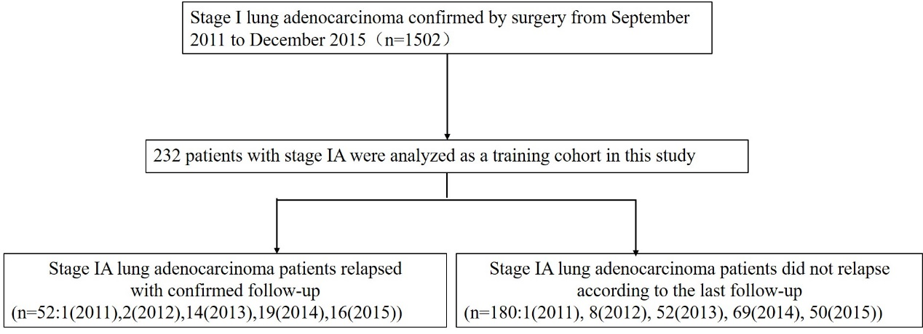

Table S1 Point assignment of prognostic model
Variable | Points
Tumor differentiation
High differentiation | 0
High-middle differentiation | 35
Middle differentiation | 31
Middle-low differentiation | 52
Low differentiation | 58
Unknown | 24
EGFR mutation
No | 93
EGFR 19del | 100
EGFR 21L858R | 77
Unknown | 0

Table S2 1-year, 3-year and 5-year DFS rate in different risk groups stratified by nomogram in training and validation cohorts
 | Training cohort |  |  | Validation cohort
 | Low-risk group | Middle-risk group | High-risk group | Low-risk group | Middle-risk group | High-risk group
1-year DFS rate (%) | 100.0 | 97.9 | 71.4 | 100.0 | 100.0 | 100.0
3-year DFS rate (%) | 98.1 | 84.3 | 21.8 | 100.0 | 98.2 | 87.5
5-year DFS rate (%) | 98.1 | 78.2 | 10.9 | 100.0 | 98.2 | 83.3

