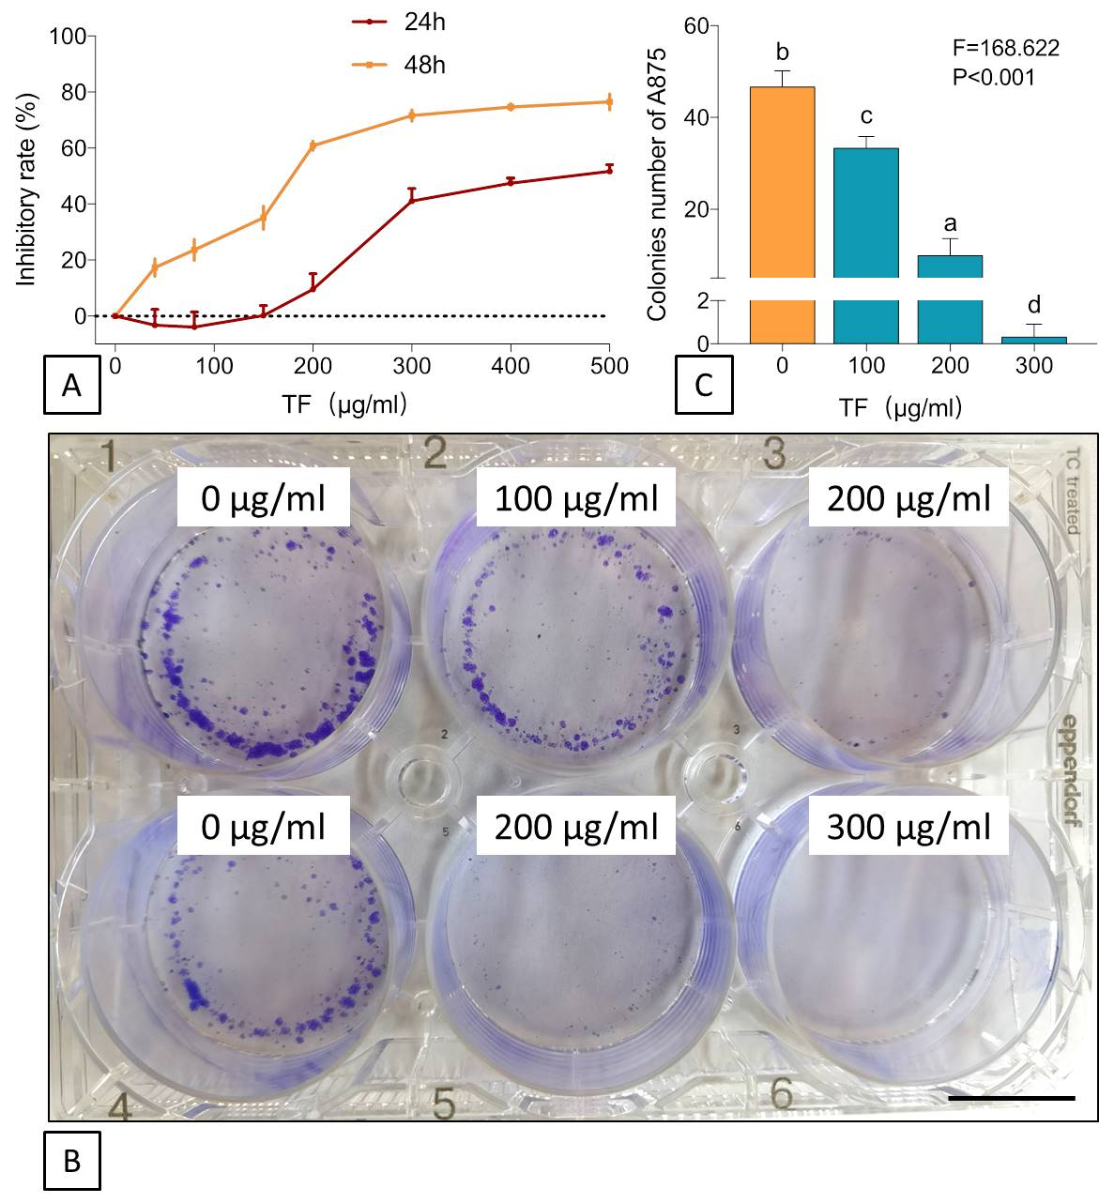
Figure S1. Cell viability (A), clonogenic assay (B) and colony numbers (C) of human A875 cells with treatments of TF. Data (mean ± SD) points with different letters (a, b, c, and d) indicate significant difference between each other [Fisher’s least significant difference (LSD), P < 0.05], and the values decrease with the order from a to d. Scale bar = 2 μm.
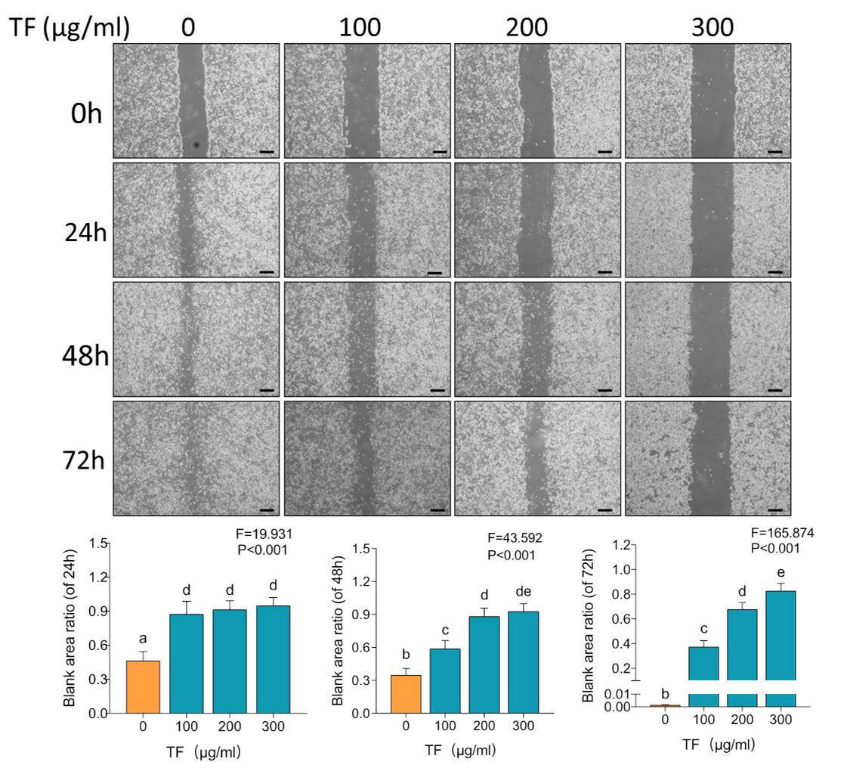
Figure S2. Wound healing assay with statistical analysis of blank area ratios on A875 cells with TF treatment. Data (mean ± SD) points with different letters (a, b, c, d, de and e) indicate significant difference between each other [Fisher’s least significant difference (LSD), P < 0.05], and the values decrease with the order from a to e. Scale bar = 300 μm.
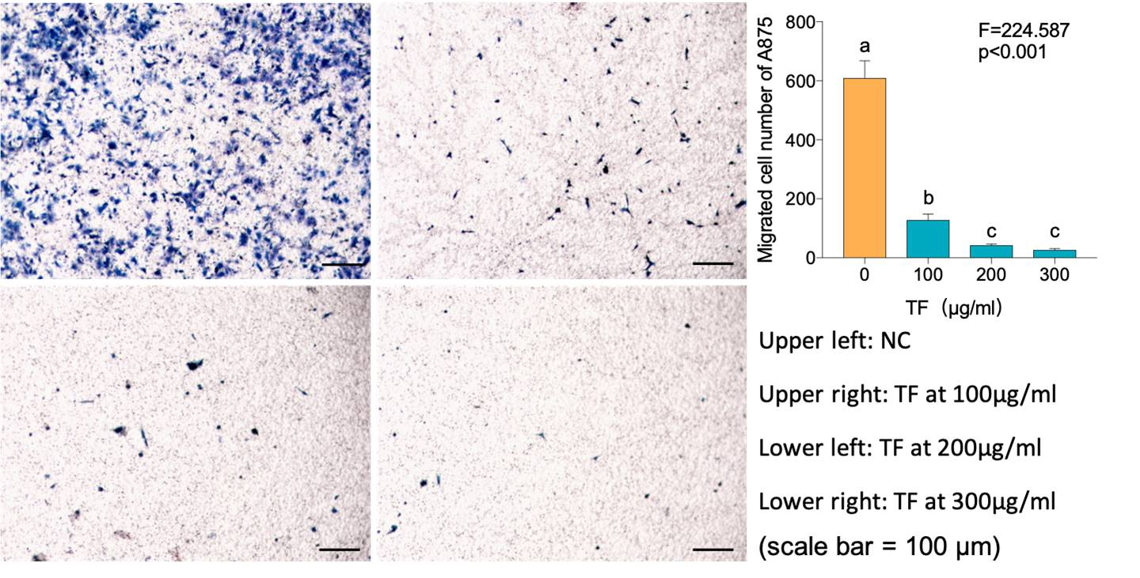
Figure S3. Transwell assay of A875 cells with TF treatments. Data (mean ± SD) points with different letters (a, b, and c) indicate significant difference between each other [Fisher’s least significant difference (LSD), P < 0.05], and the values decrease with the order from a to c. Scale bar = 300 μm.

