 | Univariate |  | Multivariate |  | Univariate |  | Multivariate
 | HR (95% CI) | p | HR (95% CI) | p | HR (95% CI) | p | HR (95% CI) | p
Chemo-immunotherapy (n=80) | Progression-free survival |  |  |  | Overall survival
Age ≥70 vs. <70 years | 0.87 (0.46-1.66) | 0.867 |  |  | 1.11 (0.48-2.58) | 0.800 | n.e.
Female vs. Male | 1.09 (0.64-1.87) | 0.749 |  |  | 1.32 (0.67-2.63) | 0.423 | n.e.
ECOG 1 vs 0 | 2.01 (1.08-3.72) | 0.027 |  |  | 4.44 (2.00-10.06) | <0.001 | n.e.
ECOG 2 vs 0 | 2.80 (1.35-5.83) | 0.006 |  |  | 7.12 (2.82-18.00) | <0.001 | n.e.
PD-L1 status (neg. vs. ≥1%) | 1.48 (0.86-2.54) | 0.155 |  |  | 1.43 (0.71-2.91) | 0.319 | n.e.
RECIST SD vs. CR/PR | 3.30 (1.64-6.66) | 0.001 | 5.07 (2.07-12.39) | <0.001 | 2.90 (1.07-7.89) | 0.037 | n.e.
RECIST PD vs. CR/PR | 7.07 (3.15-15.86) | <0.001 | 16.04 (5.51-46.72) | <0.001 | 6.99 (2.40-20.41) | <0.001 | n.e.
STM increase vs. decrease | 2.06 (1.04-410) | 0.038 |  |  | 0.61 (0.18-2.11) | 0,609 | n.e.
Mono-immunotherapy (n=54) | Progression-free survival |  |  |  | Overall survival
Age ≥70 vs. <70 years | 0.58 (0.24-1.41) | 0.227 |  |  | 0.25 (0.03-1.89) | 0.179
Female vs. Male | 0.63 (0.29-1.38) | 0.247 |  |  | 0.40 (0.11-1.39) | 0.149
ECOG 1 vs 0 | 1.74 (0.75-4.05) | 0.200 |  |  | 5.85 (1.64-20.92) | 0.007 | 4.07 (0.57-29.00) | 0.162
ECOG 2 vs 0 | 3.01 (1.17-7.74) | 0.022 |  |  | 13.12 (3.51-49.07) | <0.001 | 12.22 (1.72-86.74) | 0.012
PD-L1 status (neg. vs. ≥1%) | 1.80 (0.87-3.72) | 0.115 |  |  | 1.10 (0.38-3.16) | 0.866
RECIST SD vs. CR/PR | 6.23 (0.80-48.5) | 0.081 | 7.21 (0.92-56.73) | 0.061 | n.e.
RECIST PD vs. CR/PR | 26.54 (3.17-222) | 0.003 | 14.71 (1.71-126) | 0.014 | n.e.
STM increase vs. decrease | 5.49 (1.78-16.91) | 0.003 | 4.06 (1.15-14.33) | 0.029 | 6.07 (0.75-49.40) | 0.092
Supplementary table 1. Uni- and multivariate analyses for progression-free- and overall survival for all patients in the mono-immunotherapy and chemo-immunotherapy cohort. Data are given as hazard ratio (95% confidence interval), with a ratio >1 signifying an increased risk of progression/death or death, respectively. Bold figures are for significant hazard ratios (p<0.005). HR= hazard ratio, CI= Confidence Interval, ECOG= Eastern Cooperative Oncology Group, PD-L1= Programmed Death-Ligand 1, RECIST= response evaluation criteria in solid tumors, CR=complete remission, PR=partial remission, SD=stable disease, PD= progressive disease, STM=serum tumor marker, n.e.=not evaluable

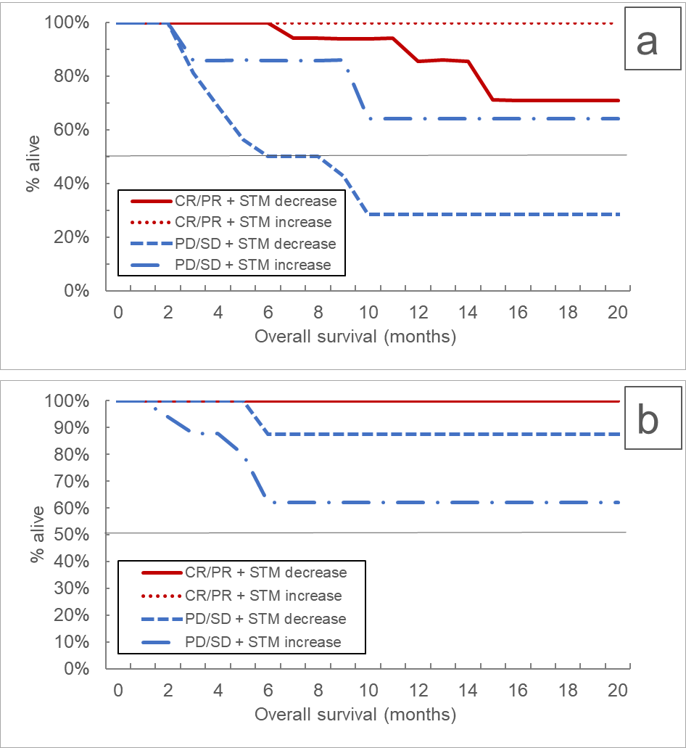
Supplementary figure 1. Kaplan-Meier curves for overall survival according to RECIST response categories and STM dynamics in the chemo-immunotherapy (a) as well as the mono-immunotherapy maintenance phase (b). RECIST=response evaluation criteria in solid tumors, CR=complete remission, PR=partial remission, SD=stable disease, PD= progressive disease, STM=serum tumor marker

