Supplementary information

Lung function
Over 24 weeks, the magnitude of improvement (mL [95% CI], unadjusted p-value) in FEV₁ AUC_{0–4} was greater with BGF MDI than BFF MDI and BUD/FORM DPI, both in those not reporting (122 [90, 153]; p<0.0001 and 77 [45, 110]; p<0.0001, respectively) and in those reporting (55 [6, 104]; p=0.0269 and 125 [78, 172]; p<0.0001, respectively) a prior exacerbation (Table S4B, Table S4C; Figure S3A). A small magnitude benefit in FEV₁ AUC_{0–4} was seen for BGF MDI versus GFF MDI in those reporting and not reporting a prior exacerbation (35 [–5, 75]; p=0.0882 and 11 [–14, 37]; p=0.3847, respectively) (Table S4B, Table S4C).
The change from baseline in morning pre-dose trough FEV₁ (mL [95% CI]) over 24 weeks was also greater with by BGF MDI versus BFF MDI and BUD/FORM DPI in the no prior exacerbation subgroup (88 [63, 113]; p<0.0001 and 46 [21, 71]; p=0.0003, respectively), and versus BUD/FORM DPI, but not BFF MDI in the prior exacerbation subgroup (96 [56, 137]; p<0.0001 and 29 [–12, 71]; p=0.1645, respectively) (Table S4B, Table S4C; Figure S3B). Small improvements in favor of BGF MDI in change from baseline in morning pre-dose trough FEV₁ versus GFF MDI were observed in those reporting and not reporting a prior exacerbation (28 [–6, 62]; p=0.1035 and 20 [–1, 40]; p=0.0559, respectively) (Table S4B, Table S4C).
Improvements for BGF MDI versus comparators were generally similar throughout the 24-week treatment period for FEV₁ AUC_{0–4} and change from baseline in morning pre-dose trough FEV₁ for both subgroups (Figure S3A, Figure S3B).

Table S1 Exacerbation outcomes in the subgroup of patients with no history of prior exacerbations in the previous 12 months and no prior ICS use (efficacy estimand, mITT population)
 | BGF MDI  320/18/9.6 μg | GFF MDI  18/9.6 μg | BFF MDI  320/9.6 μg | BUD/FORM DPI  400/12 μg
Patients, N | N=136 | N=147 | N=73 | N=77
Rate of moderate/severe COPD exacerbations
Number of events, n | 19 | 28 | 13 | 10
Adjusted annualized rate (SE) | 0.32 (0.09) | 0.45 (0.11) | 0.41 (0.14) | 0.26 (0.10)
Rate ratio, BGF MDI vs comparator (95% CI) | - | 0.73  (0.36, 1.47) | 0.79  (0.33, 1.86) | 1.24  (0.49, 3.13)
p-value | - | 0.3742 | 0.5862 | 0.6481
Time to first moderate/severe COPD exacerbation
Number of patients with exacerbations, n (%) | 18 (13.2) | 20 (13.6) | 12 (16.4) | 8 (10.4)
Hazard ratio, BGF MDI vs comparator (95% CI) | - | 0.980  (0.517, 1.857) | 0.808  (0.389, 1.680) | 1.394  (0.605, 3.213)
Cox regression  p-value | - | 0.9505 | 0.5682 | 0.4359
Log rank p-value | - | 0.9772 | 0.7105 | 0.5891
Notes: Treatments are compared adjusting for baseline post-bronchodilator percent predicted FEV₁ and baseline eosinophil count as continuous covariates and country and inhaled corticosteroid use at screening (yes/no) as categorical covariates using negative binomial regression.
Abbreviations: BFF, budesonide/formoterol fumarate; BGF, budesonide/glycopyrrolate/formoterol fumarate; BUD/FORM DPI, budesonide/formoterol fumarate dry powder inhaler; CI, confidence interval; COPD, chronic obstructive pulmonary disease; GFF, glycopyrrolate/formoterol fumarate; MDI, metered dose inhaler; mITT, modified intent-to-treat; SE, standard error.
Table S2 Model-estimated rates of moderate/severe COPD exacerbations for patients with ICS use in the 30 days prior to screening excluding the first 30 days of data (mITT population, efficacy estimand)
 | BGF MDI  320/18/9.6 μg | GFF MDI  18/9.6 μg | BFF MDI  320/9.6 μg | BUD/FORM DPI  400/12 μg
Patients, N | N=452 | N=424 | N=214 | N=215
Rate of moderate/severe COPD exacerbations
Number of events, n | 88 | 155 | 46 | 51
Adjusted annualized rate, (SE) | 0.53 (0.07) | 1.23 (0.14) | 0.60 (0.11) | 0.65 (0.12)
Rate ratio, BGF MDI  vs comparator (95% CI) | - | 0.43  (0.31, 0.60) | 0.88  (0.57, 1.37) | 0.82  (0.53, 1.25)
p-value | - | <0.0001 | 0.5797 | 0.3497
Time to first moderate/severe COPD exacerbation
Number of patients with exacerbations, n (%) | 71 (15.7) | 106 (25.0) | 42 (19.6) | 42 (19.5)
Hazard ratio, BGF MDI vs comparator (95% CI) | - | 0.54  (0.40, 0.73) | 0.75  (0.51, 1.10) | 0.81  (0.55, 1.19)
Cox regression  p-value | - | 0.0002 | 0.0456 | 0.0634
Notes: Treatments are compared adjusting for baseline post-bronchodilator percent predicted FEV₁ and baseline eosinophil count as continuous covariates and country and inhaled corticosteroid use at screening (yes/no) as categorical covariates using negative binomial regression.
Abbreviations: BFF, budesonide/formoterol fumarate; BGF, budesonide/glycopyrrolate/formoterol fumarate; BUD/FORM DPI, budesonide/formoterol fumarate dry powder inhaler; CI, confidence interval; COPD, chronic obstructive pulmonary disease; FEV₁; forced expiratory volume in 1 s; GFF, glycopyrrolate/formoterol fumarate; MDI, metered dose inhaler; mITT, modified intent-to-treat; SE, standard error.
Table S3 Model-estimated rates of moderate/severe COPD exacerbations by reported exacerbations in the previous 12 months, excluding the first 30 days of data (mITT population, efficacy estimand)
(A) Overall population
 | BGF MDI  320/18/9.6 μg | GFF MDI  18/9.6 μg | BFF MDI  320/9.6 μg | BUD/FORM DPI  400/12 μg
OVERALL POPULATION
Patients, N | N=625 | N=605 | N=303 | N=305
Rate of moderate/severe COPD exacerbations
Number of events, n | 116 | 184 | 58 | 63
Adjusted annualized rate, (SE) | 0.49 (0.06) | 0.95 (0.10) | 0.53 (0.09) | 0.55 (0.09)
Rate ratio, BGF MDI  vs comparator (95% CI) | - | 0.52  (0.39, 0.70) | 0.93  (0.63, 1.37) | 0.89  (0.61, 1.30)
p-value | - | <0.0001 | 0.7118 | 0.5501
Time to first moderate/severe COPD exacerbation
Number of patients with exacerbations, n (%) | 96 (15.4) | 129 (21.3) | 53 (17.5) | 53 (17.4)
Hazard ratio, BGF MDI vs comparator (95% CI) | - | 0.65  (0.50, 0.85) | 0.83  (0.59, 1.16) | 0.90  (0.64, 1.26)
Cox regression  p-value | - | 0.0037 | 0.1677 | 0.2237
(B) No prior exacerbations
 | BGF MDI  320/18/9.6 μg | GFF MDI  18/9.6 μg | BFF MDI  320/9.6 μg | BUD/FORM DPI  400/12 μg
Patients, N | N=460 | N=457 | N=228 | N=225
Rate of moderate/severe COPD exacerbations
Number of events, n | 77 | 120 | 33 | 39
Adjusted annualized rate, (SE) | 0.46 (0.06) | 0.81 (0.10) | 0.40 (0.08) | 0.47 (0.09)
Rate ratio, BGF MDI vs comparator  (95% CI) | - | 0.57  (0.40, 0.81) | 1.14  (0.71, 1.86) | 0.97  (0.61, 1.55)
p-value | - | 0.0017 | 0.5858 | 0.9075
Time to first moderate/severe COPD exacerbation
Number of patients with exacerbations, n (%) | 66 (14.3) | 89 (19.5) | 31 (13.6) | 33 (14.7)
Hazard ratio, BGF MDI vs comparator (95% CI) | - | 0.70  (0.51, 0.96) | 1.05  (0.68, 1.61) | 0.97  (0.64, 1.48)
Cox regression  p-value | - | 0.0344 | 0.8492 | 0.7140
(C) Prior exacerbations
 | BGF MDI  320/18/9.6 μg | GFF MDI  18/9.6 μg | BFF MDI  320/9.6 μg | BUD/FORM DPI  400/12 μg
Patients, N | N=165 | N=148 | N=75 | N=80
Rate of moderate/severe COPD exacerbations
Number of events, n | 39 | 64 | 25 | 24
Adjusted annualized rate, (SE) | 0.63 (0.13) | 1.47 (0.26) | 0.98 (0.26) | 0.85 (0.23)
Rate ratio, BGF MDI vs comparator (95% CI) | - | 0.43  (0.25, 0.72) | 0.65  (0.34, 1.23) | 0.74  (0.39, 1.42)
p-value | - | 0.0015 | 0.1847 | 0.3681
Time to first moderate/severe COPD exacerbation
Number of patients with exacerbations, n (%) | 30 (18.2) | 40 (27.0) | 22 (29.3) | 20 (25.0)
Hazard ratio, BGF MDI vs comparator (95% CI) | - | 0.55  (0.34, 0.89) | 0.54  (0.31, 0.94) | 0.78  (0.44, 1.39)
Cox regression  p-value | - | 0.0201 | 0.0193 | 0.0887
Notes: Treatments are compared adjusting for baseline post-bronchodilator percent predicted FEV₁ and baseline eosinophil count as continuous covariates and country and inhaled corticosteroid use at screening (yes/no) as categorical covariates using negative binomial regression.
Abbreviations: BFF, budesonide/formoterol fumarate; BGF, budesonide/glycopyrrolate/formoterol fumarate; BUD/FORM DPI, budesonide/formoterol fumarate dry powder inhaler; CI, confidence interval; COPD, chronic obstructive pulmonary disease; GFF, glycopyrrolate/formoterol fumarate; MDI, metered dose inhaler; mITT, modified intent-to-treat; SE, standard error.
Table S4 Lung function over 24 weeks by reported exacerbations (efficacy estimand, mITT population)
(A) Overall population
 | BGF MDI  320/18/9.6 μg | GFF MDI  18/9.6 μg | BFF MDI  320/9.6 μg | BUD/FORM DPI  400/12 μg
FEV₁ AUC_{0–4}, mL
Number of patients, n | 501 | 485 | 245 | 248
LSM (SE) | 305 (8.4) | 288 (8.5) | 201 (11.7) | 214 (11.5)
BGF MDI  vs comparator, LSM (95% CI) | - | 16  (−6, 38) | 104  (77, 131) | 91  (64, 117)
p-value | - | 0.1448 | <0.0001 | <0.0001
Change from baseline over 24 weeks in morning pre-dose trough FEV₁, mL
Number of  patients, n | 622 | 601 | 300 | 301
LSM (SE) | 147 (6.5) | 125 (6.6) | 73 (9.2) | 88 (9.1)
BGF MDI  vs comparator, LSM (95% CI) | - | 22  (4, 39) | 74  (52, 95) | 59  (38, 80)
p-value | - | 0.0139 | <0.0001 | <0.0001
(B) No prior exacerbations
 | BGF MDI  320/18/9.6 μg | GFF MDI  18/9.6 μg | BFF MDI  320/9.6 μg | BUD/FORM DPI  400/12 μg
FEV₁ AUC_{0–4}, mL
Number of patients, n | 366 | 357 | 178 | 175
LSM (SE) | 309 (9.9) | 297 (10.0) | 187 (13.8) | 231 (13.8)
BGF MDI  vs comparator, LSM (95% CI) | - | 11  (–14, 37) | 122  (90, 153) | 77  (45, 110)
p-value | - | 0.3847 | <0.0001 | <0.0001
Change from baseline over 24 weeks in morning pre-dose trough FEV₁, mL
Number of patients, n | 457 | 455 | 225 | 222
LSM (SE) | 146 (7.6) | 126 (7.6) | 58 (10.6) | 100 (10.6)
BGF MDI  vs comparator, LSM (95% CI) | - | 20  (–1, 40) | 88  (63, 113) | 46  (21, 71)
p-value | - | 0.0559 | <0.0001 | 0.0003
(C) Prior exacerbations
 | BGF MDI  320/18/9.6 μg | GFF MDI  18/9.6 μg | BFF MDI  320/9.6 μg | BUD/FORM DPI  400/12 μg
FEV₁ AUC_{0–4}, mL
Number of patients, n | 135 | 128 | 67 | 73
LSM (SE) | 297 (15.8) | 262 (16.1) | 242 (21.4) | 172 (20.7)
BGF MDI  vs comparator, LSM (95% CI) | - | 35  (–5, 75) | 55  (6, 104) | 125  (78, 172)
p-value | - | 0.0882 | 0.0269 | <0.0001
Change from baseline over 24 weeks in morning pre-dose trough FEV₁, mL
Number of  patients, n | 165 | 146 | 75 | 79
LSM (SE) | 149 (12.5) | 121 (13.3) | 119 (18.2) | 52 (17.7)
BGF MDI  vs comparator, LSM (95% CI) | - | 28  (–6, 62) | 29  (–12, 71) | 96  (56, 137)
p-value | - | 0.1035 | 0.1645 | <0.0001
Abbreviations: AUC_{0–4}, area under curve from 0–4 hours; BFF, budesonide/formoterol fumarate; BGF, budesonide/glycopyrrolate/formoterol fumarate; BUD/FORM DPI, budesonide/formoterol fumarate dry powder inhaler; CI, confidence interval; GFF, glycopyrrolate/formoterol fumarate; LSM, least squares mean; MDI, metered dose inhaler; mITT, modified intent-to-treat; SE, standard error.

Figure S1 Kaplan-Meier curves for time to first moderate/severe COPD exacerbation for patients with ICS use in the 30 days prior to screening excluding the first 30 days of data (mITT population, efficacy estimand)
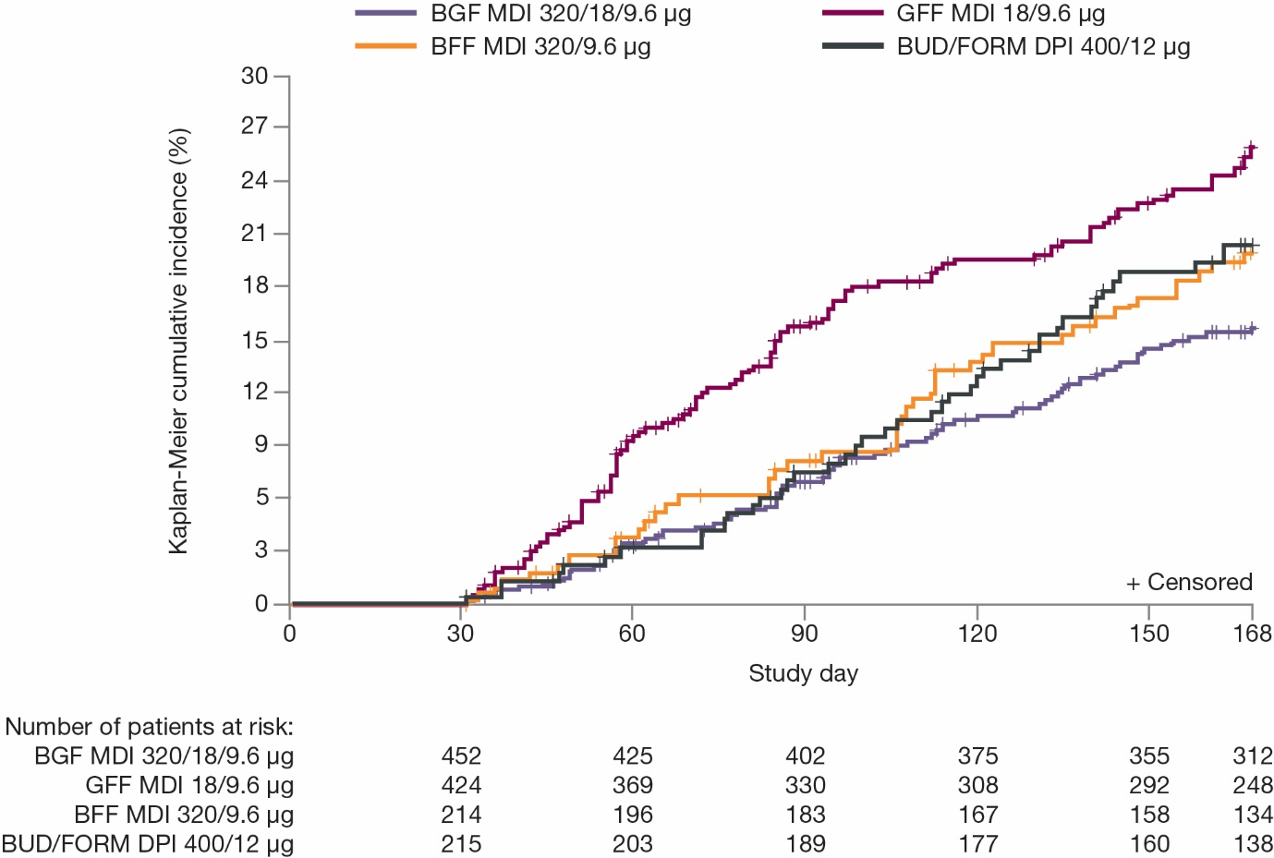
Abbreviations: BFF, budesonide/formoterol fumarate; BGF, budesonide/glycopyrrolate/formoterol fumarate; BUD/FORM DPI, budesonide/formoterol fumarate dry powder inhaler; COPD, chronic obstructive pulmonary disease; GFF, glycopyrrolate/formoterol fumarate; ICS, inhaled corticosteroids; MDI, metered dose inhaler; mITT, modified intent-to-treat.
Figure S2 Kaplan-Meier curves for time to first moderate/severe COPD exacerbation for (A) overall population, (B) reported prior exacerbations, and (C) no reported prior exacerbations excluding the first 30 days of data (mITT population, efficacy estimand)
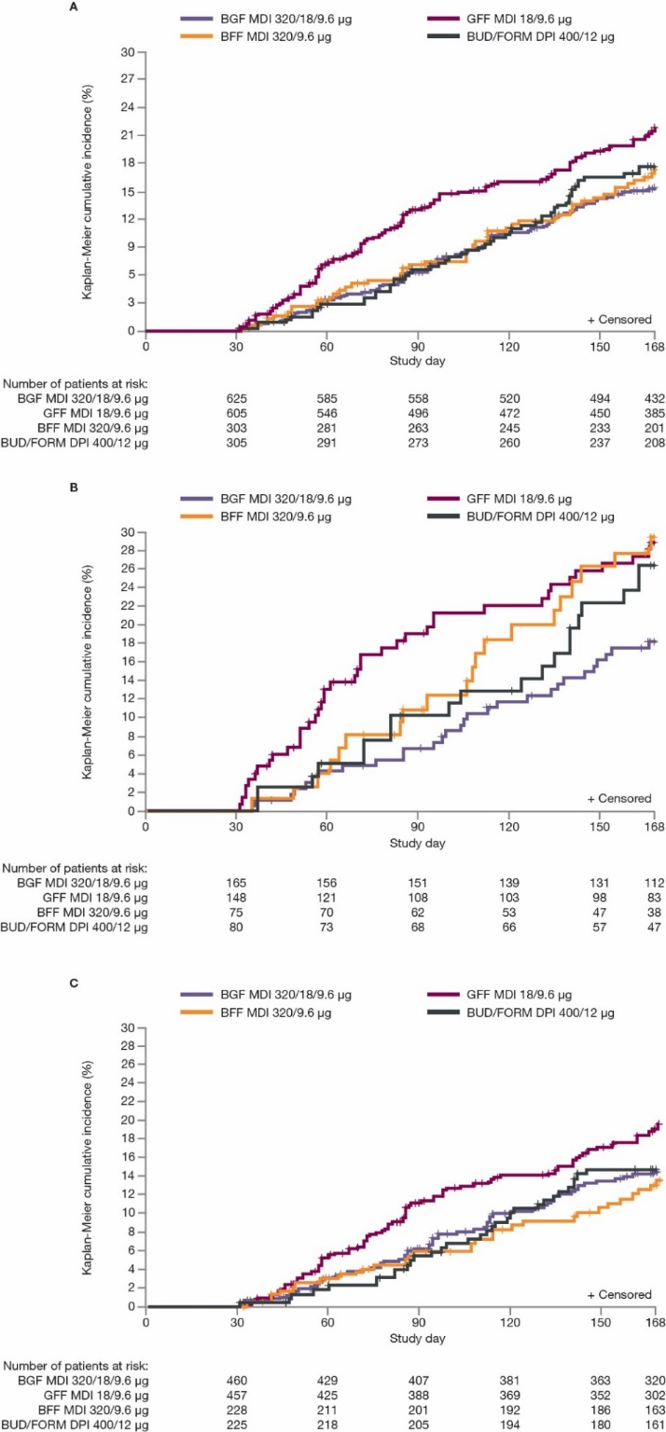
Abbreviations: BFF, budesonide/formoterol fumarate; BGF, budesonide/glycopyrrolate/formoterol fumarate; BUD/FORM DPI, budesonide/formoterol fumarate dry powder inhaler; COPD, chronic obstructive pulmonary disease; GFF, glycopyrrolate/formoterol fumarate; MDI, metered dose inhaler; mITT, modified intent-to-treat.
Figure S3 Comparison of lung function endpoints over time for patients reporting and not reporting a prior exacerbation (mITT population; efficacy estimand) (A) FEV₁ AUC_{0–4,} and (B) Change from baseline in morning pre-dose FEV₁
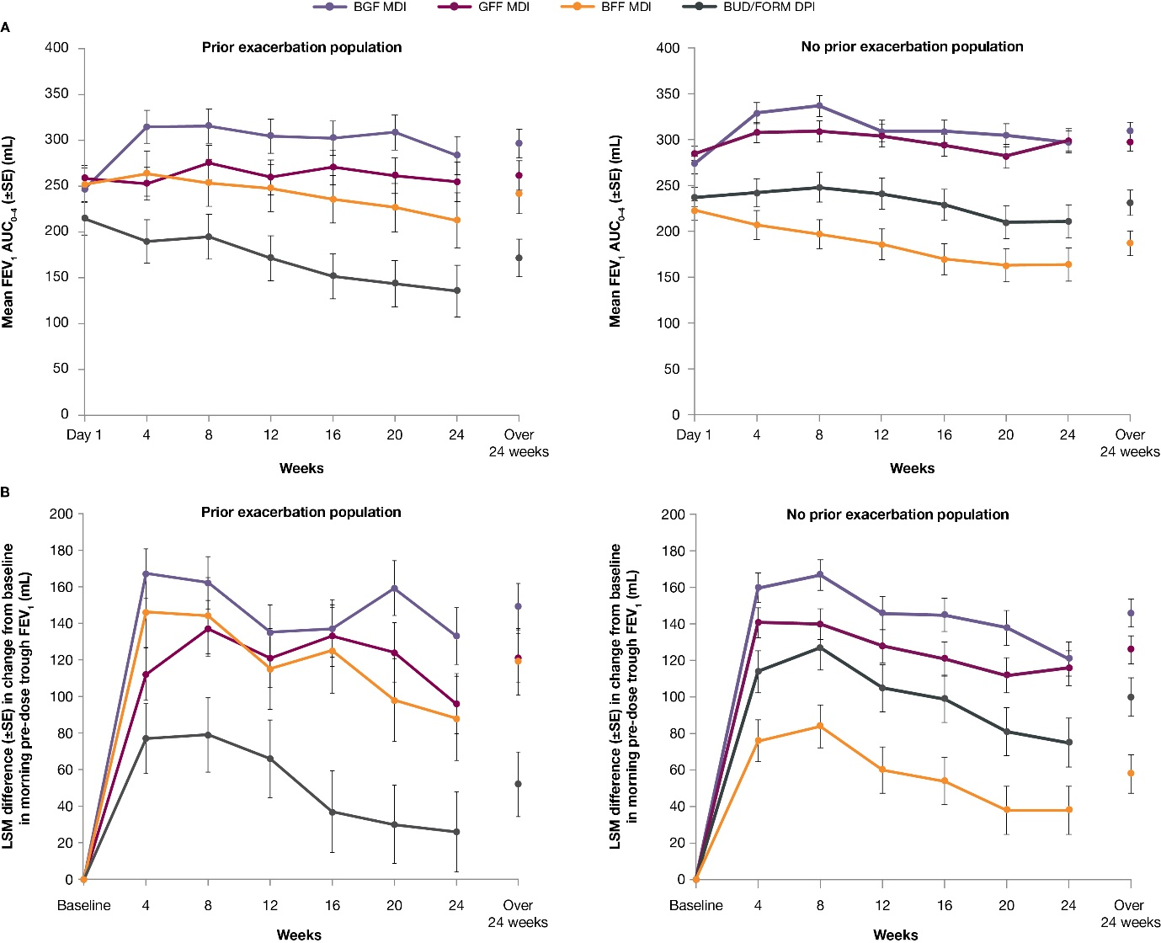
Error bars represent SE.
Abbreviations: AUC_{0–4}, area under curve from 0–4 hours; BFF, budesonide/formoterol fumarate; BGF, budesonide/glycopyrrolate/formoterol fumarate; BUD/FORM DPI, budesonide/formoterol fumarate dry powder inhaler; FEV₁, forced expiratory volume in 1 second; GFF, glycopyrrolate/formoterol fumarate; LSM, least squares mean; MDI, metered dose inhaler; mITT, modified intent-to-treat; SE, standard error.

Independent Ethics Committees/Institutional Review Boards consulted
Independent ethics committees/institutional review boards (IRB)
Schulman, 4445 Lake Forest Drive, Suite 300, Cincinnati, OH 45242, USA
Showa University Hospital IRB, 158 Hatanodia, Shinagawa-KU, Tokyo, Japan
Nihonbashi EGAWA Clinic IRB, 2F Kotobuki Bld 1-1-3 Yaesu, Chuo-ku, Tokyo, Japan
Aso Iizuka Hospital IRB, 3-83, Yoshio-machi Iizuka-shi, Fukouka, Japan
Medical Corporation IHL, Shinagawa East One Medical Clinic IRB, 2-16-1 Shinagawa East One Tower 3F, Konan, Minato-ku, Tokyo, Japan
Review Board of Human Rights and Ethics for Clinical Studies IRB, 13-2 Ichiban-cho, Chiyoda-ku, Tokyo, Japan
Social Medical Corporation Keiaikai Nakagami Hospital IRB, 6-2-25 Chibana, Okinawa-Shi, Okinawa, Japan
Harasanshin General Hospital IRB, 1-8 Taihakumachi Hakata-ku, Fukouoka-shi, Japan
Medical Corporate Corporation Mitsuyakai, Maebashi Hirosegawa Clinic IRB, 2-10-9 Chiyoda-machi, Maebashi-shi, Gunma, Japan
Toyama University Hospital IRB, 2630 Sugiya Toyama-shi, Japan
Local Independent Administrative Agencies Naha City Hospital IRB, 2-31-1 Furujima, Naha-shi, Okinawa, Japan
Yaesu Sakura-dori Clinic IRB, Yaesu Center Bldg. 3F, 1-6-6 Yaesu Chuo-ku, Tokyo, Japan
Medical Corporation Association Shintokai, Yokohama Minoru Clinic IRB, 1-13-8 Bessho Minami-ku, Yokohama-shi, Kanagawa, Japan
Medical Corporation Seiwakai Nagata Hospital IRB, 523-1 Shimomiyanaga-machi, Yanagawa-shi, Fukuoka, Japan
Aida Hospital IRB, 216 Motomachi, Yabuki-machi, Nishishirakawa-gun, Fukushima, Japan
Okitama Public General Hospital IRB, 2000 Nishiotsuka, Kawanishi-machi, Higashiokitama-gun, Yamagata, Japan
Sakaide City Hospital IRB, 3-1-2 Kotobuki-cho, Sakaide-shi, Japan
IRB of International Health and Welfare Group of Kyushu District. 3-6-45 Momochihama, Sawara-ku, Fukuoka-shi, Japan
Saiseikai Toyama Hospital IRB, 33-1 Kusunoki, Toyama-shi, Toyama, Japan
Fukuoka University Hospital IRB, 7-45-1 Nanakuma, Jonan-ku, Fukuoka-shi, Japan
Kyorin University Hospital IRB, 6-20-2 Shinkawa Mitaka-shi, Tokyo, Japan
Tosei General Hospital IRB, 160 Nishioiwake-cho, Seto-shi, Aichi, Japan
IRB of Kinki University Hospital, 377-2 Onohigashi, Osakasayama-shi, Osaka, Japan
Itabashi Hospital Nihon University School of Medicine IRB, 30-1 Oyaguchi Kamicho, Itabashi-ku, Tokyo, Japan
Matasusaka City Hospital IRB, 1550 Tonomachi, Matsusaka-shi, Mie, Japan
Hamamatsu Clinical Research Network IRB, 2-12-12, Sumiyoshi Naka-ku Hamamatsu-shi Shizuoka, Japan
National Hospital Organization Disaster Medical Center IRB, 3256 Midoricho, Tachikawa-shi, Tokyo, Japan
Iwata City Hospital IRB 512-3, Okubo Iwata-shi, Shizuoka, Japan
National Hospital Organization Kinki-Chuo Chest Medical Center IRB, 1180 Nagasonecho, Kita-ku, Sakai-shi, Osaka, Japan
Tohoku University Hospital IRB, 1-1 Seiryomachi, Aoba-ku, Sendai-shi, Miyagi, Japan
IRB of Juntendo University Hospital, 3-1-3 Hongo, Bunkyo-ku, Tokyo, Japan
Medical Corporate Corporation Mitsuyakai, Maebashi Hirosegawa Clinic IRB, 2-10-9 Chiyoda-machi, Maebashi-shi, Gunam, Japan
Shizuoka City Shizuoka Hospital IRB, 10-93 Ote-machi, Aoi-ku, Shizouka-shi Shizuoka Japan
Kokkakomuinkyosaikumiairengokai Kure Kyosai Hospital IRB, 2-3-28, Nishichuo, Kure-shi, Hiroshima, Japan
Chugoku Rosai Hospital IRB, 1-5-1 Hirotagaya, Kure-shi, Hiroshima, Japan
National Hospital Organization Okinawa National Hospital IRB, 3-20-14, Ganeko, Ginowan-shi, Okinawa, Japan
Japanese Red Cross Kyoto Daini Hospital IRB, 355-5 Haruobicho, Kamanzadori-Marutamchi-agaru, Kamigyo-ku, Kyoto, Japan
IRB of Ogaki Municipal Hospital, 4-86 Minaminokawa-cho, Ogaki-shi, Gifu, Japan
Rakuwakai Otowa Hospital IRB, 2 Otowachinji-cho, Yamashina-ku, Kyoto-shi Kyoto, Japan
NTT East Tohoku Hospital IRB, 2-29-1, Yamatomachi, Wakabayashi-ku, Sendai-shi, Miyagi, Japan
Medical Coproration Fujinokikai, Hoshikuma, Dermatology Allergy Clinic IRB, 2-1-1 Noke Sawara-ku Fukuoka-shi, Fukuoka, Japan
National Hospital Organization Tenryu Hospital IRB, 4201-2 Oro, Hamakita-ku Hamamatsu, Shizuoka, Japan
Kanazawa Medical University Hospital IRB, 1-1 Daigaku, Kahoku-gun uchinadamachi, Ishikawa, Japan
Kasaoka City Hospital IRB, 5628-1 Kasaoka, Kasaoka-shi, Okayama, Japan
Shimane Prefectural Central Hospital, IRB, 4-1-1 Himehara Izumo-shi, Shimane, Japan
Saiseikai Suita Hospital IRB, 1-2 Kawazonocho, Suita-shi, Osaka, Japan
St. Luke’s International Hospital IRB, 9-1 Akashi-cho, Chuo-ku, Tokyo, Japan
Toho University Ohashi Medical Center, 2-17-6 Ohashi, Meguro-ku, Tokyo, Japan
Sekino Hospital IRB, 3-28-3 Ikebukuro, Toshima-ku, Tokyo, Japan
Nagoya University Hospital IRB, 65 Tsurumaicho, Show-ku, Nagoysa-shi, Aichi, Japan
Medical Corporation TOUKEIKAI Kitamachi Clinic IRB, 1-1-3 Kichijoji Kitamachi, Musashino-shi, Tokyo, Japan
Toyama Medical Association IRB, 336 Ninagawa, Toyama-shi, Toyama, Japan
Takeda Hospital Group IRB, 28-1 Ishidamoriminami-cho, Fushimi-ku, Kyoto-shi, Kyoto, Japan
Center Hospital of the National Center for Global Health and Medicine IRB, 1-21-1 Toyama, Shinjuku-ku, Tokyo, Japan
National Hospital Organization Tokyo National Hospital IRB, 3-1-1 Takeoka, Kiyose-shi, Tokyo, Japan
Osaka Police Hospital IRB, 10-31 Kitayama-cho, Tennouji-ku, Osaka-shi, Osaka, Japan
Kansai Medical University Hospital IRB, 2-3-1 Shinamchi, Kirakata-shi, Osaka, Japan
Shimane University Hospital IRB, 89-1 Enya-cho Izumo-shi, Shimane, Japan
Yokohama City University Hospital IRB, 3-9 Fukuura, Kanazawa-ku, Yokohama-shi, Japan
Nagoya Ekisaikai Hospital IRB, 4-66 Shonen-cho, Nakagawa-ku, Nagoya-shi, Aichi, Japan
Fujita General Hospital IRB, 14 Sanbongi, Tsukanome, Kunimi-machi, Date-gun, Fukushima, Japan
Yasuda Clinic IRB, 53 Kuzeoyabucho, Minami-ku, Kyoto-shi, Kyoto, Japan
Daido Hospital IRB, 9 Hakusui-cho, Minami-ku, Nagoya-city, Aichi, Japan
Makita Hospital IRB, 2-6-25, Shinkotoniljo, Kita-ku, Sapporo-City, Hokkaido, Japan
Kishiwada City Hospital IRB, 1001 Gakuhara-cho, Kishiwada-shi, Osaka, Japan
Takahashi Internal Medicine and Respiratory Clinic IRB, 14 Nishi 3-jo Minami 4 chome, Obihiro-shi, Hokkaido, Japan
Nakatani Hospital IRB 2501 Hosoe, Shikama-ku, Himeji-shi, Hyogo, Japan
Medical Corporation, Ouryokukai Association Nihonbashi Sakura Clinic IRB, Inamura Bldg. 5F, 1-9-2 Nihonbashi-Kayabacho, Chuo-Ku, Tokyo, Japan
Sendai Open Hospital IRB, 5-22-1 Tsurugaya, Miyagino-ku, Sendai, Miyagi, Japan
Nagaoka Red Cross Hospital IRB, 2-297-1, Sensyu, Nagaoka-shi, Niigata, Japan
Takamatsu Municipal Hospital IRB, 2-36-1 Miyawakicho, Takamatsu-shi, Kagawa, Japan
National Hospital Organization Ehime Medical Center IRB, 366 Yokogawara, Toon-shi, Ehime, Japan
National Hospital Organization Fukuoka Higashi Medical Center IRB, 1-1-1 Chidori, Koga-shi, Fukuoka, Japan
Ethics Committee of the Chinese PLA General Hospital, No. 28 Fuxing Road, Haidian District, Beijing, China
China-Japan Friendship Hospital Ethics Committee, No. 2 East Yinghua Road, Chaoyang District, Beijing 100029, China
Medical Ethics Committee of Guangdong General Hospital, No. 106 Zhongshan Second Road, Guangzhou, Guangdong Province, China
Ethics Committee of Hainan General Hospital, 3F, Information Building, Hainan General Hospital, No. 19 Xiuhua Road, Xiuying District, Haikou, Hainan, China
Inner Mongolia People’s Hospital Clinical Trial Ethics Committee, No. 20 Zhaowuda Road, Hohhot, Inner Mongolia, 010017, China
Shanghai East Hospital, Tongji University Clinical Trial Ethics Committee, No. 1800 Yuntai Road, Pudong District, Shanghai, 200123, China
Medical Ethics Committee of Shanghai Pulmonary Hospital, No. 507 Minzheng Road, Yangpu Distr. City, Shanghai, China
Ethics Committee of The Affiliated Hospital of Inner Mongolia Medical University, No. 1, Tongadao North Street, Huimin District, Hohhot City, Inner Mongolia, China
The First Hospital of Jilin University Ethics Committee, No. 71 Xinmin Main Street, Changchun, Jilin Province, China
Ethics Committee of First Hospital of Shanxi Medical University, No. 85 Jiefang South Road, Taiyuan, Shanxi, 030001, China
Medical Ethics Committee of the General Hospital of Shenyang Military Command, No. 83 Wenhua Road, Shenhe District, Shenyang, 110016, China
Medical Ethics Committee of the Second Xiangya Hospital of Central South University, No. 139 Middle Ranmin Road, Changsha, Hunan, China
Drug Ethics Committee of Tianjin Medical University General Hospital, No. 154 An Shan Ave, Heping District, Tianjin, 300052, China
Ethics Committee of Beijing Hospital, No. 1 Dongdan Dahua Road, Dongcheng District, Beijing 100730, China
Medical Ethics Committee of Jiangxi Provincial Peoples Hospital, No. 152 Aiguo Road, Nanchang City, 330006, China
Medical Ethics Committee of Shengjing Hospital of China Medical University, No. 36 Sanhao Street, Heping District, Shenyang, 110004, China
Ethics Committee of the First Affiliated Hospital of Nanchang University, No. 17 Yongwai Main Street, Donghu District, Nanchang, Jiangxi Province, China
Clinical Trial Ethics Committee of Huazhong University of Science and Technology, No. 13 Hangkong Road, Wuhan City, 430030, China
Ethics Committee of Xinhua Hospital Shanghai Jiao Tong University School of Medicine, No. 1665 Kongjiang Road, Yangpu District, Shanghai, China
Medical Ethics Committee of Zhejiang Provincial People’s Hospital, No. 158 Shangtang Road, Hanghzou City, Zhejiang Province, China
Ethics Committee of Beijing Tongren Hospital, Capital Medical University, No. 1 Dongjiaomin Alley, Dongcheng District, Beijing City, China
Drug Clinical Trial Ethics Committee of the Third Affiliated Hospital of Guangzhou Medical University, 3/F Administrative Building, No. 63 Duobao Road, Guangzhou City, China
Medical Ethics Committee of Sun Yat-sen Memorial Hospital, Sun Yat-sen University, No. 107 Yanjiang West Road, Guangzhou City, Guangdong Province, China
Ethics Committee of the Second Affiliated Hospital of Wenzhou Medical University, No. 109 West Xueyuan Road, Wenzhou, Zhejiang, China
Drug Clinical Trial Ethics Committee of Chinese Academy of Medical Sciences, Peking Union Medical College Hospital, No. 41 Damucang Hutong, Xicheng District, Beijing, China
Ethics Committee of the Wuxi Hospital of Integrated Chinese Traditional and Western Medicine, No. 585 North Xingyuan Road, Wuxi, Jiangsu, China
Medical Ethics Committee of the First Affiliated Hospital of Guangzhou Medical University, 151 Yan Jiang Xi Road, Guangzhou (Canton) 510120, China
Guangzhou First Peoples Hospital Ethics Committee, No. 1 Panfu Road, Guangzhou, Guangdong Province, 510180, China
Clinical Trial Ethics Committee of the Affiliated Hospital of Xuzhou Medical College, No. 99 Huaihai West Road, Xuzhou City, 221000, China
Medical Ethics Committee of the Affiliated Hospital of Baotou Medical College, Inner Mongolia Science and Technology, Lin Yin Road, Kun Du District, Baotou, Inner Mongolia, China
Ethics Committee of the First Affiliated Hospital of Xinjiang Medical University, Liyushan South Road 137, Unrumqi 830054, China
Ethics Committee of Yangzhou No. 1 People’s Hospital, No. 368 Hanjiang Road, Yangzhou, China
Medical Ethics Committee of the Fifth Affiliated Hospital of Sun Yat-Sen University, No. 52 Meihua East Road, Xiangzhou District, Zhuhai, China
Ethics Committee of Pingzinag People’s Hospital, No. 8 Wugongshanzhongshan Road, Pingxiang City, China
Drug Clinical Trial Ethics Committee of Navy General Hospital, Beijing, China
Professional Council for Clinical Medicine Research, Medical Ethics Committee of the First Hospital of China Medical University, No. 155 Nanjing North Street, Heping District, Shenyang City, Liaoning Province, China
Medical Ethics Committee of Jinan Central Hospital, No. 105 Jiefang Road, Jinan 250013, China
Drug Clinical Trial Ethics Committee of Taizhou Hospital of Zhejiang Province, No. 150 Ximen Street, Linhai City, Zhejiang Province, China
Drug Clinical Trial of Ethics Committee of the Third Hospital of Changsha, No. 176 Laodong West Road, Tianxin District, Changsha City 410015, China
Medical Ethics Committee of the First People’s Hospital of Lianyungang, No. 182 Tongguan North Road, Lianyungang City, 222002, China
Anqing Municipal Hospital Drug Clinical Trial Ethics Committee, Liu Hefu, China
Ethics Committee of Yiyang Central Hospital, No. 118 North Kangfu Road, Yiyang, Hunan Province, 221000, China

