Supplemental Table 1. Onset Age-Related Clinical Characteristics
Onset Age (years) | Total  (N=497) | 0-10  (N=100) | 11-20  (N=333) | 21-30  (N=135) | 31-40  (N=14) | >40  (N=1)
Involved Sites [N (%)]
Zygomatic area | 496 (100) | 14 (100) | 333 (100) | 134 (99) | 14 (100) | 1 (100)
Below eyes | 35 (7) | 2 (14) | 18 (5) | 14 (10) | 1 (7) | 0
Root of the Nose | 27 (5) | 0 | 14 (4) | 11 (8) | 2 (14) | 0
Nose Wing | 12 (2) | 1 (7) | 7 (2) | 4 (3) | 0 | 0
Temple Area | 42 (8) | 3 (21) | 24 (7) | 14 (10) | 1 (7) | 0
Outer Frontal Area | 53 (11) | 0 | 33 (10) | 17 (13) | 3 (21) | 0
Pigment Type of Lesion [N (%)]
Yellow‐brown (light)* | 218 (44) | 4 (29) | 145 (44) | 61 (45) | 8 (57) | 0
Blue‐brown (medium) | 103 (21) | 4 (29) | 65 (20) | 29 (21) | 4 (29) | 1 (100)
Slate‐gray (dark) | 176 (35) | 6 (43) | 123 (37) | 45 (33) | 2 (14) | 0
Significance (Chi-square, p) | 61.32, p<0.0001 |  | 46.16, p<0.0001 | 17.02, p=0.0002 | 6.000, p=0.0498
Chi-square test for trend: *Chi-square=30.92, df=1, p<0.0001.

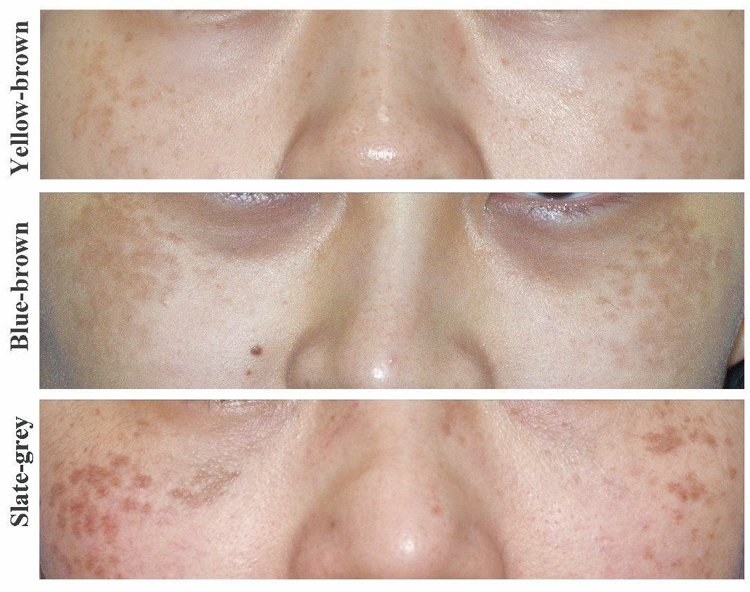
Supplemental Figure 1. Clinical Pictures of Hori’s Nevus.
Suppl Fig 1a. Lesions in yellow-brown color; Suppl Fig 1b. Lesions in Blue-brown color; Suppl Fig 1c. Lesions in slate-grey color.

