Table S1 Dosage and schedule of the treatment regimen
Regimen | Drug dosage | Schedule | Duration
SOX | Oxaliplatin: 130mg/m2 IV | Days 1 | Q3wk, up to 8 cycles
 | S-1: 80mg (<1.25m2); 100mg (1.25-1.5m2); 120mg (>1.5m2) PO | Days 1-14 | Q3wk, up to 8 cycles
CapeOX | Oxaliplatin: 130mg/m2 IV | Days 1 | Q3wk, up to 8 cycles
 | Capecitabine: 1000 mg/m2 PO | Days 1-14 | Q3wk, up to 8 cycles
FOLFOX | Oxaliplatin: 85 mg/m2 IV | Days 1 | Q2wk, up to 12 cycles
 | Leucovorin: 400 mg/m2 IV | Days 1 | Q2wk, up to 12 cycles
 | 5-Fu: 400 mg/m2 IVP | Days 1 | Q2wk, up to 12 cycles
 | 5-Fu (continuous): 2400-3000 mg/m2 IV | Days 1-2 | Q2wk, up to 12 cycles
CS | Cisplatin: 60 mg/m2 IV | Days 1 | Q3wk, up to 8 cycles
 | S-1: 80mg (<1.25m2); 100mg (1.25-1.5m2); 120mg (>1.5m2) PO | Days 1-14 | Q3wk, up to 8 cycles
PS | Paclitaxel: 80 mg/m2 IV | Days 1, 8 | Q3wk, up to 8 cycles
 | S-1: 80mg (<1.25m2); 100mg (1.25-1.5m2); 120mg (>1.5m2) PO | Days 1-14 | Q3wk, up to 8 cycles
PX | Paclitaxel: 80 mg/m2 IV | Days 1, 8 | Q3wk, up to 8 cycles
 | Capecitabine: 1000 mg/m2 PO | Days 1-14 | Q3wk, up to 8 cycles
XELIRI | Irinotecan: 180 mg/m2 IV | Days 1 | Q3wk, up to 8 cycles
 | Capecitabine: 1000 mg/m2 PO | Days 1-14 | Q3wk, up to 8 cycles
Abbreviations: PO, by oral; IV, intra venous

Fig S1 Kaplan-Meier estimates of overall survival (A) and progression free survival (B) stratified by completion of 6-cycle chemotherapy treatment
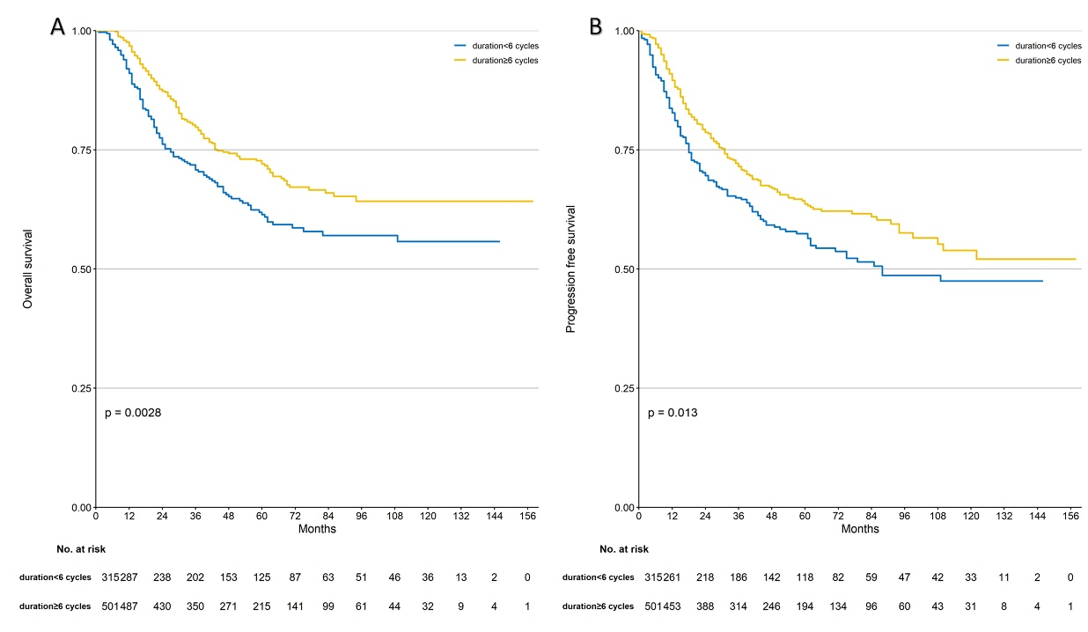

Fig S2 Kaplan-Meier estimates of overall survival (A) and progression free survival (B) according to the time interval from the completion of surgery to starting the adjuvant chemotherapy
