Supplementary materials
Supplementary Figure 1: Active TB notification among HIV-positive people in Sentinel survey sites in Ethiopia between 2010 and 2015
Supplementary Figure 2: HIV infection among all TB patients in Sentinel survey sites in Ethiopia between 2010 and 2015
Supplementary Figure 3: HIV infection among new TB patients in Sentinel survey sites in Ethiopia between 2010 and 2015

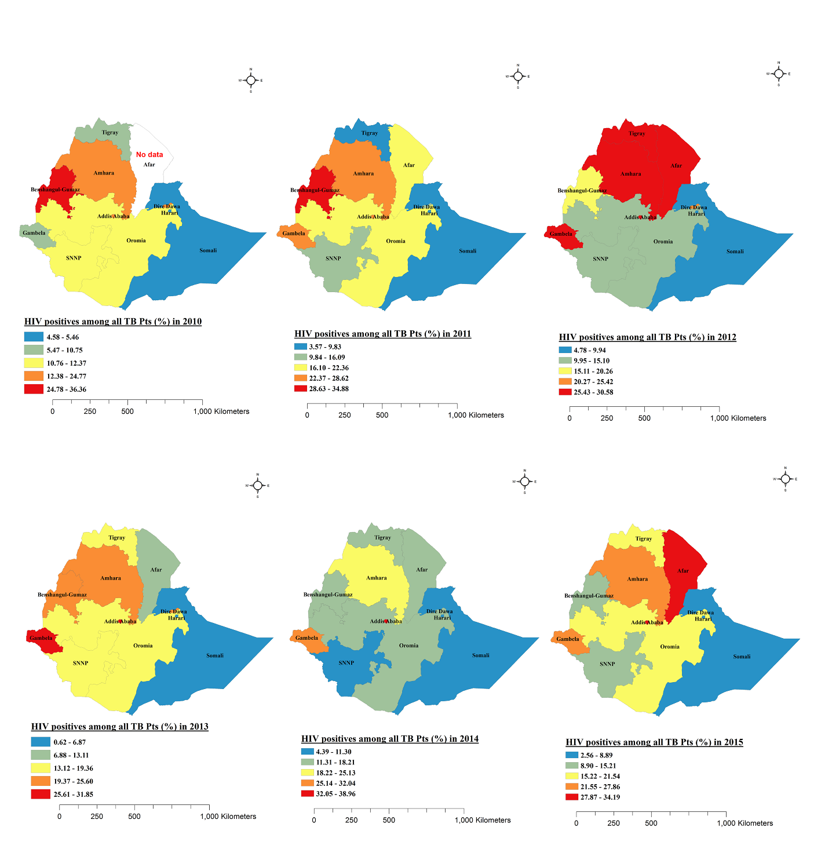
Supplementary Figure 4: Proportion of HIV positives among all TB patients by region in Ethiopia, 2010 – 2015

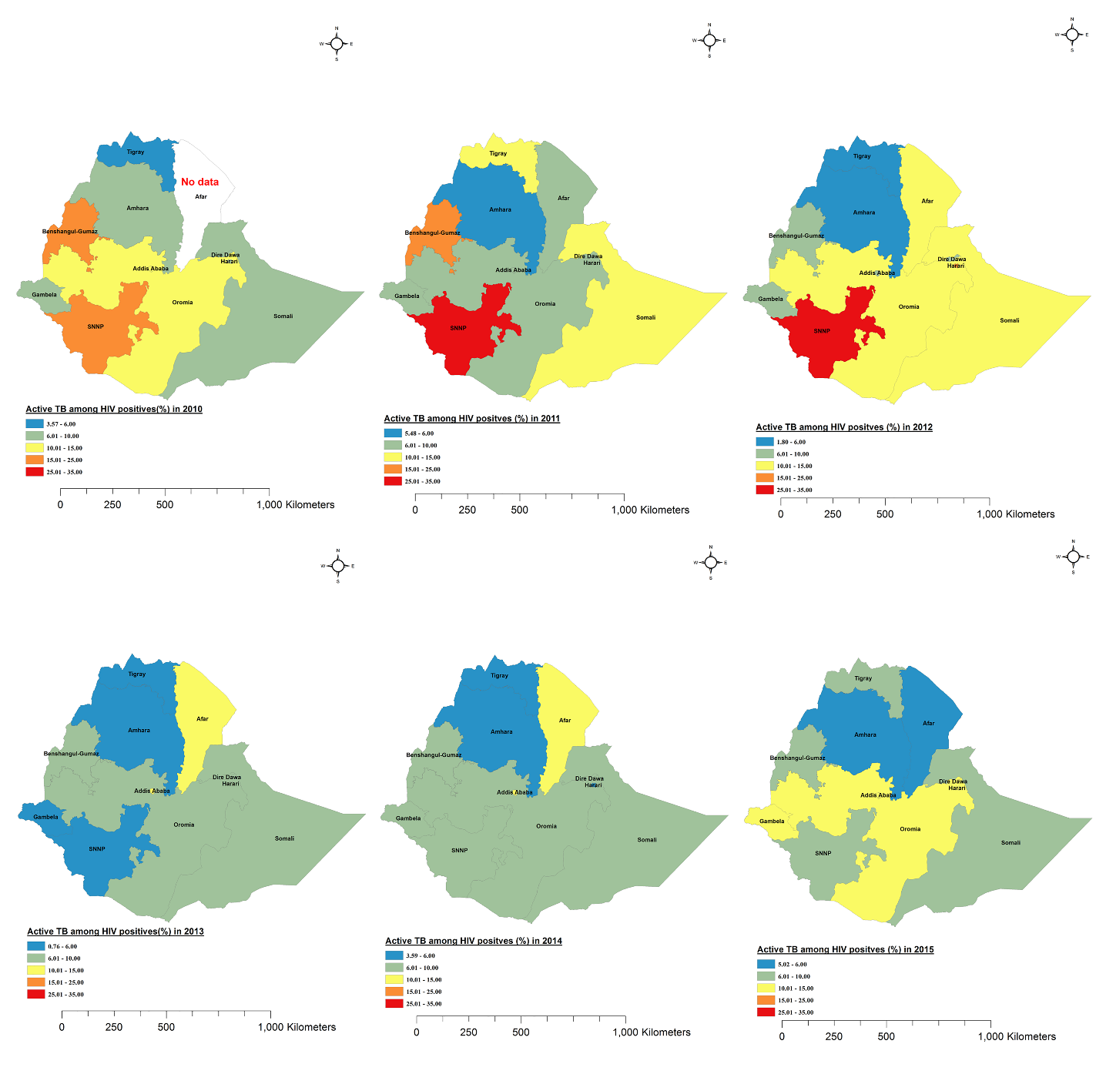
Supplementary Figure 5: Proportion of active TB among HIV positives by region in Ethiopia, 2010 - 2015

Data in the year between 2010 and 2015 from UNIADS indicated that collective and collaborative TB and HIV services have gradually increased after the WHO updated its guidelines for national collaborative TB and HIV programmes in 2012 (Figure 2).
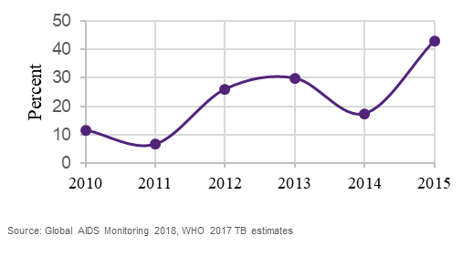
Supplementary Figure 6: Collaborative TB and HIV services in Ethiopia, 2010–2015

