SUPPLEMENTARY MATERIAL
S1 METHODS
Time-to-event model for exacerbation risk
Time-to-event data were analyzed using a Cox proportional hazard model, characterized by a hazard function for subject i, $h_{i}\left(t\right)$, dependent on a baseline hazard function $h_{0}\left(t\right)$ and the impact of Q baseline covariates (Cov_{li}), and a survival function, $S_{i}\left(t\right)$ (in this work, survival refers to exacerbation-free probability):
$\left\{\begin{aligned}h_{i}\left(t\right)=h_{0}\left(t\right)*\exp{(\sum_{l=1}^{Q}{γ_{l}*{Cov}_{li})}} \\ S_{i}\left(t\right)=exp⁡(-\int_{0}^{t}{h_{i}\left(t\right)dt}) \end{aligned}\right.$ (S1)
The survival function $S\left(t\right)$ can be further compared with Kaplan-Meier (KM) estimates, directly from the data. The baseline hazard function $h_{0}\left(t\right)$ was specified in the form of a piecewise-constant function. $exp⁡(γ_{l})$ represent the hazard ratios (HR) for the instantaneous risk change, associated with a relative change in covariate value.
Longitudinal model
Longitudinal data (biomarkers) were analyzed using a linear mixed-effects (LME) model. A model, $m_{i}(t)$, was developed using spline functions with fixed and random effects, and a residual error $ε_{i}(t)$ was taken into account. For the i^{th} subject, the time-dependent biomarker behavior can be expressed as follows:
$\left\{\begin{aligned}y_{i}\left(t\right)= m_{i}(t)+ ε_{i}(t) \\ m_{i}\left(t\right)= X_{i}\left(t\right)*β+ Z_{i}\left(t\right)*b_{i},\end{aligned}\right.$ (S2)
where X and Z are the design matrices, incorporating spline basis functions for fixed and random effects ($β$ anb $b_{i}$, respectively); and $b_{i}$ and $ε_{i}$ are conditionally independent and normally distributed. Covariate impact can be assessed for fixed effects and random effects. In this work we tested covariates on fixed effects only. The knots for the spline basis function were distributed in a way that allowed at least two measurements per knot interval. Knots positions were defined using normalized time units calculated as days/142 (approximately half a year).

Joint modeling of longitudinal and time-to-event data
The association and impact of longitudinal FEV₁ on the risk of exacerbation was analyzed using the joint modeling approach, whereby the longitudinal biomarker affects the hazard function, and the survival function is formulated as follows:
$S_{i}\left(t\right)=\exp\left(-\int_{0}^{t}{h_{0}\left(t\right)*\exp{(\sum_{l=1}^{Q}{{(γ}_{l}*{Cov}_{li}) + α*m_{i}(t))}}dt}\right),$ (S3)
where $α$ is the association parameter, a key metric for the biomarker impact on the risk of exacerbation. In the JM package, the survival function is calculated using numerical integration via pseudo-adaptive Gaussian quadrature rules. To jointly estimate model parameters, a log-likelihood (LL) objective function is developed, combining linear mixed effects modeling and time-to-event modeling, and calculated using hybrid Expectation-Minimization and quasi-Newton algorithms implemented in the JM package [1] in R [2].
Updated joint model
In the updated joint model, the hazard component is described by Equation (S3), and the longitudinal component of the model includes the covariate formoterol (yes/no):

$m_{i}\left(t\right)=β_{0}+b_{i0}+\sum_{j=1}^{N}{\left(β_{j}+β_{\left(N+j\right)|formoterol=yes}\right)*B_{n}(t,λ_{j})}+\sum_{k=1}^{M}{b_{ik}*B_{n}(t,λ_{k})},$ (S4)

where N and M represent the numbers of, respectively, fixed (β) and random (b) effects knots for B-spline basis matrices, for natural cubic splines $B_{n}(t,λ)$.
Validation procedure: Implementation steps
1) repeat the following M times:
- for each patient in validation dataset (N in total) generate individual survival curve using surfitJM function;
- based on random value from uniform distribution [0, 1] generate event time $T_{i}^{1}$ for each patient i (using individual survival curve from previous step);
2) for each simulation k, from 1 to M, build KM_{k} curve based on values $T_{i}^{k}$ (i in 1:N) using survfit function
3) compute mean KM curve and CI from set of KM_{k} curves (k in 1:M)

Consistency of association parameter per treatment arm
To investigate the consistency of the association parameter across treatment mechanisms, the joint model was re-estimated per treatment arm (and placebo) of each study. The longitudinal model included treatment as a covariate and the proportional hazards model included treatment, country and the association to longitudinal FEV₁. This model was thus similar to the base joint model (table S2), with the exception that absolute FEV₁ was analyzed.
References
- Rizopoulos, D., JM: An R Package for the Joint Modelling of Longitudinal and Time-to-Event Data. Journal of Statistical Software 2010: 35(9)
- R Core Team, R: A language and environment for statistical computing. 2016, Vienna, Austria: R Foundation for Statistical Computing, Vienna, Austria. https://www.R-project.org/
S2 RESULTS
TABLES
Table S1. Cox proportional hazard model output for Study A (from Table 3). Listing from RStudio
n= 1740, number of events= 599
coef exp(coef) se(coef) z Pr(>|z|)
Denmark 0.0583 1.0600 0.1836 0.318 0.7507
Iceland 0.7363 2.0882 0.2650 2.778 0.0054 **
Germany -0.3729 0.6886 0.1487 2.508 0.0121 *
Greece 0.2820 1.3257 0.2369 1.190 0.2341
Hungary -0.3505 0.7043 0.1217 2.879 0.0039 **
Mexico -1.4937 0.2245 0.3217 -4.643 3.43e-06 ***
Romania -0.7748 0.4607 0.1899 -4.079 4.52e-05 ***
Bulgaria -0.3281 0.7203 0.1618 -2.027 0.0426 *
Formoterol 9 -0.1574 0.8543 0.1125 -1.399 0.1617
For/BUD 9/160 -0.3460 0.7075 0.1154 -2.998 0.0027 **
For/BUD 9/320 -0.4358 0.6467 0.1171 -3.721 0.0002 ***
FEV1_baseline -0.8513 0.4268 0.11793 -7.219 5.24e-13 ***
Signif. codes: 0 ‘***’ 0.001 ‘**’ 0.01 ‘*’ 0.05 ‘.’ 0.1 ‘ ’ 1

Concordance = 0.653 (se = 0.012 )
Rsquare = 0.089 (max possible = 0.993 )
Likelihood ratio test = 162.3 on 12 df, p = 0
Wald test = 150.1 on 12 df, p=0
Score (logrank) test = 158.8 on 12 df, p = 0
__________________________________________________
coef - coefficient, se - standard error, df - degrees of freedom, z - z-score, p - p-value

Table S2. Base joint model output for Study A (from Table 3). Listing from RStudio
Data Descriptors:
Longitudinal Process Event Process
Number of Observations: 8982 Number of Events: 599 (34.4%)
Number of Groups: 1740
Joint Model Summary:
Longitudinal Process: Linear mixed-effects model
Event Process: Relative risk model with piecewise-constant baseline risk function
Parameterization: Time-dependent

log.Lik AIC BIC
1733.369 -3382.738 -3153.349
Variance Components:
StdDev
(Intercept) 0.0000
ns(months, knots = c(0.401, 1.465))1 0.2341
ns(months, knots = c(0.401, 1.465))2 0.5093
ns(months, knots = c(0.401, 1.465))3 0.2289
Residual 0.1232

Coefficients:
Longitudinal Process
Value Std.Err z-value p-value
(Intercept) 0.0016 0.0029 0.5325 0.5944
ns(months, knots = c(0.197, 0.568, 1.465))1 0.0262 0.0256 1.0208 0.3073
ns(months, knots = c(0.197, 0.568, 1.465))2 0.0074 0.0220 0.3367 0.7364
ns(months, knots = c(0.197, 0.568, 1.465))3 0.0083 0.0228 0.3653 0.7149
ns(months, knots = c(0.197, 0.568, 1.465))4 -0.0147 0.0231 -0.6374 0.5239
ns(months, knots = c(0.197, 0.568, 1.465))1:Formoterol 9 0.0171 0.0348 0.4918 0.6229
ns(months, knots = c(0.197, 0.568, 1.465))2:Formoterol 9 0.0261 0.0296 0.8824 0.3776
ns(months, knots = c(0.197, 0.568, 1.465))3:Formoterol 9 0.1646 0.0297 5.5384 <0.0001
ns(months, knots = c(0.197, 0.568, 1.465))4:Formoterol 9 0.0479 0.0311 1.5388 0.1238
ns(months, knots = c(0.197, 0.568, 1.465))1:For/BUD 9/160 0.0254 0.0342 0.7447 0.4564
ns(months, knots = c(0.197, 0.568, 1.465))2:For/BUD 9/160 0.0658 0.0290 2.2681 0.0233
ns(months, knots = c(0.197, 0.568, 1.465))3:For/BUD 9/160 0.1706 0.0292 5.8404 <0.0001
ns(months, knots = c(0.197, 0.568, 1.465))4:For/BUD 9/160 -0.0166 0.0305 -0.5430 0.5871
ns(months, knots = c(0.197, 0.568, 1.465))1:For/BUD 9/320 0.0801 0.0340 2.3563 0.0185
ns(months, knots = c(0.197, 0.568, 1.465))2:For/BUD 9/320 0.0309 0.0290 1.0665 0.2862
ns(months, knots = c(0.197, 0.568, 1.465))3:For/BUD 9/320 0.2105 0.0292 7.2170 <0.0001
ns(months, knots = c(0.197, 0.568, 1.465))4:For/BUD 9/320 0.0390 0.0304 1.2813 0.2001
Event Process
Value Std.Err z-value p-value
Formoterol 9 -0.1134 0.1133 -1.0005 0.3171
For/BUD 9/160 -0.2757 0.1171 -2.3541 0.0186
For/BUD 9/320 -0.3654 0.1189 -3.0732 0.0021
Denmark 0.0244 0.1841 0.1326 0.8945
Iceland 0.7330 0.2655 2.7610 0.0058
Germany -0.3734 0.1488 -2.5085 0.0121
Greece 0.2169 0.2378 0.9120 0.3618
Hungary -0.3501 0.1220 -2.8690 0.0041
Mexico -1.3830 0.3227 -4.2853 <0.0001
Romania -0.7862 0.1902 -4.1345 <0.0001
Bulgaria -0.3520 0.1622 -2.1708 0.0299
FEV1_baseline -0.8917 0.1184 -7.5286 <0.0001
Delta_FEV1 -0.9991 0.2865 -3.4866 0.0005
Integration:
method: (pseudo) adaptive Gauss-Hermite
quadrature points: 3
Table S3. Updated joint model output for Study A (from Table 4). Listing from RStudio
Data Descriptors:
Longitudinal Process Event Process
Number of Observations: 8982 Number of Events: 599 (34.4%)
Number of IDs: 1740

Joint Model Summary:
Longitudinal Process: Linear mixed-effects model
Event Process: Relative risk model with piecewise-constant baseline risk function
log.Lik AIC BIC
-853.4 1772.8 1953.0

Variance Components:
StdDev
(Intercept) 0.397
ns(months, knots = c(0.401, 1.465))1 0.2040
ns(months, knots = c(0.401, 1.465))2 0.3502
ns(months, knots = c(0.401, 1.465))3 0.1920
Residual 0.1398

Coefficients:
Longitudinal Process
Value Std.Err z-value p-value
(Intercept) 1.0508 0.0101 104.2922 <0.0001
ns(months, knots = c(0.197, 0.568, 1.465))1 0.0361 0.0224 1.6083 0.1078
ns(months, knots = c(0.197, 0.568, 1.465))2 0.0152 0.0229 0.6625 0.5076
ns(months, knots = c(0.197, 0.568, 1.465))3 0.0276 0.0238 1.1567 0.2474
ns(months, knots = c(0.197, 0.568, 1.465))4 -0.0119 0.0227 -0.5261 0.5988
ns(months, knots = c(0.197, 0.568, 1.465))1:formyes 0.0345 0.0253 1.3646 0.1724
ns(months, knots = c(0.197, 0.568, 1.465))2:formyes 0.0344 0.0257 1.3357 0.1817
ns(months, knots = c(0.197, 0.568, 1.465))3:formyes 0.1622 0.0267 6.0733 <0.0001
ns(months, knots = c(0.197, 0.568, 1.465))4:formyes 0.0233 0.0254 0.9151 0.3602

Event Process
Value Std.Err z-value p-value
dosedep -0.1669 0.0505 -3.3036 0.0010
breathsc 0.1790 0.0641 2.7927 0.0052
XDPNO 0.1269 0.0335 3.7844 0.0002
Denmark 0.0678 0.1846 0.3676 0.7132
Iceland 0.9572 0.2718 3.5220 0.0004
Germany -0.3260 0.1486 -2.1930 0.0283
Greece 0.2883 0.2405 1.1987 0.2306
Hungary -0.2881 0.1228 -2.3463 0.0190
Mexico -1.4284 0.3222 -4.4337 <0.0001
Romania -0.9731 0.1975 -4.9269 <0.0001
Bulgaria -0.3197 0.1614 -1.9806 0.0476
FEV1 Assoct -0.8240 0.1163 -7.0845 <0.0001
Integration method: (pseudo) adaptive Gauss-Hermite
quadrature points: 3

Table S4. Update joint model output, re-estimation for Study B. Listing from RStudio
Data Descriptors:
Longitudinal Process Event Process
Number of Observations: 6630 Number of Events: 396 (24.7%)
Number of Groups: 1604

Joint Model Summary:
Longitudinal Process: Linear mixed-effects model
Event Process: Relative risk model with piecewise-constant
baseline risk function
Parameterization: Time-dependent

log.Lik AIC BIC
-524.3422 1100.684 1240.571

Variance Components:
StdDev
(Intercept) 0.3867
ns(months, knots = c(0.401408450704225))1 0.2676
ns(months, knots = c(0.401408450704225))2 0.1358
Residual 0.1416

Coefficients:
Longitudinal Process
Value Std.Err z-value p-value
(Intercept) 1.0549 0.0103 102.7464 <0.0001
ns(months, knots = c(0.197, 0.568))1 -0.0210 0.0188 -1.1145 0.2651
ns(months, knots = c(0.197, 0.568))2 0.0234 0.0187 1.2500 0.2113
ns(months, knots = c(0.197, 0.568))3 0.0124 0.0148 0.8416 0.4000
ns(months, knots = c(0.197, 0.568))1:formyesyes 0.0275 0.0227 1.2132 0.2251
ns(months, knots = c(0.197, 0.568))2:formyesyes 0.1203 0.0224 5.3734 <0.0001
ns(months, knots = c(0.197, 0.568))3:formyesyes 0.0002 0.0179 0.0088 0.9930

Event Process
Value Std.Err z-value p-value
dosedep -0.1336 0.0563 -2.3715 0.0177
breathsc 0.2202 0.0772 2.8512 0.0044
XDPNO 0.2668 0.0388 6.8788 <0.0001
Czech Republic -0.5189 0.1811 -2.8660 0.0042
Netherlands 1.1135 0.1675 6.6492 <0.0001
Poland -0.2156 0.1274 -1.6921 0.0906
South Afric 0.1866 0.1769 1.0553 0.2913
FEV1 Assoct -0.9201 0.1561 -5.8927 <0.0001

Integration:
method: (pseudo) adaptive Gauss-Hermite
quadrature points: 3

Table S5. Updated joint model output, re-estimation for Study C. Listing from RStudio
Data Descriptors:
Longitudinal Process Event Process
Number of Observations: 4785 Number of Events: 458 (44%)
Number of Groups: 1042

Joint Model Summary:
Longitudinal Process: Linear mixed-effects model
Event Process: Relative risk model with piecewise-constant
baseline risk function
Parameterization: Time-dependent

log.Lik AIC BIC
-460.7483 979.4967 1123.015

Variance Components:
StdDev
(Intercept) 0.4058
ns(months, knots = c(0.401408450704225, 1.465))1 0.2227
ns(months, knots = c(0.401408450704225, 1.465))2 0.3266
ns(months, knots = c(0.401408450704225, 1.465))3 0.1189
Residual 0.1287

Coefficients:
Longitudinal Process
Value Std.Err z-value p-value
(Intercept) 1.0130 0.0132 76.8845 <0.0001
ns(months, knots = c(0.197, 0.568, 1.465))1 0.0728 0.0129 5.6353 <0.0001
ns(months, knots = c(0.197, 0.568, 1.465))2 0.0689 0.0149 4.6188 <0.0001
ns(months, knots = c(0.197, 0.568, 1.465))3 0.1769 0.0148 11.9489 <0.0001
ns(months, knots = c(0.197, 0.568, 1.465))4 -0.0029 0.0187 -0.1529 0.8785

Event Process
Value Std.Err z-value p-value
dosedep -0.1072 0.0577 -1.8593 0.0630
breathsc 0.3393 0.0631 5.3745 <0.0001
exachistory 0.1338 0.0379 3.5295 0.0004
Argentina 0.1269 0.1371 0.9260 0.3545
Brazil 0.2571 0.1818 1.4140 0.1573
South Aftrica 0.5752 0.1284 4.4808 <0.0001
Chile 0.1209 0.2291 0.5275 0.5978
Columbia -0.1235 0.3877 -0.3185 0.7501
Mexico 0.0274 0.2148 0.1275 0.8986
Peru -0.1675 0.4189 -0.3998 0.6893
Venezuela 0.3414 0.7116 0.4799 0.6313
FEV1 Assoct -0.9178 0.1291 -7.1097 <0.0001

Integration:
method: (pseudo) adaptive Gauss-Hermite
quadrature points: 3

FIGURES
Figure S1. Additional diagnostics of the updated joint model fitted to Study A. A Mean population predictions of FEV₁ (top) and change from baseline FEV₁ (bottom) with 95% CI (solid colored lines and shaded areas) with means of the original data (stars) vs. time. B Residuals of the longitudinal model vs. time based on individual (top) and population prediction (bottom)
A
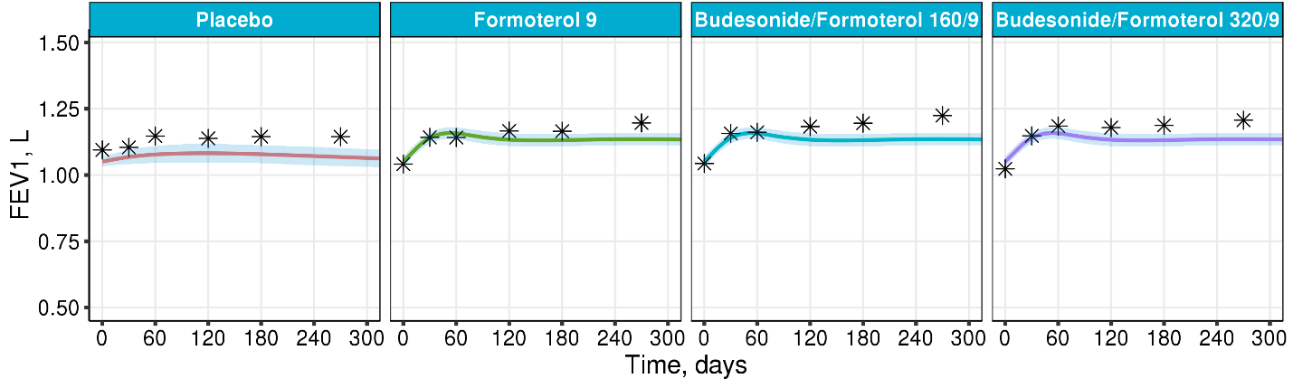
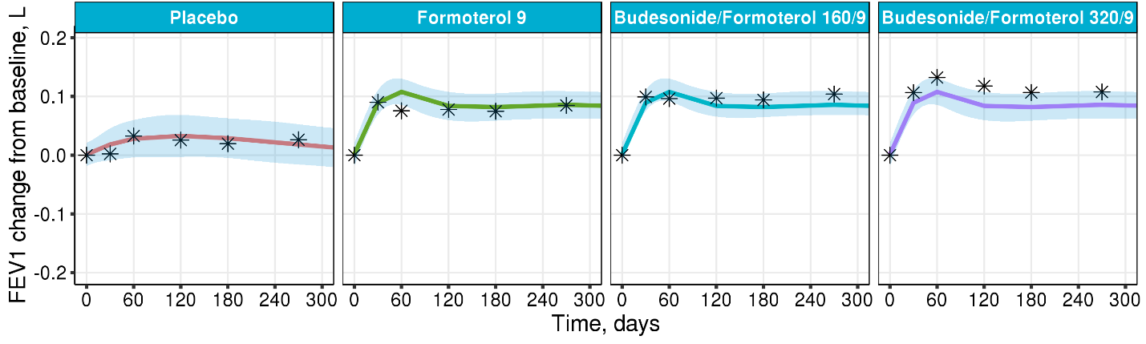
B
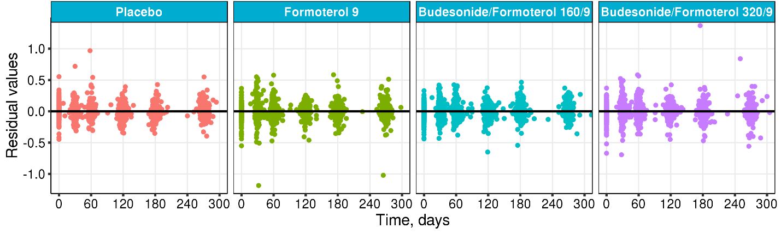
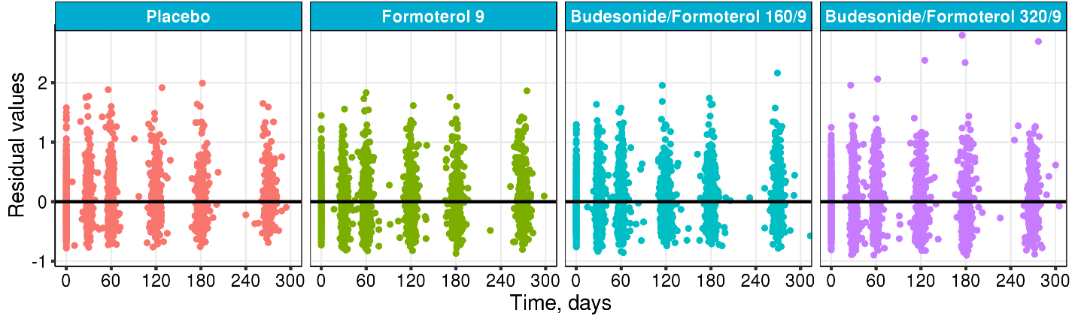
Figure S2. Diagnostics of the updated joint model re-estimated on Study B data.
Individual (A, top) and population (A, bottom) predictions of absolute FEV₁, individual (B, top) and population (B, bottom) change from baseline FEV₁, mean with 95% CI (solid colored lines and shaded areas) and mean of original data (stars) vs. time. Residuals vs time based on individual (C, top) and population (C, bottom) predictions. Predicted exacerbation-free probabilities (D), mean (solid line) with interquartile range (shaded area) and Kaplan-Meier estimates (dashed line)
A
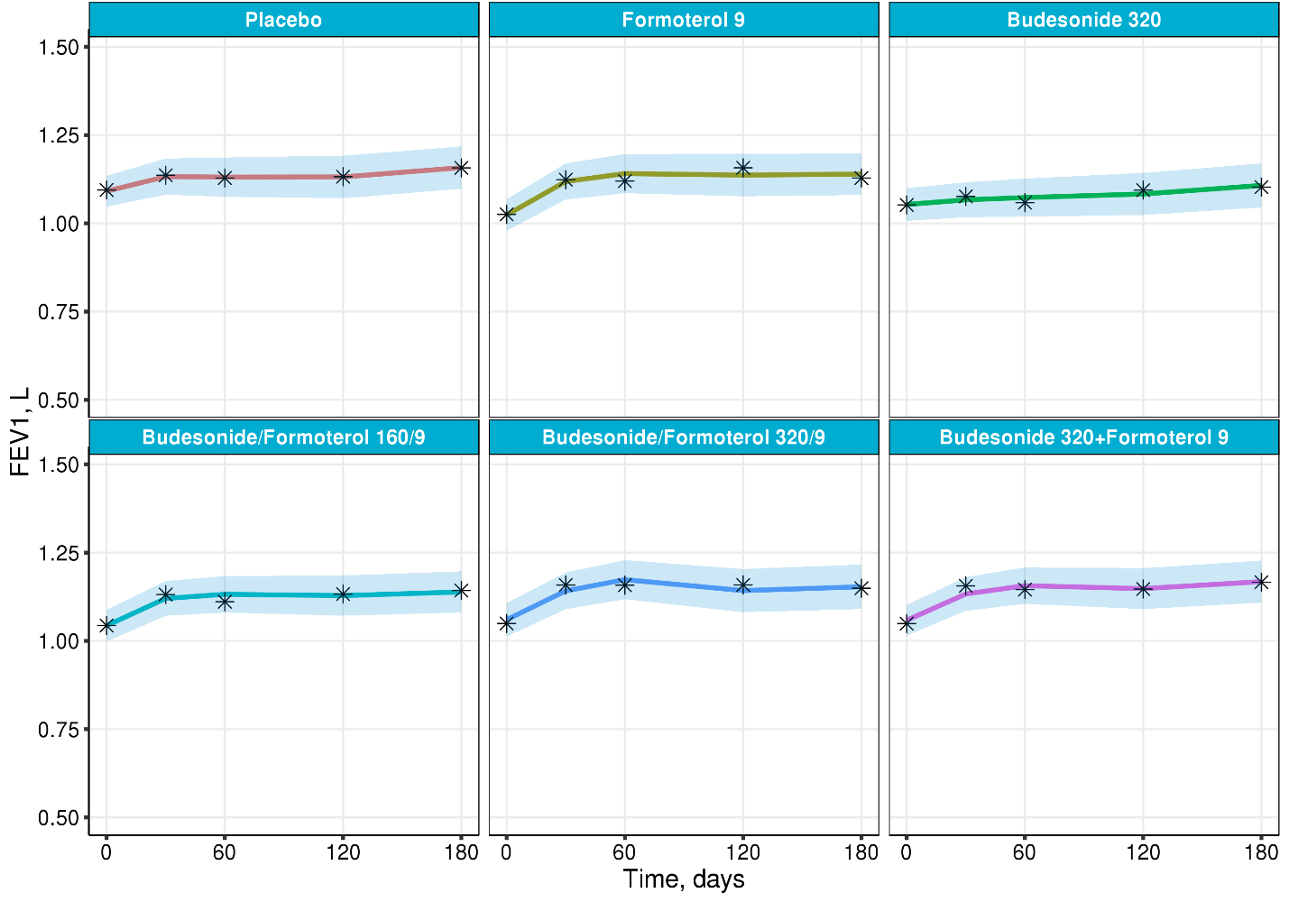
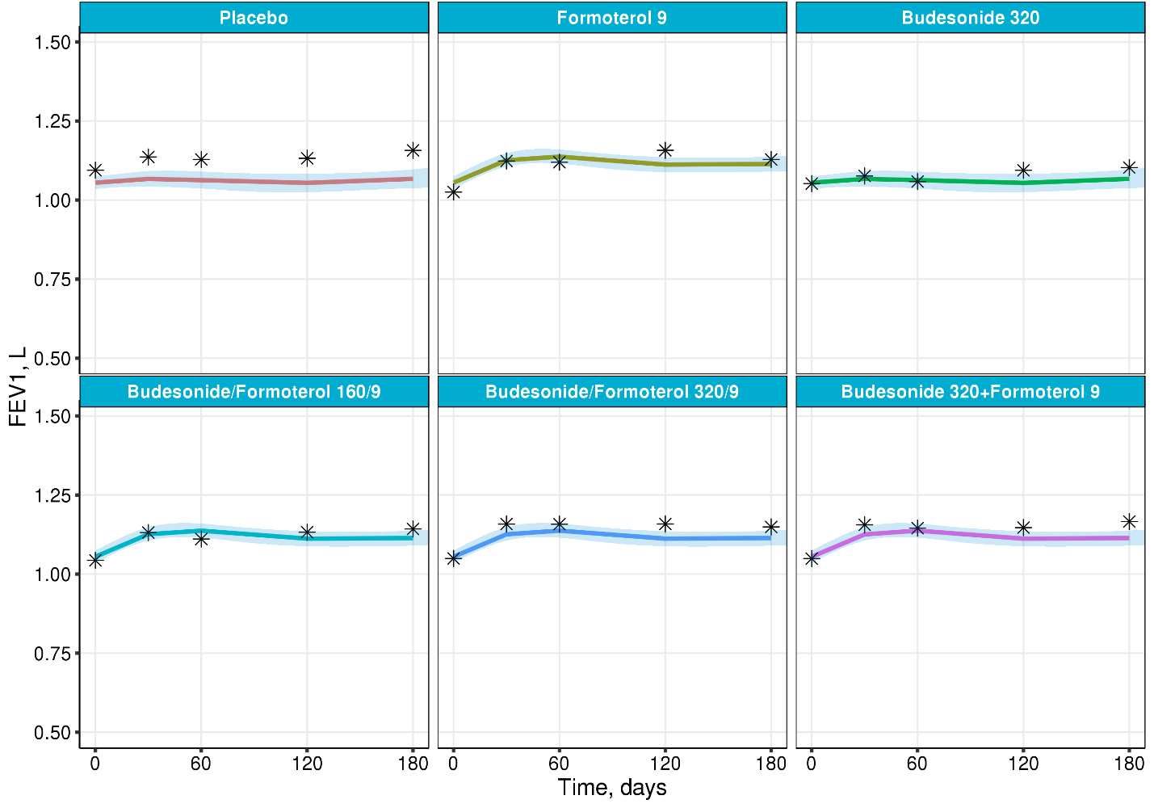
B
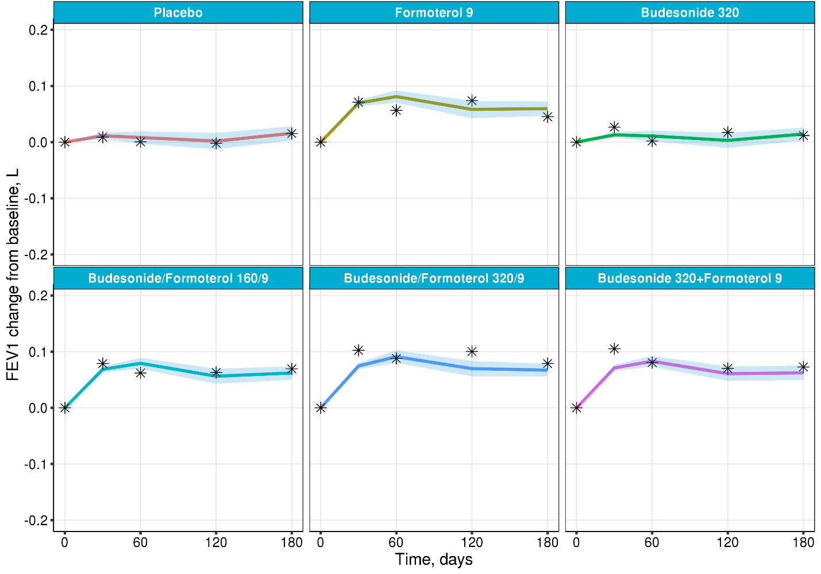
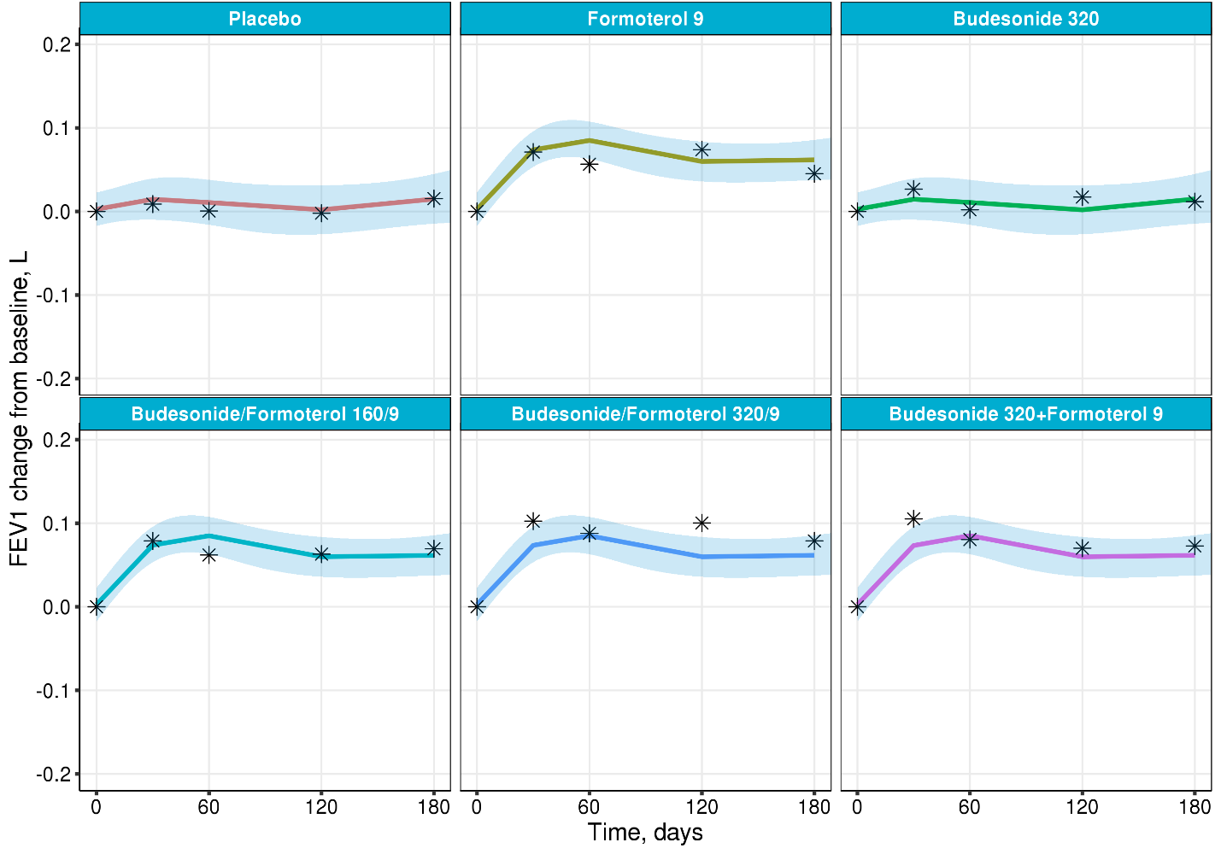

C
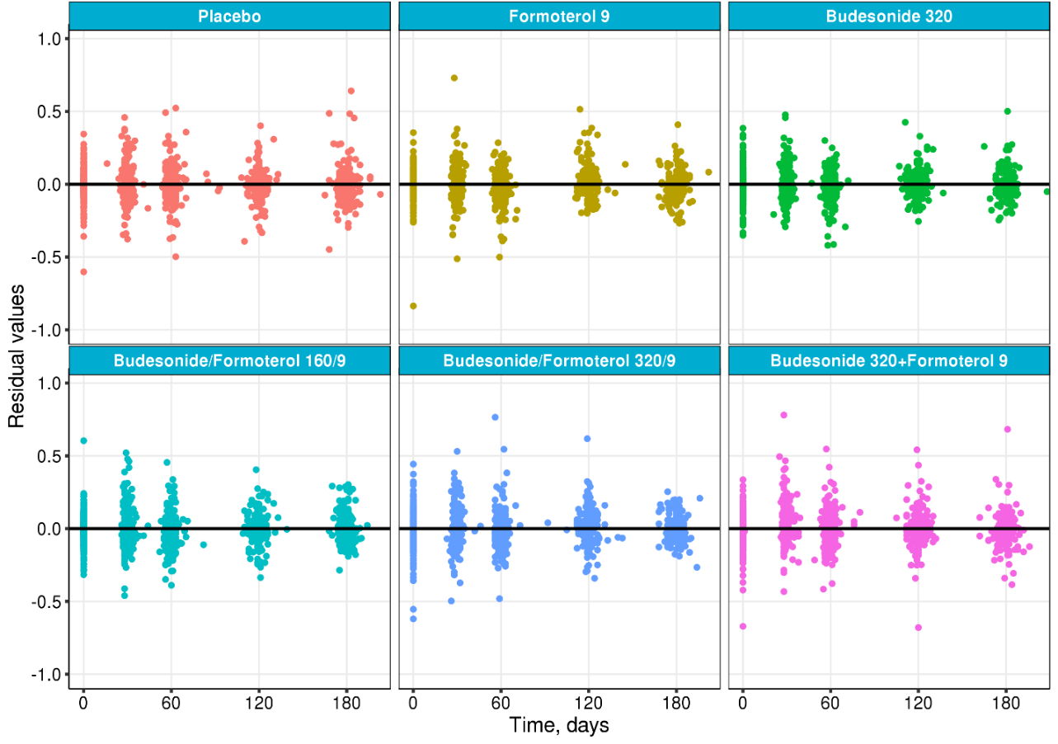
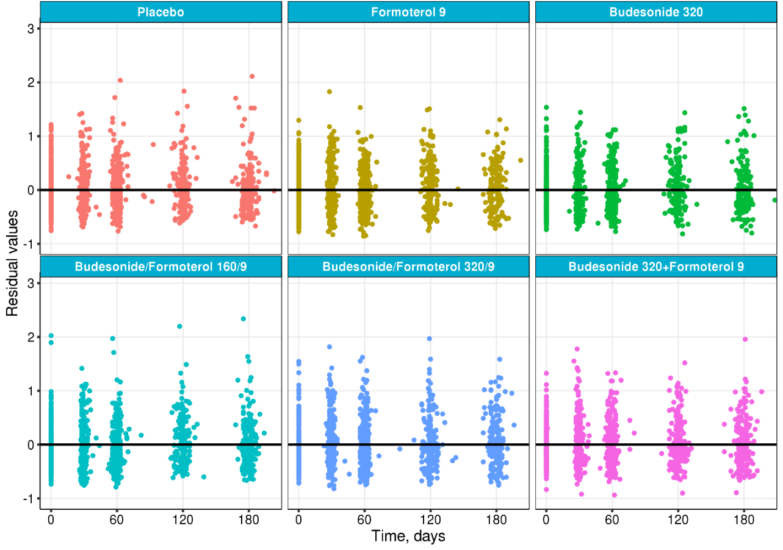
D
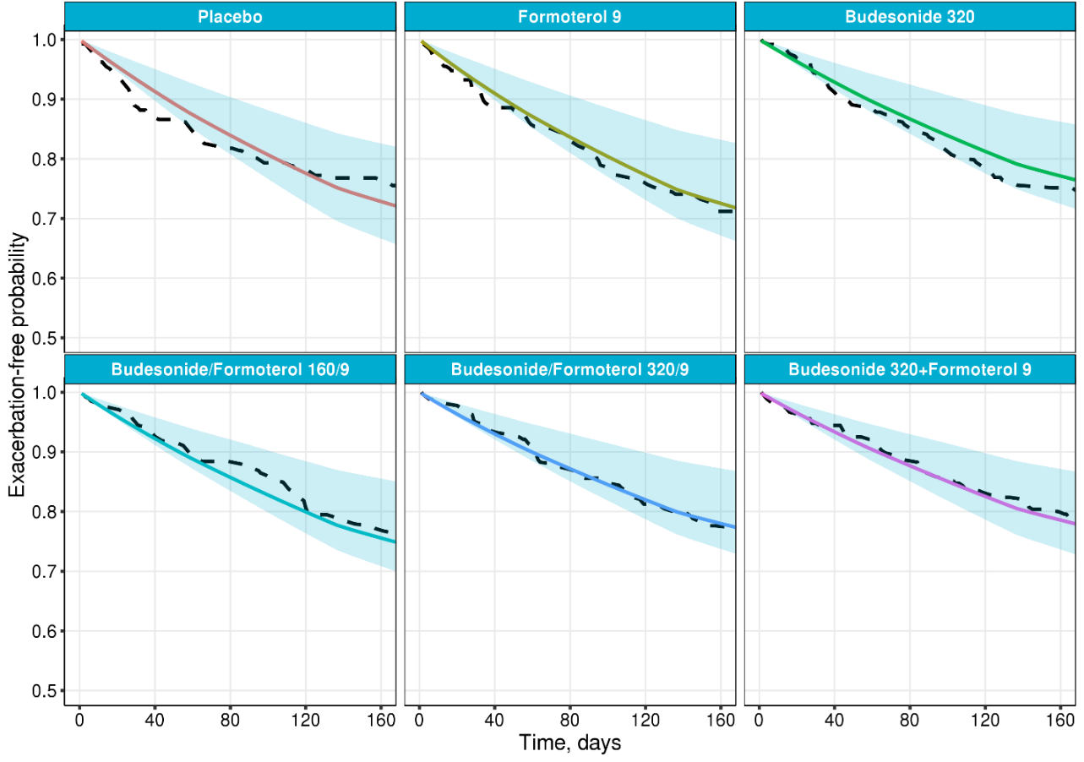

Figure S3. Diagnostics of the updated joint model fitted to Study C. Individual (A, top) and population (A, bottom) predictions of absolute FEV₁, individual (B, top) and population (B, bottom) change from baseline FEV₁, mean with 95% CI (solid colored lines and shaded areas) and mean of original data (stars) vs. time. Residuals vs time based on individual (C, top) and population (C, bottom) predictions. Predicted exacerbation-free probabilities (D), mean (solid line) with interquartile range (shaded area) and Kaplan-Meier estimates (dashed line)
A
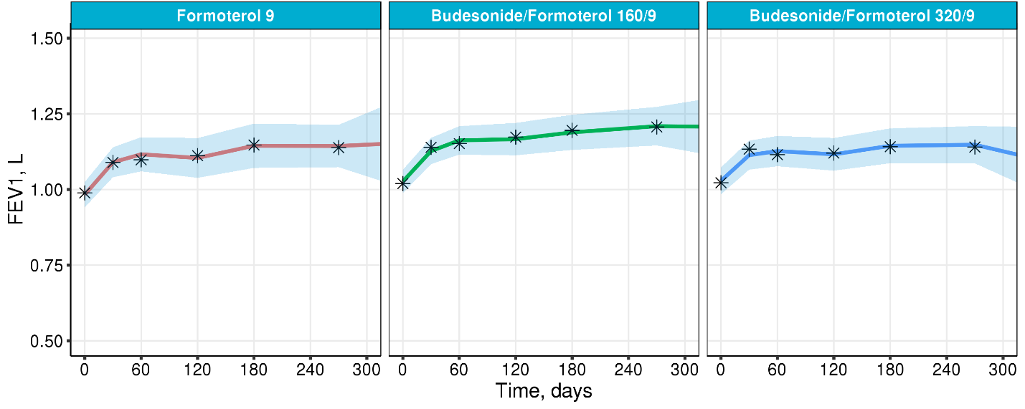
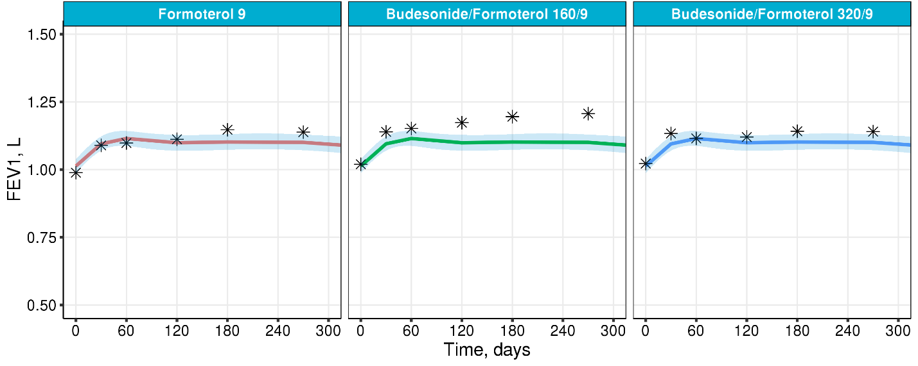

B
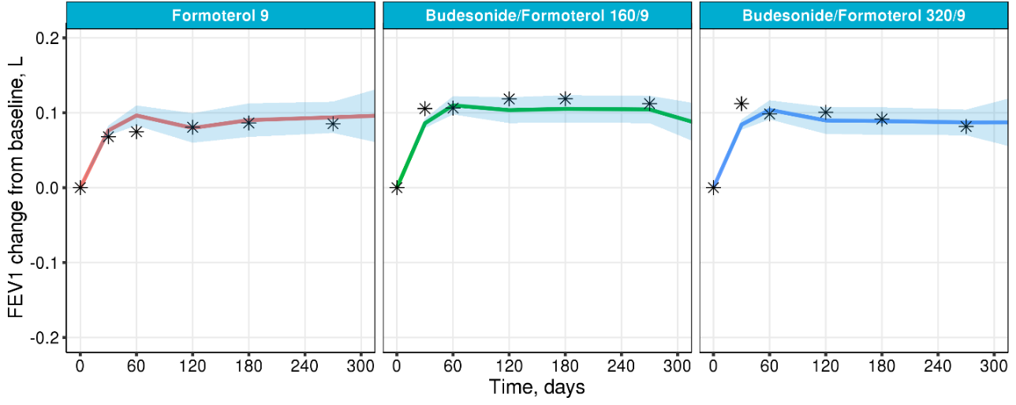
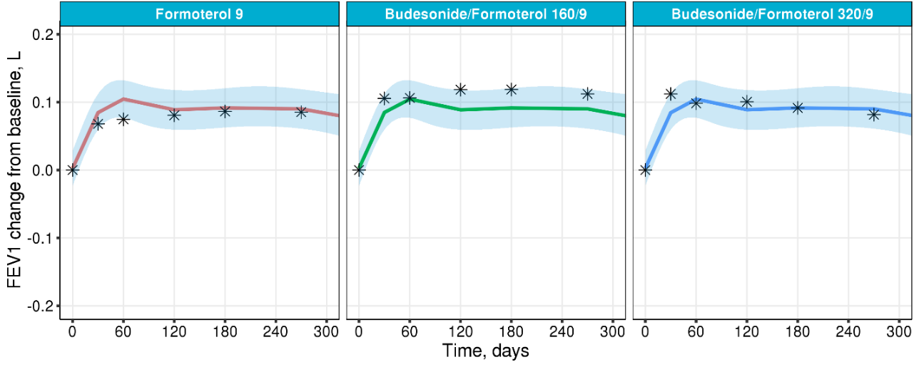
C
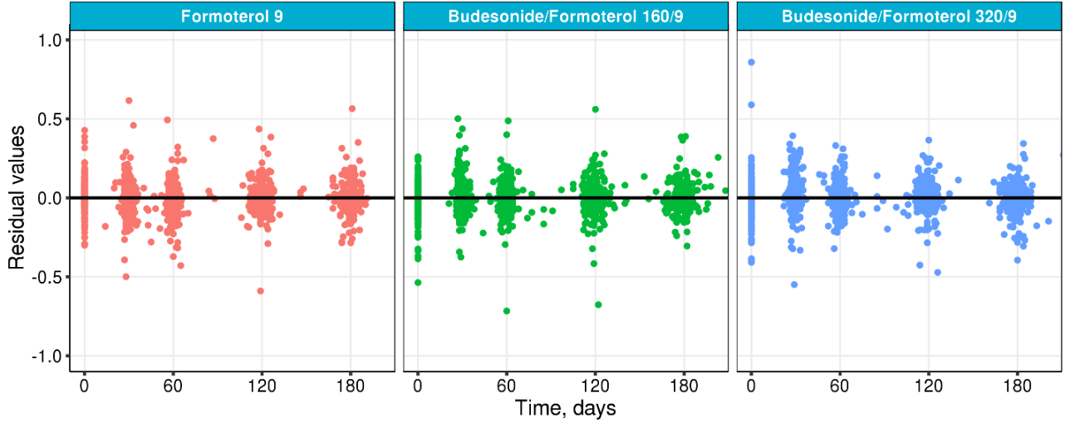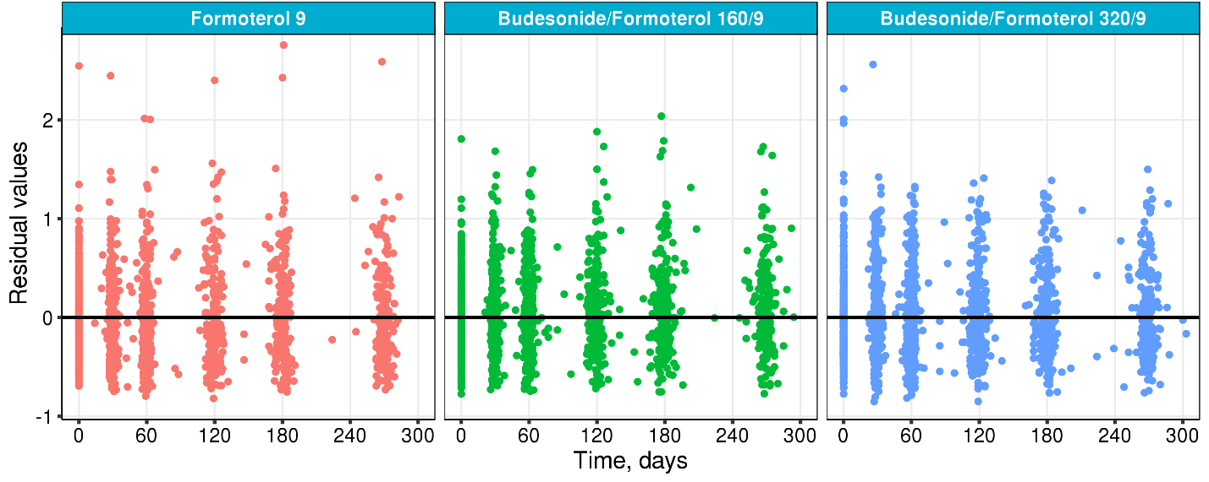
D
