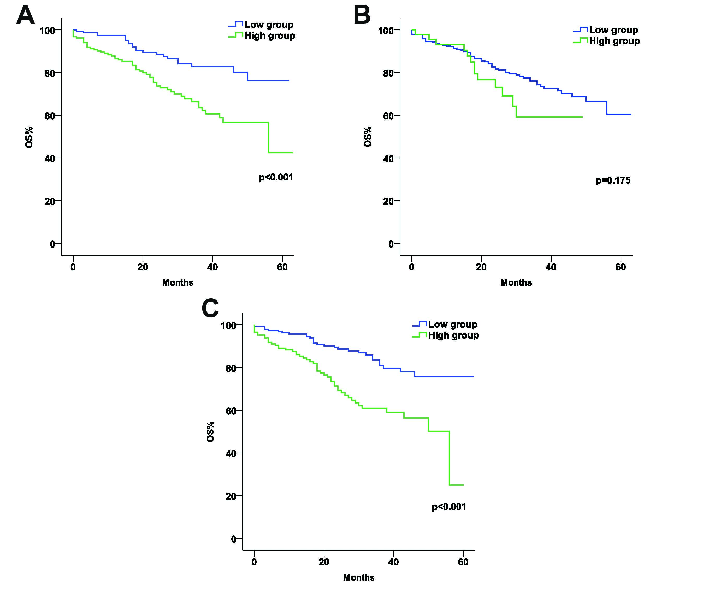
Supplementary Figure.1. Kaplan–Meier analysis showing cumulative mortality according to the optimal cut off value. (A) the reciprocal of lymphocyte counts, (B) platelet counts, (C) neutrophil counts.
Abbreviations: OS: overall survival.

