Supporting Information

Facile Synthesis of Melanin-Dye Nanoagent for NIR-II Fluorescence/Photoacoustic Imaging-Guided Photothermal Therapy
Jinghua Sunª, Wenwen Caiª, Yao Sun^{b}, Chunyan Guoª and Ruiping Zhangª*
ª Center for Translational Medicine Research, Shanxi Medical University, Imaging Department, The Affiliated Bethune Hospital of Shanxi Medical University, Taiyuan 030001, China
^{b} Key Laboratory of Pesticides and Chemical Biology, Ministry of Education, College of Chemistry, Central China Normal University, Wuhan 430079, China
* E-mail: zrp_7142@sxmu.edu.cn
Jinghua Sun, Wenwen Cai and Yao Sun were contributed equally to this work.

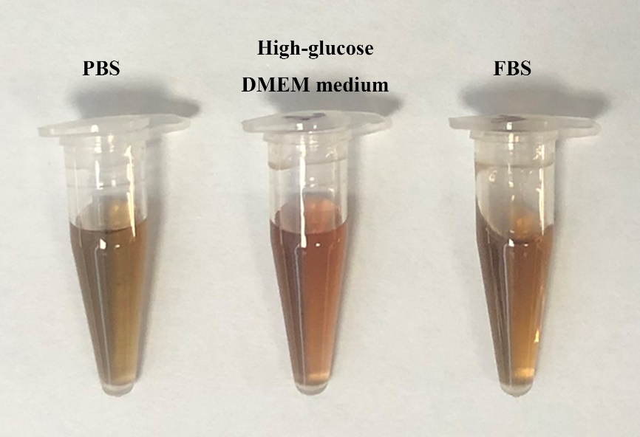
Figure S1. The stability result of MNPH2 in different medium after 48 h incubation.

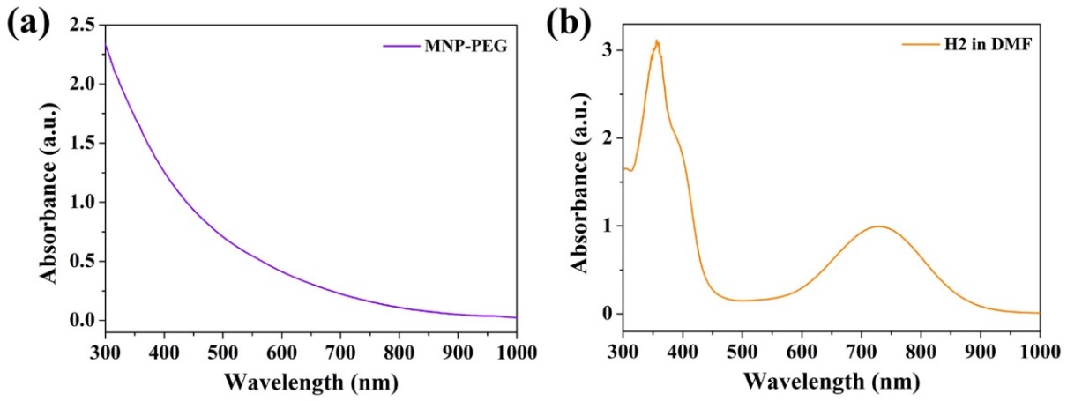
Figure S2. UV-vis-NIR absorbance spectra of MNP-PEG in DI and H2 in DMF.

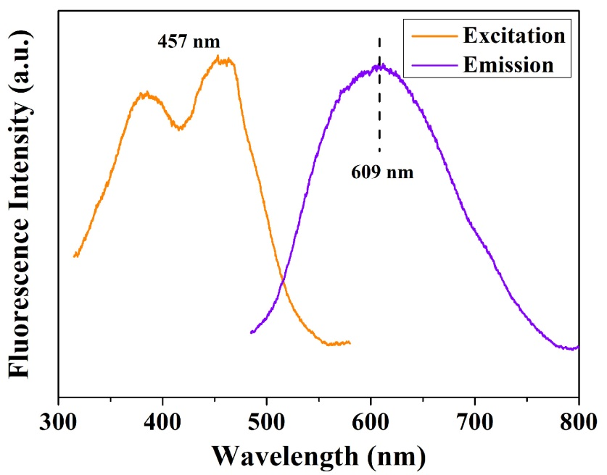
Figure S3. Fluorescent excitation and emission spectrum of MNPH2 aqueous solution in the visible region.

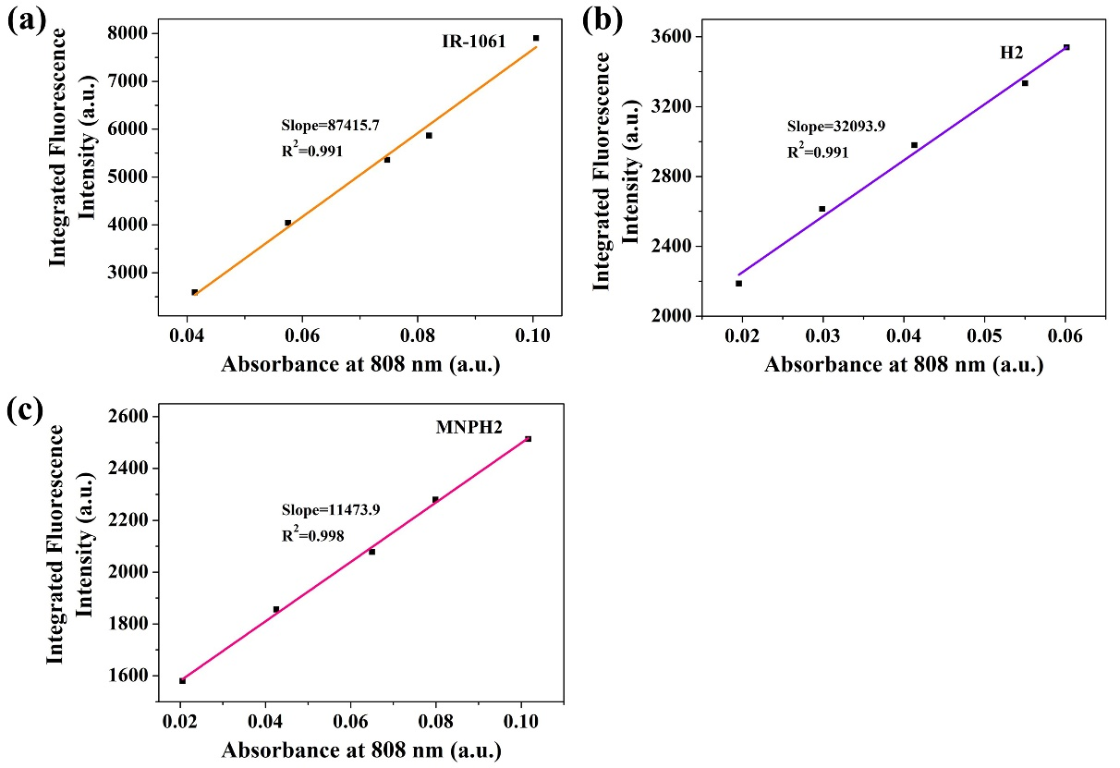
Figure S4. Fluorescence quantum yield measurements. The integrated fluorescence was plotted against absorbance for both IR1061 in dichloromethane (a), H2 in DMF (b), and MNPH2 in water fitted into a linear function. The quantum yield was calculated in the following manner:
$${QY}_{sample}={QY}_{IR1061}×\frac{{Slope}_{sample}}{{Slope}_{IR1061}}×\frac{{n_{sample}}^{2}}{{n_{IR1061}}^{2}}$$

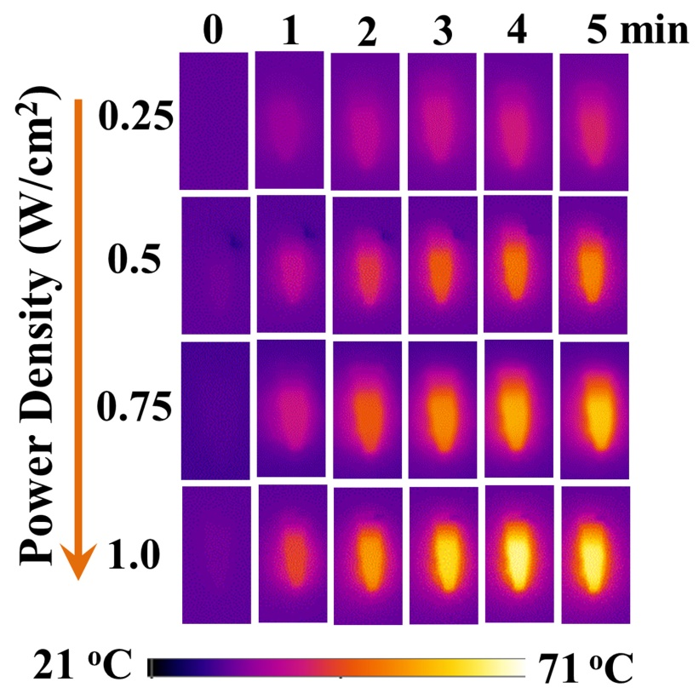
Figure S5. Power density-dependent thermal images of MNPH2 solution within 5 min at a concentration of 100 μg/mL.

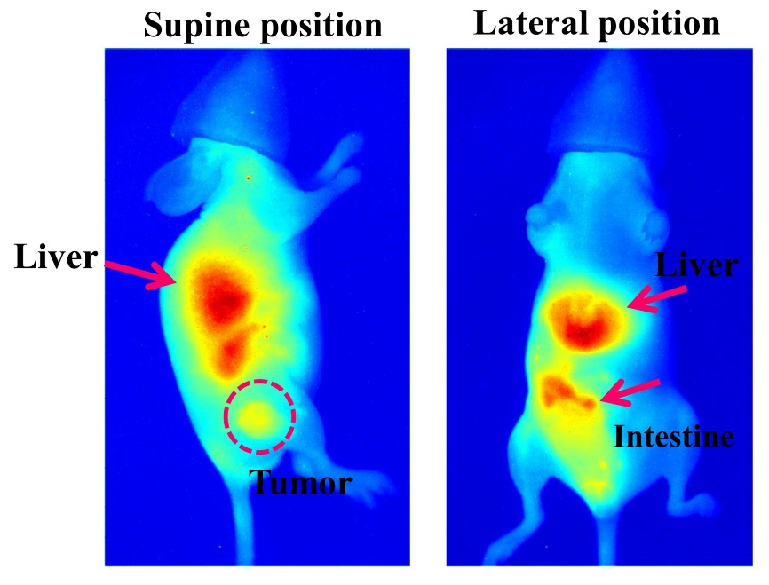
Figure S6. The whole-body NIR-Ⅱ fluorescent images of mice in the lateral and supine position at 8 h.

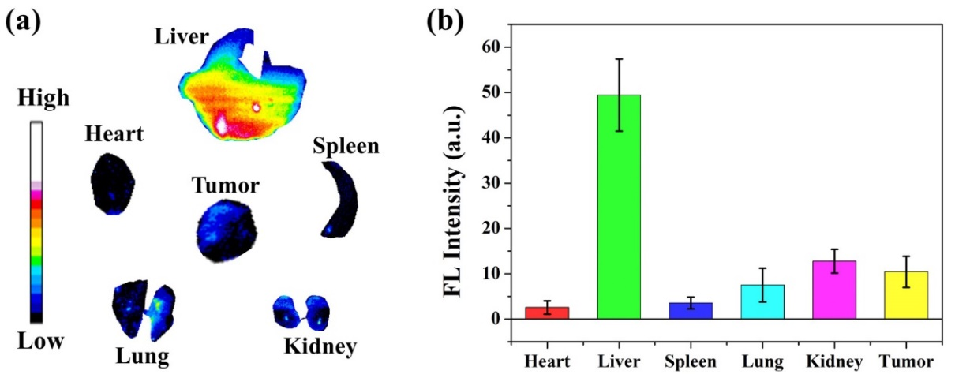
Figure S7. (a) NIR-Ⅱ fluorescence images of the tumor and major organs (heart, liver, spleen, lung, kidney) ex vivo. (b) Quantitative NIR-Ⅱ fluorescence intensities in tumor area and other major organs.

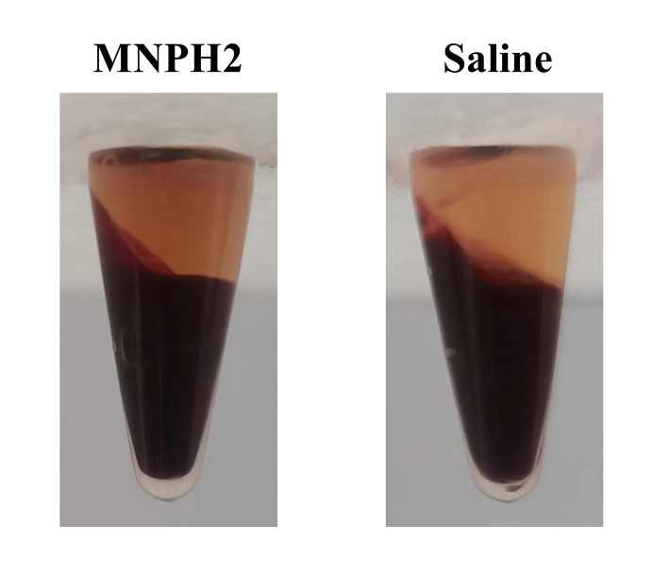
Figure S8. Hemolysis photos after centrifugation of MNPH2 incubated with blood cells for 2 h, using saline as a negative control.

