Supplementary material
Figure S1: Prototype of the thigh cuff used for measurement via volume plethysmography

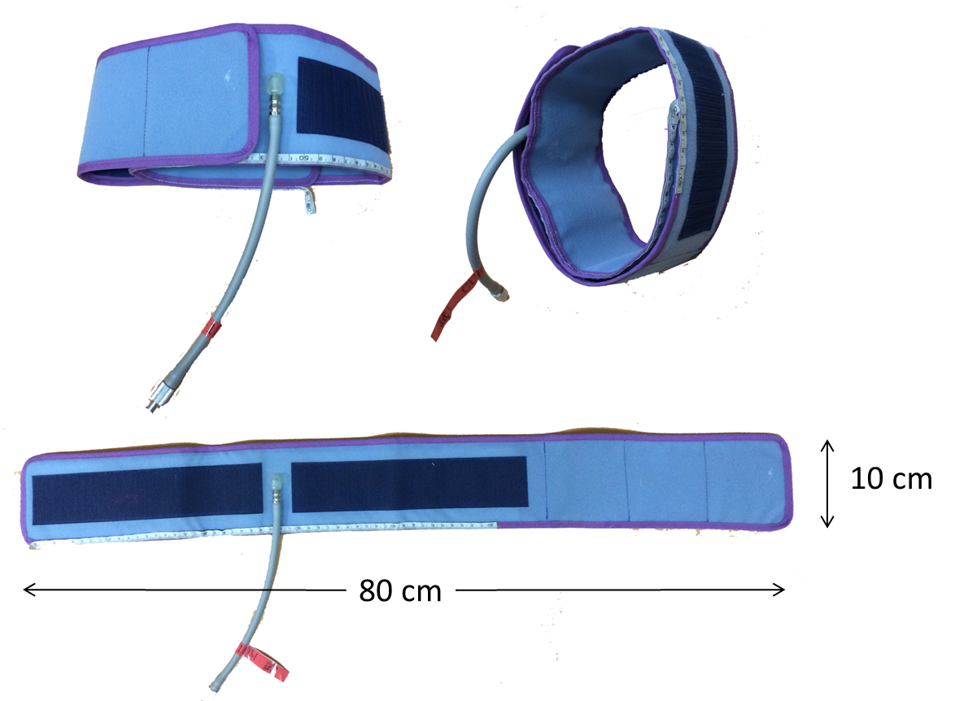
The reliable measurement range of this thigh cuff was the thigh circumference from a minimum of 30 cm to maximum of 75 cm.

