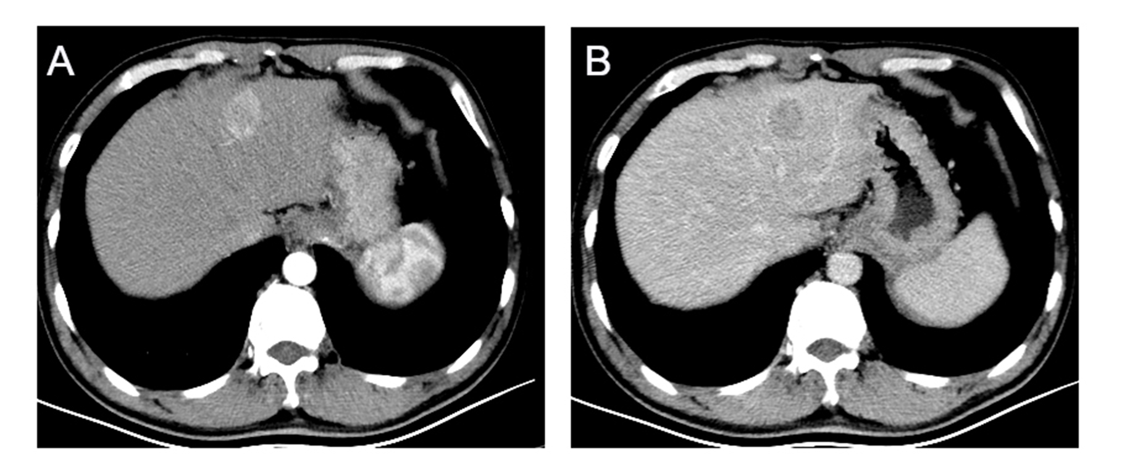
Supplemental Figure 1. Enhanced abdominal CT scan shows a heterogeneous irregular mass measuring up to 2.3*2.2cm with arterial phase enhancement (A) and venous phase washout (B).

