Supplement Fig. 1: Partial least-squares discriminant analysis of metabolomics data in different time point of TN group.
A. Score plot. Green represents the first week. Orange represents the second week. Grey represents the fourth week. Violet represents the sixth week.
B. 100-permutation test.
C. loading plot.
D. VIP value plot.
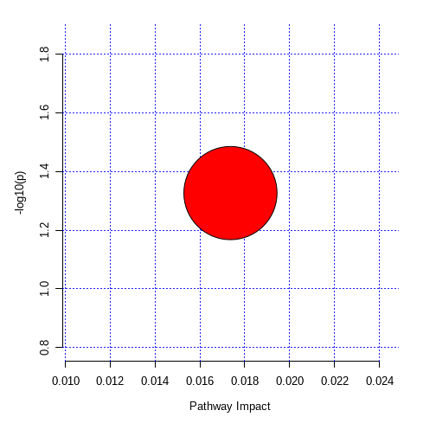
Supplement Fig. 2: Pathway enrichment analysis for Glycerophospholipid metabolism in metabolites changed after TN.

