Supplemetary Materials

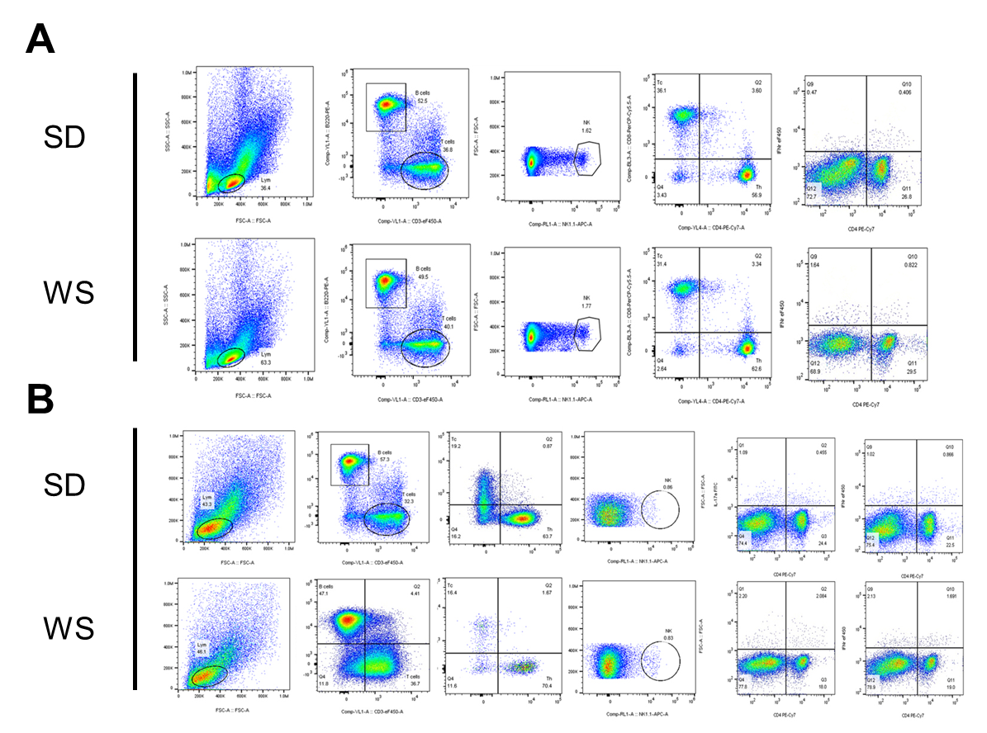
Figure S1 The representative images of the flow cytometry. The representative images of the proportions of immune cells in the tumor (A) and spleen (B). SD, standard diet group; WS, wushen group.

Table S1 Antioxidant components in the functional food
No. | Components | Content  (mg/100g) | Functions
1 | procyanidin | 244 | effectively clear free radical
2 | anthocyanin | 15.87 | effectively clear free radical; antioxidant; tumor prevention
3 | vitamin C | 24.4 | remit leucoderma; reduce cancer incidence; antioxidant
4 | taurine | 9.39 | protect retina; protect myocardium; antioxidant; promote immune; promote lipid absorption
5 | vitamin E | 6.72 | antioxidant; prevent free radical damage
6 | lutein | 1.78 | antioxidant
7 | squalene | 1.64 | improve SOD activity; enhance immunity; anti-aging; anti-hangover; anti-tumor
8 | zeaxanthine | 236 | antioxidant
9 | resveratrol | <0.3 | anti-tumor; protect cardiovascular system; antioxidant; resistance to free radicals; antibacterial; anti-aging
10 | total flavone | 0.01 | protect hematopoietic system; protect immune system; clear free radical; antioxidant; protect DNA

Table S2 Immune-enhancing components in the functional food
No. | Components | Content  (mg/100g) | Function
1 | polysaccharide | 12050 | promote bifidobacterium proliferation; inhibit pathogen; regulate gastrointestinal function; enhance immunity
2 | squalene | 164 | improve SOD activity; enhance immunity; anti-aging; anti-hangover; anti-tumor
3 | selenium | 16.9 | serum selenium level is associated with cancer incidence; enhance immunity
4 | taurine | 9.39 | protect retina; protect myocardium; antioxidant; promote immune; promote lipid absorption
5 | β-carotene | 1.47 | slow down aging; enhance immunity; cancer prevention
6 | vitamin A | 0.007 | protect epithelial tissue cell; promote immune globulin synthesis; inhibit tumor growth; nutritional supplement
7 | total flavone | 0.01 | protect hematopoietic system; protect immune system; clear free radical; antioxidant; protect DNA

Table S3 The main composition of the standard diet and functional food
 | Standard diet (%) | Wushen (%)
Protein | 19 | 22.1
Fat | 4 | 12.7
Carbohydrate | 50 | 36.36
Fiber | 5 | 21.7
Ash content | 8 | 3.6
Water content | <10.0 | 3.49
Calories per gram | 3.12kcal | 3.91kcal

Table S4 The exact antibody information used in flow cytometry tests
Antibody | Manufacturer | Article number
anti-mouse CD4 FITC | Thermo | 11-0042-82
anti-mouse Foxp3 PE | Thermo | 12-5773-82
anti-mouse CD25 APC | Thermo | 17-0251-82
anti-mouse NK1.1 APC | BioLegend | 108710
anti-mouse CD3 eF450 | Thermo | 48-0031-82
anti-human/mouse B220 PE | Thermo | 12-0452-81
anti-mouse CD4 PE-Cy7 | BioLegend | 100528
anti-mouse CD8a PerCP-Cy5.5 | Thermo | 45-0081-82
anti-mouse IL-17A AF488 | BioLegend | 506909
anti-mouse IL-4 APC | Thermo | 17-7041-81
anti-mouse IFNr eF450 | Thermo | 48-7311-82

Table S5 TOP 20 differential fecal metabolites between the Model group and the control group

Table S6 TOP 20 differential fecal metabolites between the FFD group and the Model group

Table S7 TOP 20 differential serum metabolites between the Model group and the control group

Table S8 TOP 20 differential serum metabolites between the FFD group and the Model group

