Supplementary Methods

PIVOTAL protocol
The PIVOTAL study design is summarized below; a more detailed description of the study design was published by Macdougall et al. (2018).
In the PIVOTAL trial, the amount of IV iron to be administered in the following month was based on the most recent levels of ferritin and TSAT, and is summarized in Table 1.
- In the proactive high-dose arm, patients received 600 mg IV iron at the start of the study (200 mg during each of the 3 dialysis sessions during the first week), and then 400 mg each month thereafter – 200 mg twice/week in the week following monthly blood tests. Doses were held if ferritin >700 ng/mL or TSAT ≥40%.
- In the reactive low-dose arm, patients received IV iron only if they deemed to be iron deficient. Doses were held if monthly labs showed (i) ferritin >200 ng/mL and TSAT >20%; (ii) ferritin >700 ng/mL; or (iii) TSAT ≥40%. Otherwise IV iron was administered based on the following protocol:
  - 100 mg monthly if ferritin 201-700 ng/mL and TSAT ≤20%
  - 200 mg monthly if ferritin 100-200 ng/mL and TSAT <40%
  - 400 mg monthly if ferritin <100 and TSAT <40%
In the PIVOTAL trial, ESA doses were to be titrated to achieve target hemoglobin of 10-12 g/dL throughout the study, with dose adjustments made at the investigator’s discretion.
In our emulation of PIVOTAL, we chose not to “intervene” on ESA dose for several reasons. First, “ESA dose requirement” was considered to be a secondary outcome in PIVOTAL – not an intervention. Second, the ESA treatment strategy did not vary between the two PIVOTAL arms. Third, there was no specific ESA dosing protocol included in the study design – clinicians were simply instructed to maintain hemoglobin levels within the target range of 10-12 g/dL – and so we would have had to create an ESA dosing algorithm that may not have been consistent with clinical practice. For these reasons, we only performed the natural course simulation to predict ESA doses, which should generally be in line with the prevailing clinical practice to maintain hemoglobin levels between 10-12 g/dL.

Step 1: Parametric models
To estimate the coefficients used in the Step 2 simulation, we first modeled the joint distribution of all relevant variables, using baseline and time-lagged variables. We specified variables as either time-fixed (captured once at study enrollment) or time-updated (measured monthly). We fit separate regression models for each time-updated variable – including treatments, potential confounders, and outcomes – for all patient-months with available data. The data were at the patient-month level, and all models in month k included the following variables:
(1) Time-fixed covariates: indicators for DOPPS phase and country; sex; age and time since hemodialysis initiation (updated monthly); weight; and 14 indicators for summary comorbidities.
(2) Time-updated covariates measured monthly: Values from months k-1 and k-2 for the following time-updated covariates: indicators for hospitalization (any during month) and catheter use for vascular access (status at month end); serum phosphorus; hemoglobin; ESA dose; and IV iron dose.
(3) Time-updated covariates measured less frequently in some dialysis centers: Value from month k-1 (carried forward up to 2 months) for the following time-updated covariates: C-reactive protein (CRP); serum albumin; ferritin; and TSAT. Because these variables were only assessed every 3 months in some hemodialysis facilities, we carry forward to represent the most recent chart information available to the prescribing physician; to help counter potential biases with this approach, models also included indicator variables for whether each lab was most recently measured 1, 2, or 3 months prior. DOPPS facilities that did not routinely measure ferritin or TSAT (in <25% of patient-months) were excluded.
Table 2 provides details on how each time-updated variable was parameterized when used as the outcome and when used as an exposure. Model choices were intuitively linked to the distribution (e.g., logistic regression for binary, linear regression for normally distributed, log-transform if skewed). IV iron doses were primarily limited to a small number of discrete prescriptions (e.g., 25, 50, 62.5, or 100 mg/week). We thus categorized doses into 4 groups (0, 1-35, 35-63, >63 mg/week), with each category roughly corresponding to 1 of the 4 doses assigned per clinical protocol in PIVOTAL (0, 100, 200, 400 mg/month). Other continuous covariates were included as linear terms if linear associations were observed and biologically expected (serum albumin, CRP) or as categories if relationships with other variables were not monotonic (serum phosphorus, hemoglobin, ferritin, TSAT, ESA dose). Because clinicians often make treatment decisions based on specific cutpoints (e.g., administer more iron if TSAT <20 or ferritin <200), a categorical-based approach was chosen in favor of splines. All variables were parameterized and modeled as shown in Table 2.
Table 2 also describes the sequential model ordering. Model 1 (hospitalization as the outcome) includes all predictors described in groups 1-3 above, then Model 2 (CRP) includes all variables described above, plus an indicator for hospitalization in the current month, then Model 3 adds CRP in the current month, etc. The model numbering indicates a natural ordering within each month: hospitalizations occurring during the month, then laboratory measurements, then catheter use and prescription of medications at month end. Laboratory values are generally measured simultaneously and thus the lab ordering is largely arbitrary. However, medication prescriptions at month end depend on the current month’s lab values (not vice versa), illustrating the importance of a “causal” ordering. Death is the last ordered variable and reflects whether the patient died during the following month (k+1) – not the current month (k); for death only, we avoid including predictors from the same month because laboratory values can change in response to the death process and thereby bias the estimated coefficients. We did not include a model for censoring in Step 1 because in Step 2 we intervene to enforce no censoring during follow-up, per Taubman et al. (2009).

Step 2: Simulation
In the next step, we simulated variables and outcomes for each patient in the DOPPS sample using output from the Step 1 models. We began with the third month patients were enrolled in the study because data from the prior 2 months are needed to serve as inputs. We augmented our data by re-sampling patients with replacement (N=10,000) to obtain more stable estimates as recommended by Keil et al. (2014).
Starting with Model 1 (hospitalization) in Table 2, we calculated the predicted probability ($\hat{p}$) of hospitalization for each patient by applying model coefficients from Step 1 to the observed covariates. We then moved to Model 2 (CRP) and calculated the predicted value for CRP by similarly applying model coefficients from Step 1 to the observed covariates and the newly predicted binary hospitalization indicator. This process was repeated iteratively for each modeled outcome in Table 2 through Model 10, when we calculated the predicted probability that the patient died in the following month, based on all of the newly predicted values plus patient characteristics and 2-month risk factor history. By predicting death in month k+1 rather than month k, we avoid simulating variables when patients have already died (or more accurately, were simulated to have died). If the patient is simulated to have died in month k+1, then the patient is removed from the simulation from that point moving forward, and thus no values for any other non-death variable are simulated for month k+1 or henceforth.
Rather than assign values deterministically, error terms were added to every predicted value. For continuous outcomes, we added the square root of the model mean squared error (root MSE) multiplied by a randomly drawn value from a normal (0,1) distribution. If the updated predicted value falls outside the range of observed data, we re-drew the random value until it fell within the boundaries. For binary outcomes, we compared $\hat{p}$ with a randomly drawn value (U) from a uniform (0,1) distribution, assigning a value of 1 if $\hat{p}$ > U and 0 if $\hat{p}$ < U. For multinomial outcomes, we divided the space between 0 and 1 proportionally based on the predicted probability of each category, then randomly drew a value from a uniform (0,1) distribution, assigning the value to whichever “bucket” the random number falls.
After predicting values for all modeled variables in month k, we removed patients who were simulated to have died in that month and replaced the observed k-2 values with observed k-1 values, and replaced the k-1 values with the newly predicted month k values. Starting again with Model 1, we predicted values in month 2 for hospitalization, CRP, etc. This process was iterated for 12 months to simulate 1 year of follow up. This simulation is considered to be the (expected) “natural course” because all variables – including the exposure of interest (IV iron dose) – were assigned probabilistically. Assuming independent censoring, the simulated risk factor histories and risk of death under the natural course should match the observed data because the joint distribution for the simulated population should be equal to the study population; any departures may signify potential model misspecification.
We performed this 12-month simulation three times: once under the “natural course” and then again under the proactive high-dose and reactive low-dose IV iron treatment strategies to simulate what would occur if the entire study population were treated under each protocol. For the latter approaches, we assigned IV iron deterministically, under the protocols detailed in Table 1, based on the most recent values of each patient’s ferritin and TSAT levels.

Multiple imputation and bootstrapping
Confidence intervals (CIs) were estimated by combining multiple imputation with bootstrapping (Schomaker 2018); the relevant paper by Schomaker and Heumann (2018) includes a worked example applying this method to a parametric g-formula analysis. This “MI boot (pooled sample)” described by Schomaker and Heumann was previously implemented by Karaboyas et al. (Karaboyas 2020).
To deal with missing data, we first used last observation carry forward (LOCF; up to 2 months) for a subset of variables (CRP, serum albumin, ferritin, TSAT) measured less frequently in routine clinical practice (every ~3 months). To fill in the remaining missing data for these labs, as well as any missing data for other variables, we applied multiple imputation to the patient-month level dataset used in the Step 1 models. We used the Sequential Regression Multiple Imputation Method by IVEware (Raghunathan 2002). Information from both between-patient and within-patient (using each of the 3 prior months) was used to fill in missing covariate data, including lagged variables from months k-1 and k-2 (and k-3 to help further inform the imputation models – not used in analyses) for each row in the data. This results in different values being imputed across rows for a given hemoglobin value in month m (e.g., one value for Hgb in row m and another value for Hgb (k-1) in row m+1), though these seeming within-patient inconsistencies are inconsequential because we are only using this longitudinal data to calculate model coefficients. Performing a “wide” imputation using lagged variables rather than a true longitudinal imputation, while unconventional, was a simple and effective way to estimate unbiased coefficients in the Step 1 models. The proportion of patients with missing data at baseline was <10% for all key variables (Table S2), and was only >10% for serum phosphorus (11%), CRP (22%) and hospitalization (31%). We then resampled patients with replacement 100 times and performed Step 1 and Step 2 on each resample. This process was repeated for 10 imputations, resulting in 1000 datasets. We then derived the 95% CI as the 2.5th and 97.5th percentile of the estimator distribution from these datasets based on the “MI boot (pooled sample)” procedure described by Schomaker and Heumann (Schomaker 2018).

References
Karaboyas A, Morgenstern H, Li Y, et al. Estimating the fraction of first-year hemodialysis deaths attributable to potentially modifiable risk factors: results from the DOPPS. Clin Epid 2020:12 51–60
Keil AP, Edwards JK, Richardson DB, et al. The parametric g-formula for time-to-event data: intuition and a worked example. Epidemiology. 2014 Nov;25(6):889-97
Macdougall IC, White C, Anker SD, et al. Randomized trial comparing proactive, high-dose versus reactive, low-dose intravenous iron supplementation in hemodialysis (PIVOTAL): Study design and baseline data. Am J Nephrol. 2018;48(4):260-268
Raghunathan TE, Solenberger PW, Van Hoewyk J. IVEware: Imputation and Variance Estimation Software: User Guide. Ann Arbor, MI: Institute for Social Research, University of Michigan. 2002
Schomaker M, Heumann C. Bootstrap Inference When Using Multiple Imputation. Stat Med. 2018 Jun 30;37(14):2252-2266
Taubman SL, Robins JM, Mittleman MA, Hernán MA. Intervening on risk factors for coronary heart disease: An application of the parametric g-formula. Int J Epidemiol. 2009;38(6):1599-1611

Supplementary Tables

Table S1a
Title. Target trial protocol: Comparing inclusion and exclusion criteria for PIVOTAL trial¹⁵ vs. target trial vs. emulated trial using the full DOPPS sample and PIVOTAL-restricted DOPPS subset
Legend. LOCF=Last observational carried forward; PD=peritoneal dialysis; HD=hemodialysis;
 |  | Primary analysis: Full DOPPS sample |  |  | Subset analysis restricted to PIVOTAL criteria
 | PIVOTAL trial | Target trial | Emulation in DOPPS | Target trial |  | Emulation in DOPPS
Inclusion criteria
 | Chronic HD patients age >18 with informed consent | Chronic HD patients age >18 with informed consent | All DOPPS patients meet these criteria | Same as primary analysis |  | Same as primary analysis
 | On ESA therapy | No restriction | N/A | ESA use in previous month |  | ESA dose >0 in previous month
 | TSAT <30% | No restriction | N/A | Most recent TSAT <30% |  | TSAT <30% in previous month (LOCF up to 2 months)
 | Ferritin <400 ng/mL | No restriction | N/A | Most recent ferritin <400 ng/mL |  | Ferritin <400 ng/mL in previous month (LOCF up to 2 months)
 | 0-12 months after commencing HD | No restriction | N/A | <12 months on HD |  | <12 months after HD initiation
Exclusion criteria
 | Not clinically stable / Life expectancy <12 months per the judgement of the investigator | No restriction | N/A | Life expectancy <12 months |  | Predicted "died next month" risk >5% (>96th percentile) in Step 1 models
 | CRP >50 mg/L | No restriction | N/A | Most recent CRP >50 mg/L |  | CRP >50 mg/L in previous month (LOCF up to 2 months)
 | Known HIV, active hepatitis B, or active hepatitis C | No restriction | N/A | Known HIV, hepatitis B, or hepatitis C |  | Diagnosis of HIV, hepatitis B, or hepatitis C in medical history
 | Active infection | No restriction | N/A | Active infection |  | Hospitalization with infection-related diagnosis or procedure code in previous month
 | Advanced heart failure | No restriction | N/A | Advanced heart failure |  | Hospitalization with heart failure-related diagnosis or procedure code in previous 2 months
 | Living-donor transplant scheduled within 12 months; Scheduled to switch to PD or home HD; Current active malignancy; Chronic liver disease and/or screening ALT or AST >3 × ULN; Pregnancy or breast feeding; History of acquired iron overload; Previous severe hypersensitivity reactions to IV iron sucrose; Compromised ability to comply with study procedures | No restriction | N/A | None; unable to further excluded based on these criteria due to data limitations |  | N/A

Table S1b
Title. Target trial protocol: Comparing treatment strategies, outcomes, and analyses for PIVOTAL trial¹⁵ vs. target trial vs. emulated trial using the DOPPS observational data
Legend. Treatment strategies, outcomes, and analyses were the same in the full DOPPS sample vs. PIVOTAL-restricted DOPPS subset. LOCF=Last observational carried forward; MI=myocardial infarction; HF=heart failure.
 | PIVOTAL trial | Target trial | Emulation in DOPPS
Treatment strategies
 | IV iron:  High dose: Receive IV iron sucrose 200 mg during each of the 3 dialysis sessions at the start of the study, and during each of the first 2 dialysis sessions of the week following the monthly blood tests for all subsequent months (i.e., 400 mg per month). If monthly testing demonstrated ferritin > 700 μg/L and/or TSAT ≥40%, IV iron was withheld for the month.  Low dose: Receive iron based on a pre-specified dosing schema, which permitted the administration of iron only if patients were deemed “iron deficient” as assessed by serum ferritin levels and TSAT. If monthly testing demonstrated (1) ferritin > 200 μg/L and TSAT > 20%, (2) ferritin > 700 μg/L, or (3) TSAT ≥40%, iron was not administered that month. Provided that TSAT was < 40%, patients with ferritin < 100 μg/L received iron sucrose 200 mg during the first 2 dialysis sessions of the week; if ferritin was 100–200 μg/L, it was administered only during the first dialysis session of the week. Patients with ferritin levels 201–700 μg/L and TSAT ≤20% received IV iron sucrose 100 mg during the first dialysis session of the week. | See Table 1 | A monthly dose of iron was assigned to patients based on the algorithm illustrated in Table 2, with the dose only dependent on the value of TSAT and ferritin in the previous month (LOCF up to 2 months)
 | ESA therapy: Clinicians were instructed to adjust the dose of ESA therapy to maintain a target hemoglobin level of 10–12 g/dL. The maximum dose of ESA allowed was 30,000 international units of epoetin per week (or an average of 150 μg per week of darbepoetin alfa or methoxypolyethylene glycol epoetin beta). | Adjust ESA dose to maintain hemoglobin levels in target range of 10-12 g/dL | Treat ESA dose as a "natural course" variable, assigning ESA dose based on baseline and time-varying patient characteristics, rather than attempt to define a more formal intervention strategy
Outcomes
 | Primary outcome: A composite of nonfatal MI, nonfatal stroke, hospitalization for HF or death from any cause, analyzed as time-to-first event | Not studied | N/A
 | Secondary outcome: All-cause mortality | Primary outcome: All-cause mortality | Death dates reported by study coordinator at each dialysis center
 | Other clinical outcomes: Total MI, stroke, hospitalization for HF and deaths, including first and recurrent events; First composite cardiovascular event (MI, stroke, and hospitalization for HF); Fatal or nonfatal MI; Fatal or nonfatal stroke; Heart failure hospitalization; Transfusion requirements; Vascular access thrombosis; All-cause hospitalization; Hospitalization for infection; Time to first and number of infection episodes | Not studied | N/A
 | Quality of life outcomes: EuroQol-5D (EQ-5D), Kidney Disease Quality of Life (KDQOL) Instrument | Not studied | N/A
 | Medication outcomes: ESA dose requirements; Cumulative dose of iron | ESA dose after 12 months; Cumulative iron dose over the 12 months | Median ESA dose during the 12th month of follow-up; Mean cumulative iron received over the 12 months of follow-up
 | Laboratory outcomes: hemoglobin, serum ferritin, TSAT, platelet count, serum albumin | Levels of hemoglobin, ferritin, and TSAT after 12 months; serum albumin not an outcome of interest, and limited platelet count data in DOPPS | Trajectories of mean hemoglobin, median ferritin, and median TSAT over the 12 months of follow-up, with a focus on values during the 12th month when the population has reached a steady-state
Follow-up
 | Maximum 42 months | 12 months | From assignment of initial treatment intervention for a maximum of 12 months
Causal contrasts
 | Intent-to-treat effect, with sensitivity analysis for per-protocol effect | Per-protocol effect | As-treated = Per-protocol effect (forced 100% adherence with no loss to follow-up)
Statistical analysis
 | Cox proportional hazards model to estimate hazard ratio | Parametric g-formula to estimate 1-year cumulative mortality under each strategy | As in target trial

Table S2
Title. Summary of missing data at baseline
 |  | DOPPS: Primary  analysis |  | DOPPS: PIVOTAL-  restricted data
Patient characteristics |  | N pts | % miss | N pts | % miss
N patients |  | 6325 |  | 1508
Time-fixed variables
 | Age | 6322 | 0.0% | 1505 | 0.2%
 | Sex | 6322 | 0.0% | 1506 | 0.1%
 | Time since HD start | 6249 | 1.2% | 1483 | 1.7%
 | Weight | 6297 | 0.4% | 1496 | 0.8%
Anemia-related variables
 | Serum ferritin (LOCF) | 5994 | 5.2% | 1375 | 8.8%
 | TSAT (LOCF) | 5891 | 6.9% | 1346 | 10.7%
 | Hemoglobin | 5772 | 8.7% | 1376 | 8.8%
 | ESA use | 6126 | 3.1% | 1457 | 3.4%
 | ESA doseª | 4946 | 8.4% | 1344 | 7.8%
 | IV iron use | 6129 | 3.1% | 1459 | 3.2%
 | IV iron doseª | 4161 | 3.4% | 1148 | 3.3%
Other time-updated variables
 | Serum albumin (LOCF) | 5915 | 6.5% | 1381 | 8.4%
 | Serum phosphorus | 5635 | 10.9% | 1339 | 11.2%
 | C-reactive protein (LOCF) | 4961 | 21.6% | 1133 | 24.9%
 | Hospitalized in last month | 4383 | 30.7% | 1221 | 19.0%
 | Catheter use (%) | 5701 | 9.9% | 1414 | 6.2%
Comorbidity history
 | Coronary artery disease | 6295 | 0.5% | 1497 | 0.7%
 | Heart failure | 6299 | 0.4% | 1497 | 0.7%
 | Cerebrovascular disease | 6301 | 0.4% | 1498 | 0.7%
 | Other cardiovascular disease | 6308 | 0.3% | 1500 | 0.5%
 | Cancer (non-skin) | 6301 | 0.4% | 1495 | 0.9%
 | Diabetes | 6296 | 0.5% | 1497 | 0.7%
 | Hepatitis B or C | 6279 | 0.7% | 1494 | 0.9%
 | Gastrointestinal bleeding | 6277 | 0.8% | 1488 | 1.3%
 | Hypertension | 6295 | 0.5% | 1497 | 0.7%
 | Lung disease | 6304 | 0.3% | 1497 | 0.7%
 | Neurologic disease | 6309 | 0.3% | 1499 | 0.6%
 | Psychiatric disorder | 6306 | 0.3% | 1497 | 0.7%
 | Peripheral vascular disease | 6308 | 0.3% | 1499 | 0.6%
 | Recurrent cellulitis, gangrene | 6306 | 0.3% | 1497 | 0.7%
ªDoses restricted to users; LOCF= Last observation carried forward for 2 months, due to less frequent routine measurement in some dialysis centers

Supplementary Figures

Figure S1
Title. Comparison of observed DOPPS data vs. natural course simulation
Legend. DOPPS data observed over the 12 months after baseline; Natural course simulation based on 12 simulated months using the parametric g-formula; Outcomes: (a) all-cause mortality, (b) hemoglobin, (c) serum ferritin, (d) TSAT, (e) ESA dose, (f) IV iron dose.
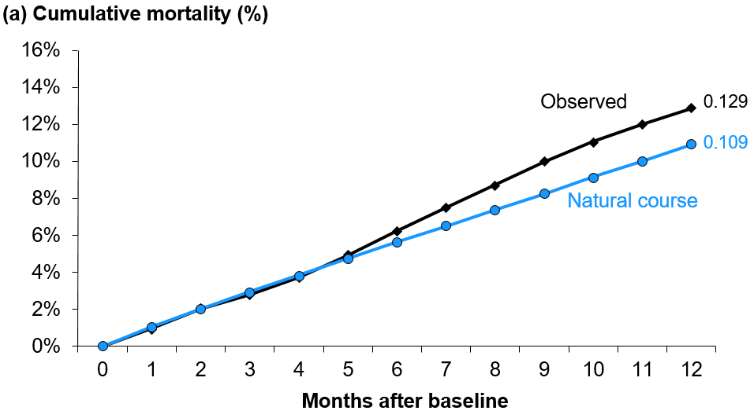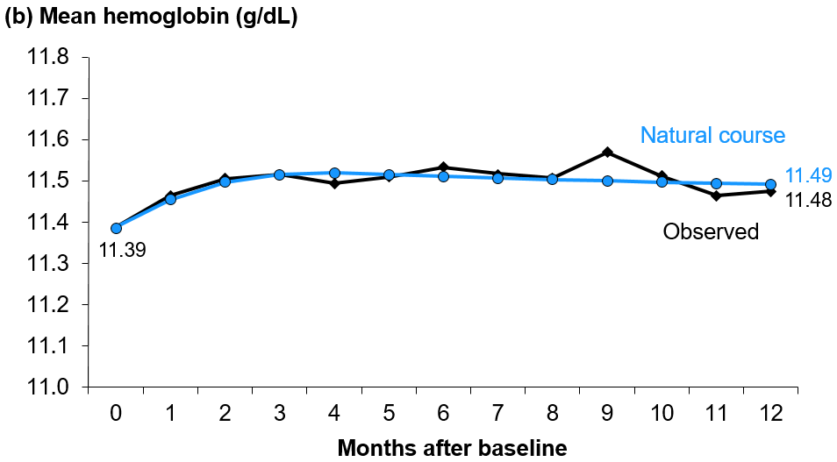
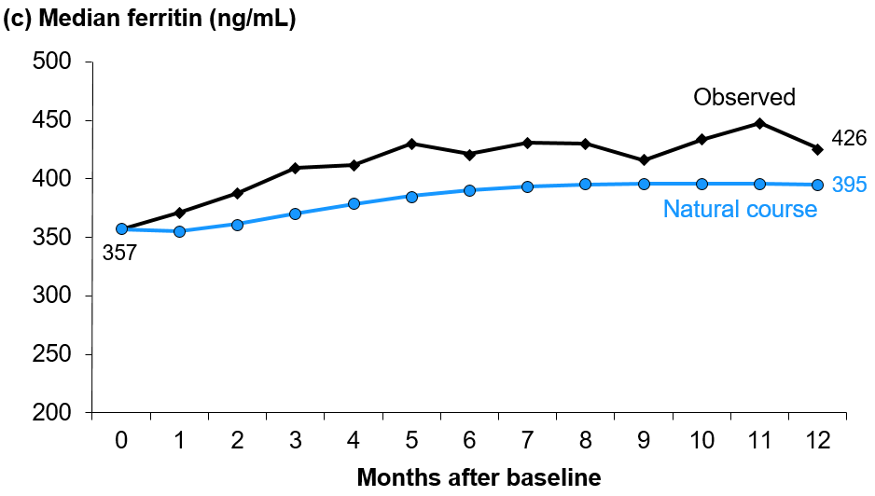
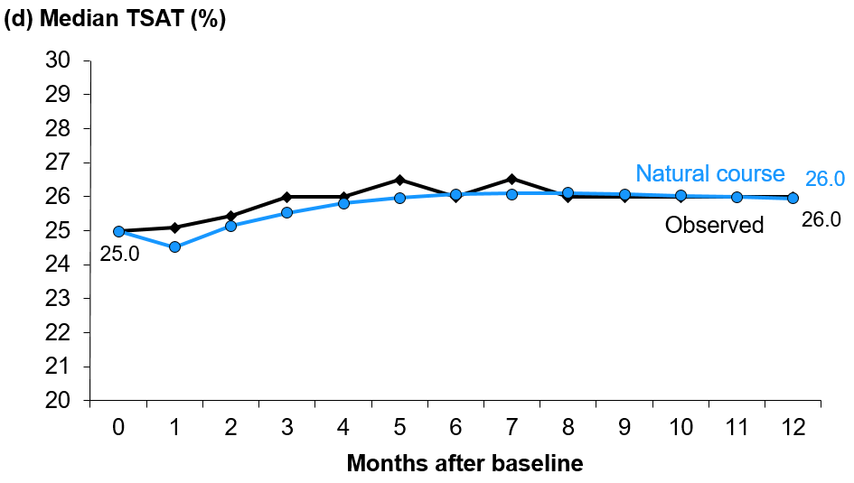
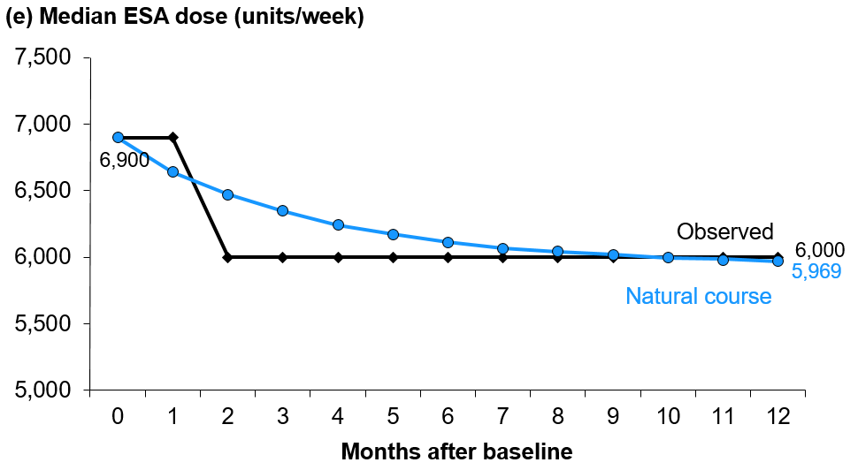
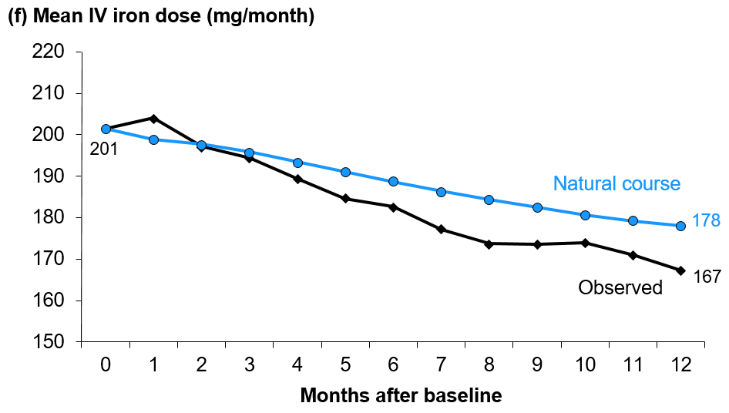

Figure S2
Title. Proactive high-dose vs. reactive low-dose IV iron treatment strategy: Comparison of cumulative doses of ESA and IV iron over 12 months using the parametric g-formula
Legend. High dose and low dose strategies defined by PIVOTAL trial protocol as described in Table 1; Outcomes: (a) cumulative ESA dose; (b) cumulative IV iron dose
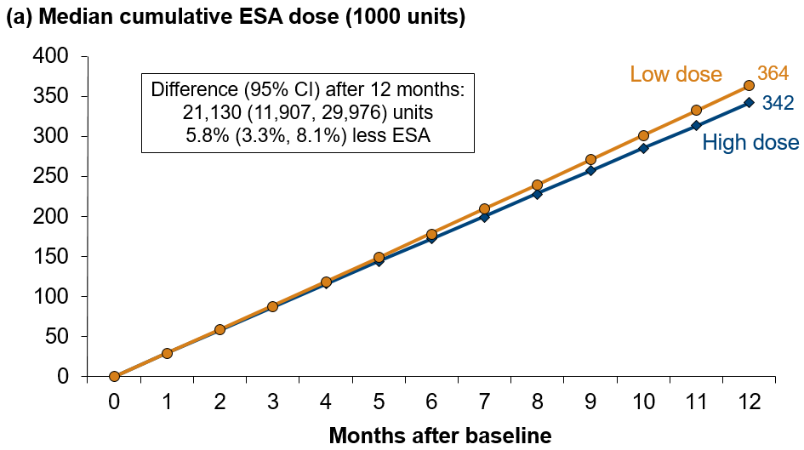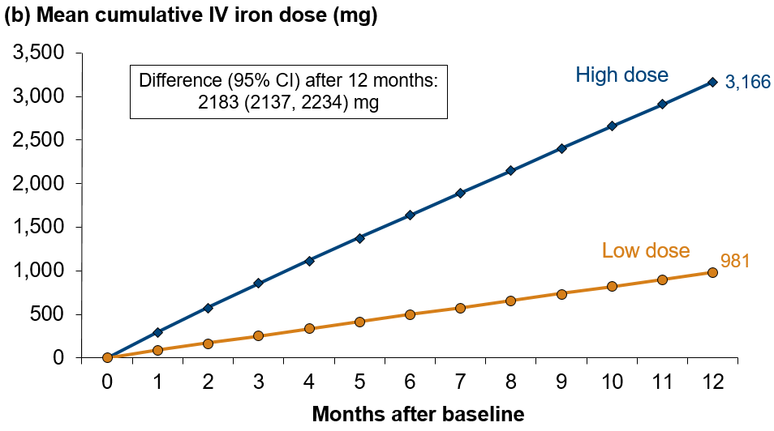

Figure S3
Title. Comparison of proactive high-dose vs. reactive low-dose IV iron treatment strategy over 12 months using the parametric g-formula: Complete-case sensitivity analysis
Legend. RR=Risk ratio; RD=Risk difference; High dose and low dose strategies defined by PIVOTAL trial¹⁵ protocol as described in Table 1; Outcomes: (a) all-cause mortality, (b) hemoglobin, (c) serum ferritin, (d) TSAT, (e) ESA dose, (f) IV iron dose. Step 1 models limited to 40,721 (of 97,044) patient-months with complete data; Step 2 utilized first instance of complete data for each of 3,994 (of 6,325) patients.
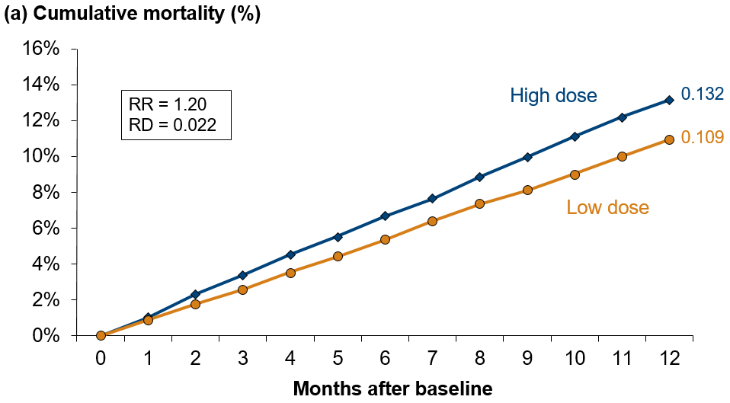
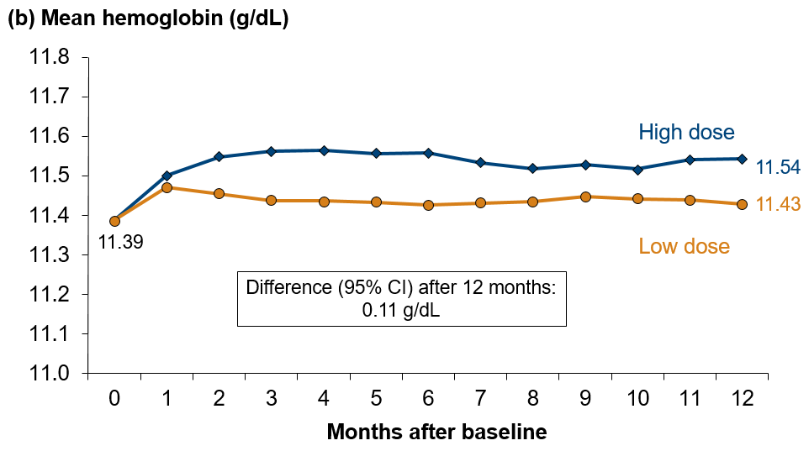

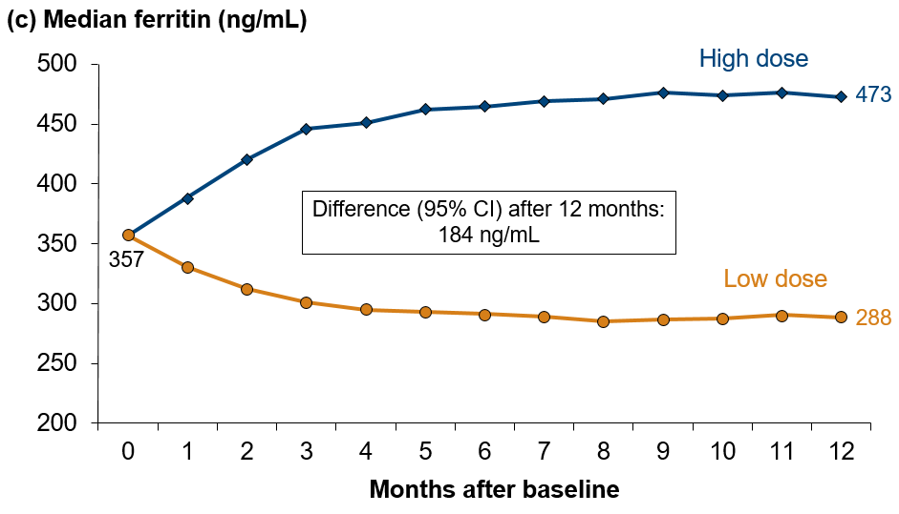
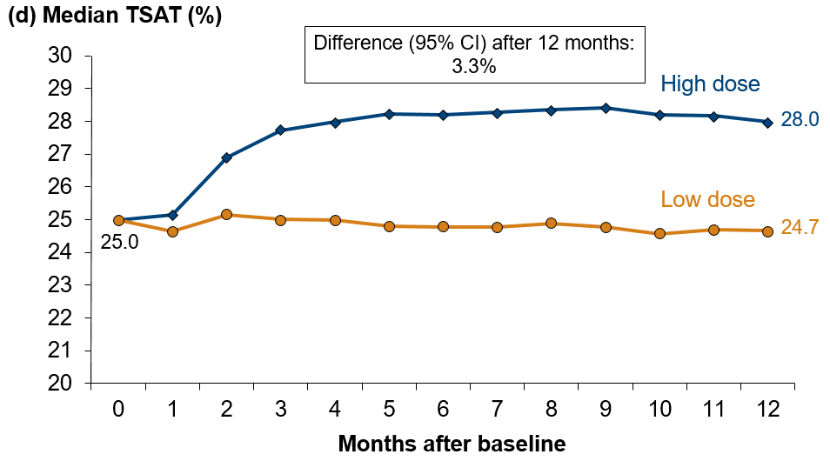

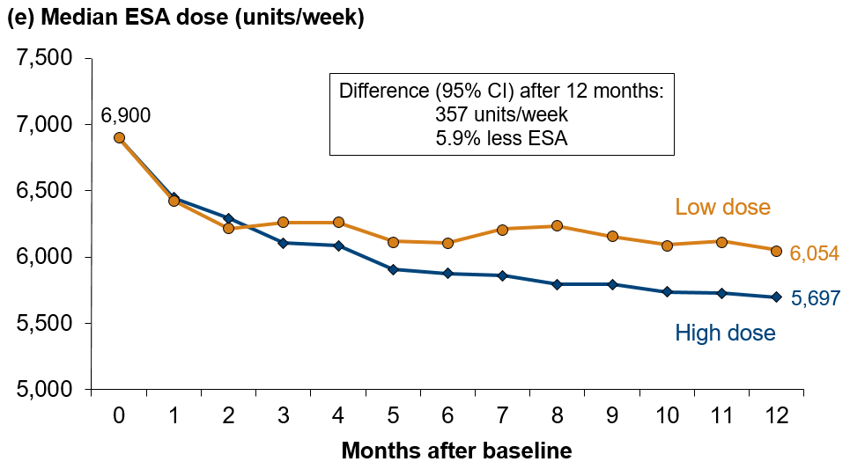
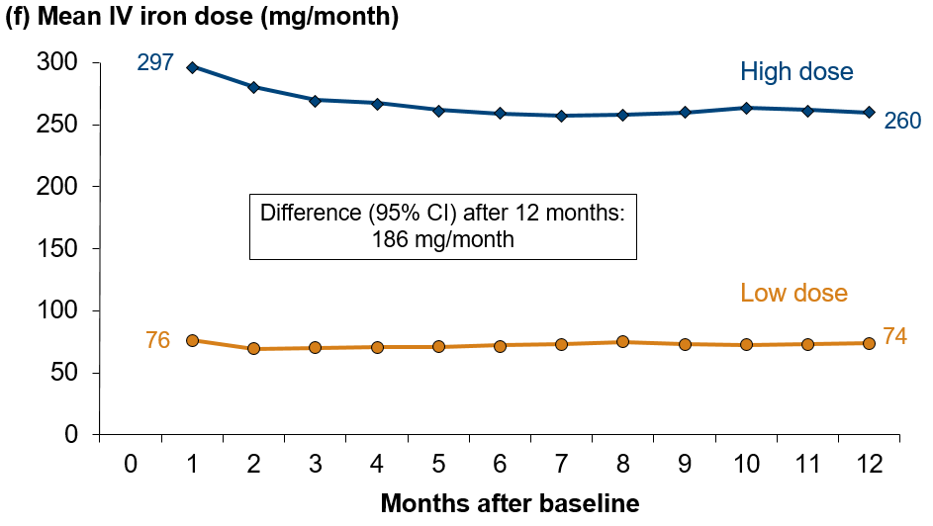

Figure S4
Title. Comparison of observed DOPPS data vs. natural course simulation, restricted to PIVOTAL-like patients
Legend. DOPPS data observed over the 12 months after baseline; Natural course simulation based on 12 simulated months using the parametric g-formula; N=1508 PIVOTAL-like DOPPS patients restricted to emulate PIVOTAL exclusion criteria; Outcomes: (a) all-cause mortality, (b) hemoglobin, (c) serum ferritin, (d) TSAT, (e) ESA dose, (f) IV iron dose.
