Quality assessment and comparison plasma-derived extracellular vesicles separated by three commercial kits for prostate cancer diagnosis

Bairen Pang^{1,2}, Ying Zhu^{1,2,3*,} Jie Ni^{1,2}, Juanfang Ruan^{4,5}, James Thompson^{1,6,7}, David Malouf^{2,6}, Joseph Bucci^{1,2}, Peter Graham^{1,2}, Yong Li^{1,2,8*}
¹St George and Sutherland Clinical School, UNSW Sydney, NSW 2052, Australia
²Cancer Care Centre, St. George Hospital, Sydney, NSW 2217, Australia
³School of Biomedical Engineering, University of Technology Sydney, NSW 2007, Australia
⁴Electron Microscope Unit, UNSW Sydney, NSW 2052 Australia
⁵School of Biotechnology and Biomolecular Sciences, UNSW Sydney, NSW 2052 Australia
⁶Department of Urology, St George Hospital, Sydney, NSW 2217, Australia
⁷Garvan Institute of Medical Research/ APCRC, Sydney, UNSW, 2010, Australia
⁸School of Basic Medical Sciences, Zhengzhou University, Henan 450001, China
* Corresponding authors at: Level 2, Research and Education Centre, St George Hospital, 4-10 South St, Kogarah, NSW 2217, Australia. Email addresses: ying.zhu@unsw.edu.au (Y. Zhu) or y.li@unsw.edu.au (Y. Li)

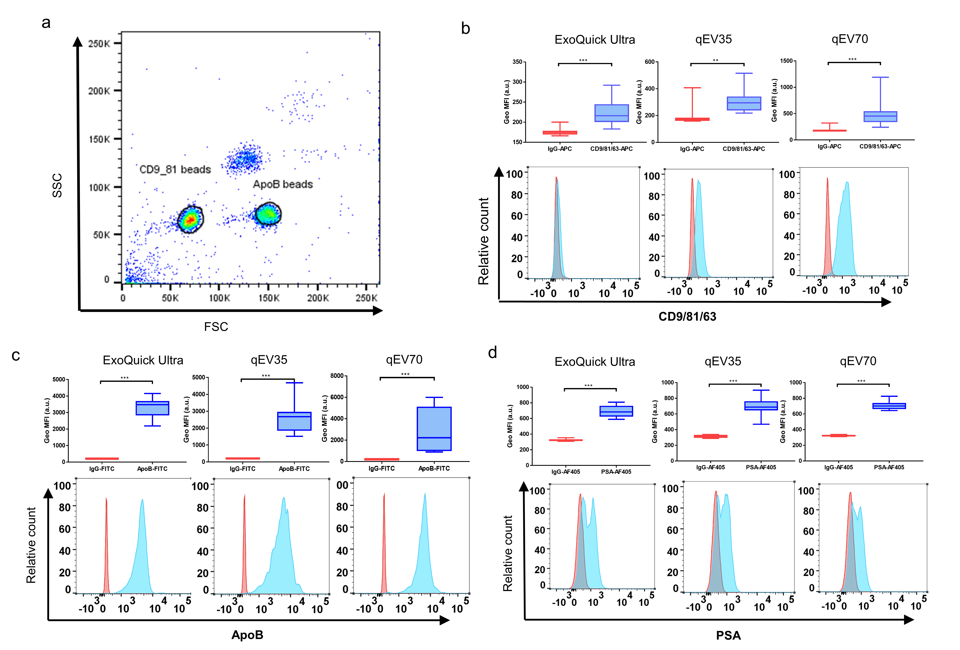
Fig S1. Interpretation of EV detected by flow cytometry using immunomagnetic beads. (a) Scatter plots of forward scatter vs side scatter from a mixture of 2.7 μm anti-CD9 and anti-CD81 beads and 4.5 μm anti-ApoB beads. Beads singlets were gated for flow cytometry analysis. (b-d) Up: the comparison of geometric mean fluorescent intensity (gMFI, a.u.) between the detection markers and the IgG isotype control, bottom: representative images of the histograms from one fluorescence channel. (b) Hybridised anti-CD9/81/63-APC signal, (c) anti-ApoB FITC signal, (d) anti-PSA Alexa Fluor 405 signal. **P < 0.01, ***P < 0.001.

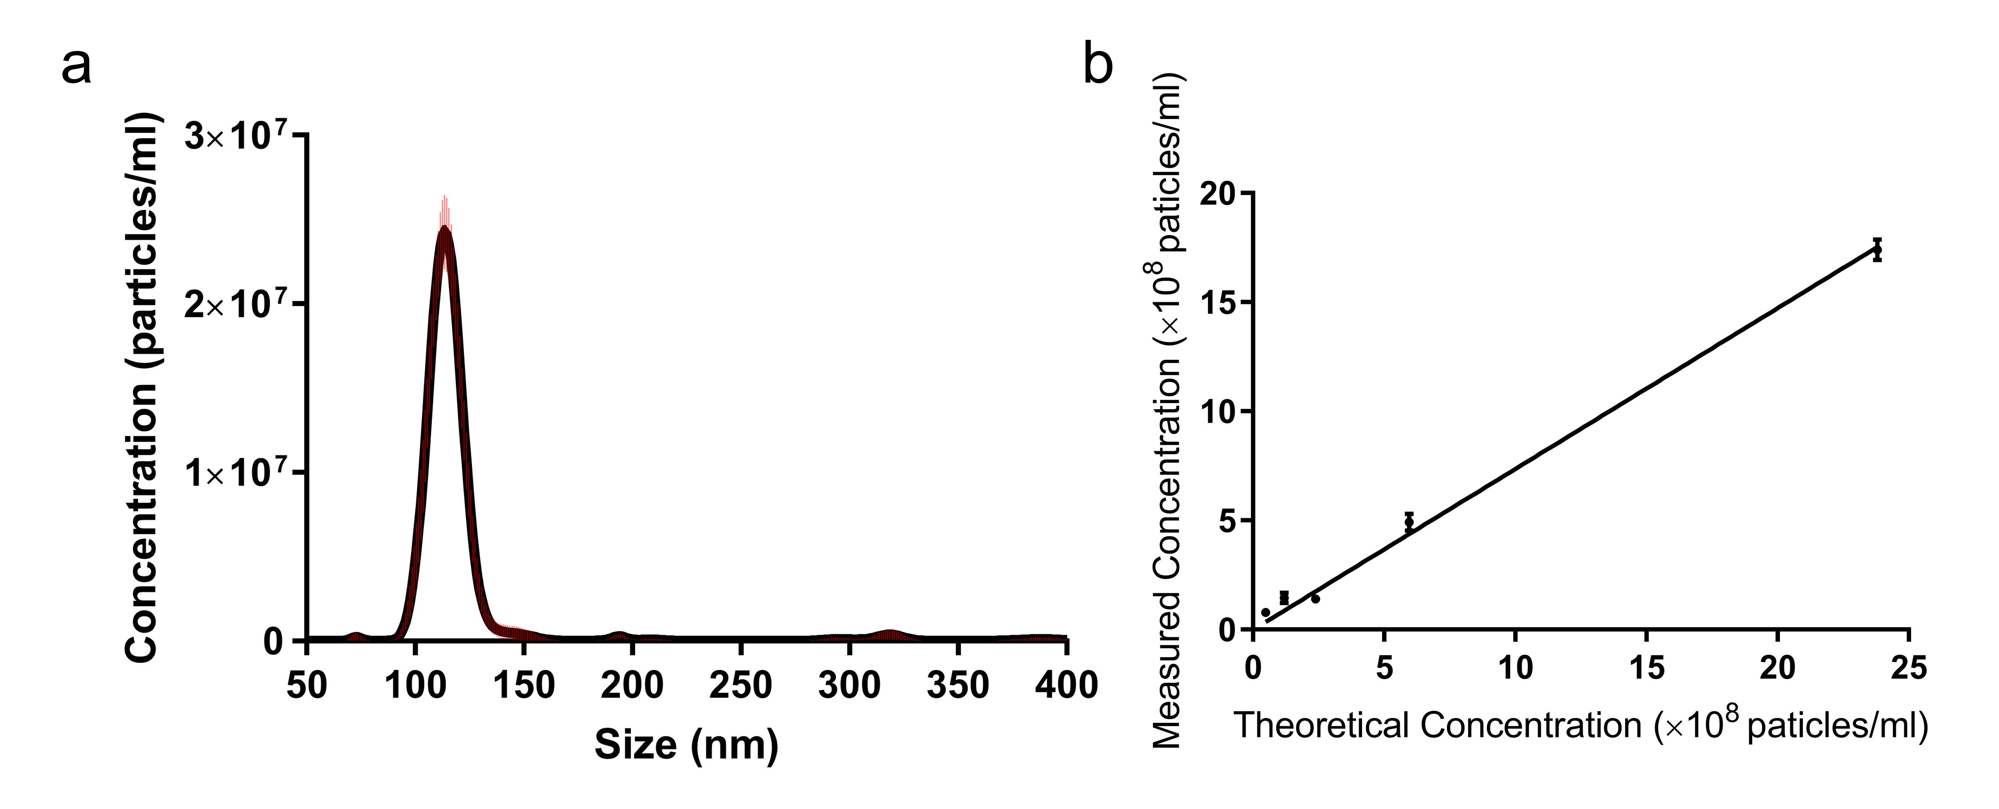
Fig S2. NTA calibration of particle concentration and size distribution. Calibration measurement for NTA was performed using 100 nm SiO₂ microsphere. The measured mode size 114 nm is slightly larger than the theoretical size 100 nm as NTA measures the hydrodynamic diameters. (a) a narrow particle size distribution. (b) a good linear relationship between the theoretical and known particle concentrations.

Table S1．Summary of PCa patient information
ID | Age | Risk Group | Serum PSA level | Gleason Sum | Gleason | TNM stage
L1 | 65 | Low | 4.6 | 7 | （3+4） | T1cN0M0
L2 | 72 | Low | 5.84 | 7 | （3+4） | T1cN0M0
L3 | 78 | High | 29 | 7 | （3+4） | T2aN0M0
L4 | 71 | High | 4.93 | 7 | （4+3） | T2aN0M0
L5 | 55 | High | 6.1 | 9 | （4+5） | T2aN0M0
L6 | 69 | High | 3.8 | 7 | （4+3） | T2cN0M0
Note: All patients are with localized PCa.

