Supplementary Figure S1

a.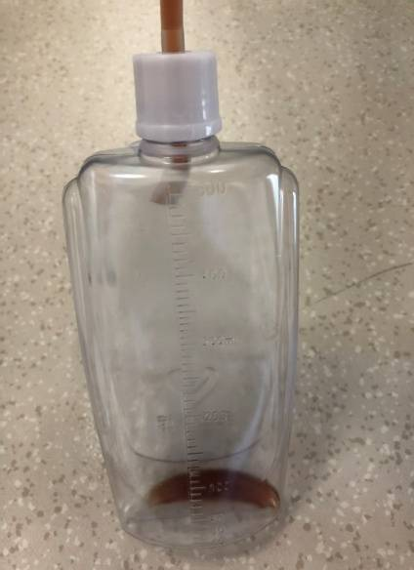 b. 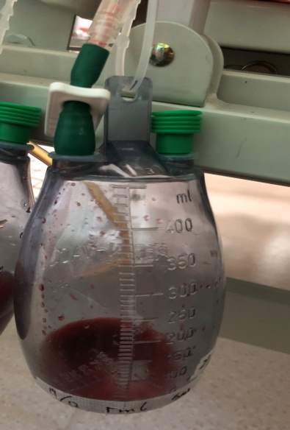

Supplementary Figure S1. Figure of negative vacuum drainage bottle.
a. the low vacuum drainage bottle (pressure=－12kPa) b. the high vacuum drainage bottle (pressure=－98kPa).
Supplementary Table S1. Comparison of the different negative drainage system used in this study.
 | Low vacuum drainage system | High vacuum drainage system
 | KANGLI®, W-II type wound drainage, SUNLIGHT MEDICAL, China | Jet-Vac®, Redon wound drainage, pfm medical, Germany
Maximum negative pressure (kpa) | -12 | -98
Bottle volume (ml) | 500 | 400(+50ml safety volume)
Application | No limited | Orthopaedics or breast surgery, non-abdominal surgery
Connector | Bottle cap, plug-connection | Luer-Lock connection, plug-connection
Shape of drain | Round | Round
Size of drain | 12 Fr | 12 CH
Scale | Rough graduation | Rough and fine graduation
Advantage | 1.Double one-way valve to prevent reverse flow.  2.Easy to change the bottle.  3.Squeeze bottle body to produce negative pressure | 1. Do not need to replace the bottle until the drainage is full.  2.Stable high negative pressure.
Defect | 1.Need to change drainage bottle per day. | 1.Need to change a new drainage once the bottle occurs air leakage.  2.It’s complicated process to change the bottle.
Size of diameter, 1 Fr ≈1 CH.

