Supporting Information

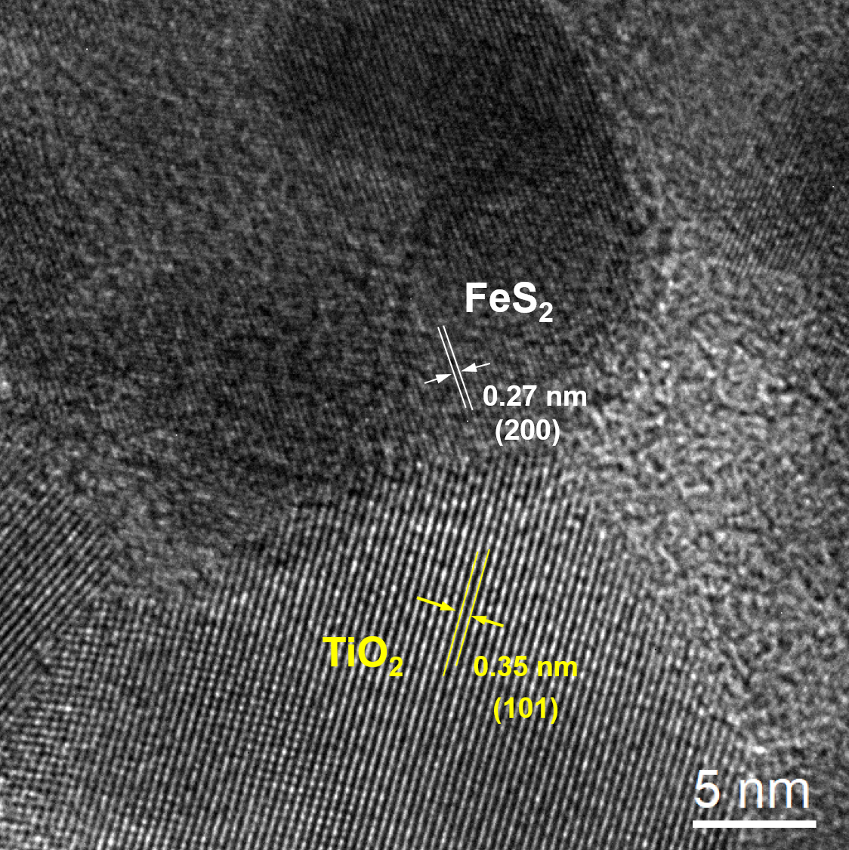
Figure S1. High-resolution transmission electron microscopy (HRTEM) image of heterostructured TiO₂-FeS₂ nanocomposites (NCs) consisted with TiO₂ nanoparticles (NPs) and FeS₂ NPs. In TiO₂-FeS₂ NCs, TiO₂ NPs exhibited clearly lattice fringes with an interplanar distance of 0.35 nm corresponding to the (101) plane of the TiO₂ anatase structure. FeS₂ NPs revealed lattice fringes with 0.27 nm interplanar distance corresponding to the (200) plane of the FeS₂ pyrite structure.

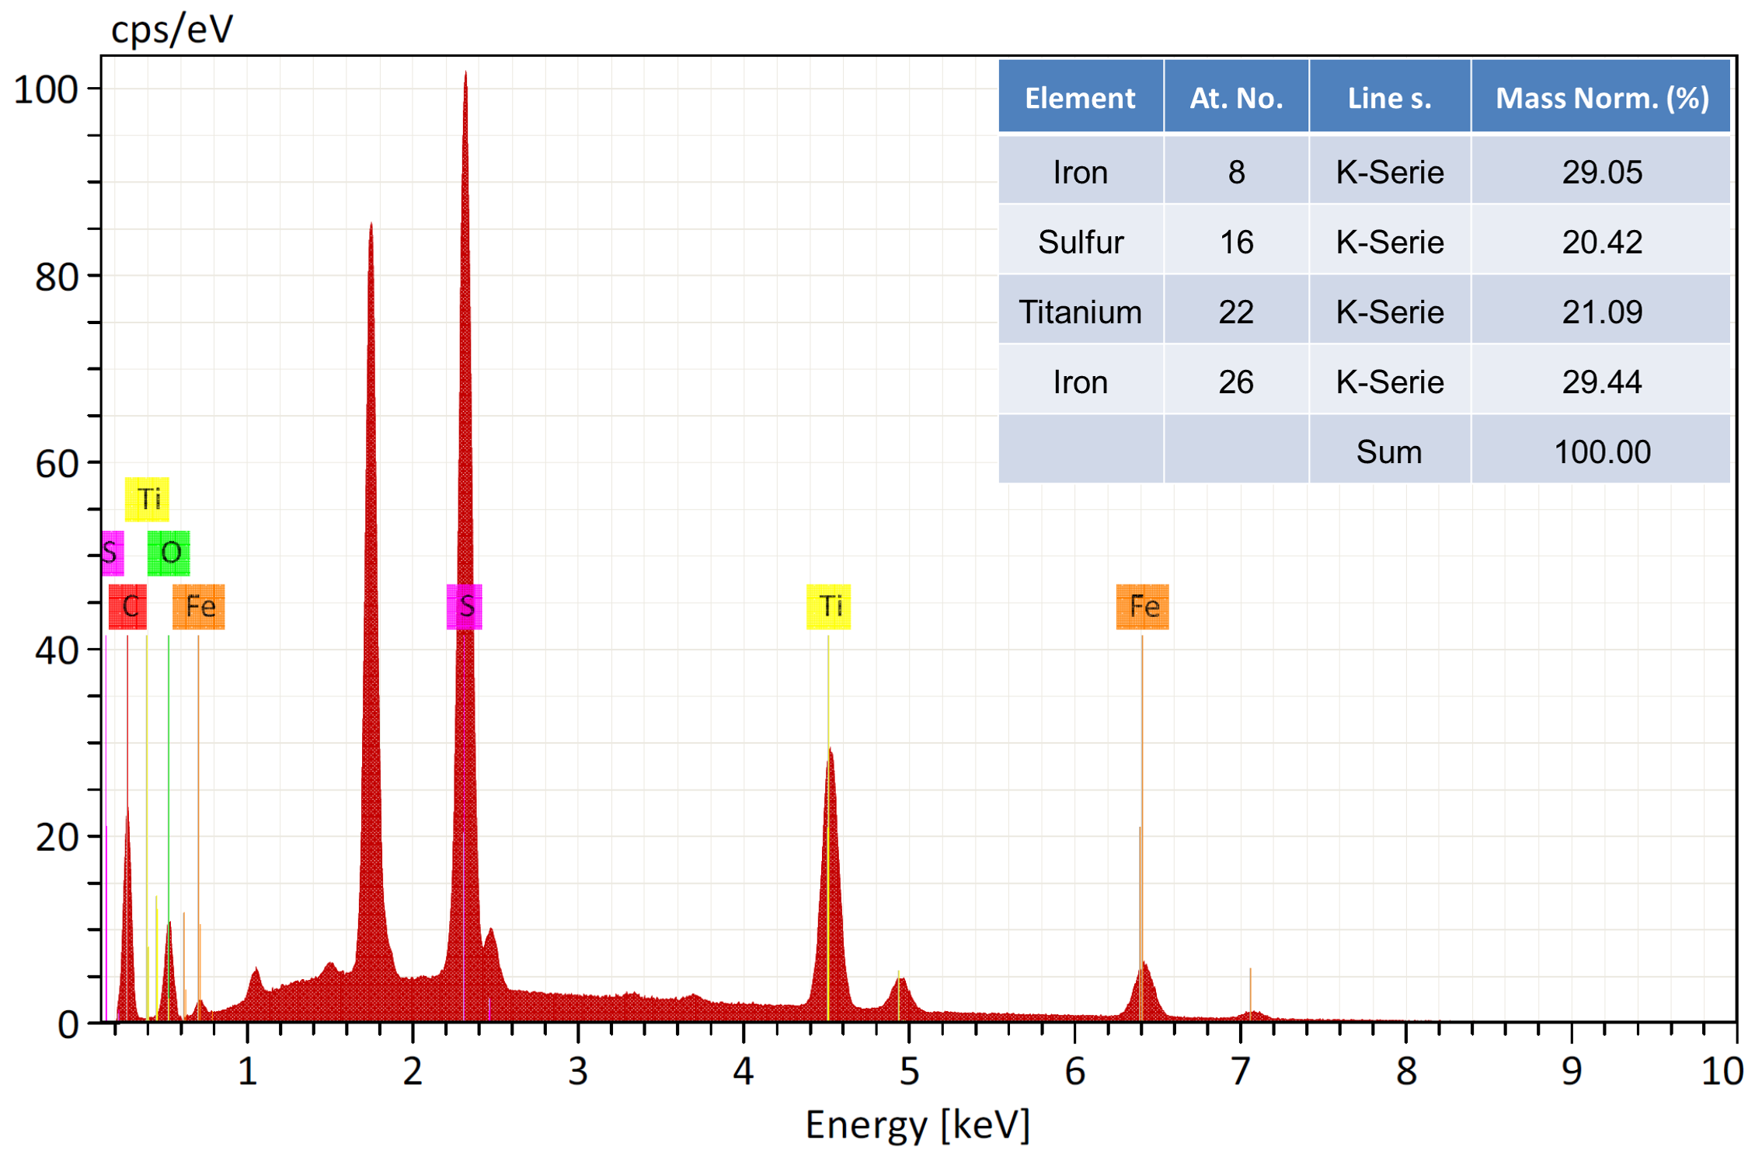
Figure S2. The energy-dispersive X-ray spectroscopy (EDS) spectra of TiO₂-FeS₂ nanocomposites (NCs). EDS spectra revealed the weight percent of FeS₂ and TiO₂ were respectively 49.47% and 50.53% in TiO₂-FeS₂ NCs.

