Supplementary Figure S1 Decrease in DAS28-ESR in MTX+HCQ and MTX+LEF after propensity score matching over 24 months.

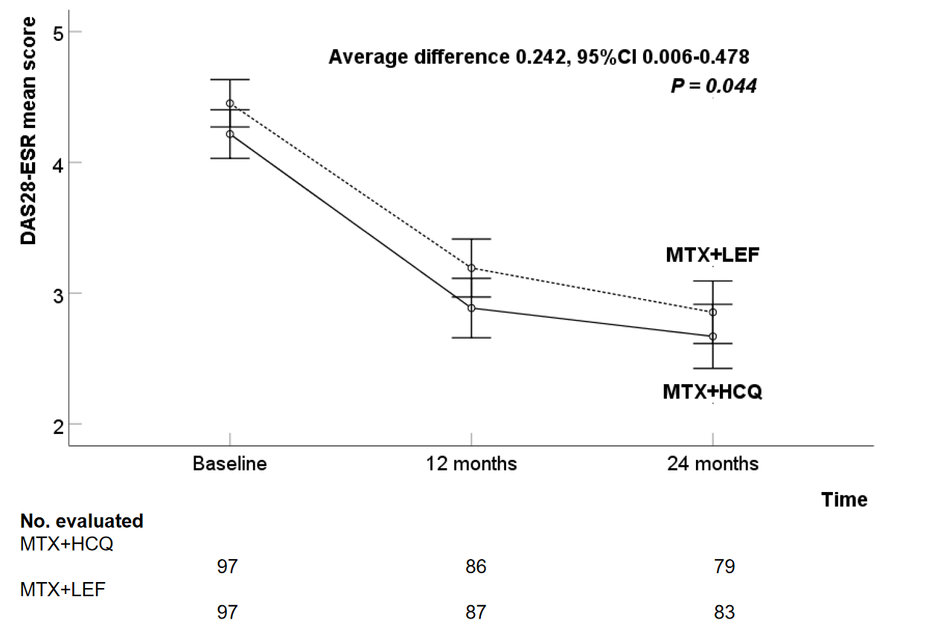

The solid line represents MTX+HCQ, and dashed line represents MTX+LEF. MTX+HCQ therapy was superior to MTX+LEF therapy (F=4.103, P=0.044).
DAS28-ESR, disease activity score in 28 joints using erythrocyte sedimentation rate; MTX, methotrexate; HCQ, hydroxychloroquine; LEF, leflunomide
Supplementary Figure S2 Cost-effectiveness acceptability curves of 2 strategies.

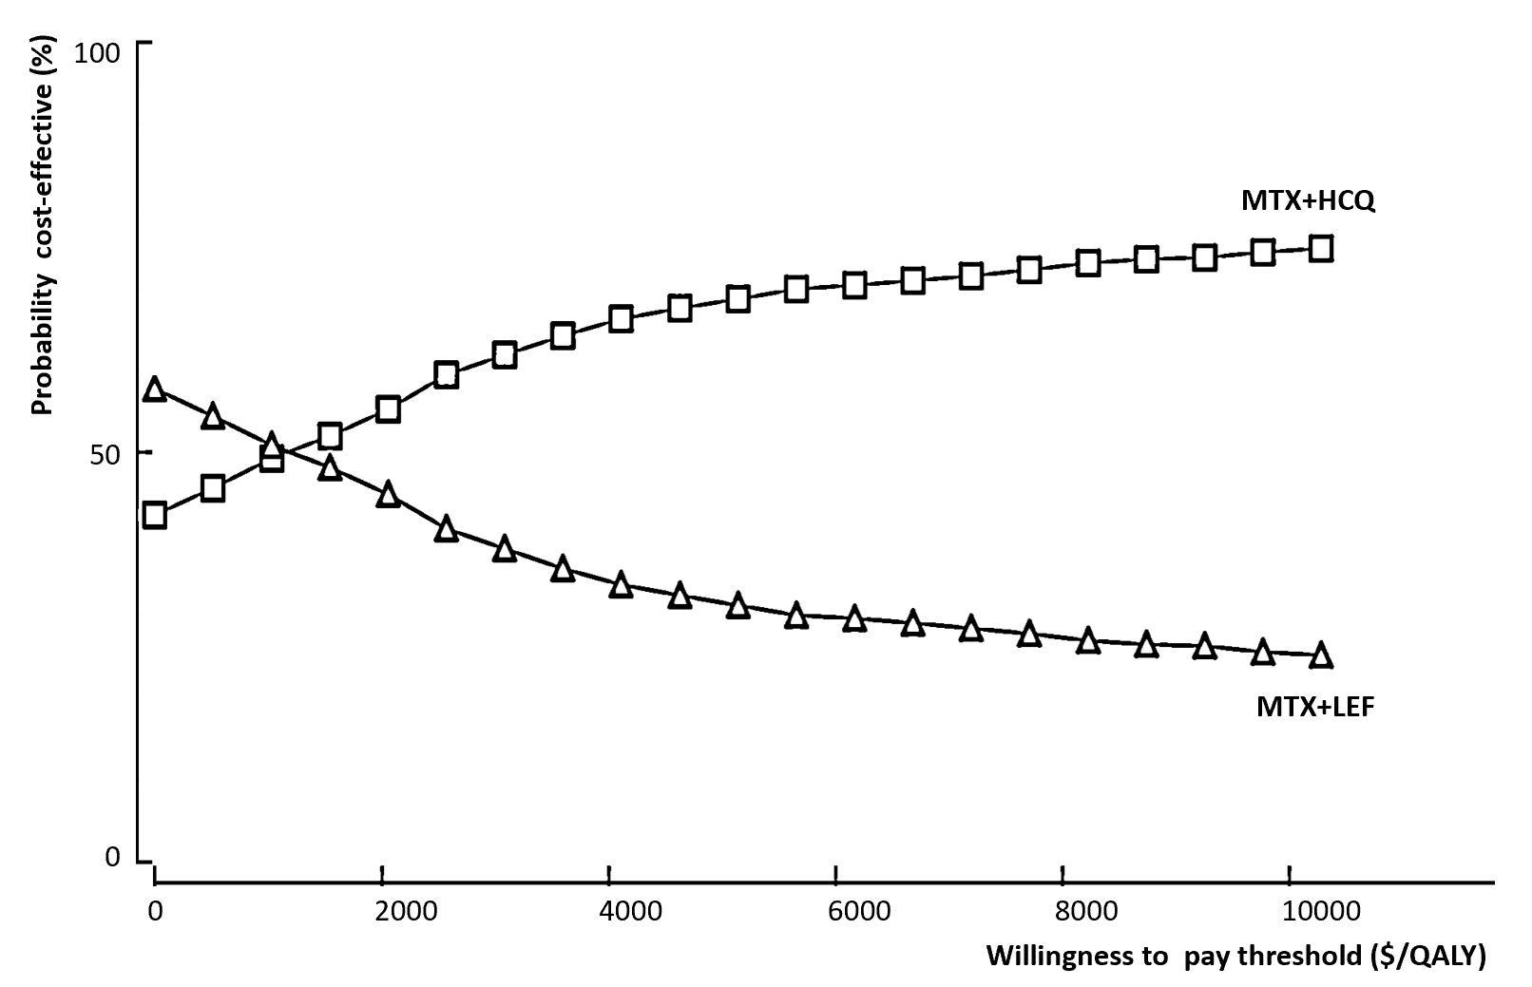
The small squares connected by the line represents the MTX+HCQ group, and the small triangles connected by the line represents the MTX+LEF group.
MTX, methotrexate; HCQ, hydroxychloroquine; LEF, leflunomide

