Celecoxib exerts a therapeutic effect against demyelination by improving the immune and inflammatory microenvironments

Supplementary materials

Supplementary Table S1. Primer sequences for qRT-PCR.
Gene | GenBank | Sequence
β-actin | NM_131031 | Forward: 5’-TTCACCACCACAGCCGAAAGA-3’  Reverse: 5’-TACCGCAAGATTCCATACCCA-3’
arg1 | NM_001045197 | Forward: 5’-ACACACCTTTAACCACACCGACTG-3’  Reverse: 5’-CCTTTCCTTTATGCTCCC-3’
caspase-3 | NM_131877 | Forward: 5’-TGTTCTTTATTCAGGCTTGT-3’  Reverse: 5’-CACTGCCATACTTTGTCATC-3’
caspase-7 | NM_001020607 | Forward: 5’-AGCAATGCCCATCAAGA-3’  Reverse: 5’-ATCGTCAAACTCCGAACCC-3’
cox-2 | NP_059334 | Forward: 5’-ACTACCCCTGAGCTTCTCACA-3’  Reverse: 5’-GATGCTGTTGATGATATCCCAGATTG-3’
il-10 | NM_001020785 | Forward: 5’-TTCTGCTCTGCTCACGCTTC-3’  Reverse: 5’-AGCCCTCCACAAATGAGCAA-3’
il-12 | NM_001007108 | Forward: 5’-GTGCCAGTGATCTGTGGAGAAGC-3’  Reverse: 5’-CACCGTCACCGTAATCCTGTTTCC-3’
il-1β | NM_212844 | Forward: 5’-TTCTGCTCAGCCTGTGTGTTTGG-3’  Reverse: 5’-AGATGTGGAGCGGAGCCTTCG-3’
il-4 | NM_001170740 | Forward: 5’-TCTCTGCCAAGCAGGAATGG-3’  Reverse: 5’-CCAGTCCCGGTATATGCTGC-3’
il-6 | NM_001261449 | Forward: 5’-ACGGAAAGATGTCTAACGC-3’  Reverse: 5’-ATAGGGAAGTGCTGGATG-3’
Mbp | XM_002665561 | Forward: 5’-AAAATCCCTGAACCAACC-3’  Reverse: 5’-CCTTTCCTTTATGCTCCC-3’
mrc1 | XM_002662968 | Forward: 5’-CTCCACCAACTACCGTAACCCAAG-3’  Reverse: 5’-GAACGAGCGAGCATCTTCCATAGG-3’
tnf-α | NM_212859 | Forward: 5’-TACCGCTGGTGATGGTGT-3’  Reverse: 5’-TGATTGCCCTGGGTCTTA-3’

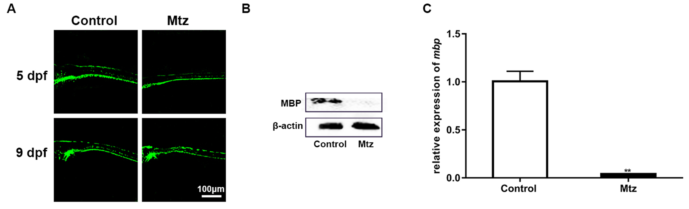
Supplementary Figure S1. Mtz induction specifically depletes oligodendrocytes in Tg (mbp:nfsB-egfp) larvae.
(A) GFP-positive signals in spinal cords from control and Mtz-induced fish. (B) The expression of MBP protein, as analyzed by western blotting. (C) Relative mbp mRNA expression. Note that mbp expression was decreased in the Mtz-induced group compared to the control group (Student’s t-test). Abbreviation: dpf, days post fertilization. **, P<0.01.

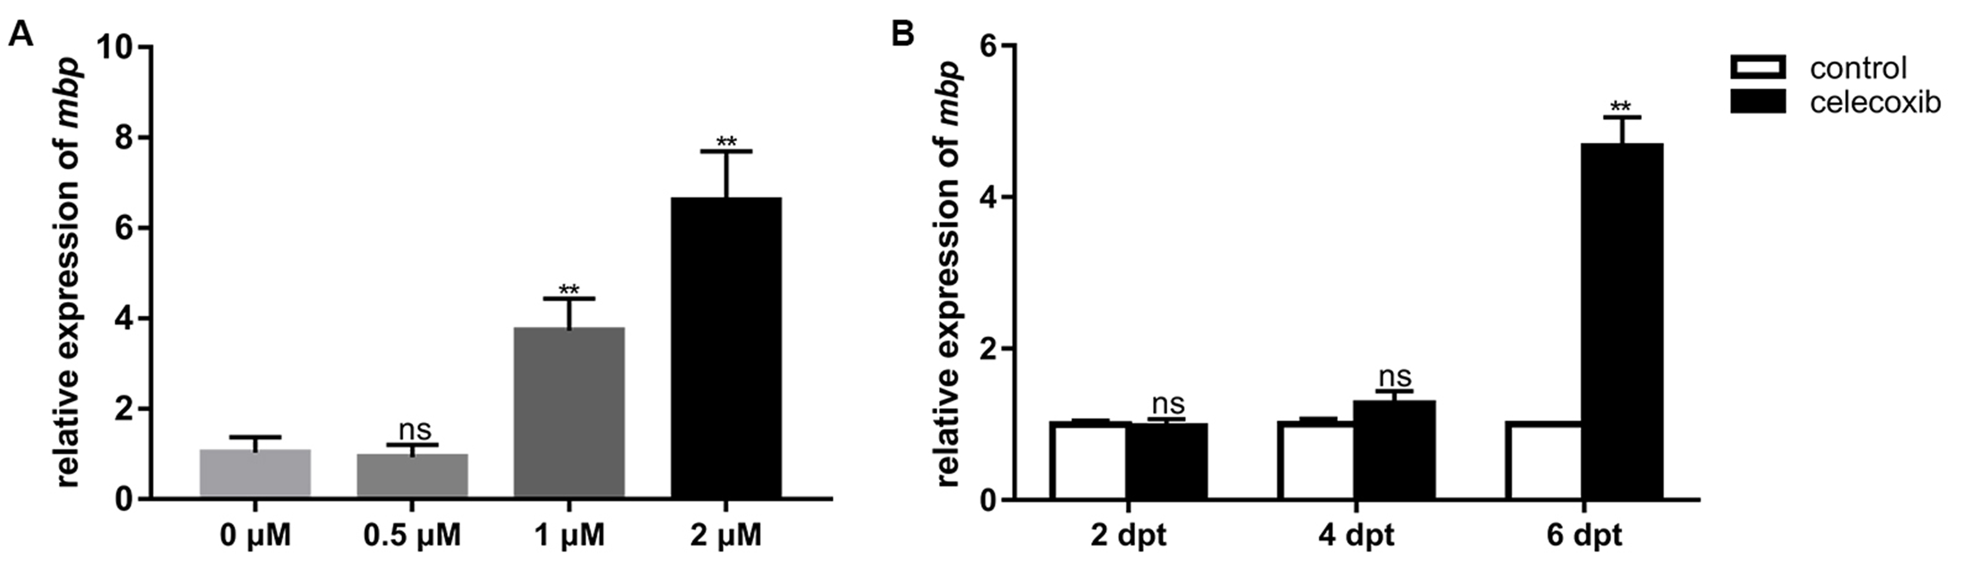
Supplementary Figure S2. mbp mRNA expression in demyelinated adult zebrafish treated with celecoxib.
(A) Relative mbp mRNA expression following 6 days of treatment with different concentrations (0, 0.5, 1 and 2 μM) of celecoxib. Note the significant increase in the 1 and 2 μM-treated groups compared to the 0 and 0.5 μM-treated groups (ANOVA). (B) Relative mbp mRNA expression follow treatment with 2 μM celecoxib for different durations. Note that the expression level increased significantly at 6 days post treatment (dpt; ANOVA). Abbreviations: dpt, days post treatment; ns, not significant. **, P<0.01

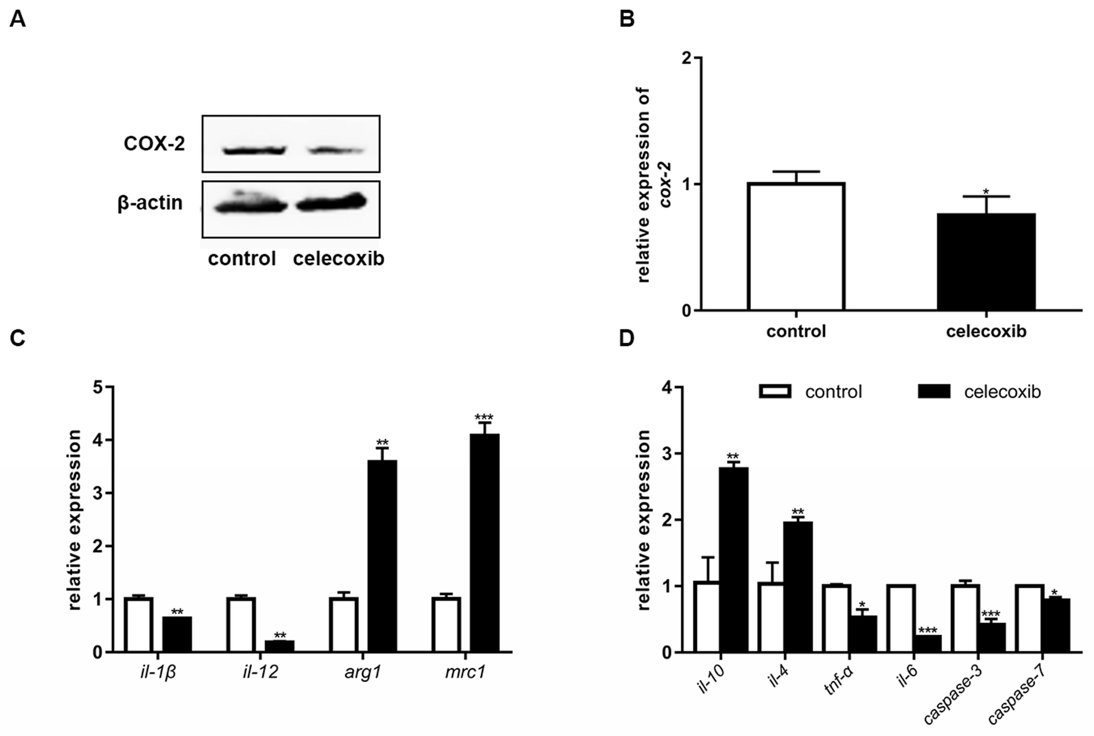
Supplementary Figure S3. The expression of COX-2, microglia/macrophage markers, inflammatory mediators and apoptotic factors in larvae following celecoxib treatment.
(A) The expression of the COX-2 protein, as analyzed by western blotting, at 3 dpt. (B) Relative expression of cox-2 mRNA (Student's t-test). (C) Relative expression of the microglia/macrophage markers il-1β, il-12, arg1 and mrc1 (Student's t-test). (D) Statistical analysis of mRNA expression of il-10, il-4, tnf-α, il-6, caspase-3 and caspase-7 between the control and celecoxib-treated groups (Student’s t-test). *, P < 0.05; **, P < 0.01; ***, P < 0.001.

