SUPPLEMENTAL DATA

Supplementary Table 1 The clinical characteristics of patients with plaque with or without diabetes.
No. | Type | Disease state | Sex | Age | Cva / tia
Diabetic_1 | Diabetic plaque macrophage | Diabetic | F | 43 | Asymptomatic
Diabetic_3 | Diabetic plaque macrophage | Diabetic | M | 64 | Asymptomatic
Diabetic_5 | Diabetic plaque macrophage | Diabetic | M | 67 | Asymptomatic
Diabetic_6 | Diabetic plaque macrophage | Diabetic | M | 67 | Asymptomatic
Diabetic_7 | Diabetic plaque macrophage | Diabetic | M | 69 | Asymptomatic
Diabetic_8 | Diabetic plaque macrophage | Diabetic | M | 49 | Asymptomatic
Control_2 | Control plaque macrophage | Control | M | 62 | Asymptomatic
Control_3 | Control plaque macrophage | Control | M | 65 | Asymptomatic
Control_4 | Control plaque macrophage | Control | M | 65 | Asymptomatic
Control_10 | Control plaque macrophage | Control | F | 89 | Asymptomatic
Control_15 | Control plaque macrophage | Control | M | 60 | Asymptomatic
Control_16 | Control plaque macrophage | Control | M | 65 | Asymptomatic

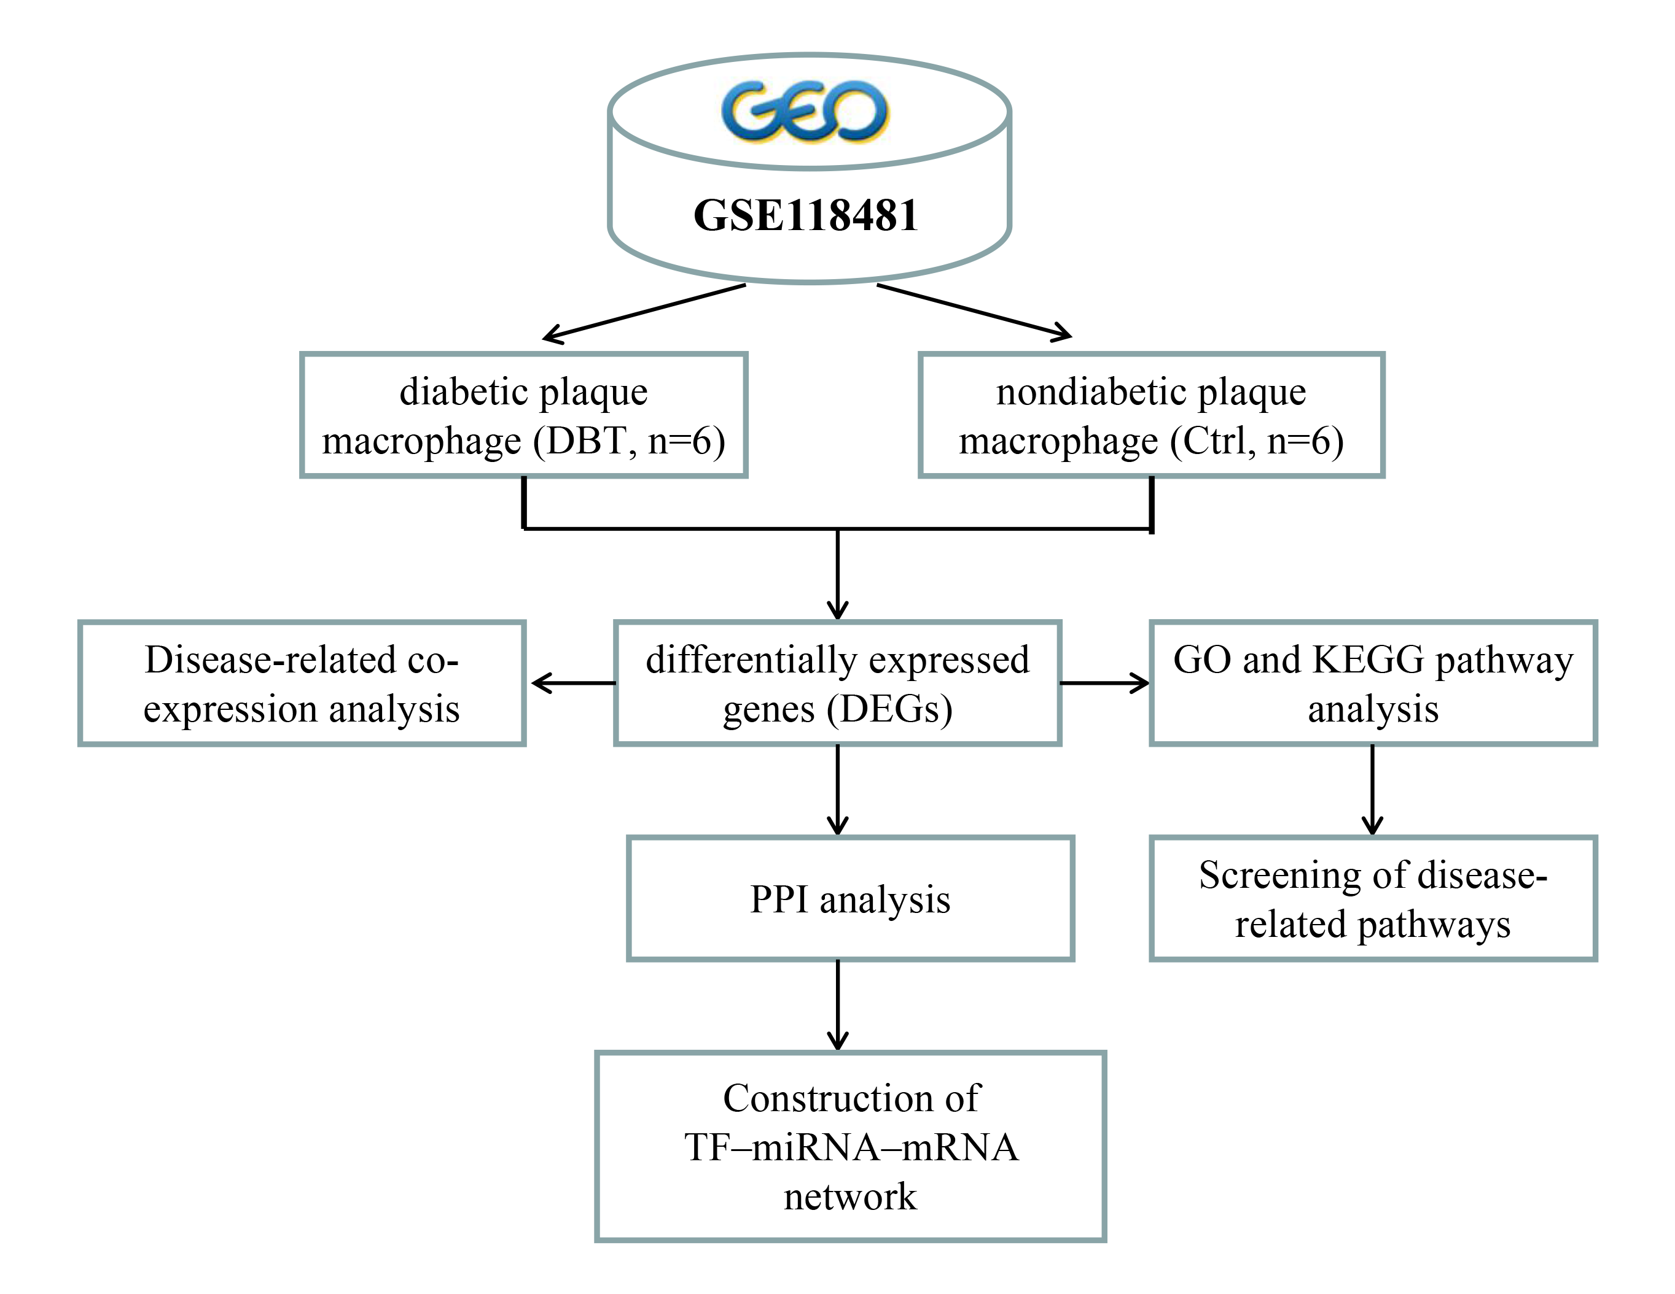
Supplementary Figure 1. A flow chart of the analysis regarding GSE118481.

