Supporting information

Mitochondria-Targeting Oxygen-Sufficient Perfluorocarbon Nanoparticles for Imaging-Guided Tumor Phototherapy
Sijie Chen, ^{a, b, c} Biying Huang, ^{a, b} Wenjing Pei, ^{a, b} Long Wang, ^{d} Yan Xu ^{a, b} and Chengcheng Niu ^{a, b,} *
ª Department of Ultrasound Diagnosis, The Second Xiangya Hospital, Central South University, Changsha, Hunan 410011, China
^{b} Research Center of Ultrasonography, The Second Xiangya Hospital, Central South University, Changsha, Hunan 410011, China
^{c} Department of Ultrasound Diagnosis, Changsha Central Hospital, Nanhua University, Changsha, Hunan 410014, China
^{d} Department of Orthopedics, Xiangya Hospital, Central South University, Changsha, Hunan 410008, China
Keywords
IR780, Mitochondria-targeting, Perfluorocarbon, Photodynamic therapy, Photothermal therapy
Address all correspondence to: Chengcheng Niu, Department of Ultrasound Diagnosis and Research Center of Ultrasonography, The Second Xiangya Hospital, Central South University, Changsha, Hunan, China, 410011; E-mail: niuchengcheng@csu.edu.cn

Supporting information 1. Appearance of IRP NPs (a) and IR NPs (b).
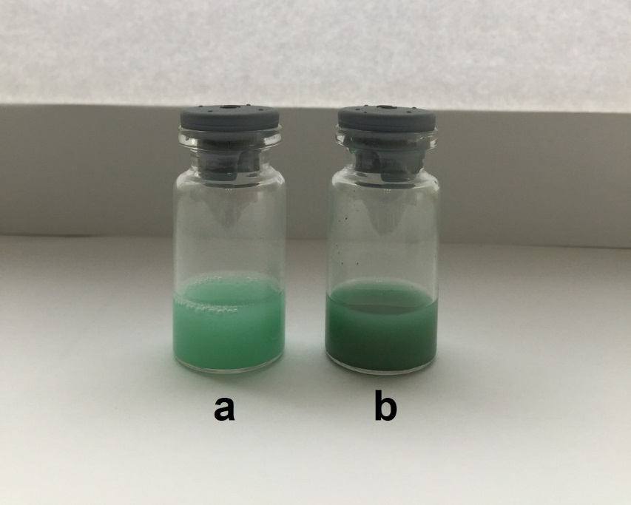
Fig. S1. Appearance of IRP NPs(a) and IR NPs (b).
Supporting information 2. Molar absorption coefficient of IRP NPs
Fig. S2 Linear relationship between absorbance and concentration

Supporting information 3. The photothermal conversion efficiency (η) of IRP NPs
The photothermal conversion efficiency (η) of IRP NPs was calculated by the following equations (1-3):
η = [hS(T_{max}- T_{sur})-Q₀]/[I(1-10^{-A})] (1)
hS = m_{s}C_{s}/τ (2)
t = -τln(θ) = -τln(T- T_{sur})/(T_{max}- T_{sur}) (3)
where h is the heat transfer coefficient, S is the surface area of the container, T_{max} represents the equilibrium temperature, T_{sur} is the ambient temperature of the environment, Q₀ expresses the heat dissipation from the light absorbed by the quartz sample cell (220 mW), I expresses the laser power density (2.0 W cm⁻²); A represents the absorbance of NPs at 808 nm; m_{s} and C_{s} are the mass (1.0 g) and heat capacity (4.2 J g⁻¹) of deionized water as a solvent, respectively; τ stands for the time constant of sample, which can be determined by the linear regression curve of temperature cooling time (t) vs –ln(θ) of NPs.
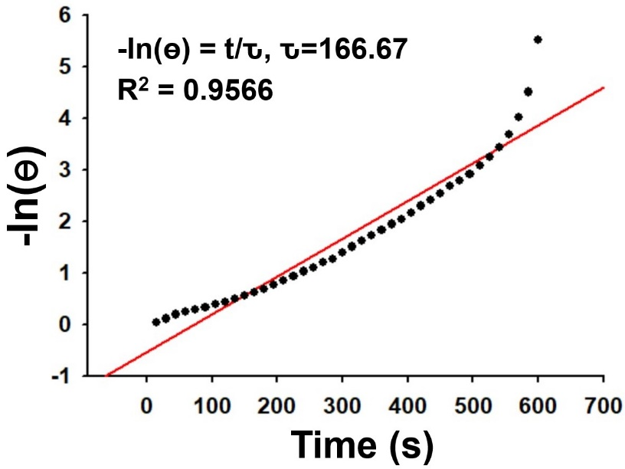
Fig. S3 The linear regression curve of temperature cooling time (t) vs –ln(θ) of IRP NPs.
Supporting information 4. Photodynamic measurement of IRP NPs
Fig. S4 ¹O₂ generation from different concentration of IRP/O₂ NPs using SOSG as a fluorescence probe with 808 nm laser irradiation (2 W cm⁻²). (a) 2.5 mg mL⁻¹, (b) 5 mg mL⁻¹, (c) 10 mg mL⁻¹.

Supporting information 5. ¹O₂ quantum yield measurement of IRP NPs
Singlet oxygen quantum yield was calculated by Ф_{Δ(X)} = Ф_{Δ(ICG)}×(S_{X}/S_{ICG}), in which the subscripts X and ICG represent IRP NPs and indocyanine green, respectively. S represents slope of absorbance plot of SOSG (525 nm) vs irradiation time.
Fig. S5. ¹O₂ generation from a plot of changes in absorbance by SOSG at 525 nm against different irradiation time (with 808 nm laser) in the presence of IRP NPs in water with ICG as a standard.
Supporting information 6. The biocompatibility of IRP NPs
Fig. S6 Relative viability of 4T1 cells incubated with different concentrations of IR NPs and IRP NPs.
Supporting information 7. FL/US imaging performance
Fig. S7 Fluorescence intensities and images with different concentration of IRP NPs.

Supporting information 8

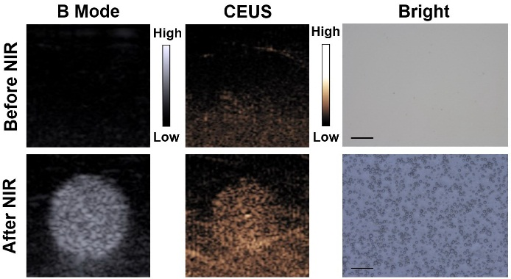
Fig. S8 B mode and CEUS mode US images, and brightfield microscopy images of IRP NPs (30 mg mL⁻¹) before and after NIR laser irradiation (808 nm, 1 W cm⁻², 5 min), scale bar = 10 μm.

Supporting information 9
Fig. S9 (a) H&E staining of heart, liver, spleen, lung, and kidney tissue slices after different treatments: (1) saline; (2) NIR; (3) IRP/O₂ NPs; (4) IRP/O₂ NPs with laser irradiation (PDT); (5) IRP/O₂ with laser irradiation (PTT); and (6) IRP/O₂ with laser irradiation (PDT+PTT) (scale bar, 50 μm). (b) Changes of mice body weight during different treatments.

