Supplementary Table 1: Description of simplified pharmacogenomics phenotypes used in the analysis
 | Simplified categories | Overall cohort  (N=10078)
CYP3A5 Phenotype, N (%)
Intermediate metabolizer | Normal | 1318 (13.1%)
Intermediate to normal (extensive) metabolizer | Normal | 1 (0.0%)
Normal (extensive) metabolizer | Normal | 72 (0.7%)
Poor to intermediate metabolizer | Normal | 11 (0.1%)
Poor metabolizer | Slow | 8628 (86.0%)
CYP2D6 Phenotype, N (%)
Intermediate metabolizer | Normal | 3232 (32.2%)
Normal (extensive) metabolizer | Normal | 3082 (30.7%)
Intermediate to normal (extensive) metabolizer | Normal | 1970 (19.6%)
Intermediate to rapid metabolizer | Fast | 1 (0.0%)
Intermediate to ultrarapid metabolizer | Fast | 3 (0.0%)
Rapid metabolizer | Fast | 126 (1.3%)
Ultrarapid metabolizer | Fast | 79 (0.8%)
Poor metabolizer | Slow | 695 (6.9%)
Poor to intermediate metabolizer | Slow | 805 (8.0%)
Poor to normal (extensive) metabolizer | Slow | 37 (0.4%)
HLA-B 5701 Phenotype, N (%)
No increased risk of abacavir hypersensitivity reaction | Normal | 9406 (93.8%)
Significant risk of abacavir hypersensitivity reactions | Slow | 624 (6.2%)
HLA-B 1502 HLA-A 3101 Phenotype, N (%)
No increased risk for a hypersensitivity reaction to carbamazepine | Normal | 9436 (94.1%)
Significant risk for a hypersensitivity reaction to carbamazepine | Slow | 594 (5.9%)
SLCO1B1 Phenotype, N (%)
Normal function | Normal | 6283 (62.6%)
Decreased function (1/21) | Slow | 609 (6.1%)
Decreased function (1/5 or 1/15) | Slow | 2279 (22.7%)
Decreased to poor function (1/17, 5/21, or 15/21) | Slow | 426 (4.2%)
Poor function (17/17) | Slow | 6 (0.1%)
Poor function (17/21) | Slow | 16 (0.2%)
Poor function (21/21) | Slow | 22 (0.2%)
Poor function (5/17 or 15/17) | Slow | 69 (0.7%)
Poor function (5/5 or 15/15) | Slow | 181 (1.8%)
Possible increased risk of simvastatin myopathy | Fast | 102 (1.0%)
Increased risk of simvastatin myopathy | Fast | 37 (0.4%)
CYP2C9 Phenotype, N (%)
Intermediate metabolizer | Normal | 1277 (12.7%)
Intermediate to normal (extensive) metabolizer | Normal | 2084 (20.8%)
Normal (extensive) metabolizer | Normal | 6415 (64.0%)
Poor metabolizer | Slow | 41 (0.4%)
Poor to intermediate metabolizer | Slow | 187 (1.9%)
Poor to normal (extensive) metabolizer | Slow | 16 (0.2%)
Variable. Range: Intermediate metabolizer | Slow | 1 (0.0%)
Variable. Range: Intermediate to normal (extensive) metabolizer | Slow | 9 (0.1%)
CYP2C19 Phenotype, N (%)
Intermediate metabolizer | Normal | 1922 (19.2%)
Intermediate to normal (extensive) metabolizer | Normal | 676 (6.7%)
Intermediate to rapid metabolizer | Normal | 29 (0.3%)
Intermediate to ultrarapid metabolizer | Normal | 5 (0.0%)
Normal (extensive) metabolizer | Normal | 3950 (39.4%)
Poor metabolizer | Slow | 219 (2.2%)
Poor to intermediate metabolizer | Slow | 30 (0.3%)
Poor to normal (extensive) metabolizer | Slow | 8 (0.1%)
Rapid metabolizer | Fast | 2711 (27.0%)
Ultrarapid metabolizer | Fast | 480 (4.8%)
DPYD CPIC categorization , N (%)
2 | Normal | 9410 (93.4%)
1.5 | Intermediate | 554 (5.5%)
1 | Intermediate | 111 (1.1%)
0.5 | Poor | 1 (0.0%)
0 | Poor | 1 (6.6%)
HLA-B 5801 Phenotype, N (%)
No increased risk of allopurinol hypersensitivity reaction | Absent | 9892 (98.6%)
Significant risk of allopurinol hypersensitivity syndrome | Present | 138 (1.4%)
TPMT Phenotype, N (%)
Intermediate metabolizer | Normal | 934 (9.3%)
Intermediate to normal metabolizer | Normal | 23 (0.2%)
Normal metabolizer | Normal | 9041 (90.1%)
Poor metabolizer | Slow | 29 (0.3%)
Poor to intermediate metabolizer | Slow | 3 (0.0%)

Supplementary Table 2: Association of 10 selected pharmacogenomics phenotypes with the degree of disease burden and gender
 | Disease burden |  | Gender
 | Median  (25th – 75th %tiles) | P-values | Female,  N (%) | Male,  N (%) | P-values
CYP2C9, N (%)  Normal  Slow | 5 (3, 7)  5 (3, 7) | 0.44 | 5965 (97.7%)  141 (2.3%) | 3811 (97.1%)  113 (2.9%) | 0.09
CYP2C19, N (%)  Normal  Fast  Slow | 5 (3, 7)  5 (3, 7)  5 (3, 7) | 0.41 | 3997 (65.5%)  1950 (31.9%)  159 (2.6%) | 2556 (65.1%)  1270 (32.4%)  98 (2.5%) | 0.87
CYP2D6, N (%)  Normal  Fast  Slow | 5 (3, 7)  5 (3, 7)  5 (3, 7) | 0.72 | 5076 (83.1%)  126 (2.1%)  904 (14.8%) | 3208 (81.8%)  83 (2.1%)  633 (16.1%) | 0.19
CYP3A5, N (%)  Normal  Slow | 5 (3, 7)  5 (3, 7) | 0.13 | 870 (14.2%)  5236 (85.8%) | 532 (13.6%)  3392 (86.4%) | 0.35
DPYD, N (%)  Normal  Intermediate  Poor | 5 (3, 7)  5 (3, 7)  6 (5, 7) | 0.83 | 5744 (93.5%)  400 (6.5%)  0 (0.0%) | 3666 (93.2%)  265 (6.7%)  2 (0.1%) | 0.19
HLA-B-1502, N (%)  Absent  Present | 5 (3, 7)  5 (3, 7) | 0.57 | 5743 (94.1%)  363 (5.9%) | 3693 (94.1%)  231 (5.9%) | 0.94
HLA-B-5701, N (%)  Absent  Present | 5 (3, 7)  5 (2, 7) | 0.61 | 5714 (93.6%)  392 (6.4%) | 3692 (94.1%)  232 (5.9%) | 0.32
HLA-B-5801, N (%)  Absent  Present | 5 (3, 7)  4 (2, 7) | 0.08 | 6019 (98.6%)  87 (1.4%) | 3873 (98.7%)  51 (1.3%) | 0.66
SLCO1B1, N (%)  Normal  Fast  Slow | 5 (3, 7)  5 (2, 7)  5 (3, 7) | 0.27 | 3839 (62.9%)  77 (1.3%)  2190 (35.9%) | 2444 (62.3%)  62 (1.6%)  1418 (36.1%) | 0.38
TPMT, N (%)  Normal  Slow | 5 (3, 7)  4 (3, 7) | 0.87 | 6081 (99.6%)  25 (0.4%) | 3917 (99.8%)  7 (0.2%) | 0.07

Supplemental Table 3 Top Primary Causes of Hospitalizations.

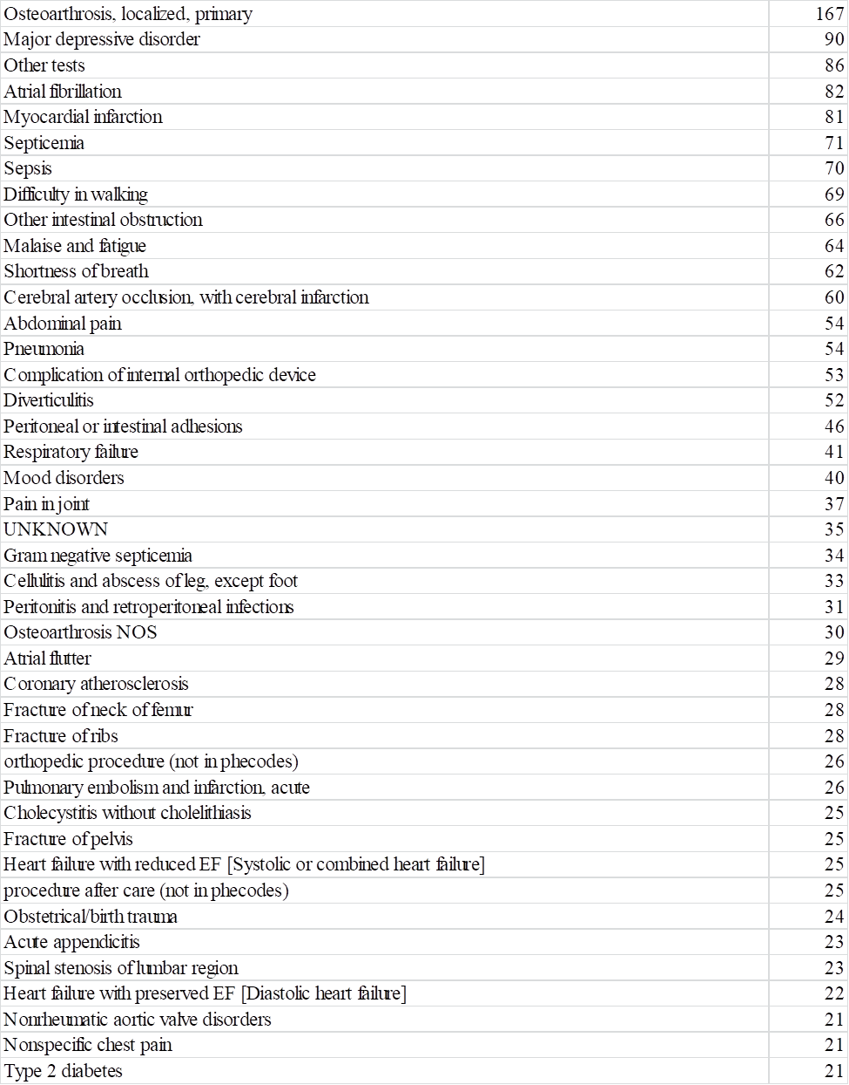
Legend: Only diagnoses with greater than 20 codes are listed.

