Supplementary materials
Figure S1 Top most abundant taxa at phylum level in CPZ group.
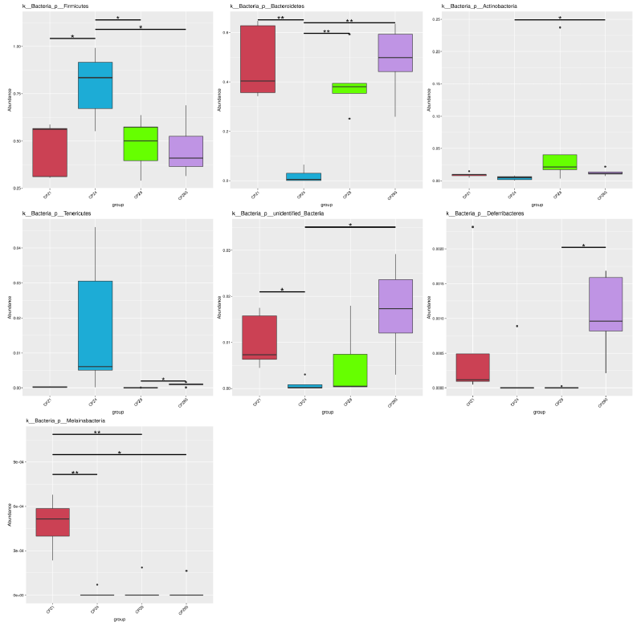
Abbreviation: CPZ, cefoperazone/sulbactam.

Figure S2 Top most abundant taxa at phylum level in LEV group.
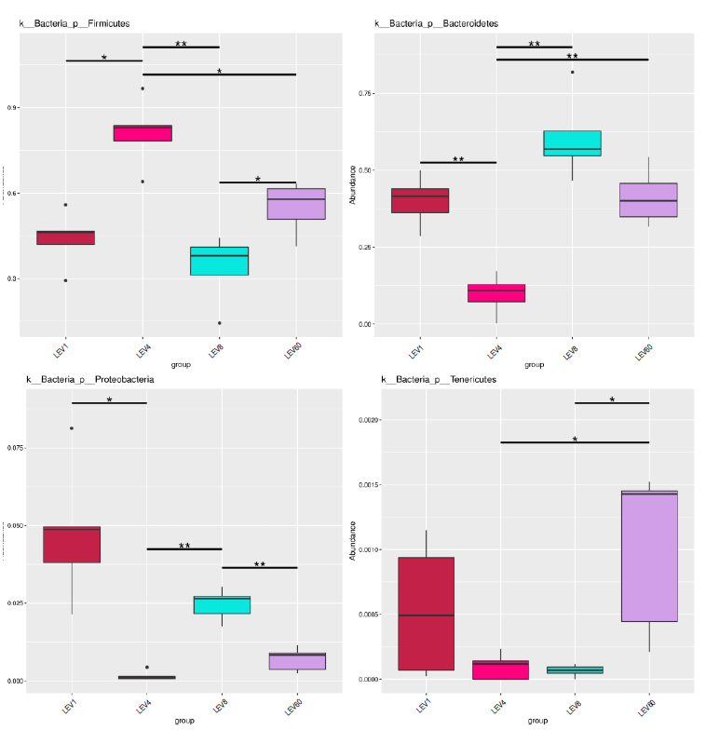
Abbreviation: LEV, levofloxacin.

Figure S3 Top most abundant taxa at phylum level in MEM group.
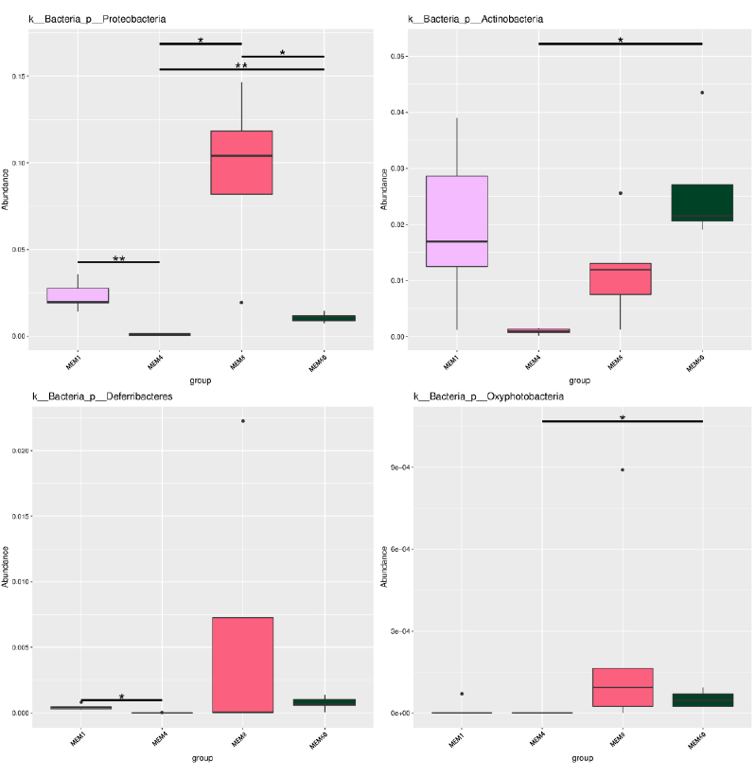
Abbreviation: MEM, meropenem.

Figure S4 Top most abundant taxa at phylum level in ATM group.
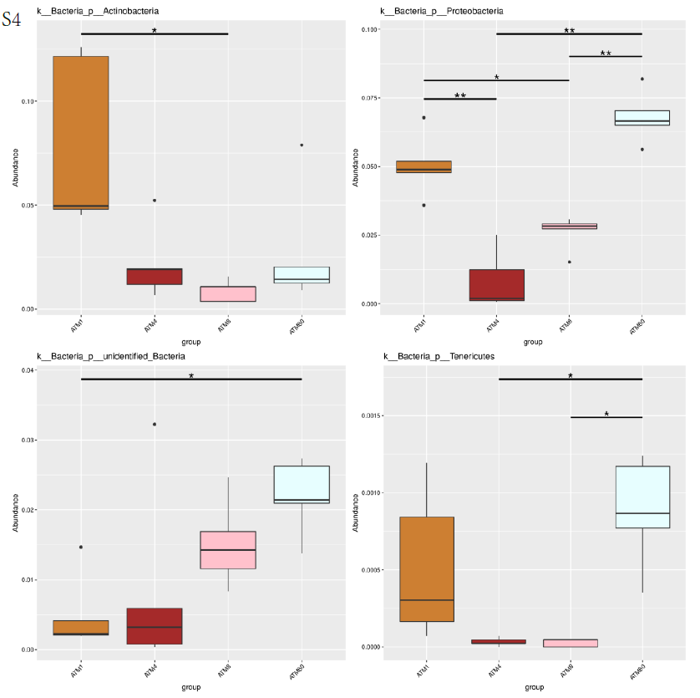
Abbreviation: ATM, aztreonam.

Figure S5 Relative abundance of top 12 bacterial taxa in CPZ group at genus level.
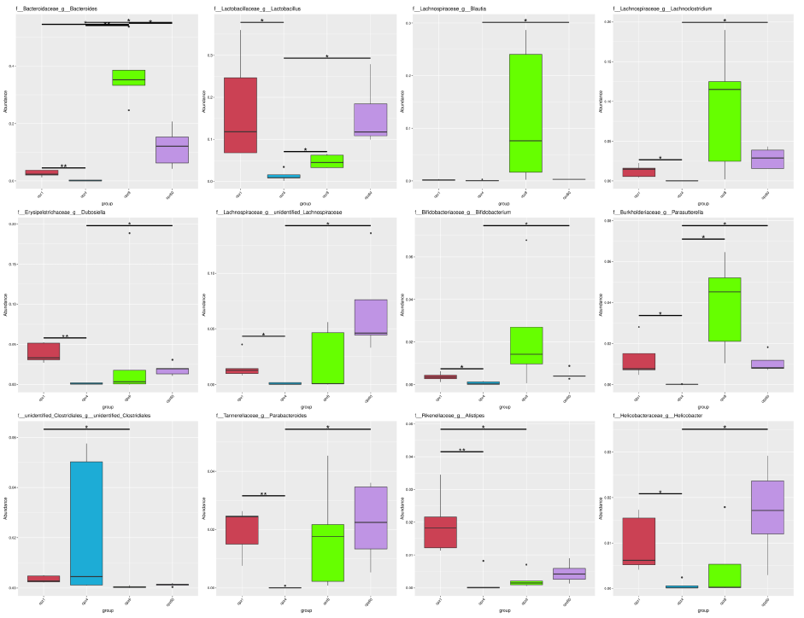
Abbreviation: CPZ, cefoperazone/sulbactam.

Figure S6 Relative abundance of top 12 bacterial taxa in LEV group at genus level.
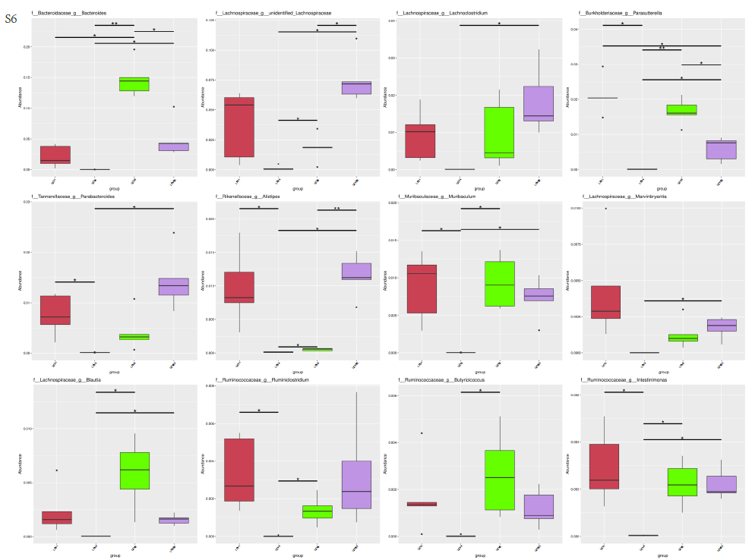
Abbreviation: LEV, levofloxacin.

Figure S7 Relative abundance of top 12 bacterial taxa in MEM group at genus level.
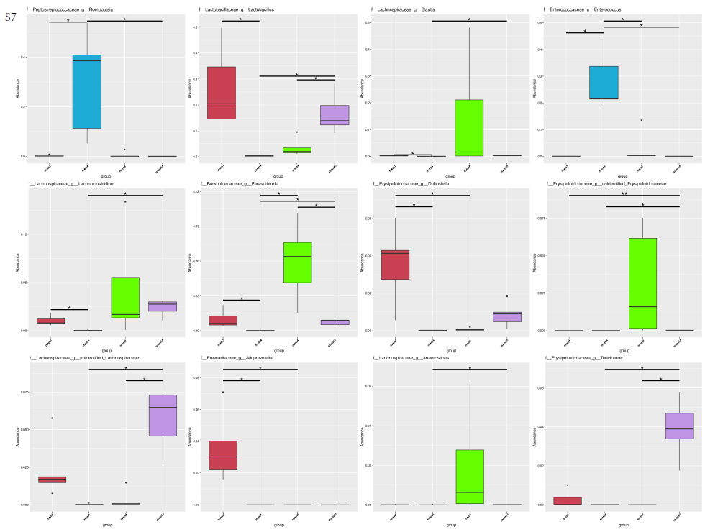
Abbreviation: MEM, meropenem.

Figure S8 Relative abundance of top 12 bacterial taxa in ATM group at genus level.
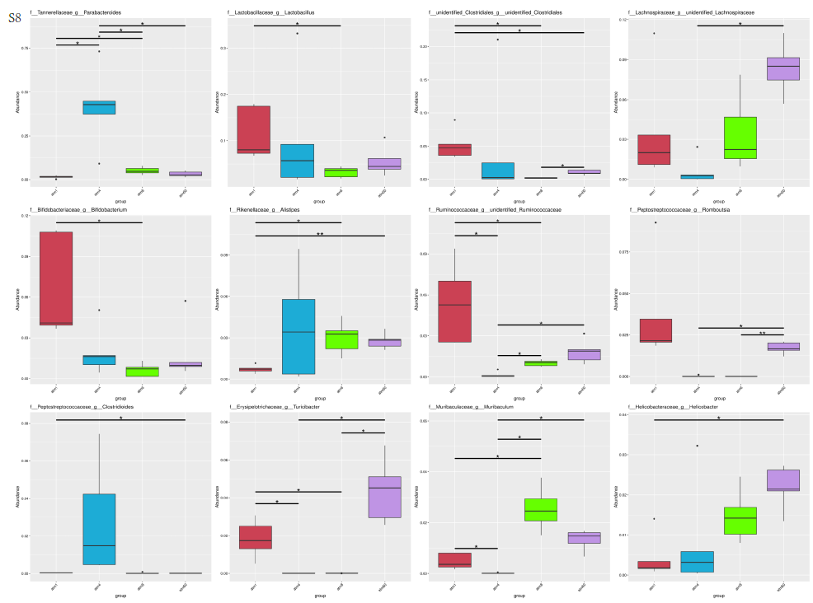
Abbreviation: ATM, aztreonam.

