Supplementary Table 1. Minimum, median and maximum values of insertion torque and resonance frequency for HAnano®, SLActive® and TiUnite® groups according to device/transducer.

Surfaces |  | Insertion torque |  |  |  | Osstell®/Smart Peg® |  |  |  | Penguin®/Multi Peg®
Surfaces |  | Minimum  (N/cm) | Median  (N/cm) | Maximum  (N/cm) |  | Minimum  (ISQ) | Median  (ISQ) | Maximum  (ISQ) |  | Minimum  (ISQ) | Median  (ISQ) | Maximum  (ISQ)
HAnano |  | 60 | 70 | 80 |  | 69 | 75 | 76 |  | 76 | 82 | 82 | *
SLActive |  | 60 | 80 | 80 |  | 74 | 77 | 79 |  | 83 | 86 | 89 | *
TiUnite |  | 60 | 80 | 80 |  | 69 | 80 | 80 |  | 82 | 87 | 88 | *

Abbreviations: SD (standard deviation); ISQ (implant stability coefficient); RFA (resonance frequency analysis).
(*) Significant difference vs. Osstell/Smart Peg.

Supplementary Table 2. Mean, standard deviation, minimum and maximum values of bone area fraction occupancy (BAFO) and bone-implant contact (BIC) for HAnano®, SLActive® and TiUnite® groups after 21- and 28-days post-implantation.

Period |  |  |  | BAFO (%) |  |  |  |  | Period |  |  | BIC (%)
(Days) | Group | Mean (n=5) |  |  | SD | Min | Max |  | (Days) | Group | Mean (n=5) |  |  | SD | Min | Max
14 | Nano HA | 47,96 |  |  | 5,377 | 43,12 | 57,14 |  | 14 | Nano HA | 66,09 |  |  | 13,12 | 51,43 | 77,99
 | SLActive | 44,49 |  |  | 9,024 | 30,91 | 56,04 |  |  | SLActive | 66,54 |  |  | 11,04 | 49,3 | 76,04
 | TiUnite | 41,5 |  |  | 2,694 | 38,18 | 45,44 |  |  | TiUnite | 61,34 |  |  | 7,278 | 53,26 | 69,2
28 | Nano HA | 65,53 | * |  | 6,227 | 59,69 | 72,75 |  | 28 | Nano HA | 82,27 | * |  | 3,381 | 76,81 | 85,2
 | SLActive | 62,56 | * |  | 7,898 | 51,3 | 73,56 |  |  | SLActive | 82,83 | * |  | 6,846 | 77,7 | 94,08
 | TiUnite | 55,68 | * |  | 5,827 | 48,78 | 63,6 |  |  | TiUnite | 80,46 | * |  | 10,04 | 70,59 | 93,11

Abbreviations: BAFO (bone area fraction occupancy); BIC (bone-implant contact); SD (standard deviation); Min (minimum); Max (maximum).
(*) Significant difference vs. the same group at previous experimental period.

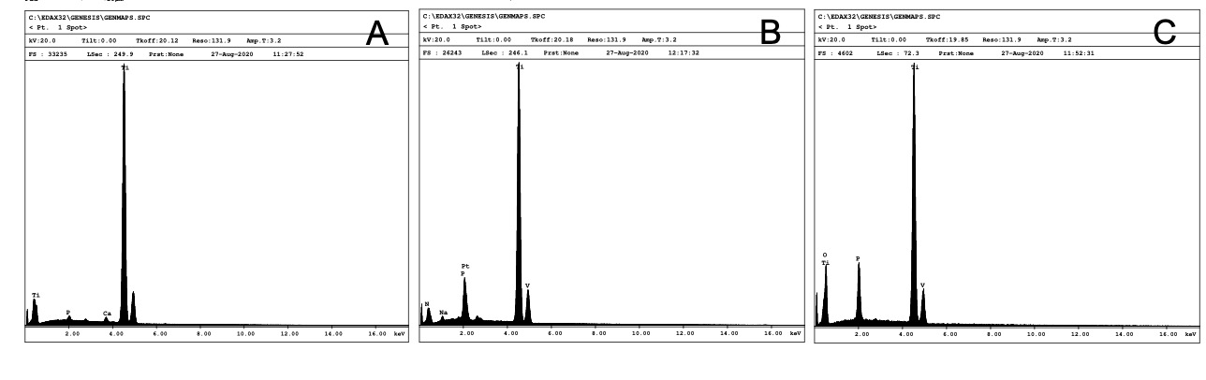
Supplementary Figure 1. Energy-dispersive spectroscopy revealed the presence of calcium only in the HAnano group (A) and that of sodium only in the SLActive® group (B). Titanium, vanadium, and phosphorus peaks were observed in all groups. A. HAnano; B. SLActive; C. TiUnite.

