APPENDIX to “Evaluating the Cost-effectiveness of Celecoxib versus Ibuprofen and Naproxen in Patients with Osteoarthritis in United Arab Emirates Based on the PRECISION Trial”

Table S1.Diagnosis codes queried in Dubai Administrative Billing Claims to obtain mean costs of AE management.
Outcomes | ICD10 | Description
Composite of serious GI events
Gastroduodenal hemorrhage/Gastroduodenal small or large bowel perforation | K25.0 | Acute gastric ulcer with hemorrhage
 | K25.1 | Acute gastric ulcer with perforation
 | K25.2 | Acute gastric ulcer with both hemorrhage and perforation
 | K25.3 | Acute gastric ulcer without hemorrhage or perforation
Symptomatic gastric or duodenal ulcer | K26.2 | Acute duodenal ulcer with both hemorrhage and perforation
 | K26.3 | Acute duodenal ulcer without hemorrhage or perforation
Gastric outlet obstruction | K31.1 | Adult hypertrophic pyloric stenosis (including "Gastric outlet obstruction")
Acute gastrointestinal hemorrhage | K92.2 | Gastrointestinal hemorrhage, unspecified
Iron-deficient anemia of GI origin | D50.9 | Iron deficiency anemia, unspecified
Composite of renal events
Hospitalization for acute renal failure | N17.8 | Other acute kidney failure
 | N17.9 | Acute kidney failure, unspecified
 | N10 | Acute pyelonephritis (including "Acute tubulo-interstitial nephritis")
Dialysis | Z49.01 | Encounter for fitting and adjustment of extracorporeal dialysis catheter
 | Z49.02 | Encounter for fitting and adjustment of peritoneal dialysis catheter
Composite of CV events
Hospitalization for congestive heart failure | I50.41 | Acute combined systolic (congestive) and diastolic (congestive) heart failure
 | I50.21 | Acute systolic (congestive) heart failure
 | I50.31 | Acute diastolic (congestive) heart failure
 | I50.9 | Heart failure, unspecified
Hospitalization for hypertension | I10 | Essential (primary) hypertension
 | I16.1 | Hypertensive emergency
Hospitalization for MI | I21.X | Available and considered ICD-10 CM codes in Dubai Claims Data for MI (I21.01, I21.02, I21.09, I21.11, I21.19, I21.21, I21.29, I21.3, I21.4)
Hospitalization for stroke | I63.9 | Cerebral infarction, unspecified
Hospitalization for unstable angina | I20.0 | Unstable angina
Hopsitalization for revascularization | I25.82 | Chronic total occlusion of coronary artery
 | I24.0 | Acute coronary thrombosis not resulting in myocardial infarction
Hospitalization for transient ischemic attack | G45.9 | Transient cerebral ischemic attack, unspecified

Table S2. Cumulative incidence of adverse events in the osteoarthritis arm in the PRECISION trial.
Month | Celecoxib |  |  |  | Ibuprofen |  |  |  | Naproxen
 | MACE | GI | Renal |  | MACE | GI | Renal |  | MACE | GI | Renal
1 | 0.207% | 0.055% | 0.014% |  | 0.112% | 0.014% | 0.070% |  | 0.112% | 0.042% | 0.014%
2 | 0.376% | 0.098% | 0.056% |  | 0.395% | 0.085% | 0.155% |  | 0.281% | 0.099% | 0.099%
3 | 0.547% | 0.112% | 0.070% |  | 0.568% | 0.157% | 0.285% |  | 0.411% | 0.170% | 0.142%
4 | 0.705% | 0.141% | 0.085% |  | 0.772% | 0.186% | 0.372% |  | 0.555% | 0.257% | 0.171%
5 | 0.807% | 0.184% | 0.128% |  | 0.964% | 0.289% | 0.431% |  | 0.775% | 0.257% | 0.186%
6 | 0.968% | 0.302% | 0.143% |  | 1.127% | 0.334% | 0.461% |  | 0.938% | 0.287% | 0.200%
7 | 1.115% | 0.316% | 0.143% |  | 1.306% | 0.364% | 0.490% |  | 1.072% | 0.376% | 0.260%
8 | 1.278% | 0.361% | 0.158% |  | 1.456% | 0.379% | 0.581% |  | 1.371% | 0.436% | 0.290%
9 | 1.458% | 0.406% | 0.188% |  | 1.714% | 0.470% | 0.581% |  | 1.492% | 0.557% | 0.320%
10 | 1.593% | 0.466% | 0.188% |  | 1.989% | 0.531% | 0.596% |  | 1.735% | 0.649% | 0.320%
11 | 1.699% | 0.527% | 0.203% |  | 2.189% | 0.655% | 0.596% |  | 1.827% | 0.725% | 0.366%
12 | 1.928% | 0.557% | 0.234% |  | 2.374% | 0.701% | 0.658% |  | 1.858% | 0.725% | 0.413%
13 | 2.097% | 0.604% | 0.326% |  | 2.654% | 0.780% | 0.689% |  | 1.982% | 0.834% | 0.459%
14 | 2.221% | 0.604% | 0.342% |  | 2.794% | 0.843% | 0.721% |  | 2.185% | 0.881% | 0.475%
15 | 2.409% | 0.619% | 0.357% |  | 2.999% | 0.922% | 0.721% |  | 2.373% | 0.928% | 0.475%
16 | 2.551% | 0.635% | 0.357% |  | 3.221% | 0.954% | 0.769% |  | 2.563% | 0.976% | 0.491%
17 | 2.708% | 0.635% | 0.389% |  | 3.396% | 0.986% | 0.801% |  | 2.816% | 0.992% | 0.507%
18 | 2.851% | 0.667% | 0.421% |  | 3.588% | 1.083% | 0.881% |  | 2.991% | 1.024% | 0.507%
19 | 2.948% | 0.716% | 0.469% |  | 3.767% | 1.149% | 0.947% |  | 3.201% | 1.138% | 0.555%
20 | 3.145% | 0.782% | 0.486% |  | 3.983% | 1.199% | 0.963% |  | 3.349% | 1.222% | 0.622%
21 | 3.245% | 0.782% | 0.486% |  | 4.169% | 1.233% | 0.997% |  | 3.552% | 1.273% | 0.673%
22 | 3.415% | 0.816% | 0.503% |  | 4.376% | 1.285% | 0.997% |  | 3.706% | 1.290% | 0.725%
23 | 3.553% | 0.885% | 0.538% |  | 4.499% | 1.338% | 1.015% |  | 3.880% | 1.326% | 0.759%
24 | 3.727% | 0.938% | 0.555% |  | 4.606% | 1.374% | 1.051% |  | 4.021% | 1.397% | 0.777%
25 | 3.923% | 1.011% | 0.573% |  | 4.789% | 1.466% | 1.143% |  | 4.201% | 1.452% | 0.850%
26 | 4.069% | 1.029% | 0.591% |  | 4.938% | 1.561% | 1.181% |  | 4.366% | 1.526% | 0.887%
27 | 4.199% | 1.104% | 0.647% |  | 5.071% | 1.638% | 1.200% |  | 4.441% | 1.583% | 0.887%
28 | 4.443% | 1.104% | 0.685% |  | 5.243% | 1.696% | 1.220% |  | 4.650% | 1.602% | 0.925%
29 | 4.557% | 1.161% | 0.685% |  | 5.359% | 1.814% | 1.259% |  | 4.880% | 1.641% | 0.964%
30 | 4.672% | 1.239% | 0.782% |  | 5.477% | 1.814% | 1.299% |  | 5.016% | 1.661% | 1.003%
Source: Data on file provided by the study sponsor.

Table S3. Age-specific background mortality for United Arab Emirates, 2015.
 | United Arab Emirates |  | Comparison to Unites States
 | 2015 | 2016 | 2015 | 2015
Age Group | Male | Female | Male | Female
15-19 years | 0.0007 | 0.0003 | 0.0007 | 0.0003
20-24 years | 0.0009 | 0.0004 | 0.0013 | 0.0005
25-29 years | 0.0009 | 0.0005 | 0.0015 | 0.0006
30-34 years | 0.0010 | 0.0006 | 0.0017 | 0.0009
35-39 years | 0.0013 | 0.0010 | 0.0020 | 0.0011
40-44 years | 0.0020 | 0.0016 | 0.0025 | 0.0016
45-49 years | 0.0032 | 0.0026 | 0.0037 | 0.0025
50-54 years | 0.0055 | 0.0042 | 0.0060 | 0.0039
55-59 years | 0.0093 | 0.0069 | 0.0092 | 0.0057
60-64 years | 0.0162 | 0.0112 | 0.0132 | 0.0079
65-69 years | 0.0265 | 0.0178 | 0.0186 | 0.0118
70-74 years | 0.0429 | 0.0289 | 0.0283 | 0.0189
75-79 years | 0.0683 | 0.0474 | 0.0419 | 0.0307
80-84 years | 0.1088 | 0.0804 | 0.0706 | 0.0529
85+ years | 0.2020 | 0.1771 | 0.1488 | 0.1325
Legend: Death was only a tertiary endpoint in the PRECISION trial with overall 1.73% of patients dying over the course of 34.1 months of average follow-up. As PRECISION was a trial conducted in 13 countries over 10 years, the background mortality is a mix of various countries and time periods. As eighty percent of the participants came from the United States, background mortality for UAE was compared to that of the United States in the table above.
Source: Life tables by country, World Health Organization¹

Table S4. Distributions and associated parameters used for probabilistic sensitivity analysis.
 |  |  |  | Mean estimate | Standard | Distribution | Alpha | Beta
Relative safety for Ibuprofen vs Celebrex |  |  |  | Mean estimate | Error
 | HR for MACE |  |  | 1.19 | 0.097 | Normal | 1.19 | 0.097
 | HR for Serious GI events |  |  | 1.47 | 0.219 | Normal | 1.47 | 0.219
 | HR for Renal events |  |  | 1.72 | 0.327 | Normal | 1.72 | 0.327
Relative safety for Naproxen vs Celebrex
 | HR for MACE |  |  | 1.06 | 0.087 | Beta | 1.06 | 0.087
 | HR for Serious GI events |  |  | 1.37 | 0.204 | Beta | 1.37 | 0.204
 | HR for Renal events |  |  | 1.3 | 0.255 | Beta | 1.3 | 0.255
Drug cost per month
 | Celebrex |  |  | $26.98 | $3.04 | Gamma | 78.9 | 0
 | Ibuprofen |  |  | $20.25 | $2.65 | Gamma | 58.23 | 0
 | Naproxen |  |  | $20.50 | $2.22 | Gamma | 85.03 | 0
Per event cost of Adverse Events
 | MACE |  |  | $6,834.73 | $1,366.95 | Gamma | 25 | 273
 | Serious GI events |  |  | $1,502.48 | $300.50 | Gamma | 25 | 60
 | Renal events |  |  | $2,436.09 | $487.22 | Gamma | 25 | 97
Post AE Annual costs
 | MACE |  |  | $683.47 | $136.69 | Gamma | 25 | 27
 | Serious GI events |  |  | $150.25 | $30.05 | Gamma | 25 | 6
 | Renal events |  |  | $243.61 | $48.72 | Gamma | 25 | 10
Excess Mortality (during AE event)
 | Celebrex MACE |  |  | 0.1037 | 0.01 | Beta | 89.52 | 773
 | Ibuprofen MACE |  |  | 0.1242 | 0.012 | Beta | 87.46 | 617
 | Naproxen MACE |  |  | 0.1446 | 0.014 | Beta | 85.4 | 505
 | Serious GI events |  |  | 0.0138 | 0.001 | Beta | 98.6 | 7,039
 | Renal events |  |  | 0.0581 | 0.006 | Beta | 94.13 | 1,526
Excess Mortality (after AE event)
 | MACE |  |  | 0.0344 | 0.0034 | Beta | 96.53 | 2,711
 | Serious GI events |  |  | 0.0036 | 0.0004 | Beta | 99.64 | 27,917
 | Renal events |  |  | 0.0373 | 0.0037 | Beta | 96.23 | 2,485
Utility weight (during AE event)
 | MACE |  |  | 0.618 | 0.124 | Beta | 8.92 | 6
 | Serious GI events |  |  | 0.692 | 0.138 | Beta | 7.01 | 3
 | Renal events |  |  | 0.41 | 0.082 | Beta | 14.35 | 21
Utility weight (after AE event)
 | MACE |  |  | 0.844 | 0.169 | Beta | 3.07 | 1
 | Serious GI events |  |  | 0.989 | 0.01 | Gamma | 10,000.00 | 0
 | Renal events |  |  | 0.785 | 0.157 | Gamma | 25 | 0
Discount % Costs |  |  |  | 3.00% | 0.60% | Beta | 24.22 | 783
Discount % Effects |  |  |  | 3.00% | 0.60% | Beta | 24.22 | 783

Figure S1. Probabilistic sensitivity analyses for celecoxib versus ibuprofen: cost-effectiveness plane (top) and cost-effectiveness acceptability curve (bottom).
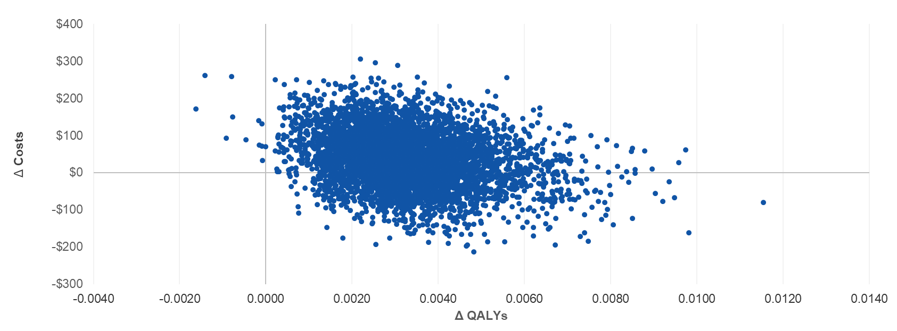
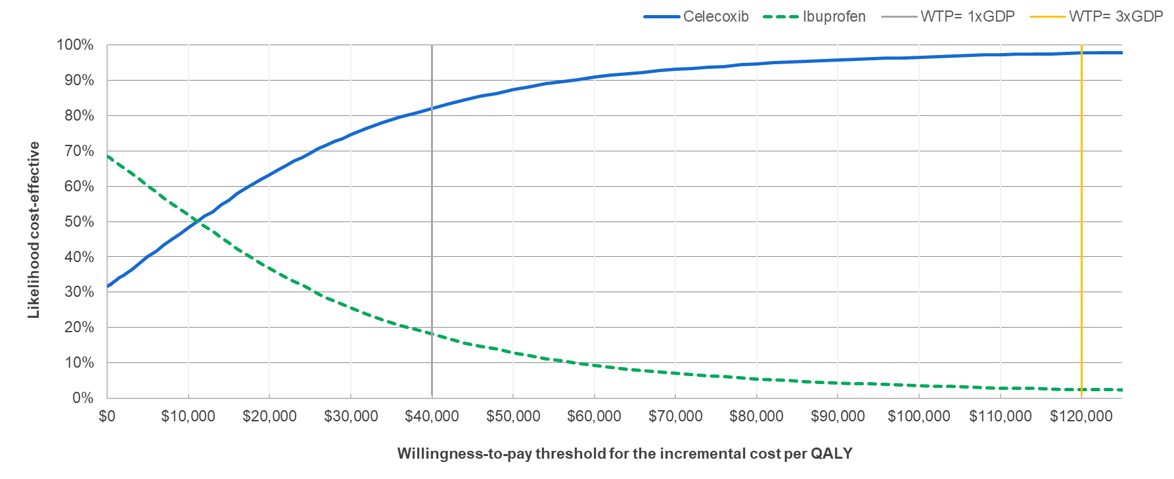
Figure S2. Probabilistic sensitivity analyses for celecoxib versus naproxen: cost-effectiveness plane (top) and cost-effectiveness acceptability curve (bottom).
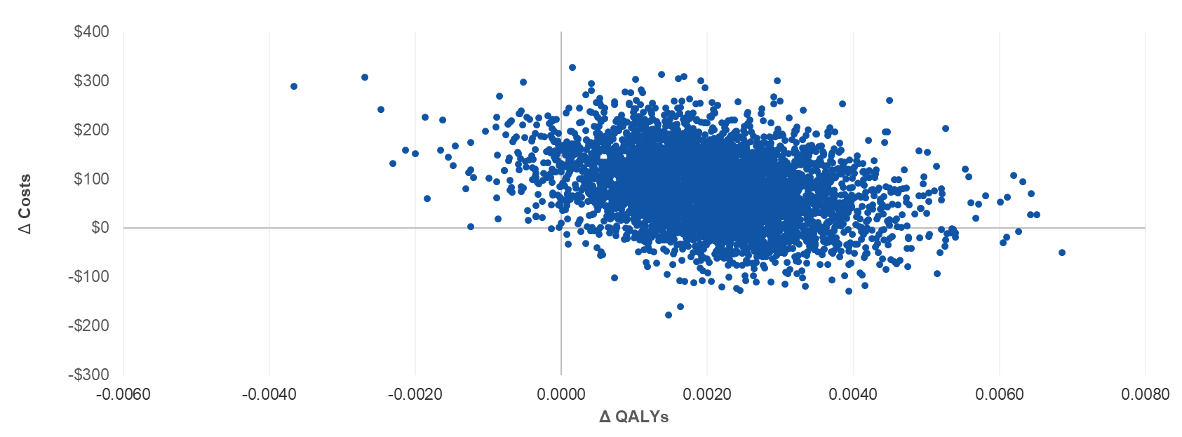
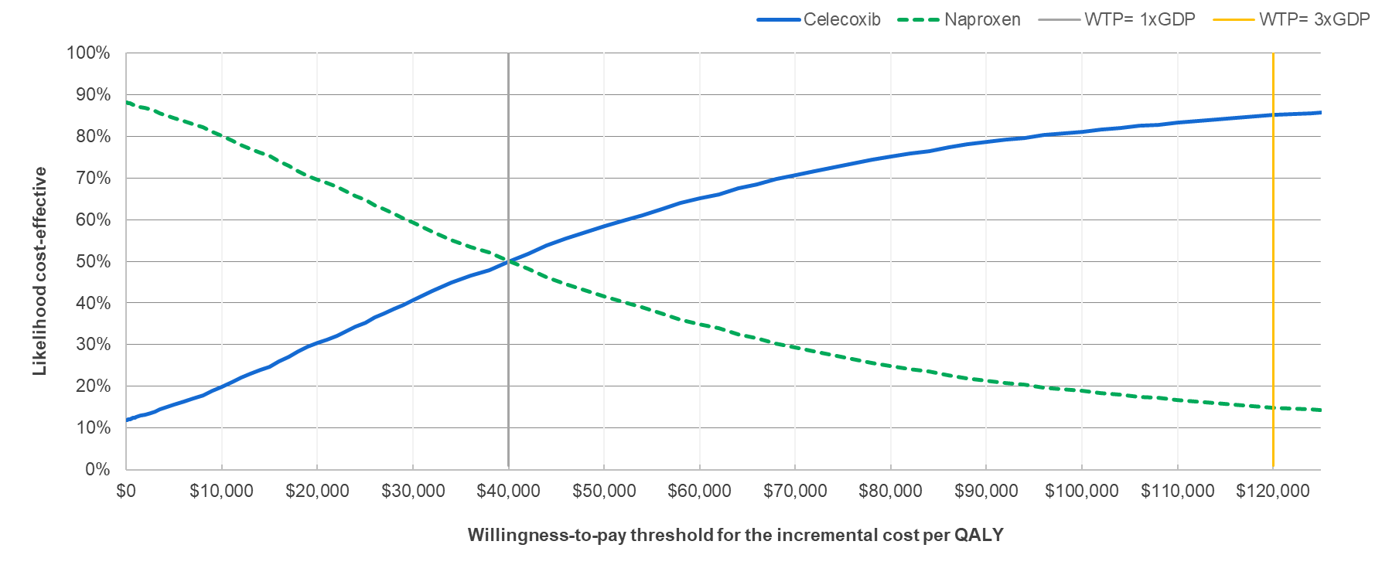

REFERENCES

1. World Health Organization. Global Health Observatory data repository. Mortality and global health estimates. Life tables. Accessed August 21, 2020. https://apps.who.int/gho/data/view.main.LT62250?lang=en

