Supplementary Material S1. Figure S1. Study population and composition of derivation cohort and validation cohort. CGA, comprehensive geriatric assessment; eSPPB, electronic Short Physical Performance Battery, CGA
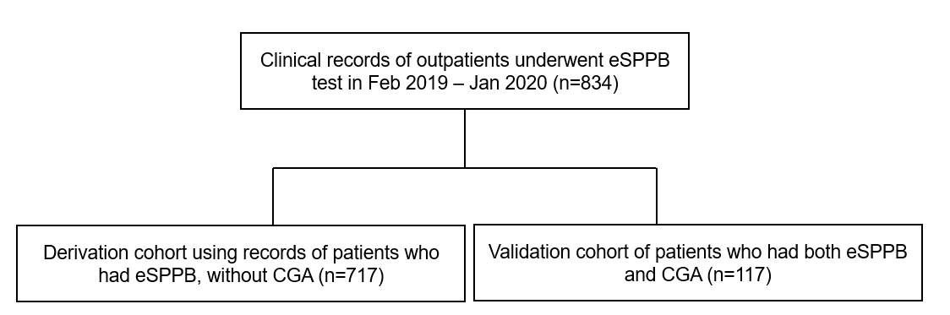

Supplementary Material S2. Table S1. Composition of frailty index from comprehensive geriatric assessment in this study.
Hypertension | Problems in dressing
Diabetes mellitus | Difficulties in washing
Chronic kidney disease | Difficulties in bathing
Atrial fibrillation | Problems in eating
Angina pectoris | Problems in moving in home
History of myocardial infarction | Toileting problems
Congestive heart failure | Difficulties in using phone
Peripheral artery disease | Problems in buying groceries
Chronic obstructive pulmonary disease | Needs help in transportation
Cerebral artery disease | Needs help in managing medications
History of stroke | Difficulties in managing finances
Dementia | Problems in preparing foods
Sensory impairment | Problems in performing basic household chores
Depression | Problems in washing clothes
Antxiety disorder | Difficult to perform stooping, crouching, or kneeling
Malignant disease | Difficult to lift or carry objects as heavy as 10 pounds
Arthritis | Difficult to write or handle and grasp small objects
Spinal disease | Difficult to walk for 400 meters
Asthma | Difficult to reach or extend arms above shoulder level
Fall history in previous 1 year | Help needed to do heavy work around the house,
Polypharmacy (5 or more medications) | Help needed to walk up and downstairs
Weight loss > 4.5kg for previous 1 year | Help needed to walk half a mile
MMSE score (0.25 for 21-24, 0.5 for 18-20, 1 for 0-17)

