Supplementary Material

ORIGINAL RESEARCH

Milanesi et al.

Distinctive under-expression profile of inflammatory and redox genes in the blood of elderly patients with cardiovascular disease
Elena Milanesi¹, Gina Manda¹, Maria Dobre¹, Elena Codrici¹, Ionela V. Neagoe¹, Bogdan O. Popescu^{1,2,3}, Ovidiu A. Bajenaru^{†2,4}, Luiza Spiru^{2,5}, Catalina Tudose^{2,6}, Gabriel I. Prada^{2,7}, Eugenia I. Davidescu^{2,3}, Gerard Piñol-Ripoll⁸, Antonio Cuadrado^{1,9,10,11,12}

¹ “Victor Babes” National Institute of Pathology, Bucharest 050096, Romania; ² “Carol Davila” University of Medicine and Pharmacy, Bucharest 020021, Romania; ³ Neurology Department, Clinical Hospital Colentina, Bucharest 020125, Romania; ⁴ University Emergency Hospital, Bucharest 050098, Romania; ⁵ “Ana Aslan” International Foundation, Excellence Center for Memory Diseases and Longevity Medicine, Bucharest 050064, Romania; ⁶ "Prof. Dr. Al. Obregia" Psychiatry Clinical Hospital & The Memory Center of the Romanian Alzheimer Society, Bucharest 041914, Romania; ⁷ “Ana Aslan” National Institute of Gerontology and Geriatrics, Bucharest 011241, Romania; ⁸ Unitat Trastons Cognitius, Hospital Universitari Santa Maria-IRBLLeida, Lleida 25198, Spain; ⁹ Instituto de Investigaciones Biomédicas "Alberto Sols" UAM-CSIC, Madrid 28029, Spain; ¹⁰ Department of Biochemistry, Faculty of Medicine, Autonomous University of Madrid, Madrid 28049, Spain; ¹¹ Instituto de Investigación Sanitaria La Paz (IdiPaz), Madrid 28046, Spain; ¹² Centro de Investigación Biomédica en Red Sobre Enfermedades Neurodegenerativas (CIBERNED), ISCIII, Madrid 28031, Spain. † Prof. Ovidiu A. Bajenaru passed away on 03.09.2020.

Correspondence:
Gina Manda
“Victor Babes” National Institute of Pathology, 99-101 Splaiul Independentei, 050096 Bucharest, Romania
Tel: +40 744246887
Fax: +40 21 3194528
Email: gina.manda@gmail.com

Antonio Cuadrado
Instituto de Investigaciones Biomédicas "Alberto Sols" UAM-CSIC, C/ Arturo Duperier 4
28029 Madrid, Spain
Tel: +34 638 29 65 85
Fax: +34 915 85 44 01
Email: antonio.cuadrado@uam.es

Supplementary Table 1 Genes involved in inflammation (RT² Profiler™ PCR Array Human NFkB Signaling Pathway (PAHS-025Z, Qiagen) and redox metabolism (RT² Profiler™ PCR Array Human Oxidative Stress Plus (PAHS-065Y, Qiagen)
Ligands and receptors: CD40 (TNFRSF5), CD83, EGFR, FASLG (TNFSF6), IL10, IL1A, IL1B, IL1R1, IL8, LTBR, NOD1 (CARD4), TLR1, TLR2, TLR3, TLR4, TLR6, TLR9, TNF, TNFRSF1A, TNFRSF10A, TNFRSF10B, TNFSF10.
Downstream signalling: BIRC2 (c-IAP2), FADD, IRAK1, IRAK2, IRF1, MYD88, RIPK1, TBK1, TICAM1 (TRIF), TNFAIP3, TRADD, TRAF2, TRAF3, TRAF6.
Cytoplasmic sequestering/releasing of NF-κB: BCL3, CHUK (IKKa), IKBKB, IKBKG, NFKBIA, NFKBIE.
Transcription factors: NFKB1, NFKB2, REL, RELA, RELB.
General immune response: CCL2 (MCP-1), CCL5 (RANTES), CSF1 (MCSF), CSF2 (GM-CSF), CSF3 (GCSF), ICAM1, IFNA1, IFNG, IL8, LTA (TNFB), TNF.
Apoptosis: AGT, BCL2A1 (BCL-X), BCL2L1, BIRC3 (c-IAP1).
Other factors involved in the NF-κB pathway:
Kinases: AKT1, MAP3K1, RAF1.
Transcription factors: ATF1, EGR1, ELK1, FOS, JUN, STAT1.
Other genes: CARD11, CASP1 (ICE), CASP8, CFLAR (CASPER), HMOX1, MALT1, PSIP1, RHOA, TIMP1.
Pathway Activity Signature Genes: BIRC3, CCL20, CD83, CXCL2, CXCL3, ICAM1, IL8, IRF1, NF-KB1, NF-KBIA, NF-KBIE, STX11, TIFA, TNF, TNFAIP2, TNFAIP3.
Endogenous antioxidant systems:
Glutathione peroxidases: GPX1, GPX2, GPX3, GPX4, GPX5, GSTP1, GSTZ1.
Peroxiredoxins: PRDX1, PRDX2, PRDX3, PRDX4, PRDX5, PRDX6 (AOP2).
Other Peroxidases: CAT, CYBB, CYGB, DUOX1, DUOX2, EPX, LPO, MPO, PTGS1, PTGS2 (COX2), TPO, TTN.
Other antioxidants: ALB, APOE, GSR, MT3, VIMP, SOD1, SOD3, SRXN1, TXNRD1, TXNRD2.
Metabolism of reactive oxygen species:
Superoxide dismutases: SOD1, SOD2, SOD3.
Other genes involved in superoxide metabolism: ALOX12, CCS, DUOX1, DUOX2, MT3, NCF1, NCF2, NOS2 (iNOS), NOX4, NOX5, UCP2.
Other genes involved in ROS metabolism: AOX1, BNIP3, EPHX2, MPV17, SFTPD.
Oxidative stress responsive genes: APOE, ATOX1, CAT, CCL5 (RANTES), CYGB, DHCR24, DUOX1, DUOX2, DUSP1 (PTPN16), EPX, FOXM1, FTH1, GCLC, GCLM, GPX1, GPX2, GPX3, GPX4, GPX5, GSR, GSS, HMOX1, HSPA1A, KRT1, LPO, MBL2, MPO, MSRA, NQO1, NUDT1, PDLIM1, PRDX2, PRDX5, PRDX6 (AOP2), PRNP, RNF7, VIMP, SEPP1, SIRT2, SOD1, SOD2, SQSTM1, SRXN1, TPO, TTN, TXN, TXNRD1, TXNRD2.
Oxygen transporters: CYGB, MB.
Pathway activity signature genes: AKR1C2, BAG2, FHL2, GCLM, GLA, HMOX1, HSP90AA1, LHPP, NCOA7, NQO1, PTGR1, SLC7A11, SPINK1, TRAPPC6A, TXN, TXNRD1.
Supplementary Table 2 Cardiovascular markers in the serum of a sub-group of elderly subjects (24 CVD patients and 22 controls), assessed by protein multiplexing using the MILLIPLEX MAP Human Cardiovascular Disease (CVD) Magnetic Bead Panel 1 (Merck Millipore) on the Luminex 200 equipment. Results are presented as mean concentration ± standard error of the mean (SEM). The Mann-Whitney U test was used for comparisons between groups

Serum cardiovascular markers |  | CVD patients (n=24) |  | Controls (n=22) |  | p-value
Abbreviation | Molecule | Mean concentration (pg/mL) | SEM | Mean concentration  (pg/mL) | SEM | p-value
CK_MB | Creatinine kinase - MB isoenzyme¹ | 6462.9 | 920.3 | 6255.9 | 1123.4 | 0.717
TROPONIN1 | Troponine² | 22.2 | 13.1 | 142.4 | 133.7 | 0.647
CXCL6 | CXC chemokine (granulocyte chemotactic protein 2)³ | 195.0 | 14.7 | 200.2 | 12.2 | 0.468
CXCL16 | CXC chemokine^{4,5} | 367.0 | 41.2 | 355.6 | 24.2 | 0.509
Endocan1 | Endothelial cell-specific molecule-1^{6,7} | 1240.1 | 83.4 | 1145.8 | 101.0 | 0.312
FABP3 | Fatty acid-binding proteins⁸ | 3992.4 | 466.2 | 3196.0 | 231.7 | 0.281
FABP4 | Fatty acid-binding proteins⁸ | 12257.4 | 1431.5 | 12536.2 | 1664.3 | 0.852
PGF | Placental growth factor⁹ | 6.2 | 1.3 | 4.4 | 1.3 | 0.215
OSM | Oncostatin M¹⁰ | 13.9 | 5.5 | 15.7 | 6.2 | 0.454

Supplementary Table 3 Gene expression changes in the blood of elderly patients with various co-morbidities: CVD, hypertension (HT), dyslipidemia (DL), out of which hypercholesterolemia (HC) and type 2 diabetes mellitus (T2DM), as compared to the corresponding controls (C). Results are expressed as Fold of Regulation (FR) as follows: when the fold of change value was above 1, FR was equal to FC, and results were reported as fold up-regulation; when the FC value was less than 1, FR was expressed as the negative inverse of FC, and results were reported as fold down-regulation. The table is based on particular genes that were found down-regulated in CVD patients (absolute value of FR>1.8 and p<0.005, marked in bold), and their FR values in other comorbidities (marked in grey if 1.5<FR<1.8 and p<0.05)
 | CVD (N=39) vs  C (N=91) |  | HT (N=74) vs  C (N=56) |  | DL (N=46) vs  C (N=84) |  | HC (N=33) vs  C (N=97) |  | T2DM (N=21) vs  C (N=109)
Genes | FR | p | FR | p | FR | p | FR | p | FR | p
Inflammatory genes
NFKB2 | -2.28 | < 0.001 | -1.02 | 0.810 | 1.25 | 0.804 | 1.62 | 0.115 | 1.61 | 0.202
NFKBIA | -2.20 | < 0.001 | 1.10 | 0.914 | -1.01 | 0.930 | 1.25 | 0.051 | 1.85 | 0.546
RELA | -1.92 | < 0.001 | -1.09 | 0.504 | 1.05 | 0.700 | 1.29 | 0.138 | 1.28 | 0.187
RELB | -2.95 | < 0.001 | 1.16 | 0.501 | -1.04 | 0.386 | 1.24 | 0.332 | 1.50 | 0.156
AKT1 | -1.87 | < 0.001 | 1.05 | 0.825 | 1.12 | 0.690 | 1.39 | 0.033 | 1.31 | 0.194
IRF1 | -1.93 | < 0.001 | 1.13 | 0.452 | 1.32 | 0.450 | 1.63 | 0.037 | 1.58 | 0.109
STAT1 | -1.89 | < 0.001 | -1.08 | 0.689 | 1.22 | 0.658 | 1.49 | 0.037 | 1.16 | 0.730
CD40 | -2.47 | < 0.001 | -1.12 | 0.441 | 1.08 | 0.984 | 1.41 | 0.073 | 1.35 | 0.405
LTA | -2.17 | < 0.001 | 1.21 | 0.544 | 1.54 | 0.744 | 1.95 | 0.573 | 2.16 | 0.485
TRAF2 | -1.97 | < 0.001 | -1.11 | 0.568 | 1.31 | 0.630 | 1.64 | 0.049 | 1.57 | 0.402
PTGS1 | -2.16 | <0.001 | 1.16 | 0.798 | 1.02 | 0.869 | 1.24 | 0.156 | 1.14 | 0.674
ALOX12 | -1.88 | <0.001 | 1.05 | 0.983 | -1.02 | 0.763 | 1.15 | 0.217 | 1.10 | 0.837
Redox genes
DUOX1 | -2.43 | <0.001 | 1.12 | 0.724 | 1.04 | 0.957 | 1.31 | 0.101 | 1.11 | 0.778
DUOX2 | -2.20 | <0.001 | 1.05 | 0.976 | 1.16 | 0.695 | 1.40 | 0.103 | 1.16 | 0.771
MPO | -1.85 | 0.002 | 1.16 | 0.871 | 1.16 | 0.804 | 1.20 | 0.443 | 1.19 | 0.107
GSR | -1.87 | 0.003 | 1.02 | 0.679 | 1.26 | 0.268 | 1.51 | 0.019 | 1.68 | 0.014
TXNRD2 | -2.02 | <0.001 | 1.01 | 0.957 | 1.04 | 0.963 | 1.32 | 0.065 | 1.06 | 0.724
HSPA1A | -2.83 | <0.001 | 1.07 | 0.869 | -1.27 | 0.644 | -1.04 | 0.182 | 1.54 | 0.515
MSRA | -1.96 | <0.001 | -1.10 | 0.554 | -1.02 | 0.779 | 1.11 | 0.153 | 1.29 | 0.407
PDLIM1 | -1.95 | <0.001 | -1.01 | 0.849 | -1.16 | 0.089 | 1.04 | 0.906 | 1.13 | 0.402

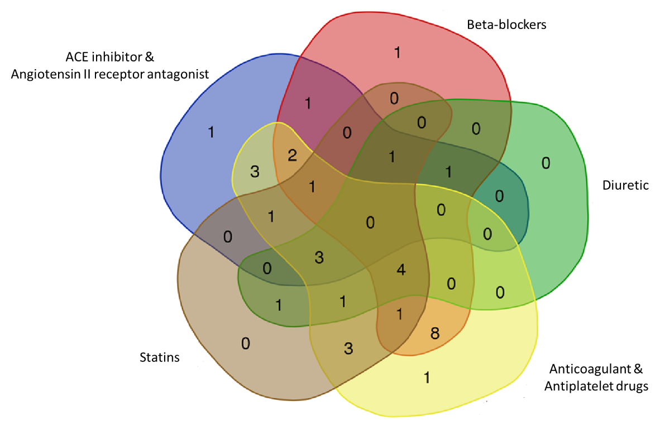
Supplementary Figure 1 Polyvalent medication in the group of CVD patients, presented as Venn diagram showing the drug combinations of the main represented drug classes

References
1. Nordlander R. Enzymes in acute myocardial infarction. Diagnosis with special reference to creatine kinase MB isoenzyme. Acta Med Scand. 2009;205(S623):18-26. doi:10.1111/j.0954-6820.1979.tb00693.x
2. Sharma S. Cardiac troponins. J Clin Pathol. 2004;57(10):1025-1026. doi:10.1136/jcp.2003.015420
3. Torán JL, Aguilar S, López JA, et al. CXCL6 is an important paracrine factor in the pro-angiogenic human cardiac progenitor-like cell secretome. Sci Rep. 2017;7(1):12490. doi:10.1038/s41598-017-11976-6
4. Borst O, Schaub M, Walker B, et al. CXCL16 is a novel diagnostic marker and predictor of mortality in inflammatory cardiomyopathy and heart failure. Int J Cardiol. 2014;176(3):896-903. doi:10.1016/j.ijcard.2014.08.033
5. Borst O, Münzer P, Gatidis S, et al. The Inflammatory Chemokine CXC Motif Ligand 16 Triggers Platelet Activation and Adhesion Via CXC Motif Receptor 6–Dependent Phosphatidylinositide 3-Kinase/Akt Signaling. Circ Res. 2012;111(10):1297-1307. doi:10.1161/CIRCRESAHA.112.276444
6. Zhao T, Kecheng Y, Zhao X, et al. The higher serum endocan levels may be a risk factor for the onset of cardiovascular disease. Medicine (Baltimore). 2018;97(49):e13407. doi:10.1097/MD.0000000000013407
7. Kosir G, Jug B, Novakovic M, Mijovski MB, Ksela J. Endocan Is an Independent Predictor of Heart Failure-Related Mortality and Hospitalizations in Patients with Chronic Stable Heart Failure. Dis Markers. 2019;2019:1-7. doi:10.1155/2019/9134096
8. Furuhashi M. Fatty Acid-Binding Protein 4 in Cardiovascular and Metabolic Diseases. J Atheroscler Thromb. 2019;26(3):216-232. doi:10.5551/jat.48710
9. Lenderink T, Heeschen C, Fichtlscherer S, et al. Elevated Placental Growth Factor Levels Are Associated With Adverse Outcomes at Four-Year Follow-Up in Patients With Acute Coronary Syndromes. J Am Coll Cardiol. 2006;47(2):307-311. doi:10.1016/j.jacc.2005.08.063
10. Sun D, Li S, Wu H, et al. Oncostatin M (OSM) protects against cardiac ischaemia/reperfusion injury in diabetic mice by regulating apoptosis, mitochondrial biogenesis and insulin sensitivity. J Cell Mol Med. 2015;19(6):1296-1307. doi:10.1111/jcmm.12501

