SUPPLEMENTARY DATA
a.
b.
c.
Supplementary figure 1. Detection of PRpSer400, PKCα and their colocalization in astrocytomas between sexes. % of positive cells for PR (a) for PKCα (b) and their colocalization PR/PKCα (c). For each sample, 25 fields were taken. Results are expressed as the mean ± SD. Dunnet post-test determined the statistical difference (* p ≤ 0.05 vs NT and & p ≤ 0.05 vs all groups). F: Female, M: male, NT: Non-Tumor, G: astrocytoma grade.
a.
b.
c.

Supplementary figure 2. Spearman correlation between astrocytomas grades and the age of patients according to detection of PR, PKCα and PR/PKCα colocalization. % of positive cells for PR (a), for PKC α (b) and their colocalization (c). Black circles: GI and GII; blue triangles: GIII; red squares: GIV.

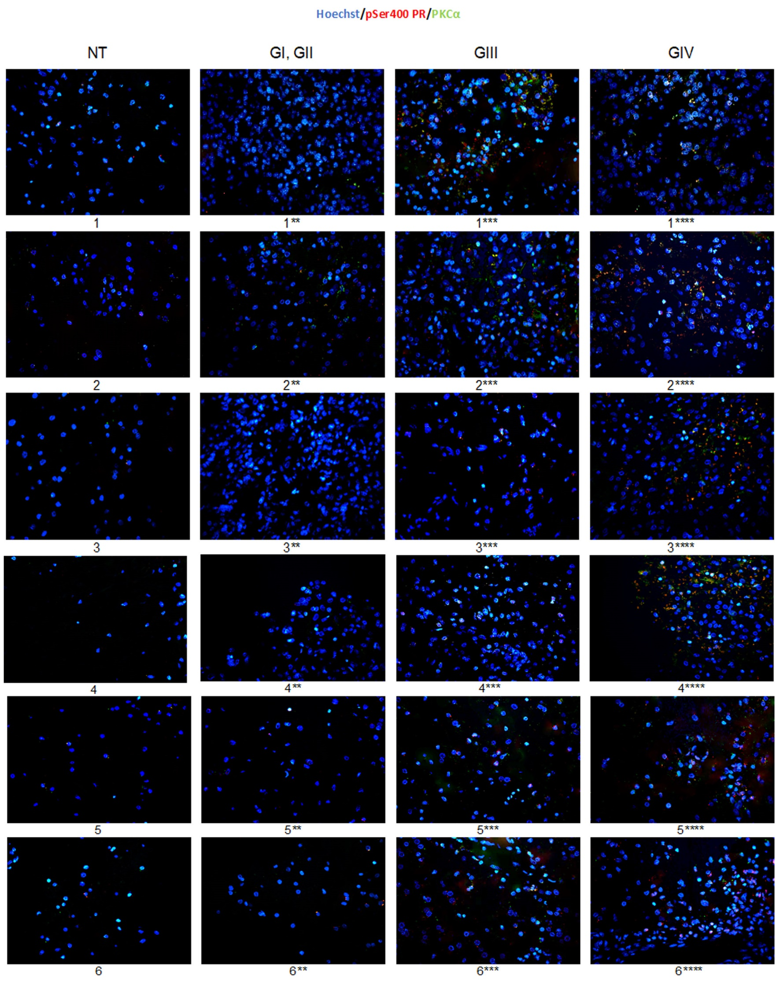

Supplementary Figure 3. Representative images of PR pSer400 and PKCα colocalization in each patient with different grades of astrocytoma. Representative sections of astrocytic tumors from each patient are shown (6 patients for each astrocytoma grade including non-tumor) NT: Non-tumor tissue, G: astrocytomas grade. Samples were immunostained for PR pSer400 and PKCα. Blue: nucleus, green: PKCα, red: PR pSer400 and orange: merge between three channels (original magnification, 600X). Asteriscs represent patients with different astrocytoma grade; numbers without asterisk represent subjects with no tumor.

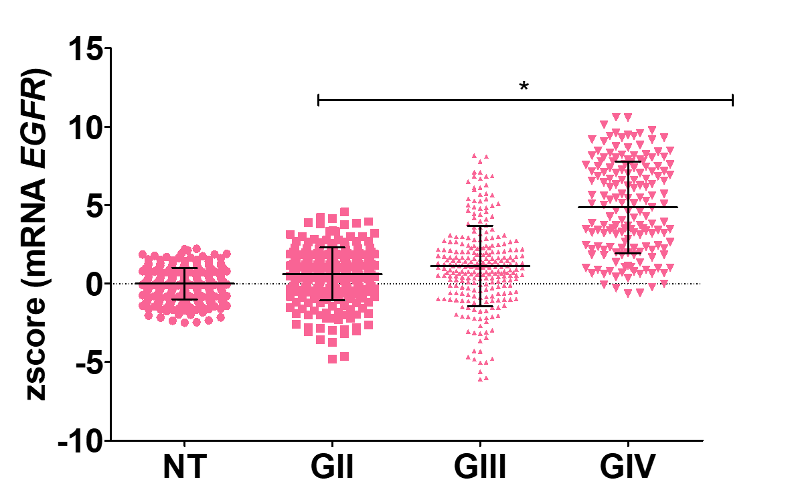

Supplementary Figure 4. Expression of mRNA for EGFR. Results are expressed as the mean ± SD. Dunnet post-test determined the statistical difference (* p ≤ 0.005 vs NT). NT: Non-Tumor, G: astrocytomas grade.

b.
a.
Supplementary figure 5. mRNA for PGR and PRKCA levels of astrocytomas grades between sexes. mRNA levels for PGR (a) and PRKCA (b) between sexes. Results are expressed as the mean ± SD. Dunnet post-test determined the statistical difference. F: female, M: male, NT: Non-Tumor, G: astrocytoma grade.
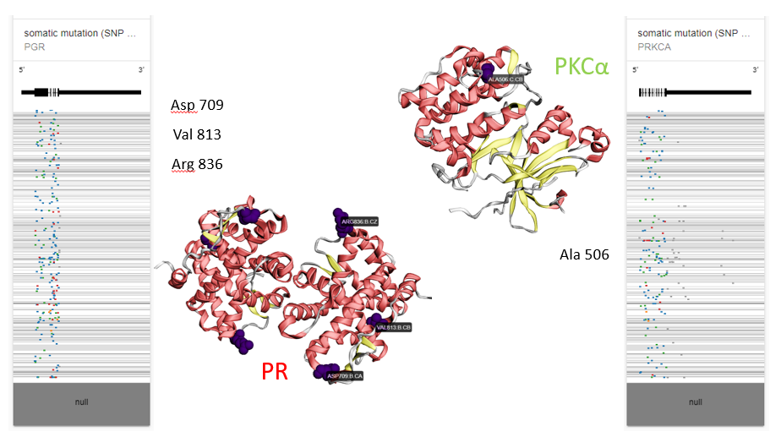
Supplementary figure 6. Mutations at protein level. In silico analysis using TCGA data for GBM mutations, PR (left) and PKCα (right). https://xenabrowser.net/heatmap/ MuPTI (hg19 coding)

