Supplementary Materials for the study:

Validation of the Summit Lab Score in Predicting Exacerbations of Chronic Obstructive Pulmonary Disease Among Individuals With High Arterial Stiffness

Benjamin D. Horne, PhD, MStat, MPH^{1,2}; Rehan Ali, MSc³; Dawn Midwinter, MSc³; Catherine Scott-Wilson, BA⁴; Courtney Crim, MD⁴; Bruce E. Miller, PhD⁵; David B. Rubin, MD⁴*

Affiliations: ¹Intermountain Medical Center Heart Institute, Salt Lake City, Utah, USA; ²Division of Cardiovascular Medicine, Department of Medicine, Stanford University, Stanford, CA, USA; ³GlaxoSmithKline plc., Stockley Park, Uxbridge, UK; ⁴GlaxoSmithKline plc., Research Triangle Park, Raleigh, North Carolina, USA; ⁵GlaxoSmithKline plc., Collegeville, Pennsylvania, USA.
*At the time of manuscript development; no longer affiliated with GlaxoSmithKline plc.

Supplemental Methods
The Summit Lab Score was calculated using previously-derived models using the following variables: baseline body mass index, number of pack years of smoking history, number of prior COPD hospitalizations, baseline FEV₁, baseline heart rate, baseline systolic blood pressure, history of prior MI, prior HF diagnosis, prior diabetes diagnosis, age at baseline, and baseline prescription of antithrombotics, antiarrhythmics, and xanthines. Further details are available in the derivation publication.¹⁴ IMRS was also previously derived and repeatedly validated using sex-specific models with the following predictors: baseline age, baseline complete blood count parameters (i.e., hematocrit, white blood cell count, platelet count, MCV, RDW, mean corpuscular hemoglobin concentration, and mean platelet volume), and baseline basic metabolic profile (i.e., sodium, potassium, calcium, bicarbonate, glucose, and creatinine).¹³ A free online calculator is available for use to compute IMRS and a combined calculator to compute the Summit Score or the Summit Lab Score, which can be found by clicking on the “Summit Risk Score Calculator” button on this website: https://intermountainhealthcare.org/about/transforming-healthcare/innovation/intermountain-risk-scores/.

Supplemental Results
When patients were grouped by tertiles of IMRS, Kaplan−Meier rates of freedom from moderate-to-severe AECOPD were 92.9%, 91.2%, and 88.3% for tertiles 1, 2, and 3, respectively (P trend = 0.141) (Supplemental Figure S1). The HR for each tertile was 1.35 (0.90, 2.00) and the HR of tertile 3 vs tertile 1 and tertile 2 combined was not statistically significant (HR 1.48; 95% CI: 0.80, 2.75; P = 0.21). Likewise, the respective rates of freedom from a first CV event were 96.1%, 93.9%, and 94.2% (P trend = 0.42) (Supplemental Figure S2); with a HR of 1.23 (95% CI: 0.74, 2.07) per tertile.

Supplemental Table S1. LIST OF INVESTIGATORS AND IECS/IRBS FOR HZC113108
Investigator | Description of Research Facility, Hospital/ Institution, and Address
Germany
Eich, Andreas. Dr. med.* | Institut fuer klinische Forschung Pneumologie GmbH & Co. KG, Stresemannallee3, Frankfurt, Hessen, 60596, Germany
Hagenow, Andreas. Dr. med | Zentrum fuer Klinische Studien, Suedbrandenburg GmbH, Ross Strasse 5, Elsterwerda, Brandenburg, 049140, Germany
Heymer, Peter. Dr. med.  Witczak, Elke (FPI) | Klinische Forschung Dresden GmbH, Prager Strasse 10, Dresden, Sachsen, 01069, Germany
Illies, Gabriele | SMO. MD, Zentrum fuer Klinische Studien , Bahrendorfer Strasse 19-20, Magdeburg, Sachsen-Anhalt, 39112, Germany
Linnhoff, Anneliese E. Dr. med.* | Praxis Dr. med. Anneliese Linnhoff, Hohenzollerndamm 2, Berlin, Berlin, 10717, Germany
Ludwig-Sengpiel, Andrea. Dr. med. | KLB Gesundheitsforschung Luebeck GmbH, Pferdemarkt 6-8, Luebeck, Schleswig-Holstein, 23552, Germany
Nischik, Ruth. Dr. med. | Studienambulanz, Medamed GmbH, Friedrich-Ebert-Strasse 33, Leipzig, Sachsen, 04109, Germany
Schenkenberger, Isabelle. MD | KFB-Klinsche Forschung Berlin, Ansbacher Strasse 17-19, Berlin, Berlin, 10787, Germany
Thron, Andrea. Dr. Med., MD  Mindt, Susanne. Dr. Med., MD (FPI)  Zemke, Katrin. MD (FPI) | Klinische Forschung Hamburg, Hoheluftchaussee 18, Hamburg, Hamburg, 20253, Germany
Tyler, Kerstin  Schaper, Lennart (FPI) | Polikum Friedenau MVZ, Marburger Strasse 12-13, Berlin, Berlin, 10789, Germany
Zachgo, Wolfgang. Dr. Med., MD* | Pneumologisches Forschungsinstitut Hohegeest GbR, Norderstrasse 12, Geesthacht, Schleswig-Holstein, 21502, Germany
Korea
Kim, Je-Hyeong. MD, PhD* | Korea University Ansan Hospital, Division of Pulmonary, Sleep and Critical Care Medicine, Department of Internal Medicine, 516, Gojan-1-dong, Danwon-gu, Ansan 425-707, Korea
Lee, ByoungJun  Roh, Yong-Ho. MD, PhD (FPI) | Seoul Veterans Hospital, Internal Medicine, 6-2 Dunchon-dong Gangdong-gu, Seoul, 134060, Korea
Lee, Sang Haak. MD, PhD | Catholic University of Korea - St.Paul's Hospital, Department of Internal Medicine, 620-56 Jeonnong-2 dong, Dongdaemun-gu, Seoul, 137-709, Korea
Lee, Sung-Soon. MD, PhD* | Inje University College of Medicine, ilsan paik hospital, Department of Internal Medicine,  2240, daehwa-dong, ilsanseo-gu, goyang-si, gyeonggi-do, 411706,  Korea
Lee, Young-Min. MD, PhD* | Inje University Pusan Paik Hospital, Pulmonary Division, Department of Internal Medicine, 633-165 Gaegumdong Busanjingu, Pusan, 614-735, Korea
Lim, Sung Chul. MD, PhD* | Chonnam National University hospital, 671, jebongro, donggu, gwangju, 501757, Korea
Shim, Jae Jeong. MD, PhD | Korea University Guro Hospital, Pulmonary department, 148, Guro-dong gil, Guro-gu, Seoul, 152-703, Korea
Yoo, Jee-Hong | KyungHee East-West Neo Medical Centre, #149 Sangil-dong, Gangdong-gu, Seoul, 134-090, Korea
Norway
Elle, Sigbjørn. MD* | Medi 3 Innlandet AS, avd. Elverum, Helge Veringsaasensvei 14, Elverum, N-2408, Norway
Karlsson, Thomas. MD* | Postgården Legesenter, Trondheimsveien 84, Kløfta, 2040, Norway
Norheim, Paal | Forusakutten AS, Avd. for Oppdragsforskning, St. Olavsgt. 2, Stavanger, 4005, Norway
Sirnes, Per. MD, PhD* | Østlandske Hjertesenter, Prinsensgate 7, Moss, 1501, Pb. 98, 1501, Norway
Philippines
De Guia, Teresita S. MD, FPCP | Philippine Heart Center, Division of Pulmonary and Critical Care, East Avenue, Diliman Quezon City, 1100, Philippines
Germar, Arnold G. MD, FPCP | The Medical City, Ortigas Avenue, Pasig City, 1600, Philippines
Jorge II, Manuel C. MD | Philippine General Hospital, Pulmonary Department, Taft Avenue, Manila, 1000, Philippines
Maliwat-Galapon, Araceli M. MD, FPCP | St. Michael Family Hospital, Poblacion II, Marilao, Bulacan, 3019, Philippines
Mendoza-Wi, Jennifer Ann. MD | Dagupan Doctors Villaflor Memorial Hospital, Mayombo District, Dagupan City, 2400, Philippines
Tindog-Isidro, Marie Grace Dawn. MD, FPCP | West Visayas State University Medical Center, E. Lopez Street, Jaro, Iloilo City, 5000, Philippines
Thailand
Boonsawat, Watchara. MD, PhD | Srinagarind Hospital, Division of Pulmonary Medicine, Department of Medicine, Khon Kaen University, 123 Mitraphap, Nueng, Khon Kaen, 40002, Thailand
Chuaychoo, Benjamas. MD, PhD | Siriraj Hospital, Mahidol University, Department of Internal Medicine, Faculty of Medicine, Division of Respiratory Diseases and Tuberculosis, 2 Prannok Road, Bangkoknoi, Bangkok, 10700, Thailand
Kiatboonsri, Sumalee. MD | Ramathibodi Hospital, Pulmonary and Critical Care Division, Department of Medicine, Sririkit Floor 3, 270 Rama VI Road, Bangkok, 10400, Thailand
Pipatvech, Kanok. MD, PhD | Nan Hospital, 1 Worawichai Road, Nan Province, 55000, Thailand
Pothirat, Chaicharn. MD | Maharajnakorn Chiangmai Hospital, Division of Pulmonary, Critical Care and Allergy, Department of Internal medicine, Faculty of Medicine, 110 Intawaroros Road, Muang, ChiangMai, 50200, Thailand
Sangsayunh, Piamlarp. MD | Central Chest Institute of Thailand, Division of Respiratory Medicine, 39 Tiwanon Road, Amphur Muang, Nonthaburi, 11000, Thailand
Suntrapiwat, Kajorn. MD | Buddhachinaraj Hospital, Department of Internal medicine, 90 Srithamapidok Road, Muang, Pitsanuloke, 65000, Thailand
United States
Alleyne, II, William F. MD, FCCP | CU Pharmaceutical Research, Suite 115, 223 South Herlong Avenue, Rock Hill, South Carolina, 29732, United States
Boscia, III, Joseph A. MD, FCCP, CPI | CU Pharmaceutical Research, 1005 Thompson Boulevard, Union, South Carolina, 29379, United States
Chandran, Ravi T. MD | Hope Pharmaceutical Research, Suites C & D, 959 Bypass 123, Seneca, South Carolina, 29678, United States
Cole, Jeremy. MD | IPS Research Company, 1111 North Lee, Suite 400, Oklahoma City, Oklahoma, 73103, United States
Condit, Jonathan. DO | American Health Network of Indiana, LLC, 3631 Morrison Road, Muncie, Indiana, 47304-5547, United States
Covelli, Henry D. MD | Pulmonary Consultants, Suite 300, 700 Ironwood Drive, Coeur D'Alene, Idaho, 83814, United States
Cruz, Humberto. DO | Florida Institure for Clincal Research, LLC, Suite 117, 10967 Lake UnderHill Road, Orlando, Florida, 32825, United States
Cullen, Edward Clark. MD | Sunstone Medical Research, LLC, 1904 East Barnett Road, Medford, Oregon, 97504, United States
Dransfield, Mark T. MD | University of Albama at Birmingham Lung Health Center, 526 20th Street South, Birmingham, Alabama, 35294, United States
Erb, David R. MD, CPI | Gaffney Pharmaceutical Research, 1529 North Limestone Street, Gaffney, South Carolina, 29340, United States
Fakih, Faisal A. MD | Florida Pulmonary Research Center, Suite B, 1788 West Fairbanks Avenue, Winter Park, Florida, 32789, United States
Feldman, Gregory J. MD, CPI | South Carolina Pharmaceutical Research, 141 Harold Fleming Court, Spartanburg, South Carolina, 29303, United States
Gotfried, Mark H. BS, MD | Pulmonary Associates, PA, 1112 East McDowell Road, Phoenix, Arizona, 85006, United States
Hill, John M. MD, RRT, CPI | Avail Clinical Research, LLC, 860 Peachwood Drive, DeLand, Florida, 32720, United States
Hyers, Thomas M. MD | CARE Clinical Research, Suite 350, 522 North New Ballas Road, Saint Louis, Missouri, 63141, United States
Johnson Jr., Frank Paul. MD | MultiSpecialty Clinical Research, 3201Bristol Highway, Suite 7, Johnson City, Tennessee, 37601, United States
Jones, Stephen Watson. MD | Boiling Springs Medical Research, 327-B West College Avenue, Shelby, North Carolina, 28152, United States
Kaplan, Adolfo E. MD, FCCP* | Pulmonary and Sleep Center of the Valley, Suite 303, 2821 Michaelangelo Drive, Edinburg, Texas, 78539, United States
Kaplan, Larry (Lawrence) D. MD | Duluth BioMedical Research, LLC, 3500 Duluth Park Lane, Duluth, Georgia, 30096, United States
Klein, Ryan M. MD, FCCP | Southern California Clinical Trials, Inc., Suite 111 and 311, 1501 Superior Avenue, Newport Beach, California, 92663, United States
Korenblat, Phillip E. MD, CPI | The Clinical Research Center, LLC, Suite 112, 1040 North Mason Road, St. Louis, Missouri, 63141, United States
Koser, Andras. MD, CCPI* | Palmetto Medical Research Associates, LLC, 201 South B Street, Easley, South Carolina, 29640, United States
Magee, Shawn M. MD | Cotton O'Neil Clinical Research Center, Suite 240, 823 South West Mulvane Street, Topeka, Kansas, 66606, United States
Nussdorfer, Thomas C. MD | Medical Research Associates At the Walk In Clinic, 3074 N US 31 South, Traverse City, Michigan, 49684, United States
Prochnau, Jay J. MD | Indiana University Health Arnett, Inc., 1500 Salem Street, Lafayette, Indiana, 47904, United States
Pudi, Krishna K. MD | Upstate Pharmaceutical Research, 30 Pointe Circle, Greenville, South Carolina, 29615, United States
Pudi, Krishna K. MD | Upstate Pharmaceutical Research, 201 Richard Street, Easley, South Carolina, 29640, United States
Robinette, Jr., Emory H. MD* | Pulmonary Research of Abingdon, 223 East Valley Street, Abingdon, Virginia, 24210, United States
Sciurba, Frank C. MD | University of Pittsburgh Medical Center, Emphysema COPD Research Center, Suite 1211, Kaufmann Medical Building, 3471 Fifth Avenue, Pittsburgh, Pennsylvania, 15213, United States
Shah, Amit G. MD | Piedmont Research Partners, LLC, Suite 1600, 9789 Charlotte Highway., Fort Mill, South Carolina, 29707, United States
Sigal, Barry W. MD, FCCP | Southeastern Research Center, LLC, 3019 Lyndhurst Avenue, Winston-Salem, North Carolina, 27103, United States
Siler, Thomas M. MD | Midwest Chest Consultants, PC, Suite 470, 330 First Capital Drive, St. Charles, Missouri, 63301, United States
Sinkowitz, Deren M. MD | Peninsula Pulmonary Medical Associates, Suite 180, 23550 Hawthorne Boulevard, Torrance, California, 90505, United States
Spangenthal, Selwyn. MD | American Health Research, Inc., 1918 Randolph Road, Suite 440, Charlotte, North Carolina, 28207, United States
Sriram, Peruvemba S. MD | North Florida / South Georgia Veterans Health System, Malcom Randall VAMC, 1601 South West Archer Road, 151, Room-E588-1, Gainesville, Florida, 32608, United States
Stegemoller, Ronald K. MD | American Health Network of IN LLC, Avon Clinical Research Department, Suite 645, 5250 East US 36, Avon, Indiana, 46123, United States
Torres II, Diego T. MD | Ribo Research LLC, Peninsula Research Inc., Suite 250, 305 Clyde Morris Boulevard, Ormond Beach, Florida, 32174, United States
Zeno, Brian R. MD | Remington-Davis Clinical Research, Inc., Suite 106 A, 1335 Dublin Road, Columbus, Ohio, 43215, United States
* No Subjects Randomised. All centres participated in the study under the US IND.
Supplemental Figure S1. Kaplan−Meier survival curves for moderate-to-severe AECOPD by IMRS tertile. AECOPD = acute exacerbation of chronic obstructive pulmonary disease.

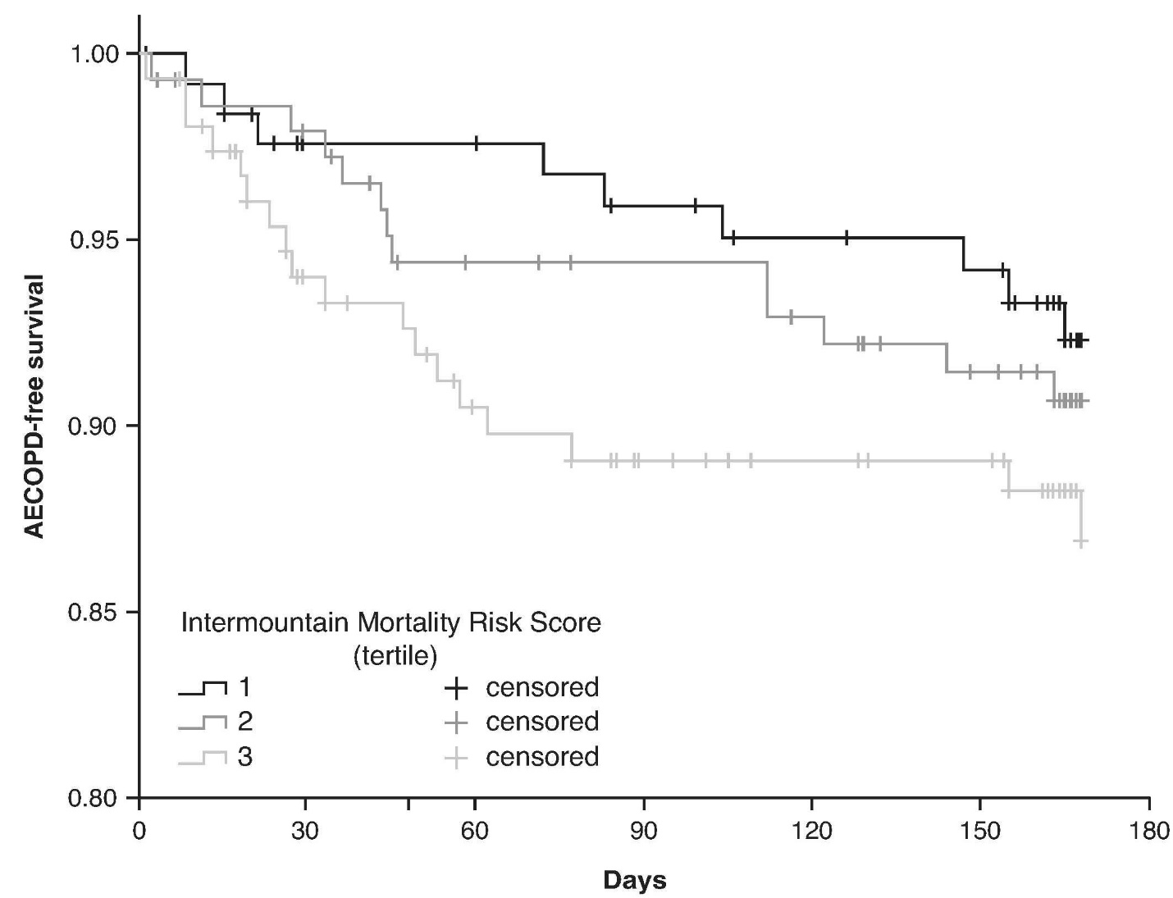

Supplemental Figure S2. Kaplan−Meier survival curves for CV event by IMRS tertile. CV = cardiovascular. CV event includes any of the following: myocardial infarction, unstable angina, stroke, transient ischemic attack, or CV mortality.

