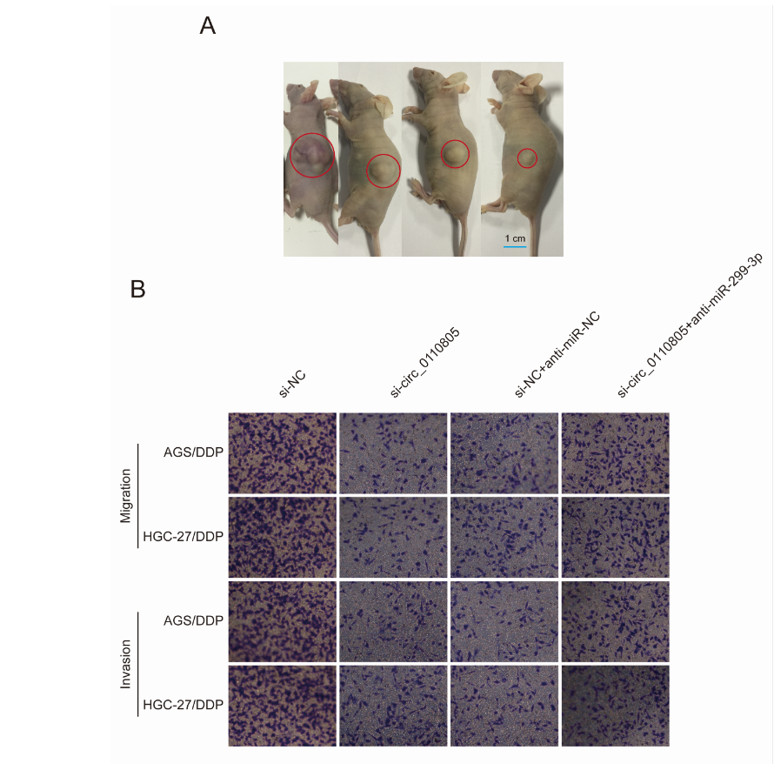
Supplementary Figure 1. The representative images. (A) The representative image of Figure 3 red circles indicate tumor volume; (B) The representative image of Figure 5F and 5G; Magnification: 200×.

