Supplementary figure S1

Supplementary figure S2

Supplementary figure S3
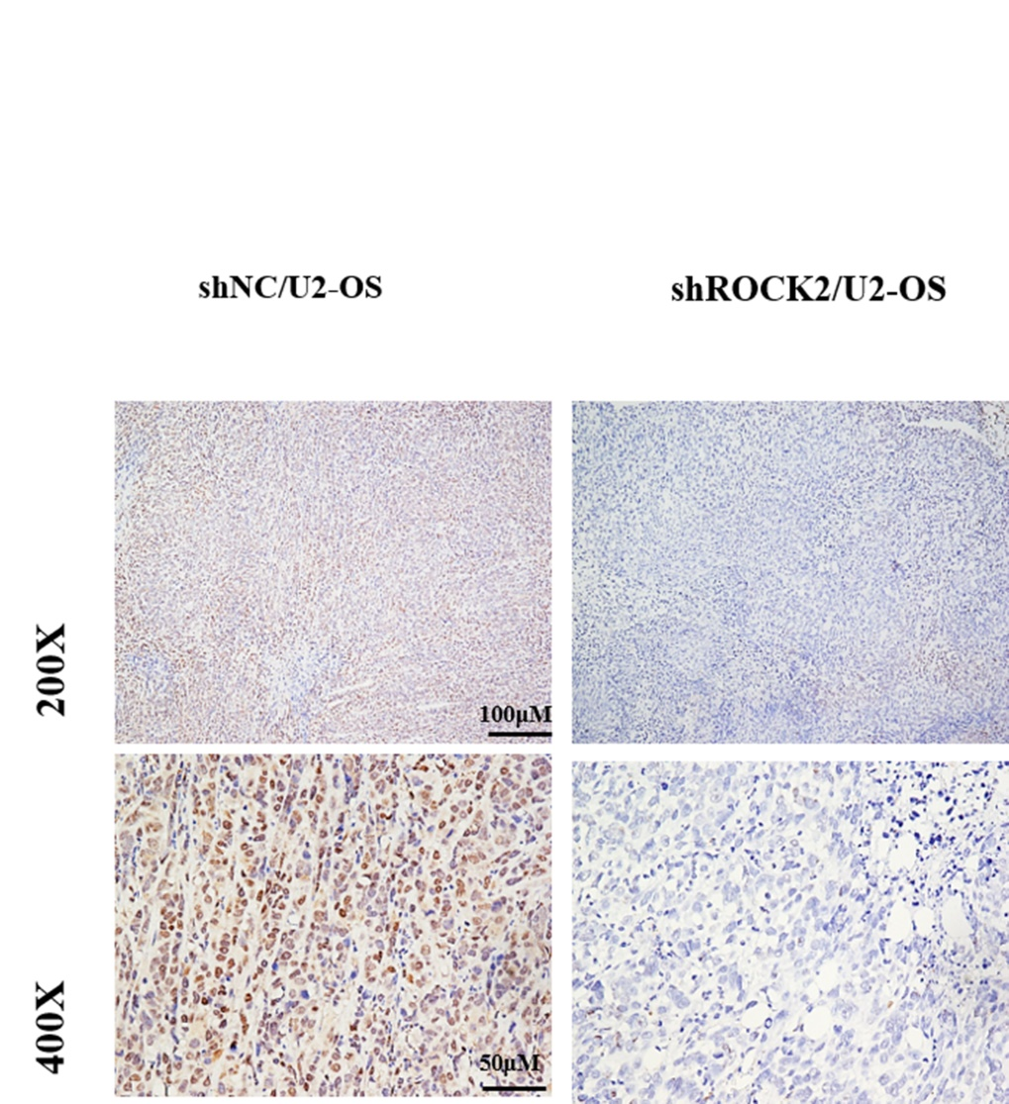

Supplementary figure S4

Supplementary figure S5

Supplementary figure S6

Supplementary figure S7

\

Supplement Figure legends
Supplement Figure S1. ROCK2 expression decreased after transfection of the corresponding shRNA plasmids. Efficiency of ROCK2 silencing in OS cell lines was measured by qRT-PCR and western blot.
Supplement Figure S2. Bcl-2 and BAX protein expression levels after knockdown of ROCK2 expression.
Supplement Figure S3 Tumor sizes of 143B-shNC and 143B-shROCK2 groups of nude mice were measured by IHC.
Supplement Figure S4 (A) Cell counting kit 8 and (B) EdU assays demonstrated a decrease in shROCK2-transfected OS cell (U2-OS and MG-63) growth compared with shNC-transfected cells (scale bars:100μM). (C) Flow cytometry analysis of OS cell apoptosis following ROCK2 silencing.
Supplement Figure S5 (A) CCK8 and (B) EdU assays confirmed that the proliferation of OS cells was significantly increased (scale bars:100μM). (C) following ROCK2 overexpression, flow cytometry was performed to determine the apoptosis rate of OS cells.
Supplement Figure S6 (A) EdU results demonstrated the proliferation of U2-OS shROCK2 cells stably transfected with P-HKII. (B) EdU results demonstrated the proliferation of Saos-2 cells transfected with p-ROCK2 in the presence or absence of shHKII.
Supplement Figure S7 EdU results show the proliferation of p-ROCK2 cells after inhibition of PI3K/AKT signalling.

