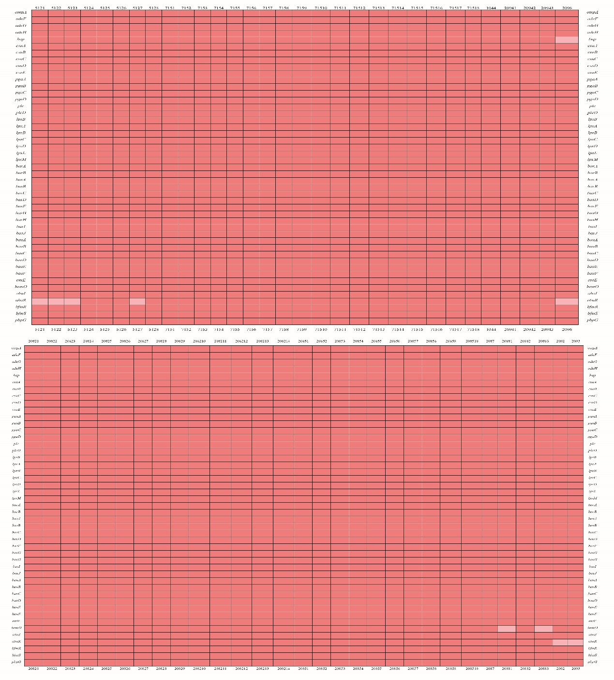
Figure S1. Virulence gene analysis of carbapenem-resistant Acinetobacter baumannii strains. Heatmaps were generated by aligning the draft genome sequence of each strain to the virulence gene database. The presence of virulence genes in a specific genome is represented by the dark red box and the absence of virulence genes is represented by the light red box. omp=outer membrane protein. ade=efflux pump/transport autoinducer genes. bap=biofilm-associated gene. csu=csu pili. pga=polysaccharide poly-N-acetylglucosamine. plc=phospholipase. bar, bas, bau, ent, hem=iron uptake gens. aba, bfm=regulation genes. pbpG=serum resistance gene.

TABLE S1 Confidence levels of genomes identified as KL49 but without gtr100
Assembly | Best match locus | Match confidence
GCF_000582155 | KL49 | Good
GCF_000811805 | KL49 | Low
GCF_001276085 | KL49 | None
GCF_001420305 | KL49 | None
GCF_001649765 | KL49 | Low
GCF_001649795 | KL49 | None
GCF_001649805 | KL49 | None
GCF_001649835 | KL49 | None
GCF_001649875 | KL49 | None
GCF_001649895 | KL49 | None
GCF_001649955 | KL49 | None
GCF_002019035 | KL49 | None
GCF_003584375 | KL49 | None
GCF_003584455 | KL49 | None
GCF_003596175 | KL49 | None
GCF_900010325 | KL49 | Good

