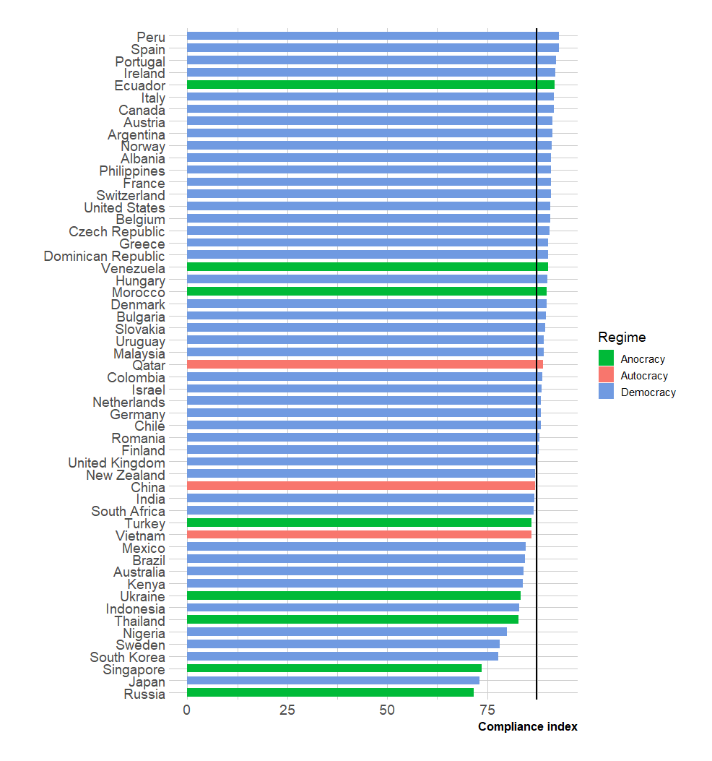
Figure S1. Average compliance index for each country included in the study group by political regimes.

