Supplementary Table 1S. Classification group based on the combinations of CETP rs3764261 with CETP rs708272

Group | Number (%) | CETP rs3764261(C>A) | CETP rs708272 (G>A)
I | 116 (38.8) | CC | GG or GA
II | 148 (49.5) | CC | AA
 |  | AA or CA | GG or GA
III | 35 (11.7) | AA or CA | AA

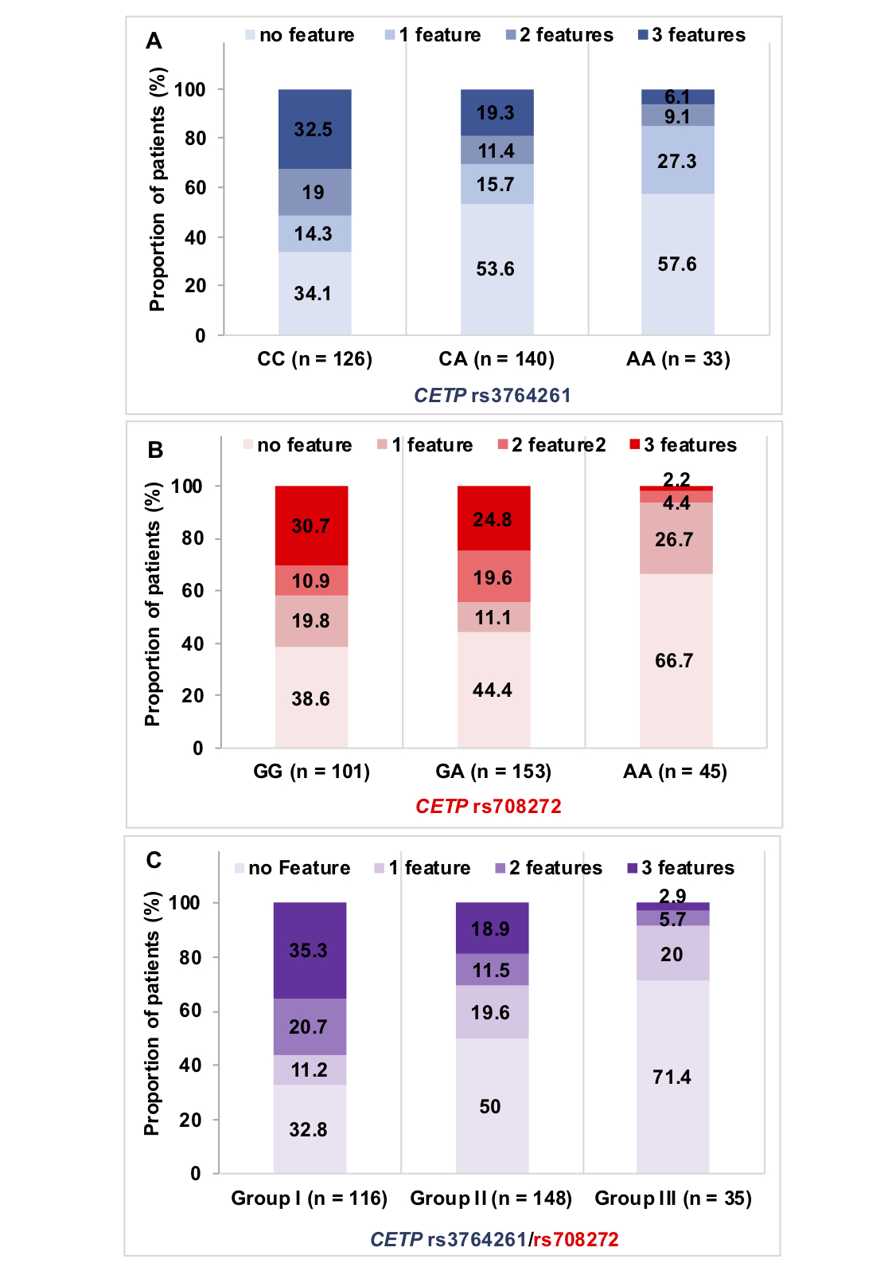
Supplementary Figure 1S. Proportions of patients without and with various numbers of lipid abnormality features (reduced HDL-C, elevated triglycerides or LDL subclass pattern B) in each genotype of CETP rs3764261 (A); rs708272 (B) and combined rs3764261/rs708272 (C). The detail of the combination groups of rs3764261/rs708272 is shown in Supplementary Table 1S.

