Supplementary materials

Supplementary Text S1: Additional information on predictors and endpoints
Imputation of predictors
We set two constraints for predictor imputation: first, no external variable, which was itself statistically associated with any of the outcomes, was involved in the imputation process. In this way, we ensured clean modelling of the associations between predictors and outcomes. Second, we only considered intelligible imputation methods to not curtail the transparency of our epidemiological analyses (e.g., frequency of nocturnal coughs in asthma described in a separate paper).
Therefore, we decided against the use of less transparent (but often more performant) imputation methods (e.g., multiple imputation, which is considered the gold standard for data imputation) and have only considered the predictor variable itself in the imputation process. The latter was facilitated due to the longitudinal measurements: past values could be used to predict missing values.
We deleted observed values (i.e., all coughs from nights 20 to 25) and benchmarked five imputation methods by comparing the imputed values with the deleted observations (Table s1).

Table s1. Benchmarking of imputation methods.
 | Kalman Smoother (overall ARMA) ª | Kalman Smoother  (patient-specific ARMA) | Patient mean ^{b} | Grand mean | Zero
Nocturnal cough
MAE | 5.70 | 5.49 | 8.32 | 10.29 | 6.14
RMSE | 7.23 | 7.53 | 9.55 | 11.64 | 8.28
Sleep quality (PSQI)
MAE | .13 | .75 | .09 | .11 | .78
RMSE | .15 | .76 | .11 | .13 | .79
Note: ª Selected method for the imputation of nocturnal cough. ^{b} Selected method for the imputation of sleep quality. ARMA: Auto-regressive moving average model. MAE: Mean absolute error. PSQI: Pittsburgh Sleep Quality Index. RMSE: Root mean squared error.

Reliability of manual nocturnal cough annotation
In order to obtain nocturnal cough frequencies, smartphone-recorded audio data had to be annotated for coughs by human annotators. To quantify labeling quality, two approaches were employed.
Firstly, human annotators were instructed to tag an acoustic event if they were uncertain whether it was a cough. Out of a total of 704,697 acoustic events, 30,260 were classified unambiguously as coughs. In 0.11% of all acoustic events, annotators were uncertain (i.e., 767 cases). These events were not considered in the analysis.
Secondly, interrater reliability was estimated. In total, five annotators labelled the data. Interrater reliability was calculated for the two annotators that labeled most of the data (i.e., together, they labelled 90.2% of all nights). We estimated intraclass correlations (ICC) for the two annotators based on 65 nights using a zero-inflated generalized mixed effects model with a Poisson response distribution [1]. The two labelers had an ICC of 95.8% (mean absolute error = 0.44 coughs per night) and 85.4% (mean absolute error = 0.76 coughs per night) for cough in general and coughs correctly assigned to the patients’ sex, respectively. These ICCs can be interpreted as excellent and good reliability, respectively [2].

Transformation of predictors
Table s2. Transformation of predictors before analyses.
 | Transformation
Objective 1 | - Aggregation of raw values to a weekly level  - Log-transformation of raw cough counts  - Variable centering to distinguish between variance sources (cf. [3])
Objective 2 and 3 | - Aggregation of raw and first-differenced values to a weekly level  - Calculation of time-series predictors [4] for the given week:  - Linearity, trend, curvature, spikes, the first coefficient of the error term of the decomposed autocorrelation function, the first autocorrelation coefficient of the regular, differenced, and twice-differenced time series, and the sum of squares of the autocorrelation function for the differenced and twice-differenced time series
Objective 4 | - Aggregation and scaling of raw (daily) values over a sliding window (with different offsets and lengths)

Table s3. Analysis plan – associations, classifications, and predictions of asthma control or asthma attacks using nocturnal cough and sleep quality as predictors.
Objective | End-point | Considered time frame of predictors |  | Method
Objective | End-point | ACT recall week | Days preceding an attack | Method
(1) Analysis of statistical associations with asthma control | ACT | X ^{c} | - | Mixed effects regression ^{f}
(2) Detect weeks with uncontrolled asthma ª | ACT | X ^{d} | - | Decision tree ^{g}
(3) Detect weeks with clinically meaningful deteriorations of asthma control ^{b} | ACT | X ^{d} | - | Decision tree ^{g}
(4) Predict asthma attacks | Asthma attacks | - | X ^{e} | Cut-offs ^{h}
Note: ª ACT scores of < 20 points (cf. [5]). ^{b} Decrease of > 2 points in the ACT (minimally important difference; [6]). ^{c} Aggregated and centered to differentiate within- and between-patient variance [3]. ^{d} Aggregations, changes, and time series characteristics. ^{e} Aggregated (sliding window approach with different window lengths and lags). ^{f} Random intercept (cf. [7]) to account for baseline differences in asthma control. ^{g} Based on recursive partitioning analysis [8, 9] with 5-fold cross validation. ^{h} Optimal cut-offs for attack prediction were identified in the train folds and applied to each test fold (8-fold cross validation). ACT: Asthma Control Test.

Distributions of predictors (contextualized with asthma control)
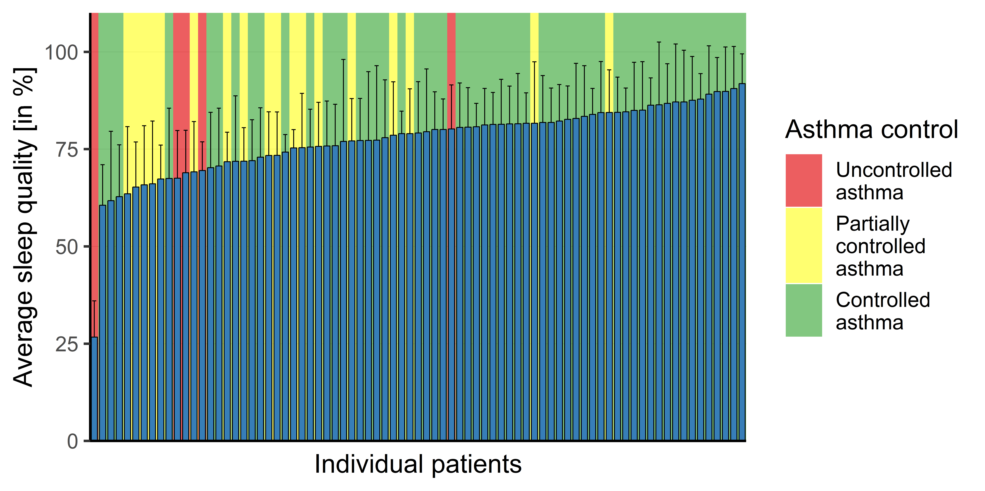
Figure s1. Distribution of average sleep quality per patient. Each bar represents one patient. Black error bars indicate one standard deviation. Controlled asthma: average weekly ACT score of ≥ 20 points. Partially controlled asthma: average weekly ACT score between 15 and 20 points. Uncontrolled asthma: average weekly ACT score of ≤ 15 points.

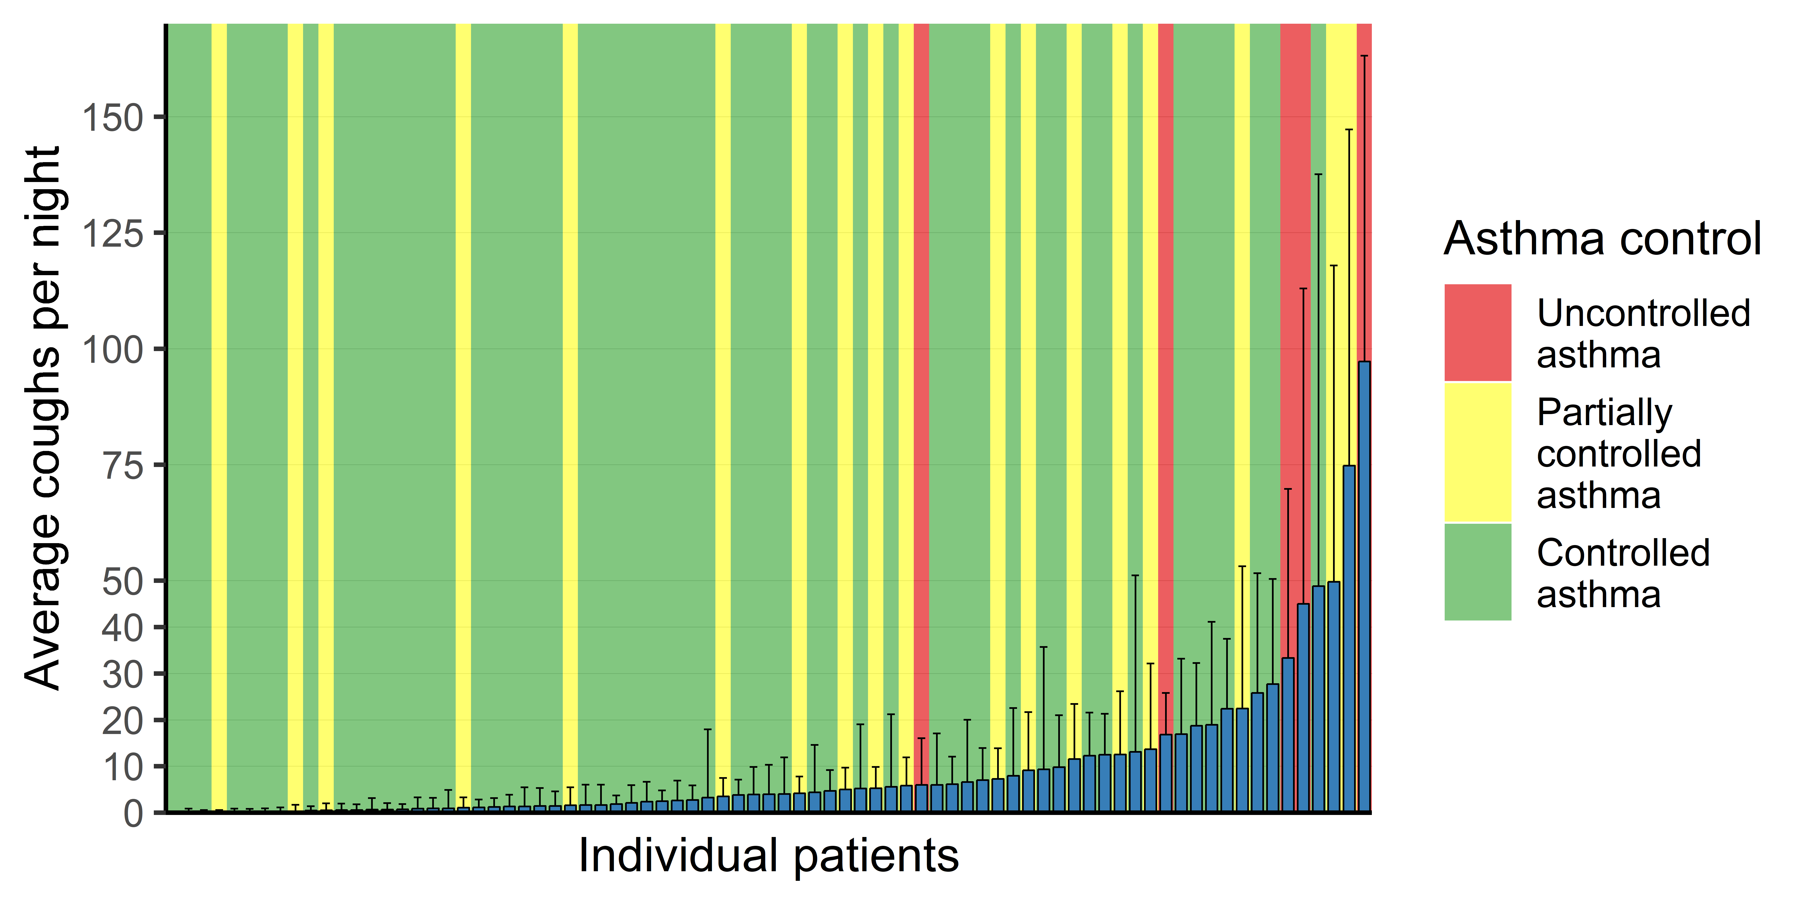
Figure s2. Distribution of average nocturnal cough frequencies per patient. Each bar represents one patient. Black error bars indicate one standard deviation. Controlled asthma: average weekly ACT score of ≥ 20 points. Partially controlled asthma: average weekly ACT score between 15 and 20 points. Uncontrolled asthma: average weekly ACT score of ≤ 15 points.

Seasonality of predictors and asthma control
Study participants were assigned to one of the following seasons based on the Swiss pollen calendar: February to April, May to July, August to October, and November to January. If participants were enrolled in the study across the boundaries of a season, they were assigned to the season in which they spent most of their study days. All scores were averaged on a patient-level prior to statistical analysis and depiction.
We have observed no statistically significant differences between seasons with regard to sleep quality (Kruskal Wallis’ H(3) = .41, p = .94) and nocturnal cough (Kruskal Wallis’ H(3) = 2.95, p = .40). However, asthma control differed significantly by season (Kruskal Wallis’ H(3) = 8.76, p = .03). While the largest numerical difference occurred between Feb-Apr (M = 18.9, SD = 1.83) and Nov-Jan (M = 21.5, SD = 1.29), pairwise comparisons failed to reach statistical significance between these two seasons (p = .06). All other comparisons also remained statistically insignificant (p’s > .15).
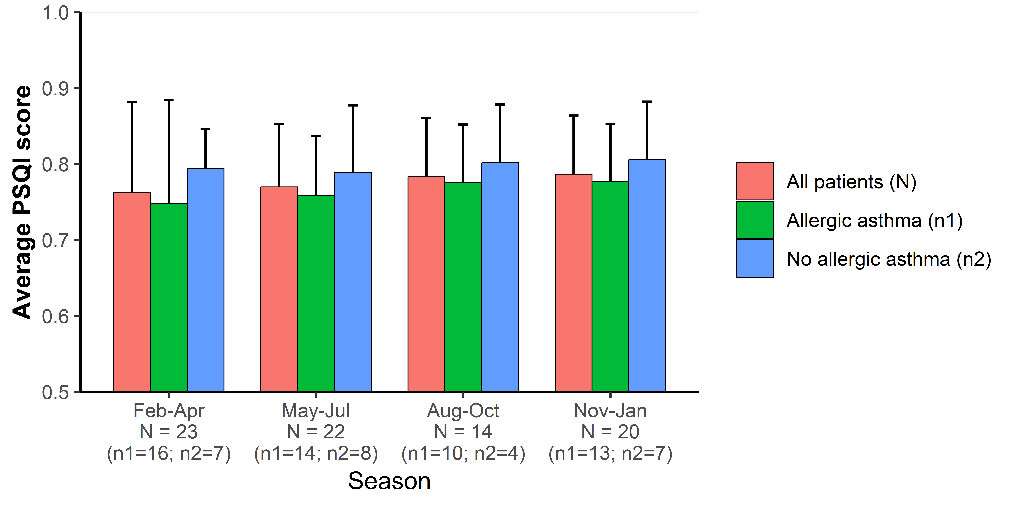
Figure s3. Average sleep quality by season. PSQI: Pittsburgh Sleep Quality Index.
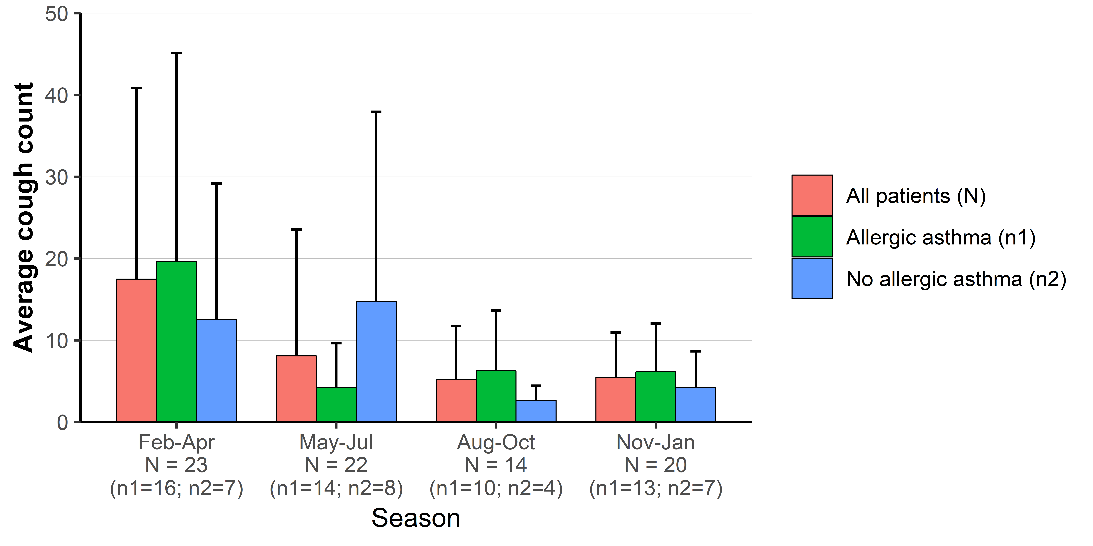
Figure s4. Average nocturnal cough count by season.

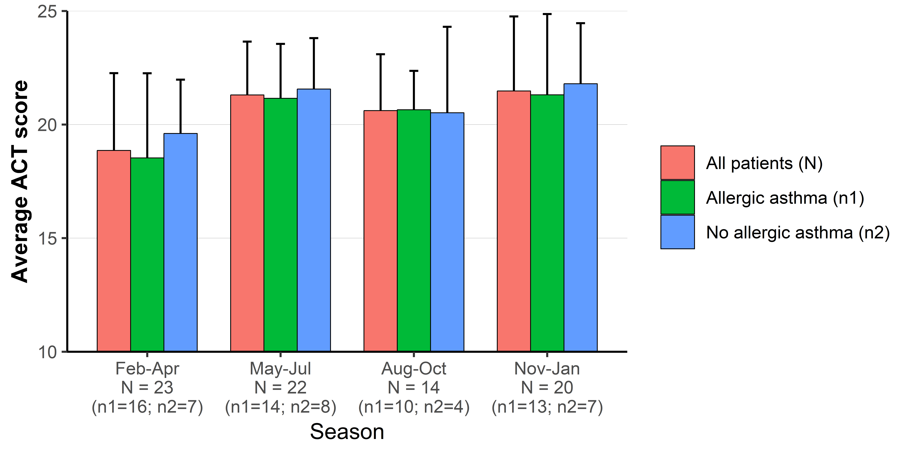
Figure s5. Average Asthma Control Test (ACT) score by season.

Adaptation of the Asthma Control Test (primary endpoint) and its distribution
The Asthma Control Test (ACT) has a recall time of one month [10], which we shortened to one week. Correlational analyses demonstrated the validity of the weekly adaption: The mean of the four weekly ACT measurements was highly correlated with the monthly ACT score (measured with the original ACT on d₂₉; r = .80, p ≤ 0.001). Moreover, the weekly (smartphone-based) ACT outperformed the original monthly ACT (measured on d₁ and d₂₉) in terms of observed internal consistency (Cronbach’s α = .73 vs. α = .60). These results indicate that adapting the ACT from its originally monthly frame of reference to a weekly measure has not decreased the reliability of the questionnaire. Figure s6 depicts the distribution of the weekly ACT scores.

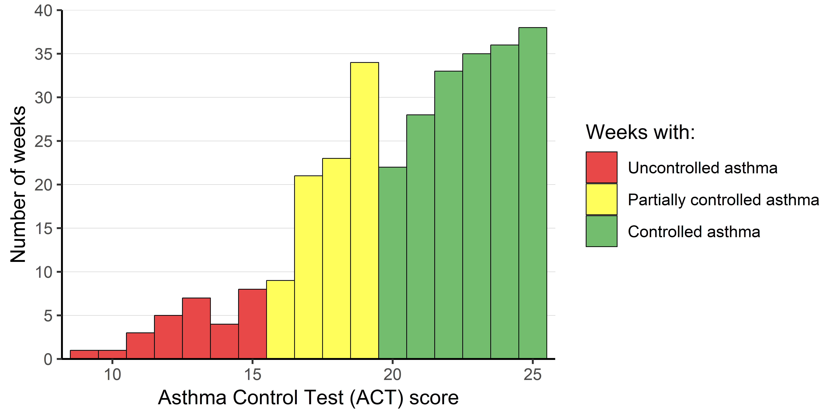
Figure s6. Distribution of asthma control in the study sample (N = 308 nights of 79 patients). Controlled asthma: ACT score > 19 points. Partially controlled asthma: ACT score between 16 and 19 points. Uncontrolled asthma: ACT score < 16 points.

Supplementary Text S2: Bivariate correlations
Correlation between nocturnal cough and sleep quality
We have estimated Pearson’s product-moment correlation based on within-patient z-standardized nocturnal cough and sleep quality (i.e., scores of the Pittsburgh Sleep Quality Index (PSQI)). We have found that nights, in which patients coughed more, were weakly (but statistically significantly) associated with worse sleep quality (et vice versa; r(2210) = -.10, 95% CI [-.14,-.06], p ≤ .001). Figure s7 depicts the bivariate association.

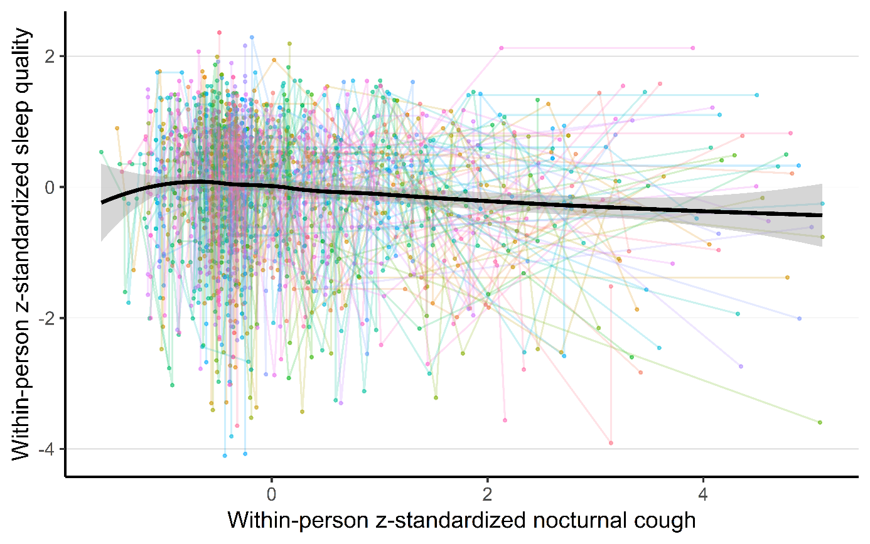
Figure s7. Correlation between nocturnal cough and sleep quality. Each color represents one patient. Black line is a local polynomial regression fitted across all nights (N = 2212 nights from 79 patients).

Bivariate correlation between sleep quality and asthma control
Pearson’s product-moment correlation was used to assess the association between sleep quality and ACT. Weekly aggregated PSQI was statistically significantly correlated with the weekly measured ACT score (r(306) = .47, 95% CI [.38,.56], p ≤ .001).

Bivariate correlation between nocturnal cough and asthma control
Pearson’s product-moment correlation was used to assess the association between nocturnal cough and ACT. Weekly aggregated nocturnal cough was statistically significantly and inversely correlated with the weekly measured ACT score (r(306) = -.37, 95% CI [-.27,-.47], p ≤ .001). Furthermore, Figure s8 depicts the correlation contingent upon which part of the night was considered.
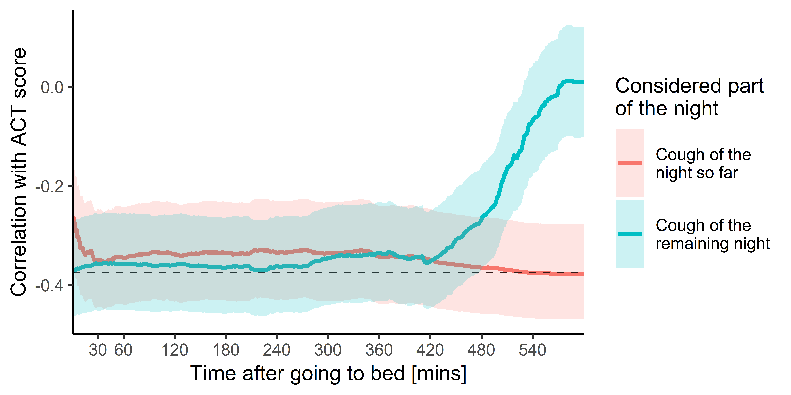
Figure s8. Correlation between weekly aggregated nocturnal cough and weekly ACT score depending on which part of the night was considered. Shaded areas indicate the 95% confidence interval. The black dashed line indicates the correlation if the entire night of cough is considered. ACT: Asthma Control Test.

Supplementary Text S3: Additional information on data modeling
Objective 1
Table s4 provides a more exhaustive overview with regard to the statistical analyses of objective 1 presented in the main paper.

Table s4. Mixed effects regression models.
 | Dependent variable: ACT score
 | Model 1 | Model 2 | Model 3 | Model 4 | Model 5 | Model 6 | Model 7
Nocturnal cough (between-patient) | -.86***  [-1.29,  -.44] |  | -.87***  [-1.29,  -.44] |  |  |  | -.51*  [-.92,  -.11]
Nocturnal cough (between-patient) | (.28) |  | (.28) |  |  |  | (.21)
Nocturnal cough  (within-patient) |  | -.46***  [-.71,  -.21] | -.46***  [-.71,  -.21] |  |  |  | -.41**  [-.66,  -.16]
Nocturnal cough  (within-patient) |  | (.13) | (.13) |  |  |  | (.13)
Sleep quality  (between-patient) |  |  |  | -2.74***  [-3.67,  -1.81] |  | -2.71***  [-3.64,  -1.77] | -2.26***  [-3.23,  -1.30]
Sleep quality  (between-patient) |  |  |  | (.48) |  | (.48) | (.50)
Sleep quality  (within-patient) |  |  |  |  | 1.04**  [-1.69,  -.39] | -1.01**  [-1.66,  -.36] | .85**  [-1.49,  -.21]
Sleep quality  (within-patient) |  |  |  |  | (.33) | (.33) | (.33)
Intercept | 20.52 | 20.51 | 20.52 | 20.51 | 22.47 | 22.40 | 22.11
Intercept | (.33) | (.36) | (.33) | (.30) | (.72) | (.69) | (.68)
Observations | 308 | 308 | 308 | 308 | 308 | 308 | 308
Log Likelihood | -717.52 | -719.00 | -712.31 | -710.04 | -719.49 | -705.67 | -699.41
Marginal R^{2 a} | 13.39% | 1.11% | 14.48% | 23.94% | .87% | 24.69% | 29.41%
Conditional R^{2 b} | 72.60% | 73.86% | 74.00% | 72.70% | 73.34% | 73.74% | 74.94%
BIC | 1,457.95 | 1,460.93 | 1,453.28 | 1,442.99 | 1,461.89 | 1,440.00 | 1,438.94
Note: First row contains the estimate of the predictor and the 95% confidence interval, second row the standard error. Nocturnal cough values are weekly sums of the log-transformed cough count (a doubling of the weekly nocturnal cough frequency within a patient is, for example in model 3, associated with a decrease of .32 points (i.e., estimate multiplied by .69 or the natural logarithm of 2) in the ACT test). Sleep quality are weekly sums of the inverted daily sleep quality score standardized from 0% to 100% (a weekly decrease of 100 points or an average daily decrease of 14.29 points within a patient is, for example in model 3, associated with a decrease of 1.01 points in the ACT score). N = 308 weeks. BIC: Bayesian Information Criterion. ª Variance explained by the predictors [11]. ^{b} Variance explained by the random intercept [11]. *p<.05. **p<.01 ***p<.001.

Objective 2 - 4
We have benchmarked different algorithms for the analysis of objective 2 and 3, namely k-nearest neighbors, neural nets, support vector machines, logistic regression, random forest, gradient boosting machines, and decision trees. Decision trees delivered the best detection results.
To grow decision trees, we have employed the “r part” package (version 4.1-13; [12]). Two strategies were applied to optimize model performance: first, the complexity parameter of decision trees has been optimized in model development (without resampling) using the “caret” package (version 6.0-84; [13]). Second, since outcome classes were unbalanced (e.g., different number of weeks with uncontrolled and controlled asthma), weighting matrices for observations have been benchmarked and the best performing weighting matrix has been selected for each objective and predictor set.
Table s5 expands the results table presented in the main paper by adding the positive predictive value (i.e., true positives/(true positives + false positives)) and negative predictive value (i.e., true negatives/(true negatives + false negatives)) [14].
Finally, Table s6 presents estimates of variable importance to facilitate the interpretation of the decision trees that were developed in objective 2 and 3.
Table s5. Results of cross-validated models.
Predictor and metric |  | Detection of weeks with uncontrolled asthma (O2)^{1,2} | Detection of weeks with deteriorations in asthma control (O3)^{1,3} | Prediction of asthma attacks X days (d_{x})  before the event (O4)^{4,5}
 |  | Detection of weeks with uncontrolled asthma (O2)^{1,2} |  | d₀ | d₋₁ | d₋₂ | d₋₃ | d₋₄ | d₋₅ | d₋₆ | d₋₇
Sleep quality
 | BAC | .68 | .56 | .68 | .65 | .66 | .69 | .68 | .63 | .57 | .46
 | Sensitivity | .66 | .63 | .75 | .62 | .62 | 1 | .62 | .50 | .50 | .12
 | Specificity | .69 | .48 | .61 | .69 | .70 | .38 | .73 | .76 | .65 | .79
 | PPV | .57 | .16 | .01 | .02 | .01 | .01 | .02 | .02 | .01 | <.01
 | NPV | .77 | .90 | >.99 | >.99 | >.99 | >.99 | >.99 | >.99 | >.99 | .99
Nocturnal cough (entire night)
 | BAC | .61 | .71 | .63 | .69 | .62 | .67 | .59 | .58 | .53 | .40
 | Sensitivity | .54 | .60 | .62 | .75 | .62 | .75 | .50 | .50 | .50 | 0
 | Specificity | .67 | .82 | .63 | .63 | .61 | .58 | .68 | .66 | .57 | .79
 | PPV | .51 | .32 | .01 | .01 | .01 | .01 | .01 | .01 | .01 | nA
 | NPV | .70 | .93 | >.99 | >.99 | >.99 | >.99 | >.99 | >.99 | >.99 | .99
Nocturnal cough (first 30 minutes after going to bed)
 | BAC | .62 | .54 | .64 | .64 | .64 | .64 | .70 | .61 | .45 | .62
 | Sensitivity | .59 | .35 | .62 | .62 | .62 | .62 | .75 | .62 | .12 | .50
 | Specificity | .64 | .74 | .66 | .66 | .66 | .66 | .66 | .60 | .78 | .73
 | PPV | .50 | .17 | .01 | .01 | .01 | .01 | .01 | .01 | <.01 | .01
 | NPV | .73 | .89 | >.99 | >.99 | >.99 | >.99 | >.99 | >.99 | .99 | >.99
Nocturnal cough (after 30 minutes until end of night)
 | BAC | .60 | .65 | .69 | .65 | .65 | .71 | .60 | .50 | .64 | .40
 | Sensitivity | .47 | .45 | .62 | .75 | .75 | .88 | .50 | .50 | .75 | 0
 | Specificity | .72 | .84 | .75 | .55 | .55 | .55 | .69 | .50 | .53 | .79
 | PPV | .51 | .29 | .02 | .01 | .01 | .01 | .01 | .01 | .01 | nA
 | NPV | .69 | .91 | >.99 | >.99 | >.99 | >.99 | >.99 | >.99 | >.99 | .99
Sleep quality and nocturnal cough (entire night) combined
 | BAC | .68 | .65 | .72 | .70 | .71 | .72 | .72 | .64 | .67 | .45
 | Sensitivity | .66 | .48 | .88 | .75 | .75 | .75 | .75 | .50 | .62 | .25
 | Specificity | .69 | .81 | .57 | .64 | .66 | .69 | .69 | .77 | .71 | .65
 | PPV | .57 | .30 | .01 | .01 | .01 | .01 | .01 | .01 | .01 | <.01
 | NPV | .77 | .92 | >.99 | >.99 | >.99 | >.99 | >.99 | >.99 | >.99 | .99
Sleep quality and nocturnal cough (first 30 minutes after going to bed) combined
 | BAC | .68 | .55 | .64 | .65 | .63 | .72 | .74 | .71 | .58 | .40
 | Sensitivity | .66 | .62 | .88 | .62 | .62 | .75 | .75 | .75 | .50 | .25
 | Specificity | .69 | .48 | .41 | .67 | .64 | .69 | .72 | .68 | .66 | .55
 | PPV | .57 | .16 | .01 | .01 | .01 | .02 | .02 | .01 | .01 | <.01
 | NPV | .77 | .89 | >.99 | >.99 | >.99 | >.99 | >.99 | >.99 | >.99 | .99
Sleep quality and nocturnal cough (after 30 minutes until end of night) combined
 | BAC | .68 | .57 | .73 | .69 | .70 | .72 | .72 | .64 | .67 | .52
 | Sensitivity | .66 | .29 | .88 | .75 | .75 | .75 | .88 | .50 | .62 | .25
 | Specificity | .69 | .84 | .59 | .64 | .66 | .69 | .56 | .78 | .71 | .80
 | PPV | .57 | .20 | .01 | .01 | .01 | .01 | .01 | .01 | .01 | .01
 | NPV | .77 | .89 | >.99 | >.99 | >.99 | >.99 | >.99 | >.99 | >.99 | .99
Note: All reported figures are averages over the five (O2 and O3) or eight (O4) folds. ¹ Model: Decision Tree. ² Positive outcome class: Uncontrolled asthma (i.e., ACT score < 20; 116 out of 308 study weeks). ³ Positive outcome class: Clinically meaningful deterioration in asthma control (i.e., a decrease in ACT score by > 2 points; 29 out of 227 study weeks). ⁴ Model: Cut-offs. ⁵ Positive outcome class: Asthma attack (i.e., 8 out of 2,008 study days). ACT: Asthma Control Test. BAC: Balanced accuracy (values over .70, a threshold for usefulness [15], are highlighted). nA: not available. NPV: Negative predictive value. O: Objective. PPV: Positive predictive value.
Table s6. Importance of variables for growing decision trees.
Predictor set |  | Variable importance of
 |  | Cough count | Δ Cough count | TS cough | Sleep quality | Δ Sleep quality | TS sleep quality
Detection of weeks with uncontrolled asthma (O2)
 | Sleep quality | - | - | - | 1 | .04 | .15
 | Nocturnal cough (entire night) | 1 | .28 | .09 | - | - | -
 | Nocturnal cough (first 30 minutes after going to bed) | .97 | .11 | .30 | - | - | -
 | Nocturnal cough (after 30 minutes until end of night) | 1 | .56 | .09 | - | - | -
 | Sleep quality and nocturnal cough (entire night) combined | .78 | 0 | .04 | 1 | 0 | .13
 | Sleep quality and nocturnal cough (first 30 minutes after going to bed) combined | .54 | .09 | .10 | 1 | 0 | .21
 | Sleep quality and nocturnal cough (after 30 minutes until end of night) combined | .75 | .20 | .04 | 1 | 0 | .15
Detection of weeks with deteriorations in asthma control (O3)
 | Sleep quality | - | - | - | .50 | .69 | .37
 | Nocturnal cough (entire night) | .58 | .40 | .40 | - | - | -
 | Nocturnal cough (first 30 minutes after going to bed) | .28 | .39 | .45 | - | - | -
 | Nocturnal cough (after 30 minutes until end of night) | .93 | .95 | .22 | - | - | -
 | Sleep quality and nocturnal cough (entire night) combined | .61 | .04 | .28 | .18 | .19 | .25
 | Sleep quality and nocturnal cough (first 30 minutes after going to bed) combined | .07 | .07 | .23 | .29 | .34 | .16
 | Sleep quality and nocturnal cough (after 30 minutes until end of night) combined | .97 | .87 | .15 | .05 | .15 | .24
Note: All reported figures are averages in importance ratings over the five folds in the training data. Figures indicate the average contribution of each variable to reducing the loss function when growing the decision tree. Values can range between 0 and 1. Higher values imply a higher importance for the decision tree. O: Objective. Δ: Weekly changes. TS: Time series variables (please refer to Table s2 for a more detailed explanation of the included variables).

References
1. Bolker, B., Getting started with the glmmTMB package. 2016.
2. Koo, T.K. and M.Y. Li, A guideline of selecting and reporting intraclass correlation coefficients for reliability research. Journal of Chiropractic Medicine, 2016. 15(2): p. 155-163.
3. Enders, C.K., Centering predictors and contextual effects, in The SAGE handbook of multilevel modeling, M.A. Scott, J.S. Simonoff, and B.D. Marx, Editors. 2013, SAGE Publications Inc.: Thousand Oaks, CA. p. 89-108.
4. Hyndman, R., et al., tsfeatures: time series feature extraction. 2019.
5. Schatz, M., et al., Asthma Control Test: reliability, validity, and responsiveness in patients not previously followed by asthma specialists. Journal of Allergy and Clinical Immunology, 2006. 117(3): p. 549-556.
6. Schatz, M., et al., The minimally important difference of the Asthma Control Test. Journal of Allergy and Clinical Immunology, 2009. 124(4): p. 719-723. e1.
7. Bates, D., et al., Fitting Linear Mixed-Effects Models Using lme4. Journal of Statistical Software, 2015. 67(1).
8. Breiman, L., Classification and regression trees. 2017: Routledge.
9. Fonarow, G.C., et al., Risk stratification for in-hospital mortality in acutely decompensated heart failure: classification and regression tree analysis. Jama, 2005. 293(5): p. 572-580.
10. Nathan, R.A., et al., Development of the asthma control test: a survey for assessing asthma control. Journal of Allergy and Clinical Immunology, 2004. 113(1): p. 59-65.
11. Edwards, L.J., et al., An R2 statistic for fixed effects in the linear mixed model. Statistics in medicine, 2008. 27(29): p. 6137-6157.
12. Therneau, T., et al., Package ‘rpart’. Available online: cran. ma. ic. ac. uk/web/packages/rpart/rpart. pdf (accessed on 20 April 2016), 2015.
13. Kuhn, M., Caret: classification and regression training, in Astrophysics Source Code Library. 2015.
14. Bossuyt, P.M., Clinical validity: defining biomarker performance. Scandinavian Journal of Clinical and Laboratory Investigation, 2010. 242(sup242): p. 46-52.
15. Swets, J.A., Measuring the accuracy of diagnostic systems. Science, 1988. 240(4857): p. 1285-1293.

