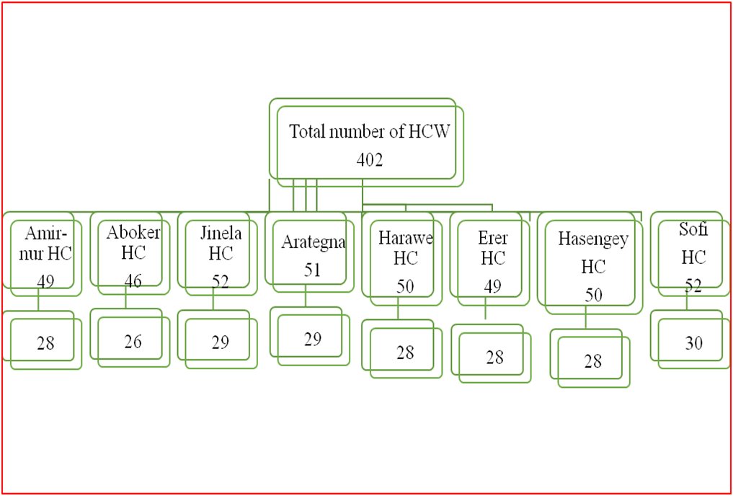
Figure (Supplementary): Sampling of health professionals from the health centers in the Harari region, Eastern Ethiopia, March-April 2019

