Supplementary materials
Table s1: Descriptive table of cough clusters
Number of coughs | Number of clusters | Isolated coughs (n) | Isolated coughs (%) | Coughs that were part of a cluster (n) | Coughs that were part of a cluster (%) | Mean coughs per cluster | Standard deviation of coughs per cluster
21157 | 5718 | 3046 | 14.4 | 18111 | 85.6 | 3.2 | 1.9

Table s2: Coughs per cluster (c/c)
Number of clusters | Min. c/c | Max. c/c | Mean c/c | Standard Deviation c/c | Geometric mean c/c | Median c/c | 25th quantile c/c | 75th quantile c/c
5718 | 2 | 20 | 3.2 | 1.9 | 2.8 | 2 | 2 | 4

Table s3: Pearson correlations between objective cough frequency and subjective cough severity ratings of the same night (VAS)
Variable transformations | r | 95% CI | t | df | p
Raw variables | 0.382* | [0.345; 0.417] | 19.242 | 2171 | 0
Within-person z-scaled variables | 0.25* | [0.209; 0.29] | 11.697 | 2059 | 0
Note: * p < .001

Table s4: Pearson correlations between objective cough frequency and subjective cough severity ratings of the preceding day (VAS)
Variable transformations | r | 95% CI | t | df | p
Raw variables | 0.3* | [0.261; 0.337] | 14.631 | 2172 | 0
Within-person z-scaled variables | 0.182* | [0.141; 0.223] | 8.536 | 2117 | 0
Note: * p < .001
Table s5: Pearson correlations between objective cough frequency and subjective cough severity ratings of the following day (VAS)
Variable transformations | r | 95% CI | t | df | p
Raw variables | 0.288* | [0.248; 0.326] | 13.735 | 2093 | 0
Within-person z-scaled variables | 0.109* | [0.066; 0.152] | 4.967 | 2040 | 0
Note: * p < .001

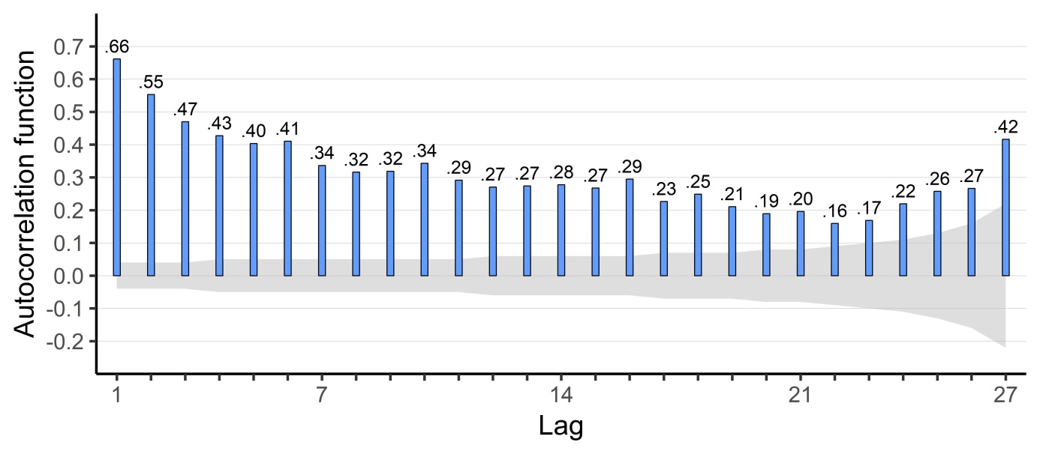
Figure s1: Auto-correlation function for nocturnal cough. Lag 0 represents the current night, lag 1 the night before et cetera. The bars indicate the correlation of the nocturnal cough rate of that night with the current night/lag 0. The grey area represents the 95% confidence bands for a correlation-coefficient of zero. When the bar exceeds the grey area, the correlation is significant.

