Supplementary materials
Table S1 SiRNA sequences used in the study
siRNA | Sense (5′-3′) | Antisense (5′-3′)
siGFP | GGCACAAGCUGGAGUACAATT | UUGUACUCCAGCUUGUGCCTT
siWWP1 | CCAUGGAAUCUGUCCGAAATT | UUUCGGACAGAUUCCAUGGTT
siNC | UUCUCCGAACGUGUCACGUTT | ACGUGACACGUUCGGAGAATT
Abbreviations: siGFP, siRNA-targeting green fluorescent protein; siWWP1, siRNA-targeting WW domain-containing E3 ubiquitin protein ligase 1; siNC, negative control siRNA

Figure S1 Dynamic light scattering and Zeta potential analysis of complexes

Figure S2 Gel electrophoresis of Ca-siRNA processed at various Ca concentrations (0.5–2.0 M)

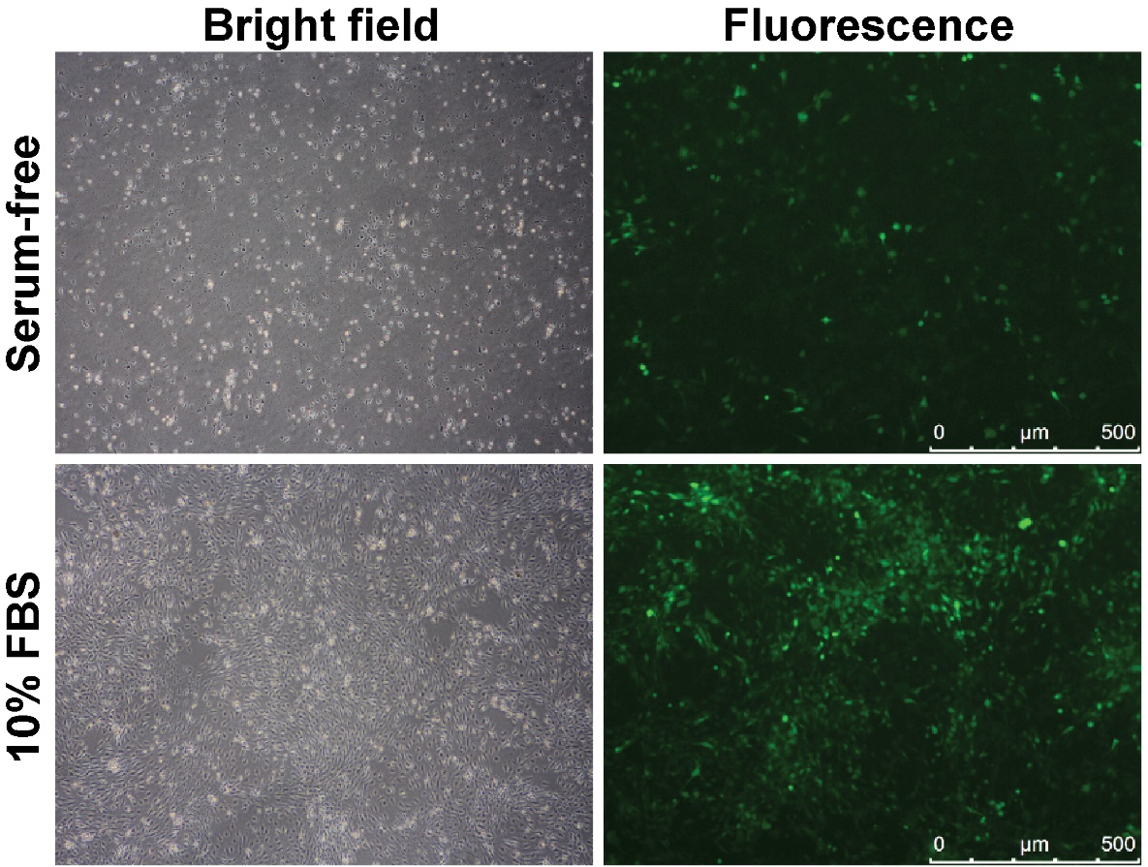
Figure S3 Effect of transfection solution with or without 10% fetal bovine serum (FBS) on cell transfection, as evaluated by fluorescence microscopy

