Supplementary materials
The boxplots for the other 13 substitution models

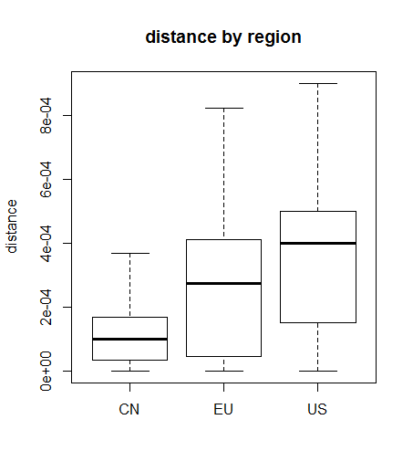
Figure S1. The boxplot of “raw” model

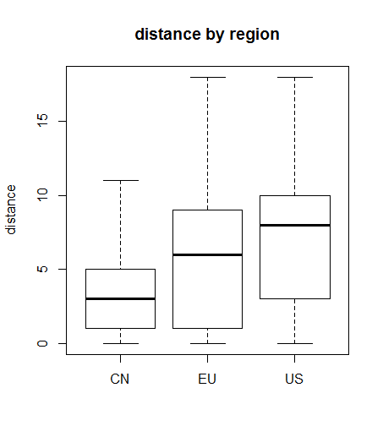
Figure S2. The boxplot of “N” model
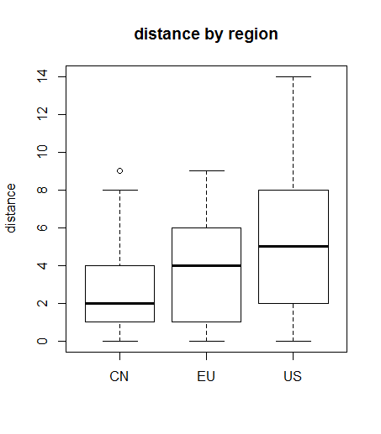
Figure S3. The boxplot of “TS” model

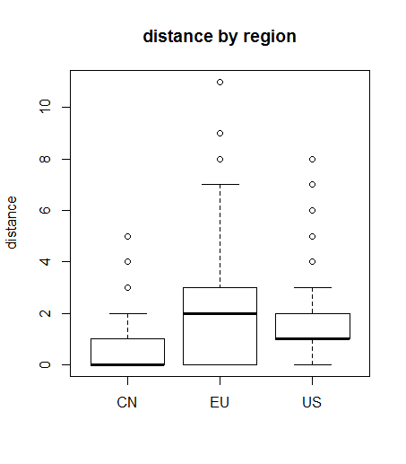
Figure S4. The boxplot of “TV” model
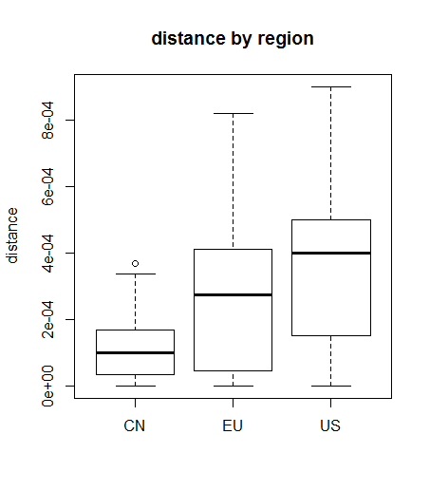
Figure S5. The boxplot of “K80” model
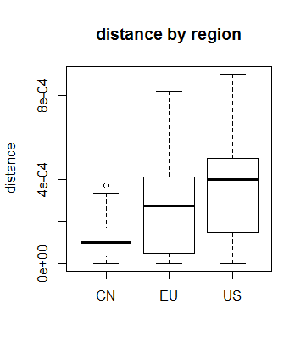
Figure S6. The boxplot of “F81” model
Figure S7. The boxplot of “K81” model
Figure S8. The boxplot of “F84” model

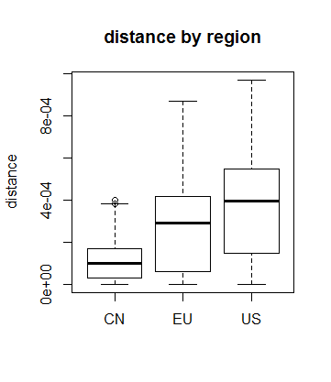
Figure S9. The boxplot of “BH87” model
Figure S10. The boxplot of “T92” model
Figure S11. The boxplot of “TN93” model

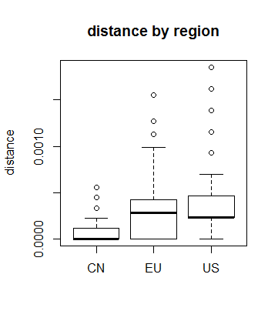
Figure S12. The boxplot of “GG95” model
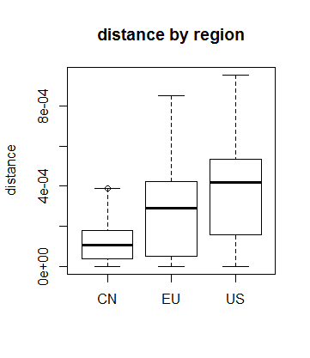
Figure S13. The boxplot of “paralin” model

The IDs of the COVID-19 sequences

China (50 sequences):
MT253696
MT253702
MT291833
MT259231
MT253701
MT123290
MT093631
MT253706
MT123291
MT259230
MT253704
MT226610
MT259226
MT291829
MT121215
MN908947
MT259228
MT039873
MT253699
MN996530
MT135044
MT253703
MT135043
MT253705
MT019533
MN975262
MT253707
MT291830
NC_045512
MT019529
MT291835
MN996531
MT253697
MT291832
MT253710
MN988668
MN988669
MT291828
MT135042
MT019531
MT135041
MT396241
MT291831
LR757998
MT291834
MN996529
MT291826
MT259229
LR757995
MT281577

Europe (43 sequences):
MT292582
MT292580
MT292581
MT198651
MT292579
MT394864
MT233520
MT198653
MT371568
MT233522
MT371569
MT328034
MT292573
MT233523
MT292571
MT233519
MT292574
MT198652
MT093571
MT020781
MT066156
MT292572
MT077125
MT292570
MT359866
MT328032
MT328035
MT328033
MT371574
MT371573
MT371571
MT371572
MT371570
MT320538
MT359865
MT292569
MT292575
MT292578
MT233521
MT292576
MT292577
MT256918
MT256917

USA(50 sequences)
MT412137
MT308695
MT345826
MT325593
MT370951
MT325589
MT370848
MT326072
MT334530
MT325567
MT326028
MT252800
MT252804
MT371020
MT246484
MT412211
MT246466
MT370998
MT371022
MT325604
MT375428
MT358675
MT304487
MT412140
MT371003
MT370841
MT252696
MT276323
MT370844
MT412139
MT370901
MT334539
MT246452
MT263433
MT370992
MT358739
MT326166
MT246464
MT419848
MT385441
MT259282
MT370965
MT308694
MT259237
MT326080
MT334572
MT370931
MT326093
MT293206
MT259256
R code:

(The R code for our sequence-distance analysis is given below, which is also available from the publicly accessible website https://reurl.cc/GrA5dd.)

if (!requireNamespace("BiocManager", quietly = TRUE))
install.packages("BiocManager")

BiocManager::install("Biostrings")

library("Biostrings")

#install.packages("seqinr")
#install.packages("ape")
library(seqinr)
library(ape)

# sa<-read.csv('D:/covid19/dist/ASN_USA.csv',header=T)
# sid<-sample(nrow(sa),50)
# sa1<-sa[sid,]
# write.table(sa1,'D:/covid19/dist/sa_USA.txt',row.names=FALSE,sep="\t", quote = FALSE)
#
# sa_c<-read.csv('D:/covid19/dist/ASN_CN.csv',header=T)
# sid_c<-sample(nrow(sa_c),50)
# sa1_c<-sa_c[sid_c,]
# write.table(sa1_c,'D:/covid19/dist/sa_CN.txt',row.names=FALSE,sep="\t", quote = FALSE)

align_usa<-read.alignment("D:/covid19/dist/usa_aln.fasta","fasta")
dis_usa <- dist.alignment(align_usa, "identity")
mean(dis_usa)
sd(dis_usa)
quantile(dis_usa)

align_cn<-read.alignment("D:/covid19/dist/cn_aln.fasta","fasta")
dis_cn <- dist.alignment(align_cn, "identity")
mean(dis_cn)
sd(dis_cn)
quantile(dis_cn)

align_eu<-read.alignment("D:/covid19/dist/eu_aln.fasta","fasta")
# sa_eu_nam<-align_eu$nam
# sa_eu_nam<-substr(sa_eu_nam,4,nchar(sa_eu_nam))
# sa_eu<-sub("\\..*","",sa_eu_nam)
# write.table(sa_eu,'D:/covid19/dist/sa_eu.txt',row.names=FALSE,sep="\t", quote = FALSE)
dis_eu <- dist.alignment(align_eu, "identity")
mean(dis_eu)
sd(dis_eu)
quantile(dis_eu)

region<-c("US","CN","EU")

#boxplot(dis_usa,dis_cn,dis_eu,names=region,ylab="distance",main="distance by region")

m_cn<-as.matrix(dis_cn)
ndx=order(m_cn,decreasing = T)[1:18]
lapply(ndx,function(x){return(which(m_cn==m_cn[x],arr.ind=T))})
m_cn[ndx]

align_cn1<-read.alignment("D:/covid19/dist/cn1_aln.fasta","fasta")
dis_cn1 <- dist.alignment(align_cn1, "identity")
mean(dis_cn1)
sd(dis_cn1)
quantile(dis_cn1)

boxplot(dis_usa,dis_cn1,dis_eu,names=region,ylab="distance",main="distance by region")

mod<-"indelblock" #"indel" #"paralin" #"logdet" #"TN93" #T92" #"BH87" #"F84" #"K81" #"F81" #"K80" #"JC69" # "TV" #"TS" #"N" #"raw"
dis_usa <- dist.dna(as.DNAbin(align_usa), model=mod)
dis_eu <- dist.dna(as.DNAbin(align_eu), model=mod)
dis_cn1 <- dist.dna(as.DNAbin(align_cn1), model=mod)

yy<-c(dis_usa,dis_cn1,dis_eu)
xx<-c(rep("US",length(dis_usa)),rep("CN",length(dis_cn1)),rep("EU",length(dis_eu)))

tapply(yy,xx,mean)
tapply(yy,xx,sd)
tapply(yy,xx,quantile)

anova(lm(yy~xx))
pairwise.t.test(yy, xx, p.adj = "bonf")

boxplot(yy~xx,ylab="distance",xlab="",main="distance by region")

