Supplementary Material
Assessment of Age-induced Changes in Body Fat Percentage and BMI Aided by Bayesian Modelling: A Cross-Sectional Cohort Study in Middle-aged and Older Adults

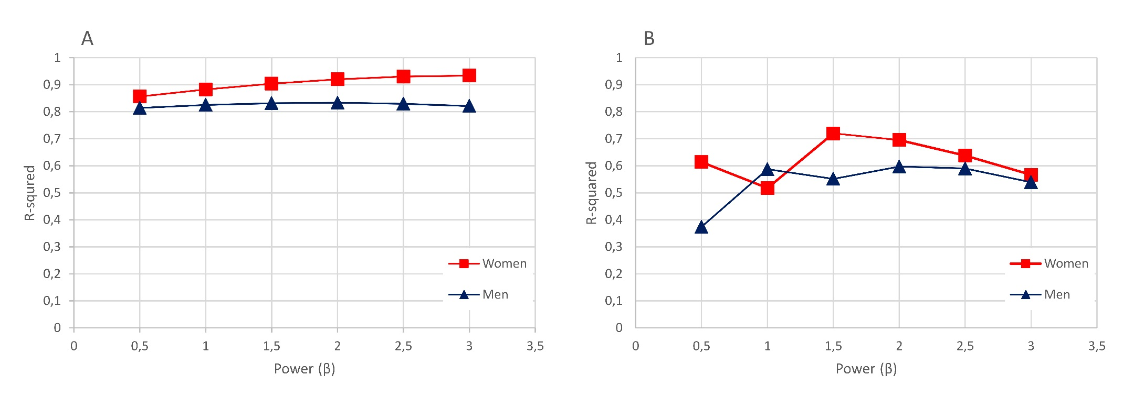
Figure S1 R-squared versus power (β), when BMI is regressed against FM/height^{β} or FFM/height^{β}. Values of β were varied from 0.5 to 3.0 in the increments of 0.5. (A) fat mass index; (B) fat-free mass index.

Table S1 Significant differences in anthropometric measures in the age-gender groups.
Age group | Gender | BF | FM | FMI | FFM | FFMI | BMI
Age group | Gender | (%) | (kg) | (kg/m²) | (kg) | (kg/m²) | (kg/m²)
40-44y | Men | 24.77±5.70 | 22.5±8.59 | 7.14±2.78 | 66.03±6.72 | 20.89±1.52 | 28.03±3.94
40-44y | Women | 33.08±6.75ª | 23.59±9.03 | 8.86±3.19ª | 45.33±4.16ª | 17.15±1.47ª | 26.01±4.37^{b}
45-49y | Men | 25.53±6.56 | 22.98±8.91 | 7.38±2.84 | 64.43±7.25 | 20.65±1.85 | 28.03±4.12
45-49y | Women | 32.83±6.38ª | 22.91±8.11ª | 8.69±3.00ª | 45.02±4.32ª | 17.12±1.64ª | 25.81±4.20^{b}
50-54y | Men | 25.87±6.04 | 22.52±7.86 | 7.35±2.58 | 62.59±6.86 | 20.38±1.74 | 27.73±3.70
50-54y | Women | 34.81±6.36ª | 24.96±8.75ª | 9.64±3.32ª | 44.82±4.37ª | 17.37±1.70ª | 27.01±4.62^{b}
55-59y | Men | 27.06±5.88 | 23.6±7.95 | 7.90±2.67 | 61.68±6.72 | 20.60±1.74 | 28.49±3.87
55-59y | Women | 36.13±6.46ª | 26.20±8.69ª | 10.32±3.36ª | 44.48±4.32ª | 17.57±1.71ª | 27.89±4.64^{b}
60-64y | Men | 27.94±6.08 | 24.2±8.18 | 8.22±2.74 | 60.67±6.32 | 20.62±1.74 | 28.84±3.66
60-64y | Women | 37.43±5.77ª | 27.46±8.39ª | 10.95±3.24ª | 44.39±4.56ª | 17.74±1.77ª | 28.69±4.57
Notes: Data are presented as mean ± standard deviation. ªP<0.001; ^{b}P<0.01 significantly different from men.
Abbreviations: BF, body fat; FM, fat mass; FMI, fat mass index; FFM, fat-free mass; FFMI, fat-free mass index; BMI, body mass index.

Table S2 Significant differences of anthropometric measures across respective age groups, separately for men and women.
Variables | 40-44y | 45-49y | 50-54y | 55-59y | 60-64y | P
Men
BF (%)^{c} | 24.77±5.70 | 25.53±6.56 | 25.87±6.04 | 27.06±5.88 | 27.94±6.08 | <0.001
FM (kg)^{e} | 22.5±8.59 | 22.98±8.91 | 22.52±7.86 | 23.6±7.95 | 24.2±8.18 | <0.05
FMI (kg/m²)^{c} | 7.14±2.78 | 7.38±2.84 | 7.35±2.58 | 7.90±2.67 | 8.22±2.74 | <0.001
FFM (kg)ª | 66.03±6.72 | 64.43±7.25 | 62.59±6.86 | 61.68±6.72 | 60.67±6.32 | <0.001
FFMI (kg/m²) | 20.89±1.52 | 20.65±1.85 | 20.38±1.74 | 20.60±1.74 | 20.62±1.74 | >0.05
BMI (kg/m²)^{d} | 28.03±3.94 | 28.03±4.12 | 27.73±3.70 | 28.49±3.87 | 28.84±3.66 | <0.001
Women
BF (%)ª | 33.08±6.75 | 32.83±6.38 | 34.81±6.36 | 36.13±6.46 | 37.43±5.77 | <0.001
FM (kg)^{b} | 23.59±9.03 | 22.91±8.11 | 24.96±8.75 | 26.20±8.69 | 27.46±8.39 | <0.001
FMI (kg/m²)ª | 8.86±3.19 | 8.69±3.00 | 9.64±3.32 | 10.32±3.36 | 10.95±3.24 | <0.001
FFM (kg) | 45.33±4.16 | 45.02±4.32 | 44.82±4.37 | 44.48±4.32 | 44.39±4.56 | <0.05
FFMI (kg/m²)^{b} | 17.15±1.47 | 17.12±1.64 | 17.37±1.70 | 17.57±1.71 | 17.74±1.77 | <0.001
BMI (kg/m²)^{b} | 26.01±4.37 | 25.81±4.20 | 27.01±4.62 | 27.89±4.64 | 28.69±4.57 | <0.001
Notes: Data are presented as mean ± standard deviation. ªSignificant differences across respective age groups (except the 45-49y age group); ^{b}Significant differences across respective age groups (except the 45-49y and 50-54y age groups); ^{c}Significant differences within the 40-44y, 45-49y, 50-54y group cluster, and the 55-59y, 60-64y age groups; ^{d}Significant differences between the 45-49y and 60-64y age groups, and the 50-54y and 55-59y, 60-64y age group cluster; ^{e}Significant differences between the 50-54y, and 60-64y age groups.
Abbreviations: BF, body fat; FM, fat mass; FMI, fat mass index; FFM, fat-free mass; FFMI, fat-free mass index; BMI, body mass index.
Table S3 Sensitivity analysis. Means and 95% credible intervals of anticipated BF% relative to BMI cut-offs, stratified by age and gender.
Age/gender | BMI = 18.5 kg/m² | BMI = 25.0 kg/m² | BMI = 30.0 kg/m²
Men
40 y | 13.0 (9.4, 16.7) | 21.3 (17.4, 25.2) | 27.6 (23.5, 31.7)
45 y | 13.4 (9.6, 17.2) | 21.6 (17.6, 25.7) | 27.9 (23.8, 32.2)
50 y | 13.8 (9.9, 17.7) | 22.0 (17.9, 26.2) | 28.3 (24.0, 32.7)
55 y | 14.1 (10.1, 18.2) | 22.4 (18.1, 26.7) | 28.7 (24.2, 33.2)
60 y | 14.5 (10.3, 18.7) | 22.7 (18.3, 27.2) | 29.0 (24.5, 33.7)
65 y | 14.9 (10.6, 19.2) | 23.1 (18.6, 27.7) | 29.4 (24.7, 34.2)
Women
40 y | 23.3 (19.6, 27.0) | 31.5 (27.6, 35.4) | 37.8 (33.7, 41.9)
45 y | 23.6 (19.9, 27.5) | 31.8 (27.8, 35.9) | 38.2 (34.0, 42.4)
50 y | 24.0 (20.1, 28.0) | 32.2 (28.1, 36.4) | 38.5 (34.2, 42.9)
55 y | 24.4 (20.3, 28.5) | 32.6 (28.3, 36.9) | 38.9 (34.5, 43.4)
60 y | 24.7 (20.6, 28.9) | 32.9 (28.5, 37.4) | 39.3 (34.7, 43.9)
65 y | 25.1 (20.8, 29.4) | 33.3 (28.8, 37.9) | 39.6 (34.9, 44.4)
Abbreviations: BMI, body mass index.

