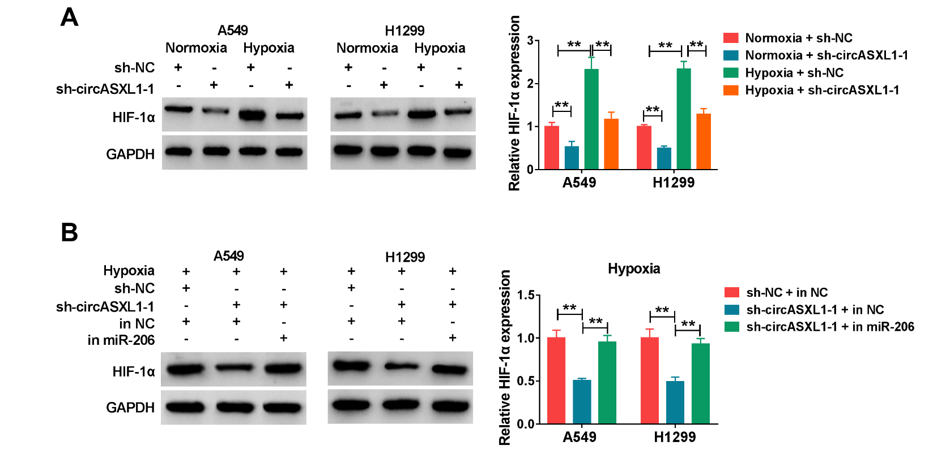
Supplementary Figure S1 CircASXL1 controlled HIF-1α expression by absorbing miR-206. (A) The impacts between hypoxia treatment and circASXL1 absence on HIF-1α protein expression were illustrated by western blot. (B) The influences between circASXL1 silencing and miR-206 inhibitor on the protein expression of HIF-1α under hypoxia were determined by western blot assay.

