Supporting Material

The effects of gold nanoparticles on Leydig cells and male reproductive function in mice

Ying Liu^{a,1}, Xiaojie Li^{a,1}, Shuwen Xiaoª, Xinyi Liuª, Xuanming Chenª, Qiyue Xiaª, Song Lei^{b}, Hongxia Liª, Zhihui Zhong^{c}, Kai Xiao^{a,}*

ª National Chengdu Center for Safety Evaluation of Drugs and National Clinical Research Center for Geriatrics, West China Hospital, Sichuan University, Chengdu, 610041, China
^{b} Department of Pathology, West China Hospital, Sichuan University, Chengdu, 610041, China
^{c} Laboratory of Non-Human Primate Disease Model research, West China Hospital, Sichuan University, Chengdu, 610041, China

¹ The authors contributed equally in the work.
*Correspondence to Dr. Kai Xiao (E-mail: xiaokaikaixiao@scu.edu.cn; Tel: +86-28-83326313)

Figure S-1. (A) The size distribution of AuNPs after 72-h incubation in cell culture medium with 5% horse serum and 2.5% fetal bovine serum were determined by dynamic light scattering (DLS). (B) The zeta potential of AuNPs was measured by DLS.

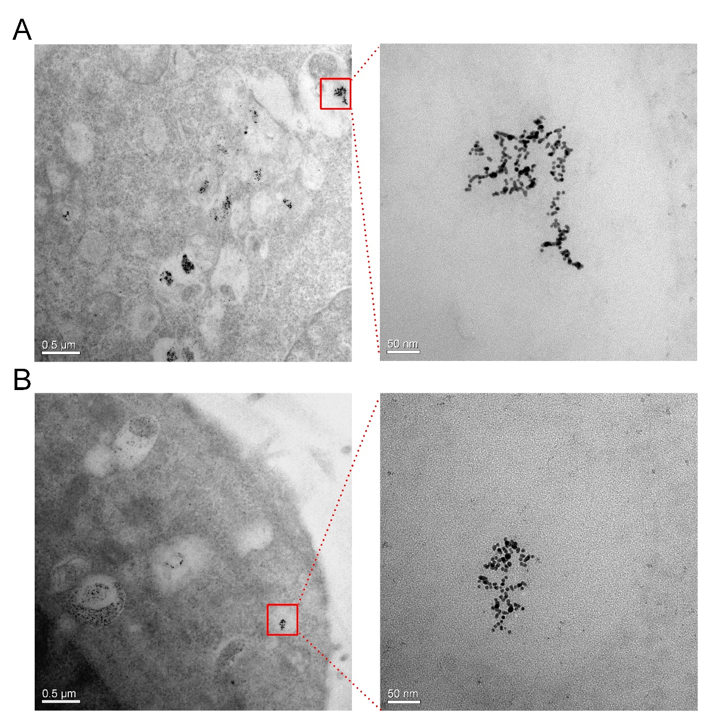
Figure S-2. Representative TEM images of TM3 cells after 48-h (A) or 72-h (B) exposure of AuNPs (5 μg/mL). AuNPs were mainly entrapped in the endosome/lysosome.

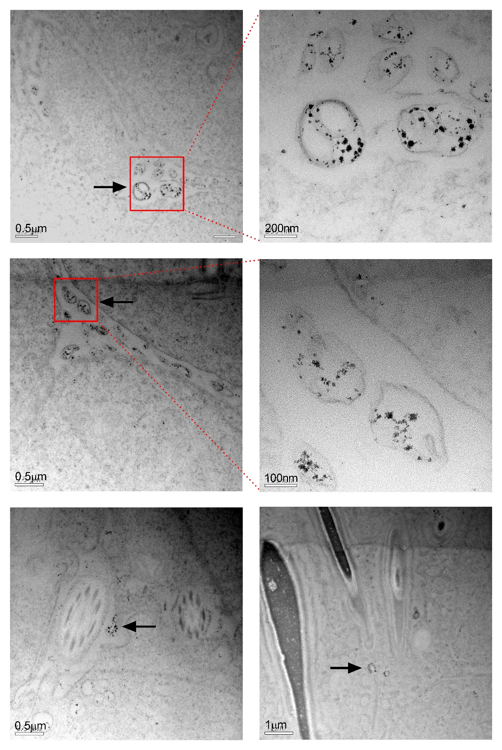
Figure S-3. TEM images of testicular sections in mice treated with 0.5 mg/kg AuNPs on day 14. Black dots (black arrow) in the section were AuNPs, which were obviously present in the testicular section and mainly packed in the vesicles.

