Supplementary data

Sample Power Analysis
Statistical Power of the Manuscript Resistance training modulates the MMP-2 activity in different trabecular bones in aging followed the instruction by Beck¹ and Faul et al².
F tests - ANOVA: Fixed effects, omnibus, (four groups)

Our research investigated we aimed to investigate the effects of RT on MMP-2 activity in the lumbar vertebra (L6), tibia and femur of young and older rats. Thus, which ones were the parameters used to make the calculations including the desired power and magnitude of difference aiming for protein abundance levels ? Refer to figure 1 as you go through the following steps. The G*Power 3.1.9.4 was used to calculate statistical power analysis.
Step 1: We selected “F tests” in the “Test family” panel.
Step 2: In the “Statistical test” panel, select “F tests - ANOVA: Fixed effects, omnibus, (four groups).”

Step 3: In the “Type of power analysis” panel, select “Post hoc: Compute achieved power – given α, sample size, and effect size.”
Step 4: In the “Input Parameters” panel, select “Determine” and this will open-up a new panel that allows the user to calculate the effect size for the protein abundance levels. For example (Pro activity of vertebrae), using the mean and standard deviation of the Table 1 for four groups we can calculate the power of the present study. Such choice is justified because it represents the main dependent variable.
TABLE S1. Pro activity of vertebrae
GROUPS | MEAN | SD
YS | 0.138 | 0.008
YT | 0.150 | 0.03
OS | 0.112 | 0.01
OT | 0.196 | 0.032

Step 5. The “Effect size d²” can be estimated from the mean and standard deviation highlighted (Table 1). To estimate the “Effect size d²” using this method, select “Determine” in the “Input Parameters” panel. Next, select “Calculate,” and “Calculate and transfer to main window.” This will transfer the estimated “Effect size f²” of 0.80 (Figure S1) to the main window. Select 0.05 for the “(1-α err prob), 5 rats for sample size group 1 and 5 rats for sample size group 2. Select “Calculate,” and observe the “Total sample size” of 5 rats required to achieve a power level of 0.95 (Figure S1).
Figure S1.
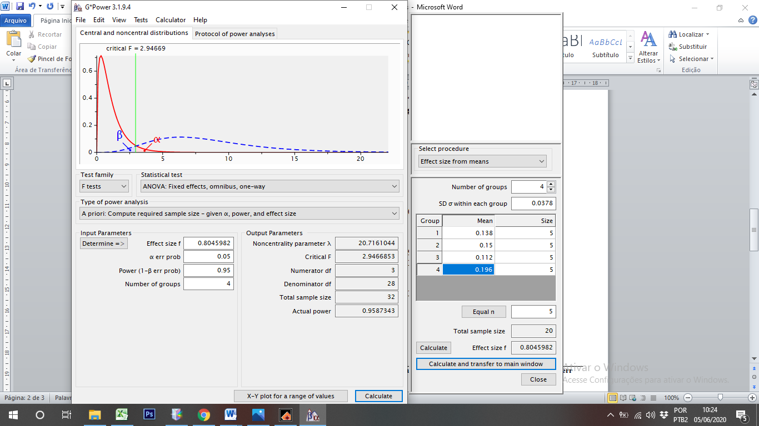
GPower Protocol
F tests - ANOVA: Fixed effects, omnibus
Analysis: A priori: Compute required sample size
Input: Effect size f = 0.8045982
α err prob = 0.05
Power (1-β err prob) = 0.95
Number of groups = 4
Output: Noncentrality parameter λ = 20.7161044
Critical F = 2.9466853
Numerator df = 3
Denominator df = 28
Total sample size = 32
Actual power = 0.9587343

Table S2. Post hoc power analysis of main outcomes

 | Noncentrality parameter λ | Critical F | Numerator df | Denominator df | Power (1-β err prob)
Vertebra
Pro | 20.7161044 | 2.94 | 3 | 28 | 0.958
Intermediate | 19.3823142 | 2.94 | 3 | 28 | 0.952
Active | 20.0203189 | 2.94 | 3 | 28 | 0.952
Femur
Pro | 17.6526084 | 2.94 | 3 | 28 | 0.952
Active | 17.2947030 | 2.94 | 3 | 28 | 0.950
Tibia
Pro | 20.4505958 | 2.94 | 3 | 28 | 0.951
Intermediate | 20.5950424 | 2.94 | 3 | 28 | 0.966
Active | 20.8126907 | 2.94 | 3 | 28 | 0.955

References
1. Beck TW. The importance of a priori sample size estimation in strength and conditioning research. J Strength Cond Res. Aug 2013;27(8):2323-2337.

2. Faul F, Erdfelder E, Lang AG, Buchner A. G*Power 3: a flexible statistical power analysis program for the social, behavioral, and biomedical sciences. Behav Res Methods. May 2007;39(2):175-191.

Table S3. Description of the p-values of factors (diet and training) and interaction
 | Anova Two-way indepedent
 | Main effects
 | P-value  (aging fator) | P-value (exercice) | P-value  (Interaction)
Vertebra
Pro | 0.336 | 0.0003 | 0.003
Intermediate | 0.004 | 0.083 | 0.124
Active | 0.327 | 0.0002 | 0.023
Femur
Pro | 0.517 | 0.662 | 0.576
Active | 0.699 | 0.698 | 0.944
Tibia
Pro | 0.0001 | 0.0011 | 0.466
Intermediate | 0.0072 | 0.4181 | 0.115
Active | 0.0003 | 0.0001 | 0.127

