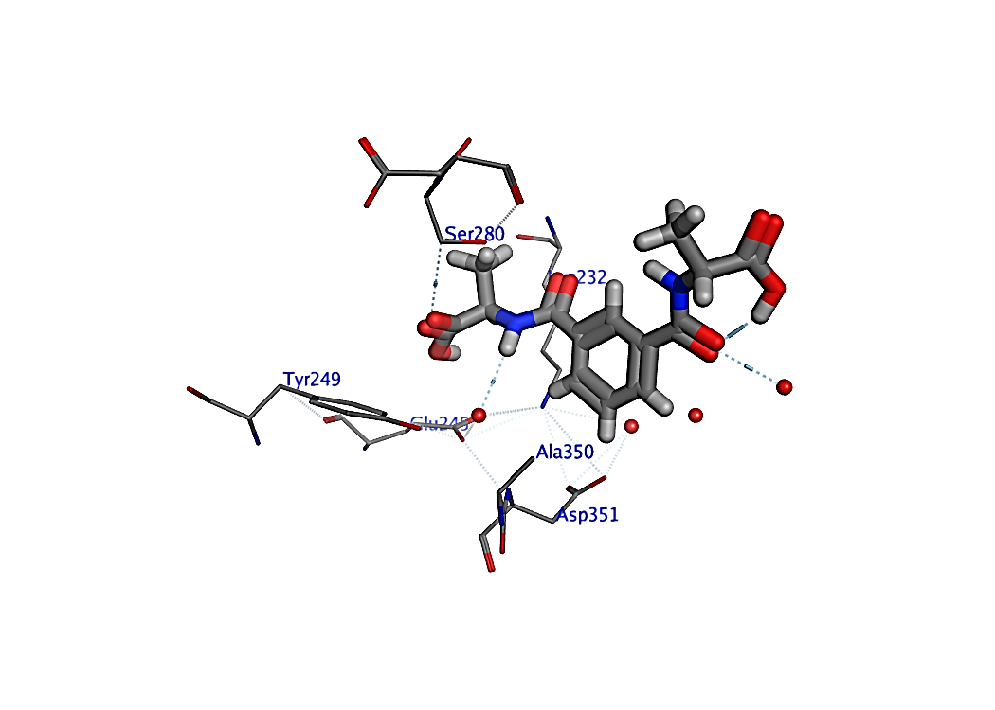
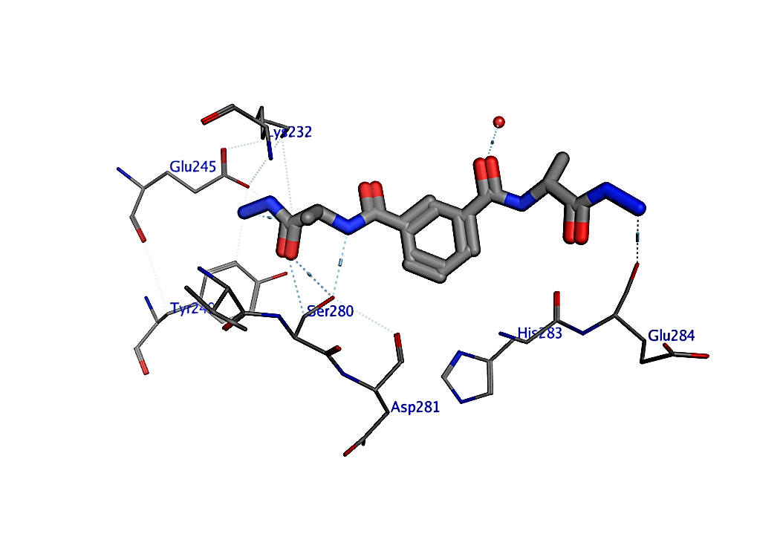
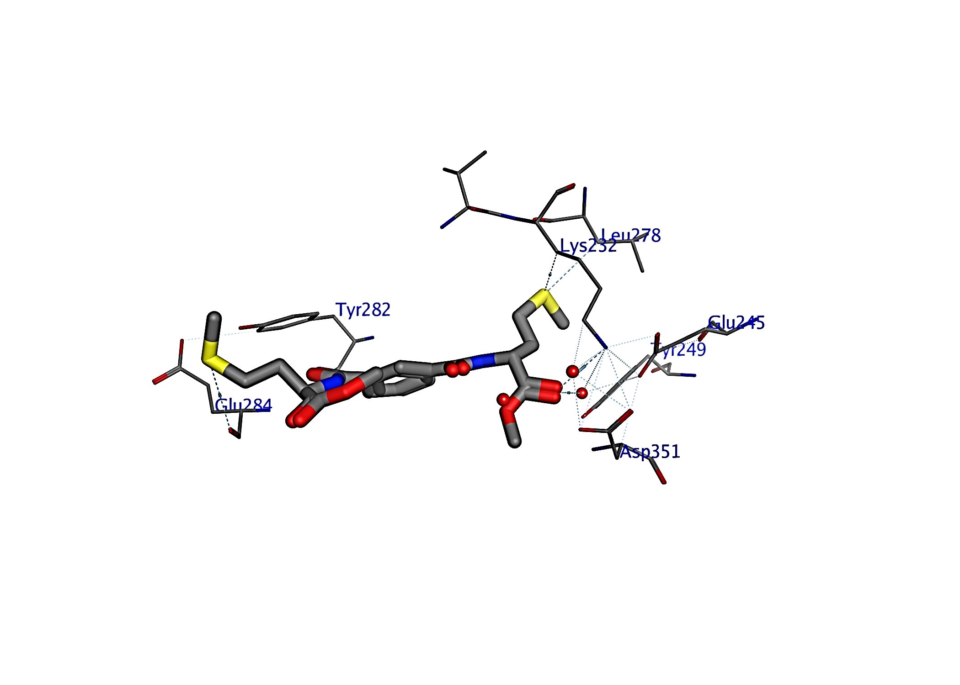
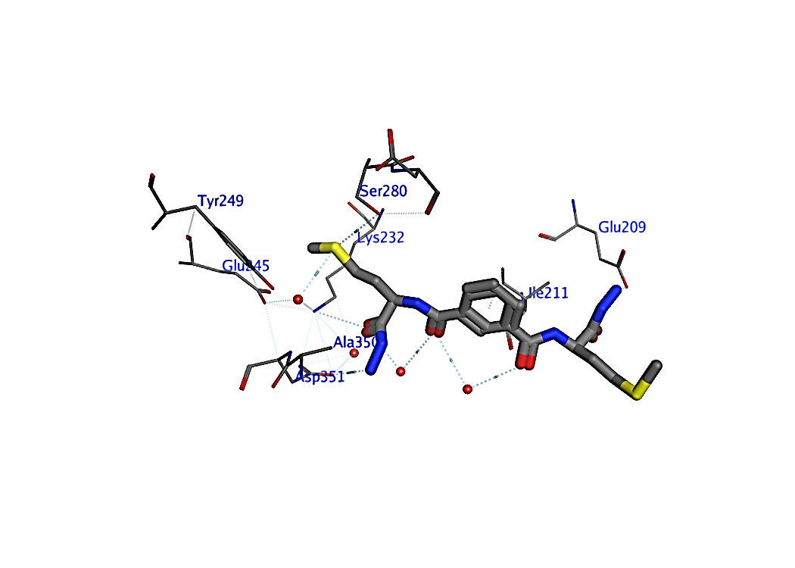
5
7
6
8

Figure S1: The binding mode of tested compounds into the activesite of 1EA1, H-bond represented as blue dashad color yellow dashed showed π- π interaction.

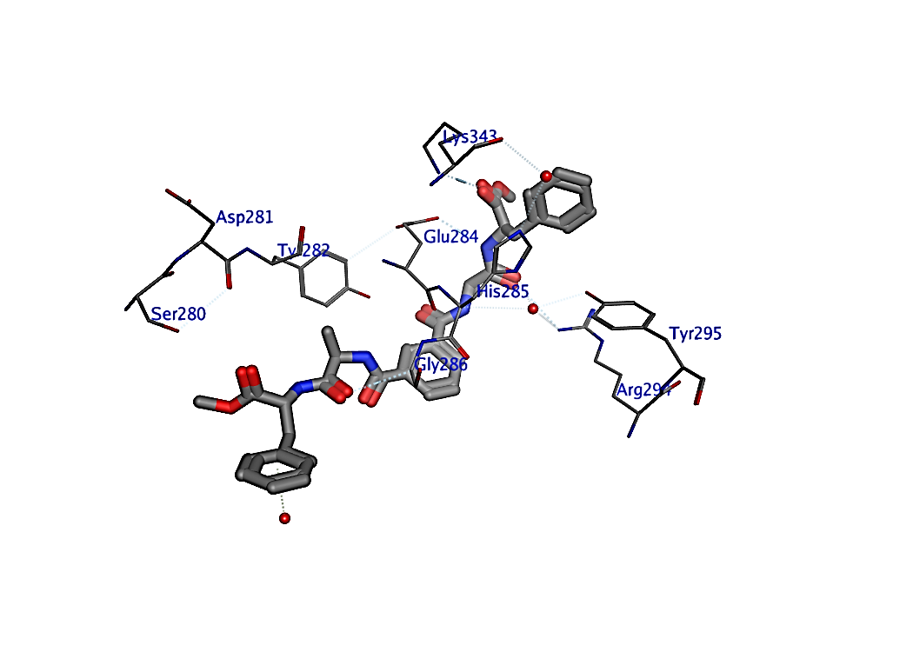
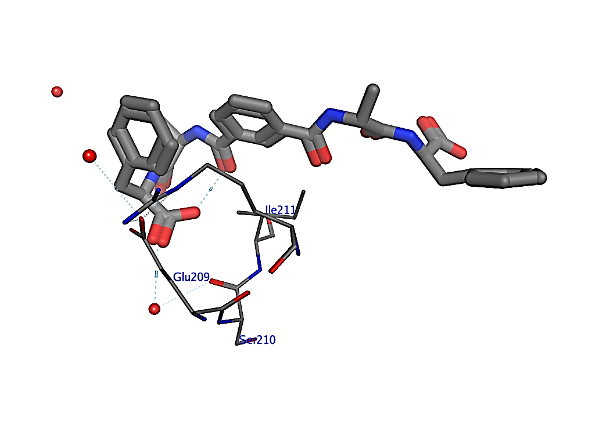
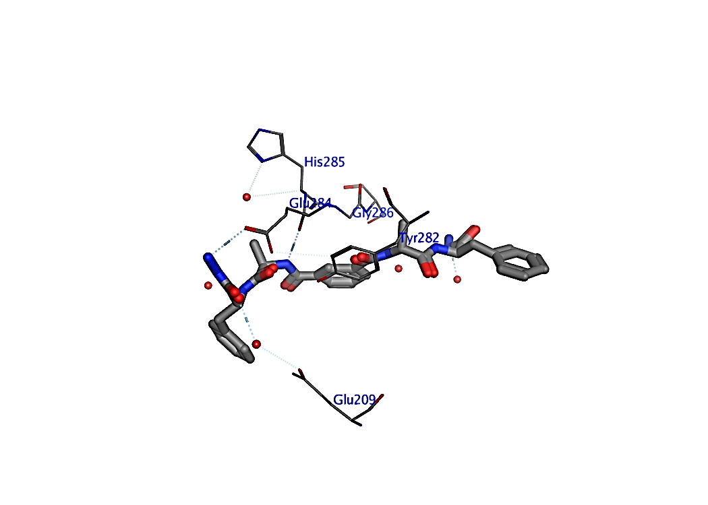
9
10
11

Figure S2: The binding mode of tested compounds into the activesite of 1EA1, H-bond represented as blue dashad color yellow dashed showed π- π interaction.

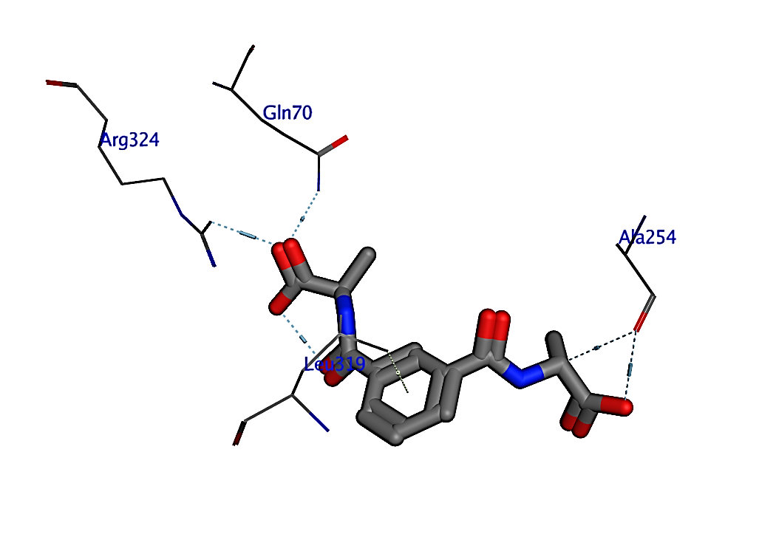
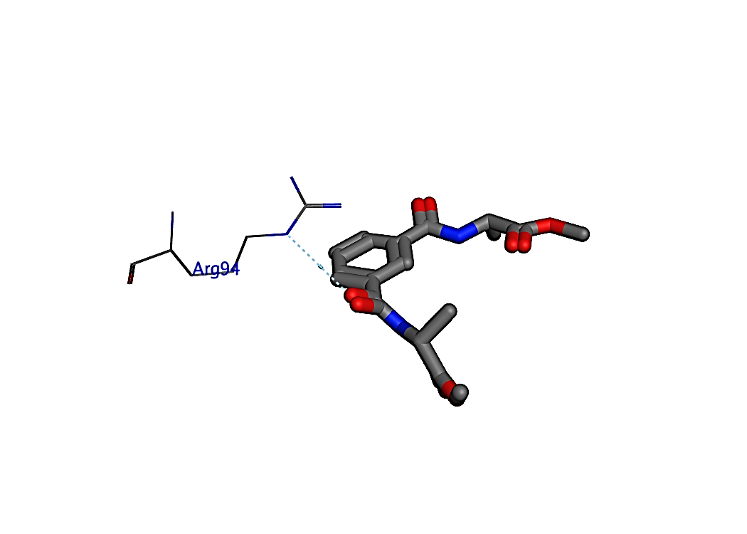
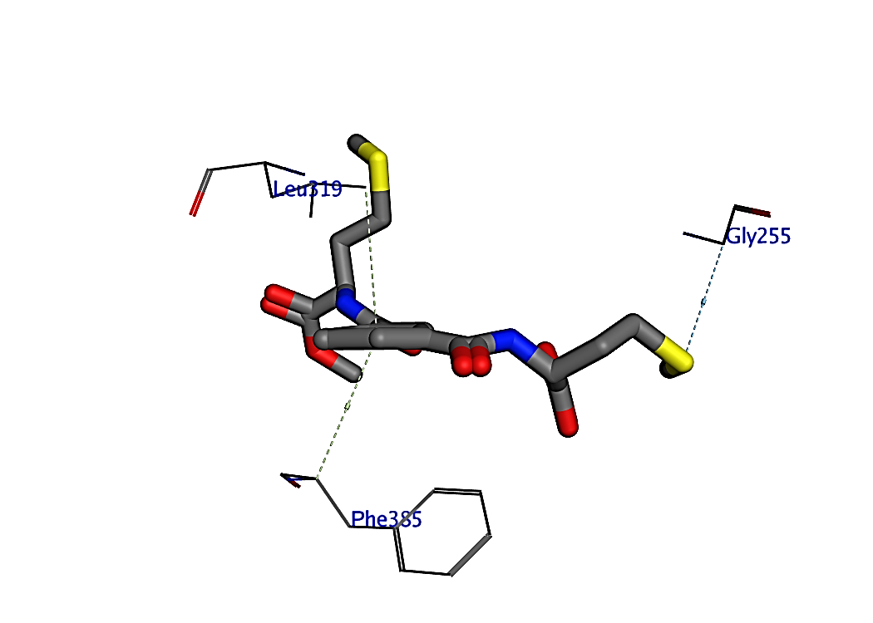
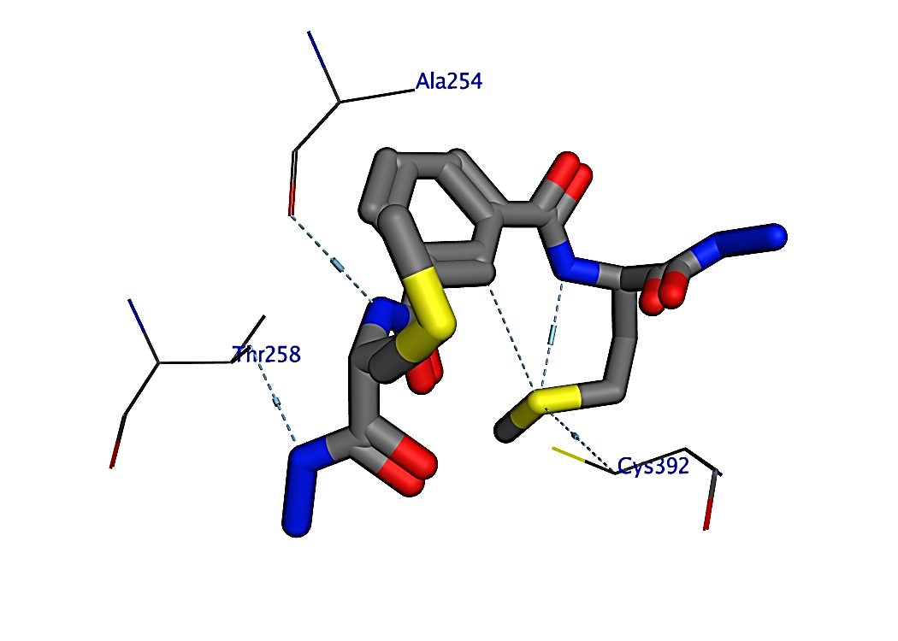
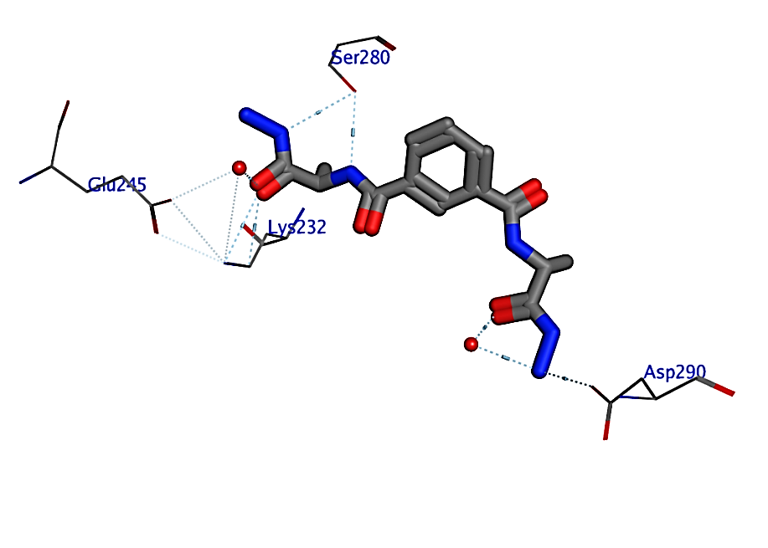
3
5
6
8
7

Figure S3: The binding mode of tested compounds into the activesite of 1VJY, H-bond represented as blue dashad color and yellow dashed showed π- π interaction.

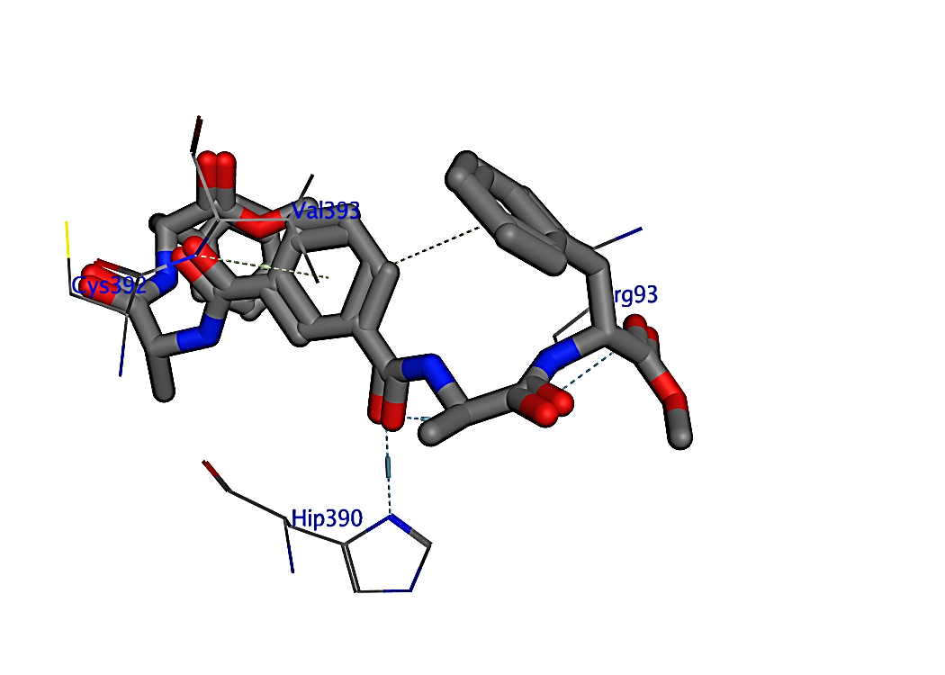
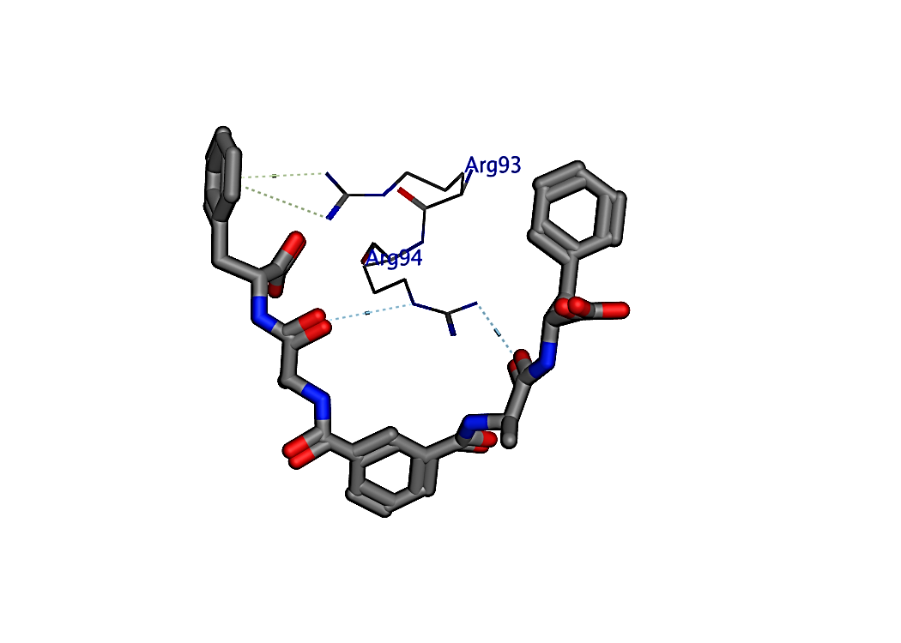
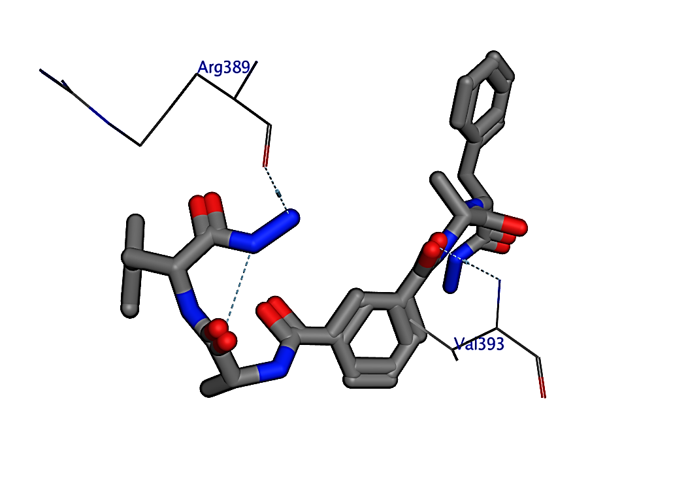
10
9
11

Figure S4: The binding mode of tested compounds into the activesite of 1VJY, H-bond represented as blue dashad color yellow dashed showed π- π interaction.

Table (S1): Key interactions of the newly designed Ligands with active sites for (ID: 4uro) DNA Gyrase B :
Atom | Receptor |  |  | Interaction | Distance | E (kcal/mol)

Compound (3)
O10 | ALA | 64 |  | H-acceptor | 2.87 | -0.9

Compound (4)
O10 | ALA | 64 |  | H-acceptor | 3.17 | -1.2
O10 | ASN | 65 |  | H-acceptor | 3.56 | -0.7
S25 | HOH | 2006 |  | H-acceptor | 3.7 | -1.5

Compound (5)
O22 | THR | 171 |  | H-donor | 2.87 | -1.4
O10 | ALA | 64 |  | H-acceptor | 2.87 | -0.9

Compound (6)
O10 | ALA | 64 |  | H-acceptor | 2.86 | -1.1
O10 | ASN | 65 |  | H-acceptor | 3.23 | -1.5
S27 | HOH | 2006 |  | H-acceptor | 3.64 | -1.5

Compound (7)
N24 | THR | 171 |  | H-donor | 2.25 | 45.2
O10 | ALA | 64 |  | H-acceptor | 2.87 | -0.9

Compound (8)
N30 | THR | 171 |  | H-donor | 2.36 | 18.5
O10 | ALA | 64 |  | H-acceptor | 2.86 | -1.1
O10 | ASN | 65 |  | H-acceptor | 3.23 | -1.5
S27 | HOH | 2006 |  | H-acceptor | 3.64 | -1.5

Compound (9)
O45 | THR | 171 |  | H-acceptor | 3.38 | -1.2
O45 | THR | 171 |  | H-acceptor | 3.07 | -0.8

Compound (10)
O44 | THR | 171 |  | H-acceptor | 3.38 | -1.2
O44 | THR | 171 |  | H-acceptor | 3.07 | -0.8

Compound (11)
O45 | THR | 171 |  | H-acceptor | 3.38 | -1.4
O45 | THR | 171 |  | H-acceptor | 3.07 | -0.9
N46 | THR | 171 |  | H-acceptor | 2.28 | 736.7

Table (S2): Key interactions of the newly designed Ligands with active sites for (ID:1EA1) Candida albicans lanosterol 14-α-demethylase
Atom | Receptor | Interaction | Distance | E (kcal/mol)

3
C17 | ALA254 | H-donor | 3.2 | -0.8
C20 | HIP390 | H-donor | 3.36 | -0.7
O37 | ALA254 | H-donor | 2.94 | -3.2
O34 | GLN70 | H-acceptor | 3.15 | -0.7
O34 | TYR74 | H-acceptor | 3.09 | -1.2
O34 | ARG324 | H-acceptor | 2.94 | -5.1
6-ring | LEU319 | pi-H | 4.05 | -0.6

7
O16 | THR  258 | H-acceptor | 2.95 | -0.7
O34 | SER  259 | H-acceptor | 2.8 | -1.8

8
N15 | ALA254 | H-donor | 2.89 | -1.8
N33 | THR258 | H-donor | 2.79 | -0.7
S40 | GLY394 | H-donor | 3.81 | -0.9
S40 | GLY394 | H-acceptor | 3.72 | -0.9
S48 | CYS392 | H-acceptor | 3.58 | -0.8

9
NH133 | ARG94 | H-acceptor | 2.69 | -1.8
NE 34 | ARG94 | H-acceptor | 3.48 | -0.8
N 78 | TYR74 | H-acceptor | 2.88 | -2.2
6-ring | ARG 93 | pi-cation | 3.73 | -1.2
6-ring | ARG94 | pi-cation | 4.31 | -0.5

10
O14 | ARG93 | H-acceptor | 2.9 | -1.9
O14 | HIP390 | H-acceptor | 3.08 | -7.5
O80 | ARG93 | H-acceptor | 3.07 | -0.5
6-ring | VAL 393 | pi-H | 4.22 | -0.9

11
N57 | ARG389 | H-donor | 2.98 | -1.9
O14 | VAL393 | H-acceptor | 3.49 | -0.7

Table (S3): Key interactions of the newly designed Ligands with active sites (ID: 1VJY) transforming growth factor (TGF) for β-receptor type I (β-RI):
Atom | Receptor | Interaction | Distance A° | E (kcal/mol)

Compound 3
N15 | HOH1001 | H-donor | 3.39 | -1.3
O14 | HOH1028 | H-acceptor | 2.87 | -1.9
O34 | SER280 | H-acceptor | 3.44 | -0.7

Compound 5
S44 | GLU284 | H-donor | 3.91 | -0.6
O32 | LYS232 | H-acceptor | 2.92 | -8.7
O32 | HOH1001 | H-acceptor | 2.95 | -0.9
S36 | LYS232 | H-acceptor | 3.7 | -0.6
S36 | LEU278 | H-acceptor | 3.5 | -0.5

Compound 6
N15 | SER280 | H-donor | 3.15 | -2.1
N35 | SER280 | H-donor | 3.27 | -1.1
N42 | ILE211 | H-donor | 2.93 | -2.3
N42 | ASP290 | H-donor | 2.95 | -1.1
O14 | HIS283 | H-acceptor | 3.6 | -0.5
O33 | HOH1028 | H-acceptor | 2.81 | -1.1
O34 | LYS232 | H-acceptor | 3 | -1.7
O34 | LYS232 | H-acceptor | 3.17 | -0.6
O34 | HOH1001 | H-acceptor | 2.9 | -1.3
N42 | HOH1028 | H-acceptor | 3.02 | -1.5

Compound 7
S40 | SER280 | H-donor | 3.62 | -0.7
N53 | ASP351 | H-donor | 2.96 | -3.6
N56 | GLU209 | H-donor | 3.28 | -0.5
O14 | HOH1028 | H-acceptor | 3.49 | -1
O16 | HOH1028 | H-acceptor | 3.58 | -0.6
O16 | HOH1030 | H-acceptor | 3.54 | -0.9
O32 | LYS232 | H-acceptor | 3.53 | -0.5
O32 | HOH1030 | H-acceptor | 3.28 | -0.7
O32 | HOH1050 | H-acceptor | 2.99 | -2.3
S40 | SER280 | H-acceptor | 3.62 | -1.3
S40 | HOH1001 | H-acceptor | 3.38 | -1.5
S48 | HOH1007 | H-acceptor | 4.03 | -0.8
6-ring | ILE211 | pi-H | 3.75 | -1.1

Compound 9
O78 | HOH1031 | H-acceptor | 3.23 | -1.9

Compound 10
N15 | HIS283 | H-donor | 3.2 | -0.5
N60 | GLU284 | H-donor | 2.91 | -3.9
O33 | ARG294 | H-acceptor | 3.44 | -2.6
O34 | GLY286 | H-acceptor | 3.4 | -1.3
O80 | LYS343 | H-acceptor | 3.09 | -5.3
6-ring | HOH1030 | pi-H | 3.24 | -0.5

Compound 11
N15 | GLU284 | H-donor | 3.02 | -4.5
N57 | GLU284 | H-donor | 3.03 | -2.9
O56 | HOH1111 | H-acceptor | 3.05 | -2.3
N82 | HOH1030 | H-acceptor | 2.95 | -1.2

Compound 3
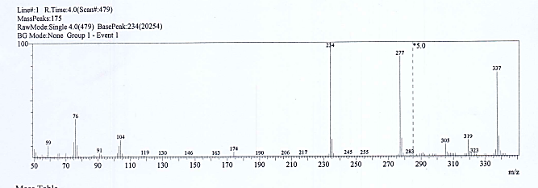

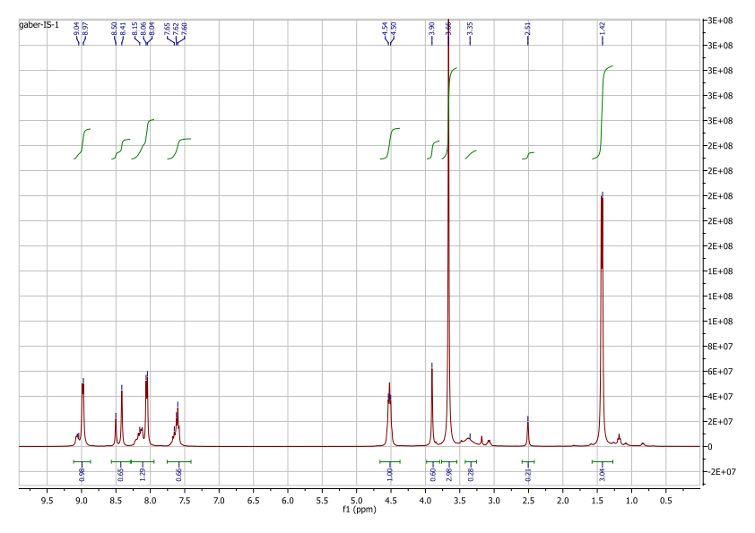

Compound 4
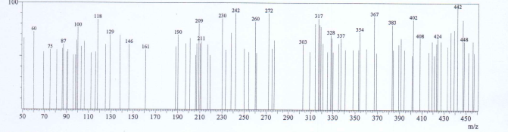
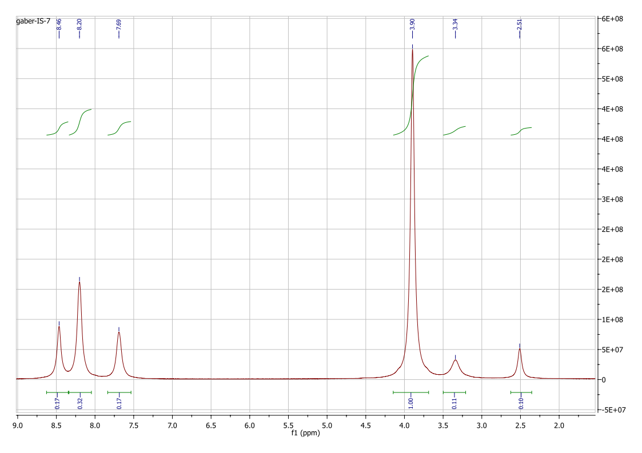
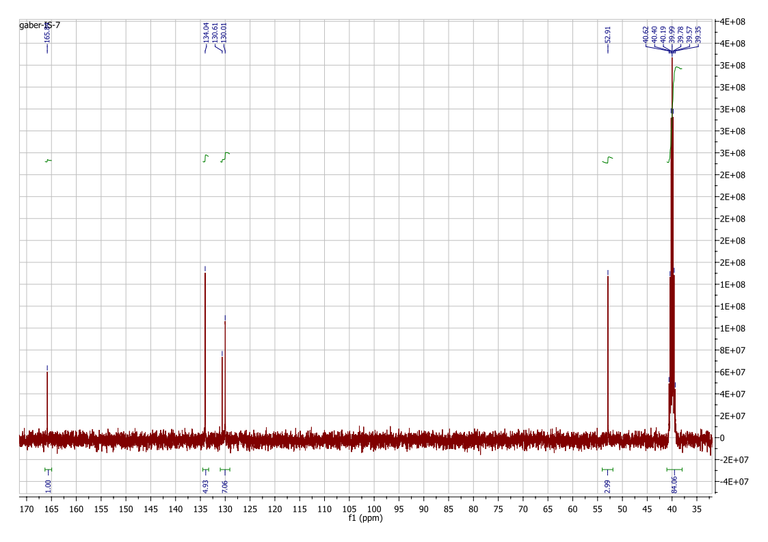

Compound 5
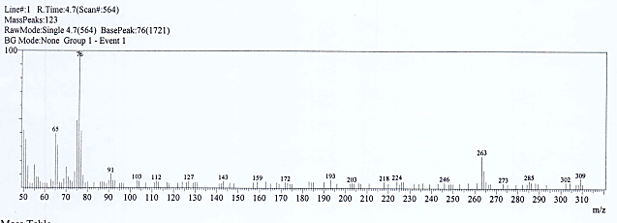
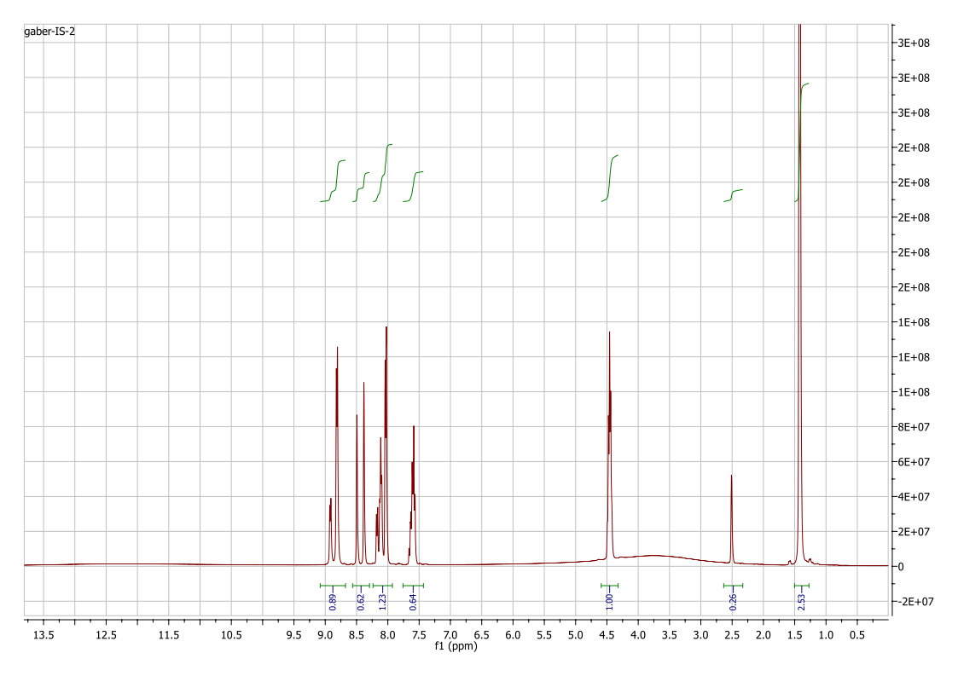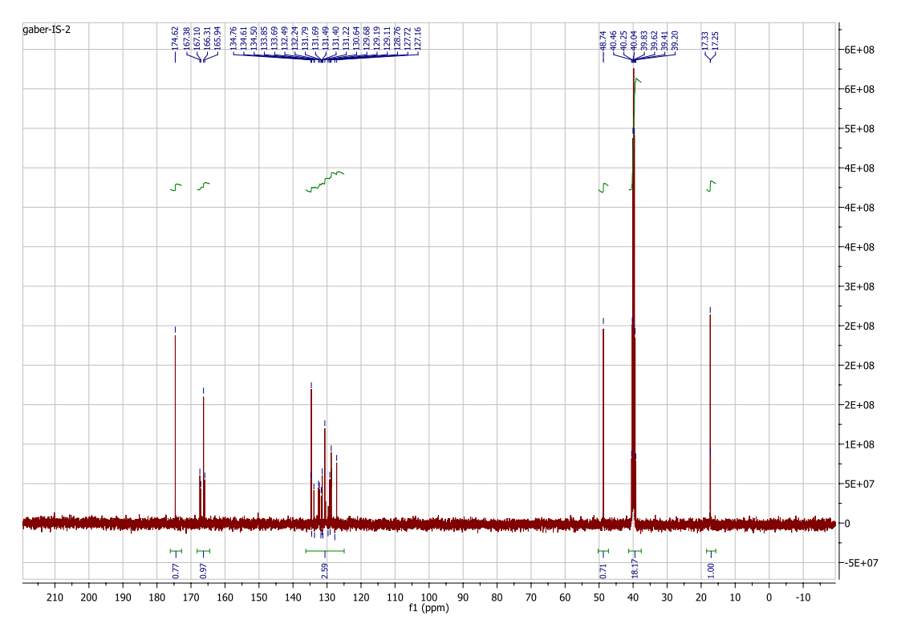

Compound 6
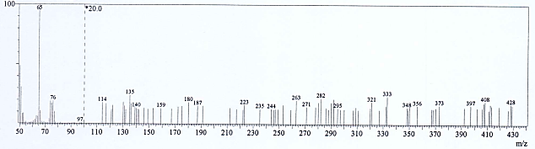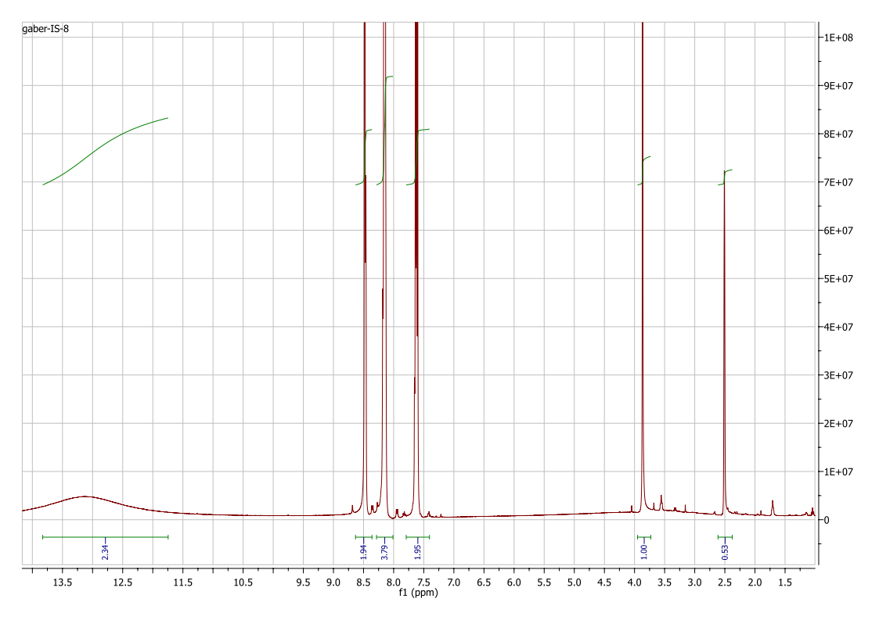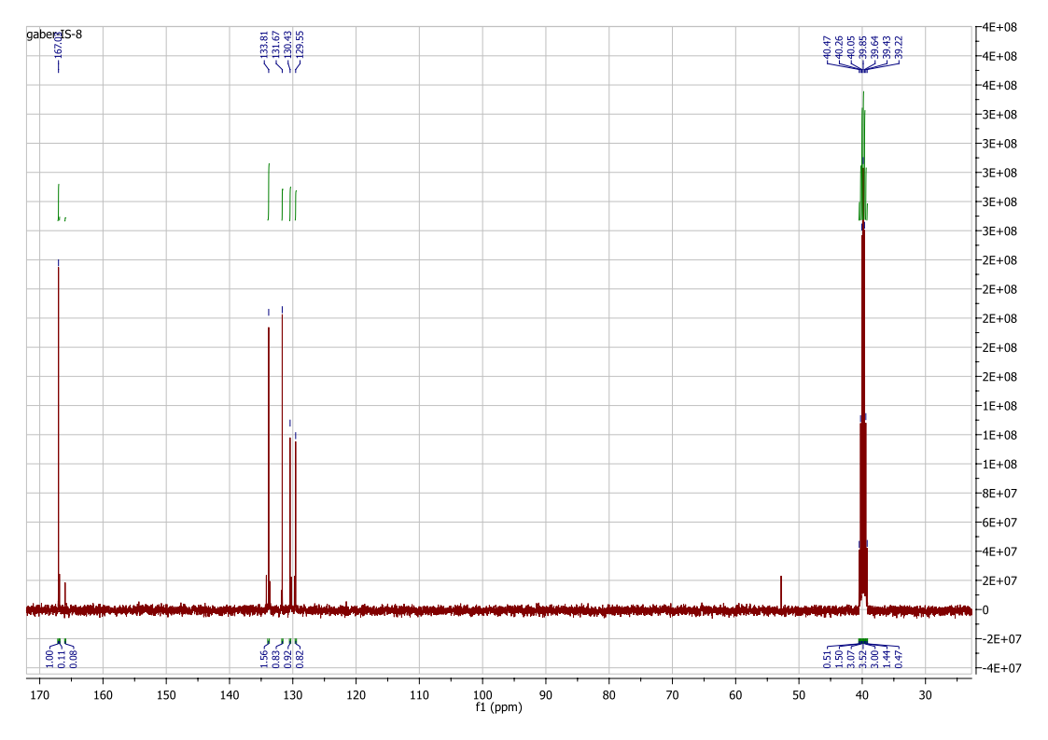

Compound 7
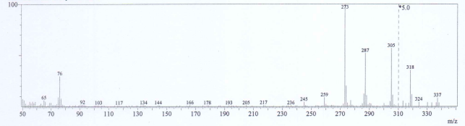
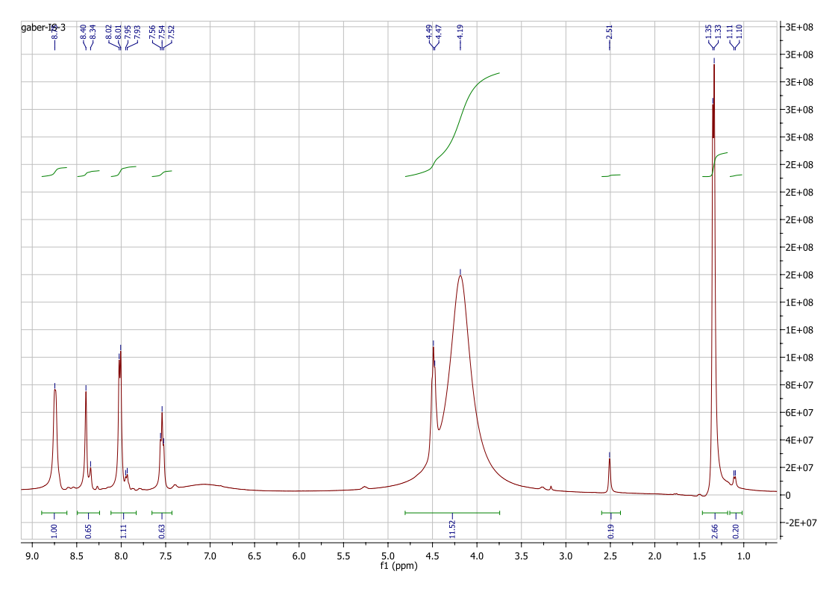
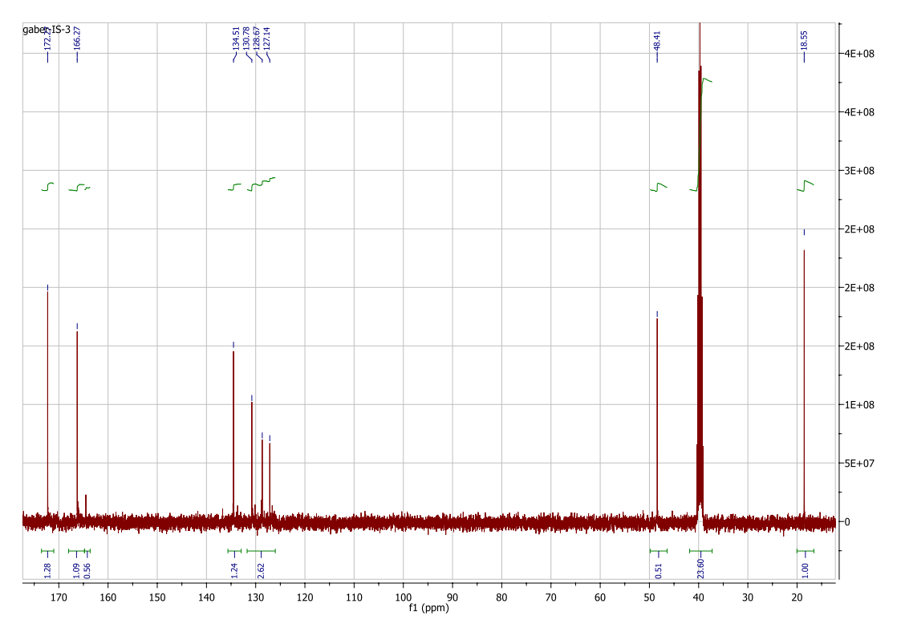

Compound 8
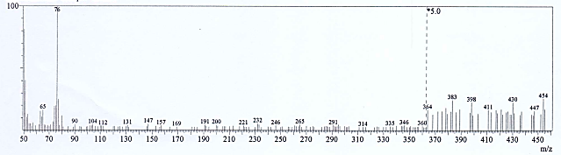
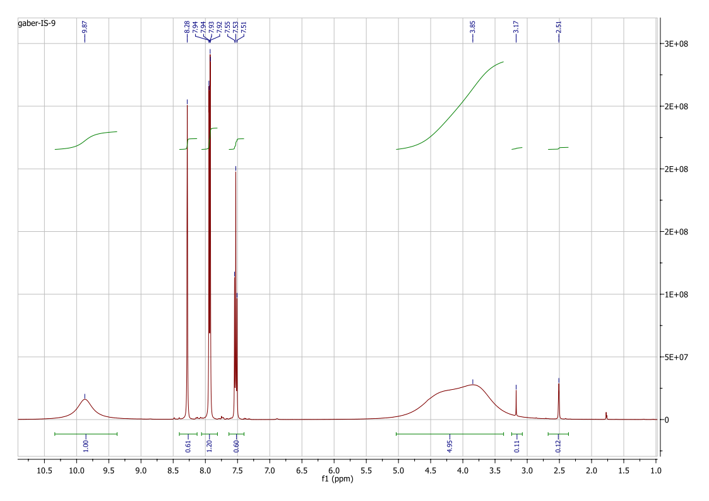
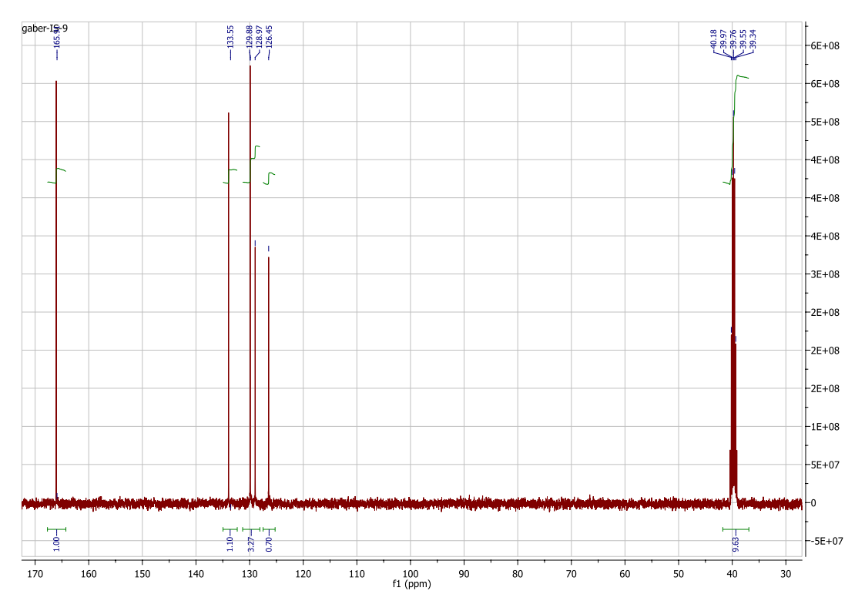

Compound 9
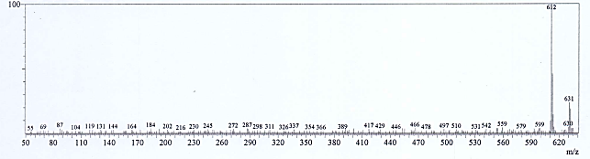
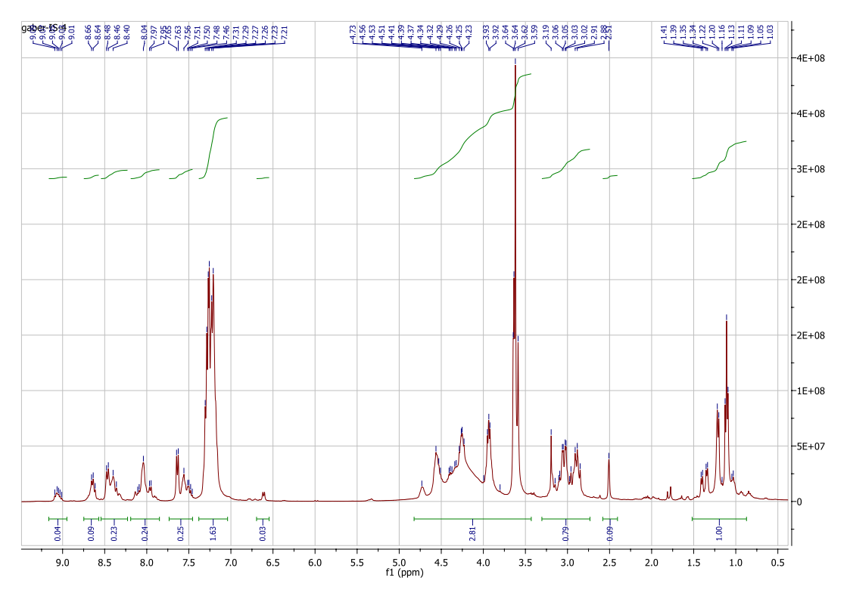

Compound 10
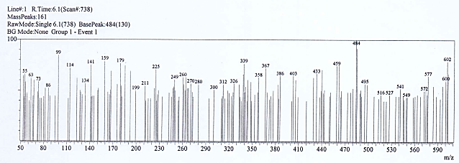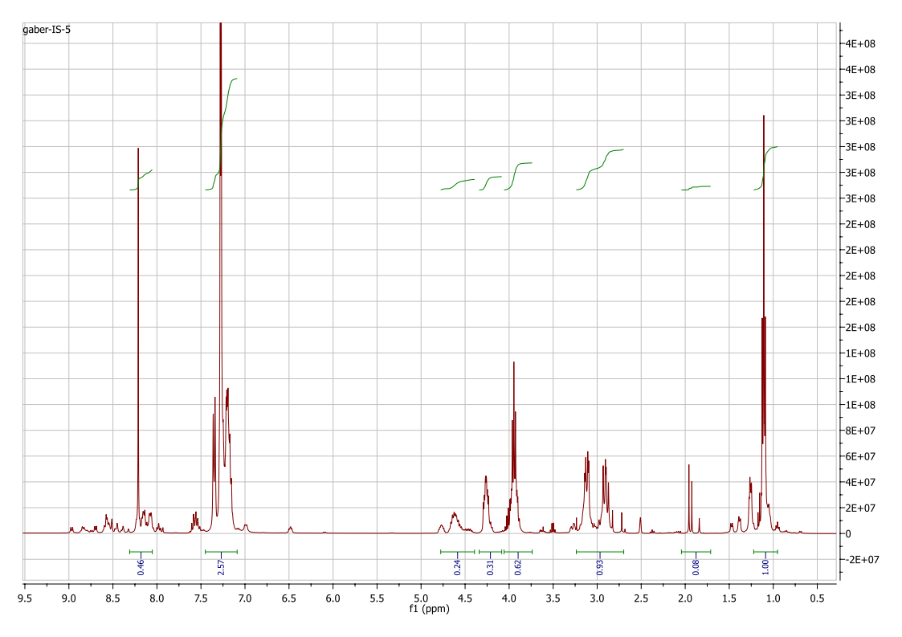

Compound 11
