Supplementary Information
A GSH Responsive Nanoprodrug System Based on Self-Assembly of Amphiphilic Lactose Modified Camptothecin for Targeted Drug Delivery and Combination Chemotherapy
Chenxi Hou^{a+}, Ning Ma^{a+}, Ziyan Shenª, Guanyu Chiª, Shuang Chaoª, Yuxin Peiª, Lan Chen ^{b}, Yuchao Lu^{b*}, Zhichao Pei^{a*}

ª Shaanxi Key Laboratory of Natural Products & Chemical Biology, College of Chemistry and Pharmacy, Northwest A&F University, Yangling, Shaanxi 712100, P. R. China
^{b} Analysis Center of College of Science & Technology, Hebei Agricultural University, Huanghua, Hebei 061100, P. R. China

*Corresponding author.
E-mail address: peizc@nwafu.edu.cn and luyuchao@hebau.edu.cn
Tel: +86 29 87091196; Fax: +86 29 87092769
⁺these authors contributed equally to this work.

I. Syntheses and characterization
1-1. Synthesis of compound 4
Scheme S1. Synthetic route of compound 4.
Compound 1: Sodium hydroxide(2.5 g, 62.5 mmol) in water(10 mL) was added to Tetraethylene glycol (10 g, 51.49 mmol) in tetrahydrofuran (20 mL). Then Tosyl chloride (8 g, 41.96 mmol) in tetrahydrofuran (40 mL) was added and the solution was stirred for 2 h at 25°C until material disappeared mearsured by TLC. The solvents were removed under vacuum. The remaining solid was disolved in CH₂Cl₂ (30 mL) and washed with H₂O (20 mL). Then wash the aqueous layer twice with dichloromethane and combine the organic phases. The organic phase was dried over Na₂SO₄, concentrated under vacuum and subjected to silica gel chromatography (PE/EA, v/v = 1:1) to give 1 (5.56 g, 31 %). ¹H NMR (500 MHz, CDCl₃, ppm) δ 7.80 (d, J = 8.0 Hz, 2H, Ph-H), 7.34 (d, J = 8.5 Hz, 2H, Ph-H), 4.17 (t, J = 4.5 Hz, 2H, CH₂), 3.72 - 3.68 (m, 4H, CH₂), 3.67 - 3.62 (m, 4H, CH₂), 3.60 (t, J = 4.5 Hz, 6H, CH₂), 2.45 (s, 3H, Me), 2.30 (s,1H, OH)。
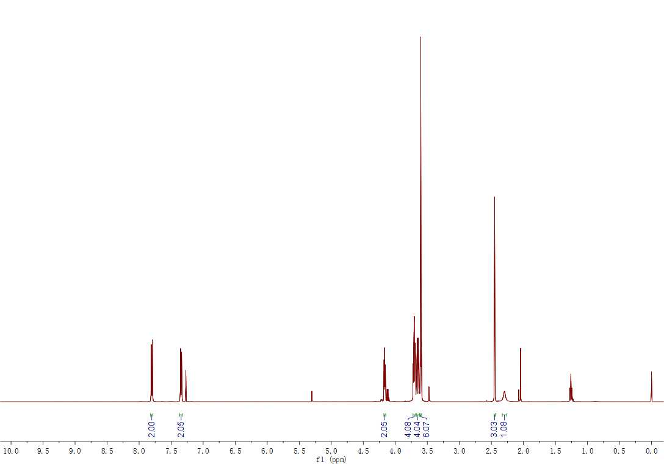
Figure S1. ¹H NMR spectrum (500 MHz, CDCl₃) of 1.
Compound 2: Lactose (15 g, 43.8 mmol) and I₂ (276 mg, 1.09 mmol) was added into Acetic anhydride (120 mL, 1331.5 mmol) and stirred at 25°C until solid dissolved completely. Saturated NaHSO₃ aqueous solution was added to the reaction solution to remove the unreacted I₂. Then washed with CH₂Cl₂ three times and added saturated Na₂CO₃ aqueous solution to neutralize unreacted acetic anhydride until no gas generation. Then collected the organic phases and dried it with Na₂SO₄. Concentrated under vacuum and subjected to silica gel chromatography (PE: EA=1:1) to give 2 (27.57 g, 95%). ¹H NMR (500 MHz, CDCl₃, ppm) δ 6.25 (d, J = 3.5 Hz, 1H, -O-CH-CH-), 5.46 (t, J = 10 Hz, 1H, -O-CH-CH-), 5.35 (d, J = 3 Hz, 1H, -O-CH-CH-), 5.12 (dd, J = 8, 10.5 Hz, 1H, -O-CH-CH-), 4.97 (ddd, J = 4, 12, 21 Hz, 2H, -O-CH-CH-), 4.49 - 4.42 (m, 2H, -O-CH₂-CH-), 4.16 - 4.07 (m, 3H, -O-CH₂-CH- and -O-CH-CH-), 4.02 - 3.97 (m, 1H, -O-CH-CH-), 3.88 (t, J = 6.5 Hz, 1H, -O-CH-CH-), 3.81 (t, J = 9.5 Hz, 1H, -O-CH-CH-), 2.18 (s, 3H, -CO-CH₃), 2.16 (s, 3H, -CO-CH₃), 2.12 (s, 3H, -CO-CH₃), 2.06 (d, J = 1.5 Hz, 6H, -CO-CH₃), 2.05 (s, 3H, -CO-CH₃), 2.00 (s, 3H, -CO-CH₃), 1.96 (s, 3H, -CO-CH₃).¹
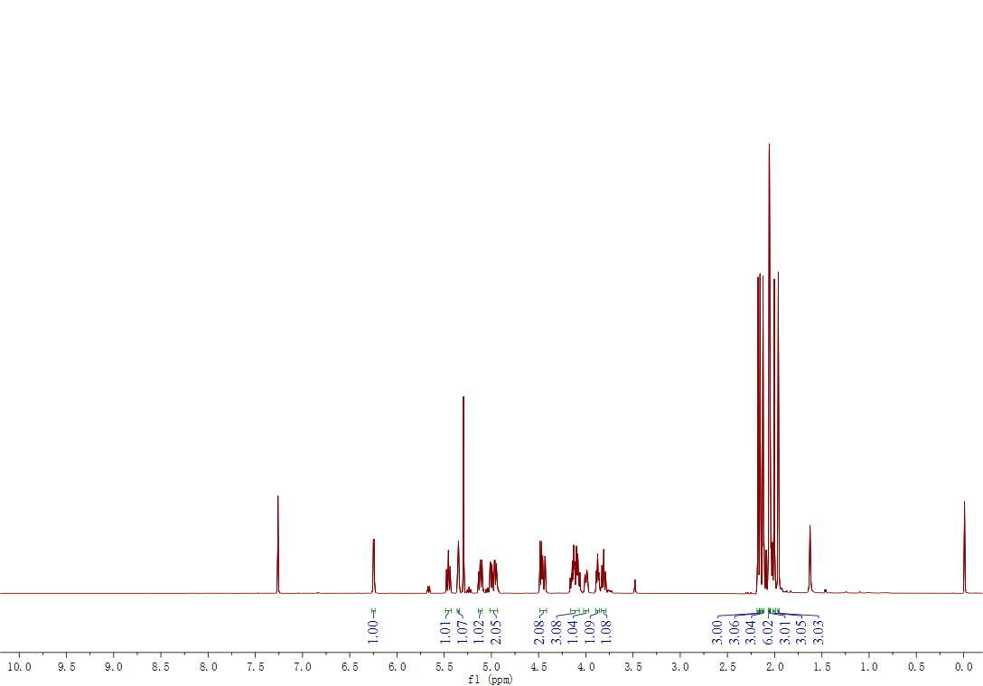
Figure S2. ¹H NMR spectrum (500 MHz, CDCl₃) of 2.
Compound 3: Compound 1 (5.22 g, 15 mmol) and compound 2 (6.63 g, 10 mmol) was added into 50 mL round-bottomed flask and added 30 mL dry CH₂Cl₂ under N₂. Then BF₃.OEt₂ (3.8 mL, 25 mmol）was added dropwise in 0℃. The reaction was stirred at 25°C for 24 h. Saturated NaHCO₃ aqueous solution was added into the reaction solution until no gas generation. Extractanted with CH₂Cl₂ twice and combine the organic phases. Then washed the organic phases with saturated NaCl and dry it with Na₂SO₄. Concentrated under vacuum and subjected to silica gel chromatography (PE: EA=1:1) to give 3 (1.8 g, 19%). ¹H NMR (500 MHz, CDCl₃, ppm) δ 7.81 (d, J = 8.5 Hz, 2H, Ph-H), 7.36 (d, J = 8.0 Hz, 2H, Ph-H), 5.31 (d, J = 3.0 Hz, 1H, -O-CH-CH-), 5.15 (t, J = 9.5 Hz, 1H, -O-CH-CH-), 5.07 (dd, J = 8.0, 10 Hz, 1H, -O-CH-CH-), 4.92 (dd, J = 3.5, 10.5 Hz, 1H, -O-CH-CH-), 4.86 (t, J = 8.5 Hz, 1H, -O-CH-CH-), 4.53 (d, J = 8.0 Hz, 1H, -O-CH-CH-), 4.48 - 4.42 (m, 2H, -O-CH₂-CH-), 4.13 (t, J = 4.5 Hz, 2H, -O-CH₂-CH₂-), 4.11 - 4.03 (m, 3H, -O-CH₂-CH- and -O-CH-CH-), 3.90 - 3.82 (m, 2H, -O-CH-CH-), 3.77 (t, J = 9.5 Hz, 1H, -O-CH-CH-), 3.65 (t, J = 4.5 Hz, 2H, -O-CH₂-CH₂-), 3.63 - 3.51 (m, 12H, -O-CH₂-CH₂-), 2.42 (s, 3H, -CO-CH₃), 2.12 (s, 3H, -CO-CH₃), 2.08 (s, 3H, -CO-CH₃), 2.03 (s, 3H, -CO-CH₃), 2.01 (s, 3H, -CO-CH₃), 2.00 (s, 3H, -CO-CH₃), 1.93 (s, 3H, -CO-CH₃).

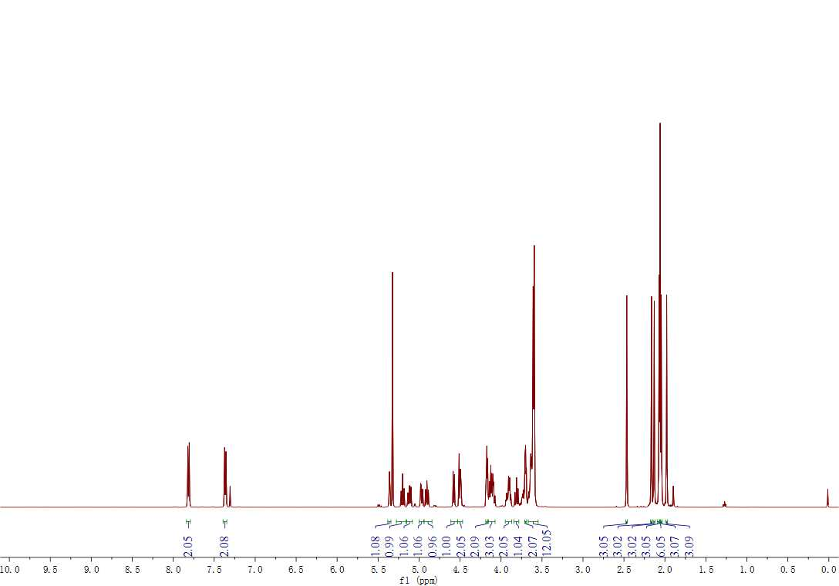
Figure S3. ¹H NMR spectrum (500 MHz, CDCl₃) of 3.
Compound 4: Compound 3 (810.3 mg, 0.85 mmol) and NaN₃ (72 mg, 1.11 mmol) in 3 mL DMF was added into round-bottomed flask and reacted at 60℃ for 24 h. After the reaction is over, CH₂Cl₂ was added and washed with water five times. Concentrated the organic phase under vacuum to give compound 4 (670.57 mg, 96%). ¹H NMR (500 MHz, CDCl₃, ppm) δ 5.39 (d, J = 3.0 Hz, 1H, -O-CH-CH-), 5.23 (t, J = 9.5 Hz, 1H, -O-CH-CH-), 5.15 (dd, J = 8.0, 10 Hz, 1H, -O-CH-CH-), 4.99 (dd, J = 3.5, 10.5 Hz, 1H, -O-CH-CH-), 4.93 (t, J = 8.0 Hz, 1H, -O-CH-CH-), 4.61 (d, J = 8.0 Hz, 1H, -O-CH-CH-), 4.55 - 4.49 (m, 2H, -O-CH₂-CH-), 4.18 - 4.11 (m, 3H, -O-CH₂-CH- and -O-CH-CH-), 3.97 - 3.89 (m, 2H, -O-CH₂-CH-), 3.83 (t, J = 9.5 Hz, 1H, -O-CH₂-CH-), 3.73 - 3.64 (m, 14H, -O-CH₂-CH₂-), 3.43 (t, J = 5.0 Hz, 2H, -O-CH₂-CH₂-), 2.19 (s, 3H, -CO-CH₃), 2.16 (s, 3H, -CO-CH₃), 2.10 (s, 3H, -CO-CH₃), 2.08 (d, J = 1.5 Hz, 9H, -CO-CH₃), 2.01 (s, 3H, -CO-CH₃).
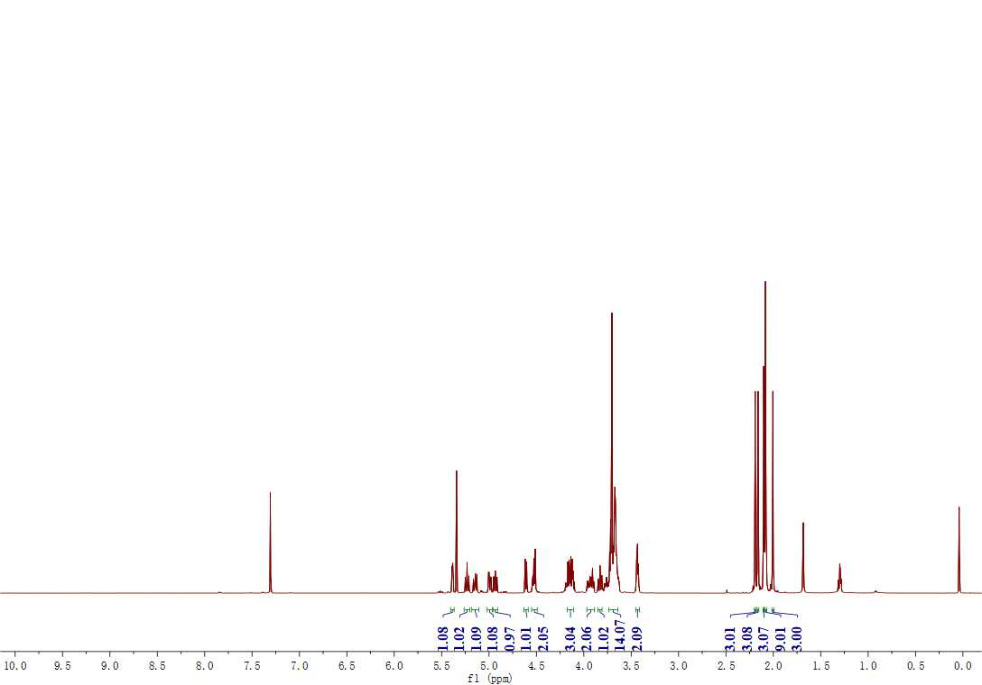
Figure S4. ¹H NMR spectrum (500 MHz, CDCl₃) of 4.
1-2. Synthesis of compound 6
Scheme S2. Synthetic route of compound 6.
Compound 5: Bis(2-hydroxyethyl) Disulfide (146.2 mg, 0.95 mmol) in 2 mL THF was added into 10 mL round-bottomed flask and NaH (18 mg, 0.75 mmol) was added into the reaction slowly at 0℃ until no gas generation. Then 3-Bromopropyne (57.1 mg, 0.48 mmol) was added dropwise under N₂. The reaction wad stirred at 25℃ for nine hours until the reaction is complete which was monitored by TLC. Filteredd, dried, added 15 mL water and washed with CH₂Cl₂ for three times. Collected the organic phase and dried with Na₂SO₄. Finally separated by column chromatography (PE: EA=5: 1) to give compound 5 (29.54 mg, 32%). ¹H NMR (500 MHz, CDCl₃, ppm) δ 4.20 (d, J = 2.0 Hz, 2H, -O-CH₂-C–), 3.92 - 3.89 (m, 2H, -O-CH₂-CH₂-), 3.81 (t, J = 6.5 Hz, 2H, -O-CH₂-CH₂-), 2.94 (t, J = 6.0 Hz, 2H, -O-CH₂-CH₂-), 2.89 (t, J = 6.0 Hz, 2H, -O-CH₂-CH₂-), 2.46 (t, J = 2.5 Hz, 1H, -C-CH), 2.00 (s, 1H, -OH).²
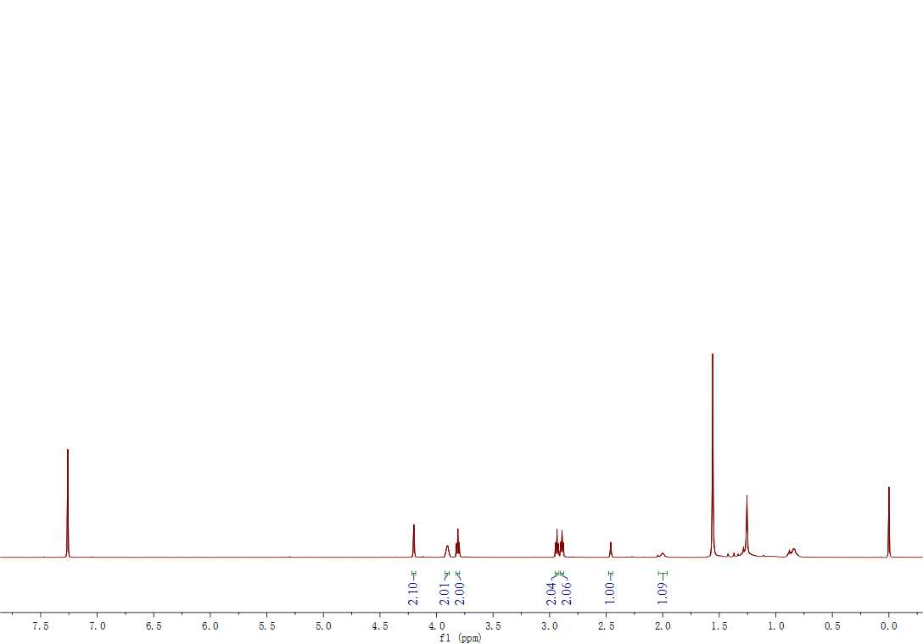
Figure S5. ¹H NMR spectrum (500 MHz, CDCl₃) of 5.
Compound 6: Triphosgene (15.8 mg, 0.05 mmol) in dry CH₂Cl₂ (1 mL) was added into Camptothecin (50 mg, 0.14 mmol) and DMAP (64.5 mg 0.53 mmol) in dry CH₂Cl₂ (1 mL) under N₂ and stirred at 25℃ for 30 min until the reaction becomes clear. Then compound 5 (27.6 mg, 0.14 mmol) in dry CH₂Cl₂ was added dropwise into the above mixed solution and reacted for one night until the reaction was ended which was mitorred by TLC. Added 20 mL CH₂Cl₂ and washed with 10 mL water for three times and saturated NaCl once. Next, the organic phase was dried with Na₂SO₄. Finally separated by column chromatography (PE: EA=2: 1) to give compound 6 (34.97 mg, 43%). ¹H NMR (500 MHz, CDCl₃, ppm) δ 8.40 (s, 1H, alkene-H), 8.23 (d, J = 8.5 Hz, 1H, alkene-H), 7.94 (d, J = 8.0 Hz, 1H, Ph-H), 7.84 (t, J = 7.5 Hz, 1H, Ph-H), 7.68 (t, J = 7.0 Hz, 1H, Ph-H), 7.33 (s, 1H, Ph-H), 5.7 (d, J = 17.0 Hz, 1H, -O-CH₂-C-, H_{a}), 5.4 (d, J = 17.0 Hz, 1H, -O-CH₂-C-, H_{b}), 5.30 (s, 2H, -N-CH₂-C-), 4.42 - 4.32 (m, 2H, -O-CH₂-CH₂-), 4.12 (d, J = 2.5 Hz, 2H, -O-CH₂-C–), 3.71 (t, J = 6.5 Hz, 2H, -O-CH₂-CH₂-), 2.98 - 2.91 (m, 2H, -O-CH₂-CH₂-), 2.87 (t, J = 6.5 Hz, 2H, -O-CH₂-CH₂-), 2.44 (t, J = 2.0 Hz, 1H, -C≡CH), 2.31 - 2.25 (m, 1H), 2.19 - 2.12 (m, 1H), 1.00 (t, J = 7.5 Hz, 3H, -CH₂-CH₃).
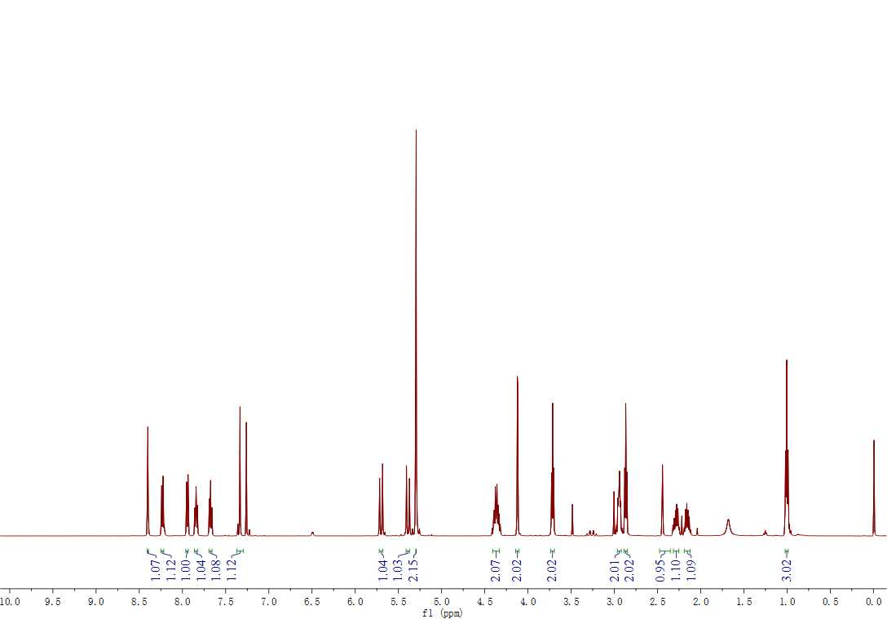
Figure S6. ¹H NMR spectrum (500 MHz, CDCl₃) of 6.
1-3. Synthesis of amphiphilic lactose-Camptothecin molecular Lac-SS-CPT
Scheme S3. Synthetic route of compound Lac-SS-CPT.
Compound 7: Compound 4 (90 mg, 0.11 mmol) , 6 (88.6 mg, 0.16 mmol) and CuSO₄.5H₂O (10 mg, 0.04 mmol) in 1 mL CH₂Cl₂ was added into 10 mL round-bottomed flask and VaNa (25 mg, 0.13 mmol) dissoved in 1 mL H₂O was added under N₂. The reaction was stirred at room temperature for 24 h until the reaction was end which was mitorred by TLC. 15 mL CH₂Cl₂ (15 mL) was added. Then washed with water(15 mL) for three times and saturated NaCl (15 mL) once. Collected the organic phase and dry it with Na₂SO₄. Finally, separated by column chromatography (DCM: MeOH=50: 1) to give compound 7 (131 mg, 86%). ¹H NMR (500 MHz, CDCl₃, ppm) δ 8.39 (s, 1H, alkene-H), 8.21 (d, J = 8.5 Hz, 1H, alkene-H), 7.93 (d, J = 8.0 Hz, 1H, Ph-H), 7.82 (t, J = 7.5 Hz, 1H, Ph-H), 7.70 (s, 1H, Ph-H), 7.65 (t, J = 7.5 Hz, 1H, Ph-H), 7.31 (s, 1H, triazole-H), 5.68 (d, J = 17.5 Hz, 1H, -O-CH₂-C-, H_{a}), 5.37 (d, J = 17.0 Hz, 1H, -O-CH₂-C-, H_{b}), 5.32 (d, J = 3.0 Hz, 1H, -O-CH-CH-), 5.28 (s, 1H, -O-CH-CH-), 5.17 (t, J = 9.5 Hz, 1H, -O-CH-CH-), 5.08 (dd, J = 8.0, 10 Hz, 1H, -O-CH-CH-), 4.94 (dd, J = 3.5, 10.5 Hz, 1H, -O-CH-CH-), 4.86 (dd, J = 8.0, 9.0 Hz, 1H, -O-CH-CH-), 4.58 - 4.44 (m ,7H, -O-CH-CH- and -O-CH₂-CH-), 4.38 - 4.29 (m, 2H, -N-CH₂-C-), 4.13 - 4.04 (m, 3H, -O-CH₂-CH- and -O-CH-CH-), 3.90 - 3.82 (m, 4H, -O-CH₂-C and -O-CH₂-CH-), 3.77 (t, J = 9.5 Hz, 1H, -O-CH₂-CH-), 3.69 - 3.55 (m, 14H, -O-CH₂-CH₂-), 2.89 (t, J = 7.0 Hz, 2H, -O-CH₂-CH₂-), 2.84 (t, J = 6.5 Hz, 2H, -O-CH₂-CH₂-), 2.31 - 2.22 (m, 1H, -O-CH-CH-), 2.12 (s, 3H, -CO-CH₃), 2.09 (s, 3H, -CO-CH₃), 2.04 (s, 3H, -CO-CH₃), 2.02 (d, J = 2.5 Hz, 6H, -CO-CH_{3,}), 2.00 (s, 3H, -CO-CH₃), 1.94 (s, 3H, -CO-CH₃), 1.86 (s, 2H, -CH₂-CH₃), 0.99 (t, J = 7.5 Hz, 3H, -CH₂-CH₃). ¹³C NMR (125 MHz, CDCl₃, ppm) δ 170.36, 170.34, 170.14, 170.04, 169.77, 169.63, 169.10, 167.30, 157.30, 153.46, 152.33, 148.92, 146.54, 145.62, 131.22, 130.73, 129.72, 128.53, 128.23, 128.10, 120.25, 101.09, 100.63, 95.97, 78.03, 77.33, 77.08, 76.83, 76.30, 72.86, 72.66, 71.69, 71.01, 70.70, 70.66, 70.58, 70.53, 70.50, 70.29, 69.45, 68.34, 67.09, 66.66, 64.32, 62.03, 60.81, 53.46, 50.23, 50.04, 38.80, 36.48, 31.90, 20.87, 20.82, 20.71, 20.63, 20.50, 7.65. HRMS: m/z calcd for [M+Na]⁺ C₆₂H₇₇N₅NaO₂₈S₂, 1426.4093, found: 1426.3984.³
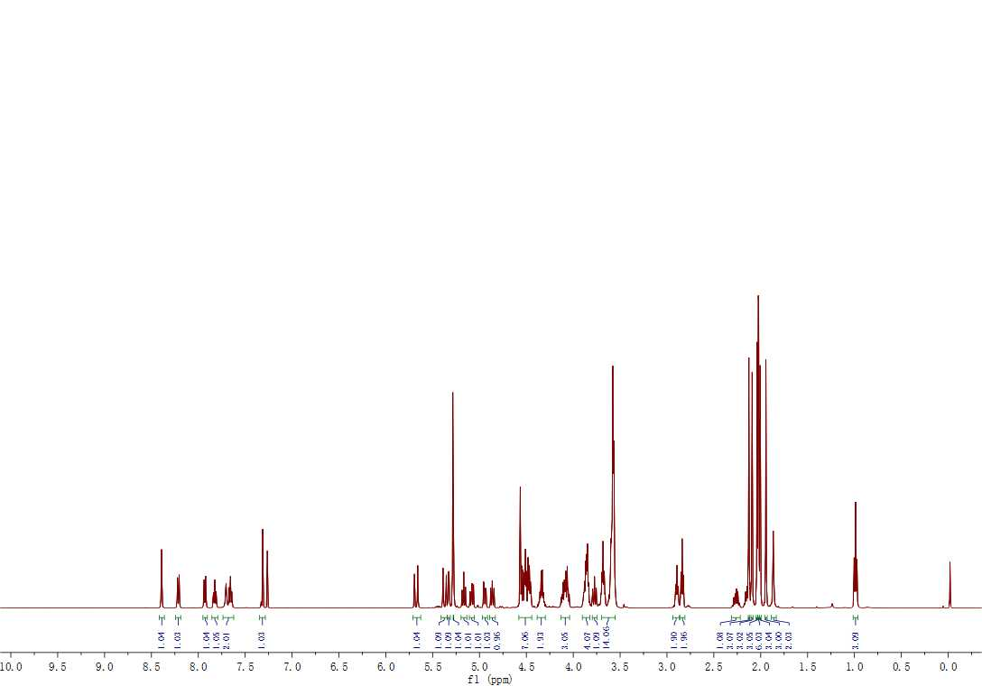
Figure S7. ¹H NMR spectrum (500 MHz, CDCl₃) of 7.
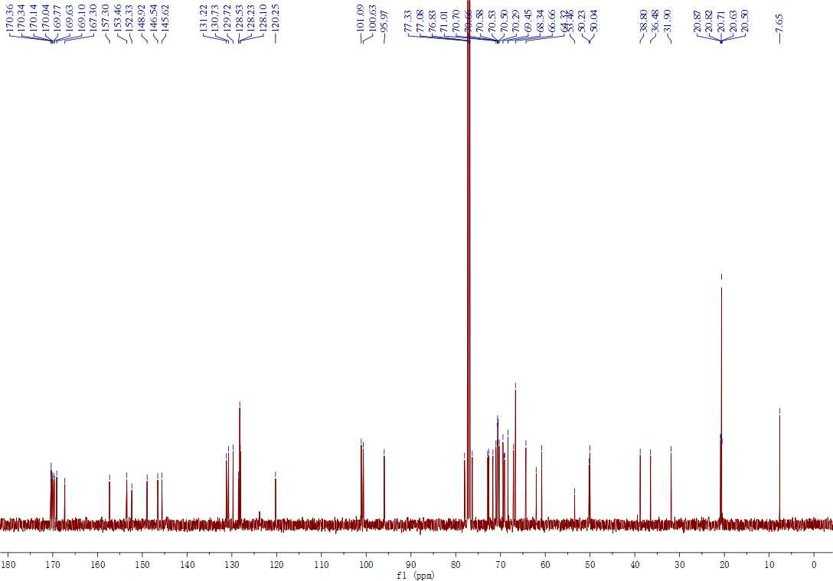
Figure S8. ¹³C NMR spectrum (125 MHz, CDCl₃) of 7.
Figure S9. High resolution mass spectrometry of 7.
Compound Lac-SS-CPT: Compound 7 (100 mg, 0.07 mmol) and CH₃ONa (19.7 mg, 0.36 mmol) in 3 mL CH₃OH was added into 10 mL round-bottomed flask and stirred at room temperature for 30 min until the reaction was end which was mitorred by TLC. Then ion-exchange resin (Amberlite IR 120 H+) was added to neutralized until pH 7, filtered, and the solvent was removed under reduced pressure to give Lac-SS-CPT (62.8 mg, 82%). ¹H NMR (500 MHz, DMSO-d₆, ppm) δ 8.71 - 8.60 (m, 1H, alkene-H), 8.47 (s, 1H, alkene-H), 8.21 - 8.09 (m, 2H, Ph-H), 8.07 (s,1H, Ph-H), 7.89 - 7.80 (m, 1H, Ph-H), 7.74 - 7.66 (m, 1H, triazole-H), 5.43 (s,1H, -O-CH₂-C-, H_{a}), 5.28 (s, 1H, -O-CH₂-C-, H_{b}), 5.20 (s, 1H, -O-CH-CH-), 4.91 (d, J = 11.5 Hz, 1H, -O-CH-CH-), 4.77 (s, 2H, -O-CH-CH-), 4.70 - 4.62 (m, 2H, -O-CH-CH-), 4.54 - 4.53 (m, 2H, -O-CH₂-CH-), 4.51 (t, J = 5 Hz, 2H, -O-CH₂-CH-), 4.21 (t, J = 7.5 Hz, 2H, -N-CH₂-C-), 3.81 (t, J = 5.5 Hz, 3H-O-CH-CH- and-O-CH₂-CH-), 3.71 -3.65 (m, 3H, -O-CH₂-CH- and -O-CH₂-CH₂-), 3.64 - 3.58 (m, 5H, -O-CH₂-CH₂-and -O-CH-CH-), 3.57 - 3.54 (m, 4H, -O-CH₂-CH₂-), 3.53 - 3.51 (m, 4H, -O-CH₂-CH₂-), 3.50 - 3.47 (m, 7H, -O-CH-CH- and -O-CH₂-CH₂-O-), 3.34 - 3.26 (m, 7H, OH-CH-CH- and -O-CH₂-CH₂-O-), 3.02 (t, J = 8.0 Hz, 1H, -O-CH-CH-), 2.90 (t, J = 6.5 Hz, 2H, -O-CH₂-CH₂-), 2.79 - 2.75 (m, 2H, -O-CH₂-CH₂-), 1.95 (d, J = 8.0 Hz, 2H, - CH₂-CH₃), 0.93 - 0.76 (m, 3H, - CH₂-CH₃). ¹³C NMR (125 MHz, DMSO-d₆, ppm) δ 178.34, 175.06, 167.21, 167.20, 161.73, 156.70, 153.73, 144.08, 131.75, 131.40, 130.61, 130.25, 129.54, 128.90, 128.20, 127.73, 125.88, 124.83, 104.35, 103.15, 97.67, 81.14, 76.05, 75.47, 75.37, 73.78, 73.59, 70.25, 70.23, 70.09, 70.02, 69.19, 68.77, 63.75, 60.99, 60.83, 60.05, 59.93, 49.83, 49.08, 41.59, 40.48, 40.31, 40.14, 39.98, 39.81, 39.64, 39.48, 38.32, 38.31, 33.65, 27.90, 23.78, 22.22, 9.52, 8.26. HRMS: m/z calcd for [M+Na]⁺ C₄₈H₆₃N₅NaO₂₁S₂, 1132.3354, found: 1132.3240.
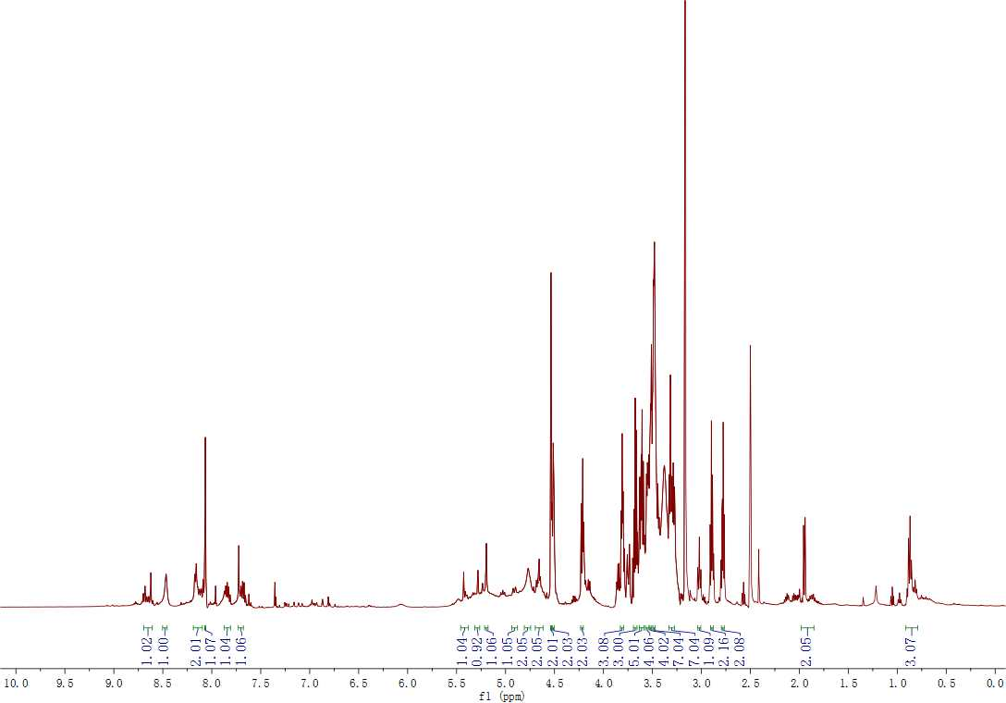
Figure S10. ¹H NMR spectrum (500 MHz, DMSO-d₆) of Lac-SS-CPT.
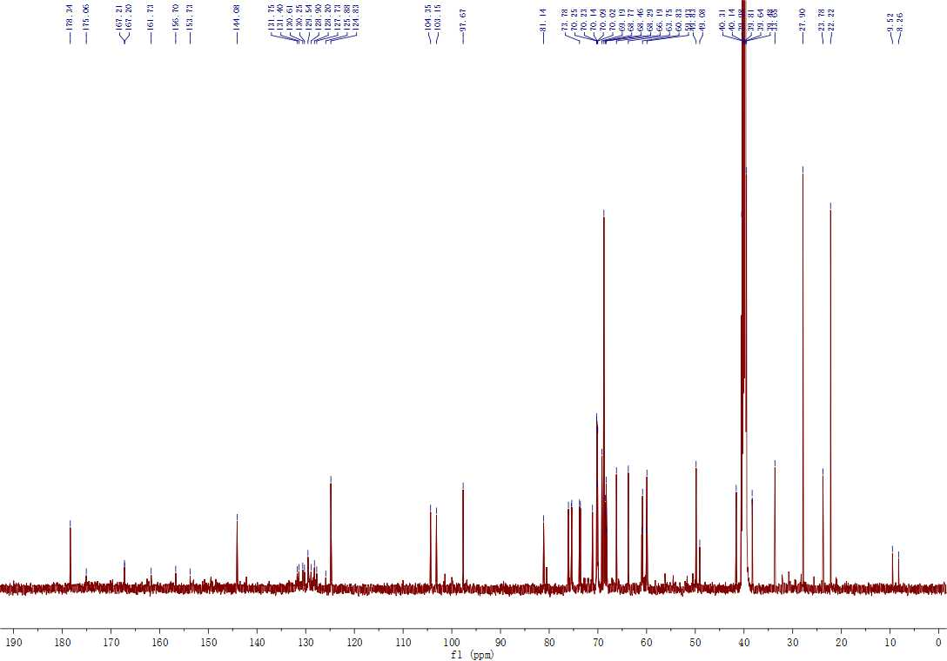
Figure S11. ¹³C NMR spectrum (125 MHz, DMSO-d₆) of Lac-SS-CPT.
Figure S12. High resolution mass spectrometry of Lac-SS-CPT.
Ⅱ. Materials and Instrumentations
Table S1. The Materials and Instrumentation used in this work
Materials/ Instrumentation | commercial sources/ model
Camptothecin | MOLBASE
Doxorubicin hydrochloride | Sangon Biotech
Tetraethylene glycol | Energy Chemical
other chemicals | Energy Chemical
¹NMR spectra | Bruker 500 MHz Spectrometer
Scanning Electron Microscopy (SEM) | Nano SEM-450
Transmission Electron Microscopy (TEM) | TECNAI G2 SPIRIT BIO
Dynamic Light Scattering (DLS) | ZEN3600
Water surface tension | BZY-3B surface tension measurer (China)
Enzyme-labeled instrument | Biotek
Flow cytometry | BD FACSAria™ III
Confocal Laser Scanning Microscopy (CLSM) | Revolution WD

Ⅲ. The characterization of the vesicles
3-1. Critical aggregation concentration (CAC)
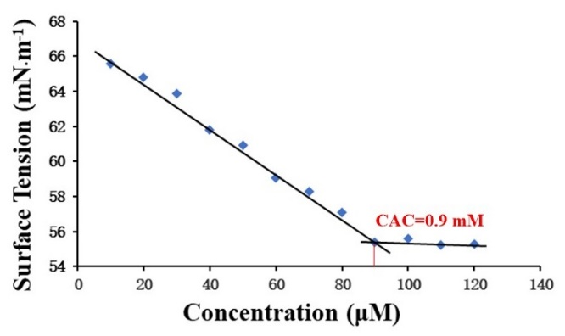
Figure S13. Surface tension of water vs. the concentration of Lac-SS-CPT glyco-nano vesicles. There are two linear segments in the curve and a sudden decrease of the slope, implying that the CAC is approximately 0.9 mM in water.
3-2 Tyndall effect
Tyndall effect can be observed clearly in Lac-SS-CPT aqueous solution which proved lots of nanoparticles existed. As show in Figure S14, Lac-SS-CPT aqueous solution was clear and beam can be seen clearly. But, a lot of precipitation was found in Lac-SS-CPT in GSH aqueous solution and there were no beam can be seen. Thus, it was proved that a lot of nanoparticles existed which can be distroyed by glutathione.
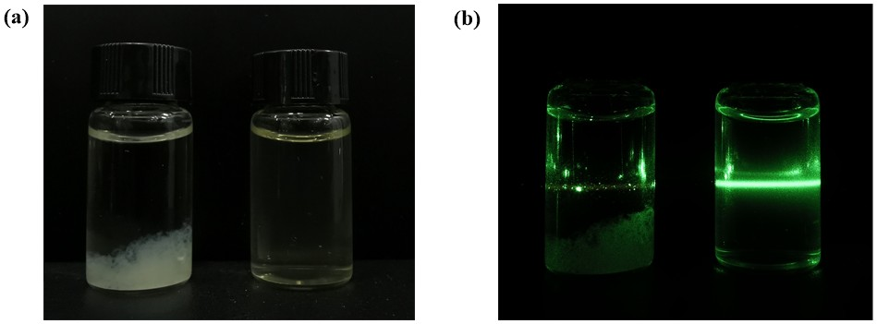
Figure S14. In natural light (a) and UV light (b) Lac-SS-CPT glyco-nano vesicles in GSH aqueous solution (left) and aqueous solution (right).
3-3. SEM image of the Lac-SS-CPT@DOX glyco-nano vesicles
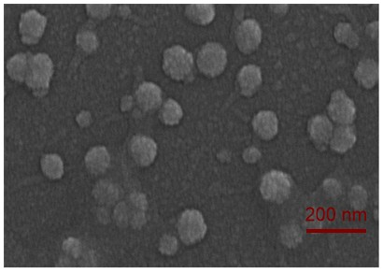
Figure S15. SEM image of Lac-SS-CPT@DOX.
3-4. DLS analysis showed that the Lac-SS-CPT@DOX glyco-nano vesicles
Figure S16. DLS data of Lac-SS-CPT@DOX.
IV. In vitro the target effect and toxicity of Lac-SS-CPT glyco-nano vesicles
4-1. Flow cytometry analyse
HepG2 cells and HL7702 cells was cultured in 6-well plates at a density of 30 × 10⁴ cells each hole. After 24 hours, removed the medium, washed with PBS and added fresh medium. The cells were cultured with CPT, Lac-SS-CPT glyco-nano vesicles, DOX and Lac-SS-CPT@DOX for 4 h. Then removed the medium and washed with PBS for three times. Added 0.5 mL trypsin to digestion for 3 min and added 1 mL 1640 to inactivate the trypsin later. Collected the mixture above into a centrifuge tube, centrifuged, discarded the supernatant, wash the cells with PBS and examined by flow cytometry. Untreated cells were used as negative control.
Figure S17. Flow cytometry analysed the targeting effect of Lac-SS-CPT and Lac-SS-CPT@DOX glyco-nano vesicles of (a) HepG2, (b) and (c) HL7702 cells.
4-2. Confocal laser scanning microscopy
HepG2 cells were seeded in 20 mm plastic bottomed μ-dishes for 24 h. The medium was replaced with a fresh one and then incubated with Lac-SS-CPT@DOX glyco-nano vesicles for 4 h. The dishes were washed with PBS for three times and the cells were all stained with Lyso Tracker Green for 30 min. Finally, the cells were washed with PBS and then observed under a confocal fluorescence microscope.
4-3. MTT assay
MTT assay was used to evaluated the relative cytotoxicities of CPT, Lac-SS-CPT glyco-nano vesicles, DOX, CPT+DOX and Lac-SS-CPT@DOX glyco-nano vesicles in vitro. Firstly, the 96-well plates was used to culture the cells of a density of 5 × 10³ cells per well for 24h at 37 °C. Secondly, different concentrations of CPT, Lac-SS-CPT glyco-nano vesicles, DOX, CPT+DOX and Lac-SS-CPT@DOX glyco-nano vesicles was added to incubate the cells for 24 h, 48 h, or 72 h. Thirdly, fresh medium which containing 10% MTT was used to replace the previous medium and continue incubating for 4 hours to generate formazan crystals. Finally, dimethyl sulfoxide (100 μL) was added to each well after removed the medium containing MTT to dissolve the formazan crystals and the absorbance was measured with a microplate reader at 490.
Figure S18. Cell viability of (a) HL7702 cells and (b) HepG2 cells after cultured with Lac-SS-CPT glyco-nano vesicles for 24h (p < 0.01).
References
- Flos MA, Moreno MG, Mellet CO, et al. Potent Glycosidase Inhibition with Heterovalent Fullerenes: Unveiling the Binding Modes Triggering Multivalent Inhibition. Chem Eur J. 2016; 22: 11450-11460.
- Liu X, Shao W, Zheng YJ, et al. GSH-Responsive supramolecular nanoparticles constructed by b-D-galactose-modified pillar[5]arene and camptothecin prodrug for targeted anticancer drug delivery†. Chem Commun. 2017; 53: 8596-8599.
- Lu YC, Hou CX, Ren JL, et al. A multifunctional supramolecular vesicle based on complex of cystamine dihydrochloride capped pillar[5]arene and galactose derivative for targeted drug delivery. Int J Nanomed. 2019; 14: 3525-3532.

