ORIGINAL RESEARCH Skubalova et al.

Passive diffusion vs. active pH-dependent encapsulation of tyrosine kinase inhibitors vandetanib and lenvatinib into folate-targeted ferritin delivery system
Zuzana Skubalova^{1,2}
Simona Rex^{1,2}
Martina Sukupova¹
Martina Zahalka¹
Petr Skladal³
Jan Priby^{l3}
Hana Michalkova^{1,2}
Akila Weerasekera⁴
Vojtech Adam^{1,2}
Zbynek Heger^{1,2*}

¹Department of Chemistry and Biochemistry, Mendel University in Brno, Zemedelska 1, CZ-613 00 Brno, Czech Republic; ²Central European Institute of Technology, Brno University of Technology, Purkynova 656/123, CZ-612 00 Brno, Czech Republic; ³Central European Institute of Technology, Masaryk University, Kamenice 5, CZ-625 00 Brno, Czech Republic; ⁴Athinoula A. Martinos Center for Biomedical Imaging, Massachusetts General Hospital, Harvard Medical School, 13th St., Charlestown, MA, USA

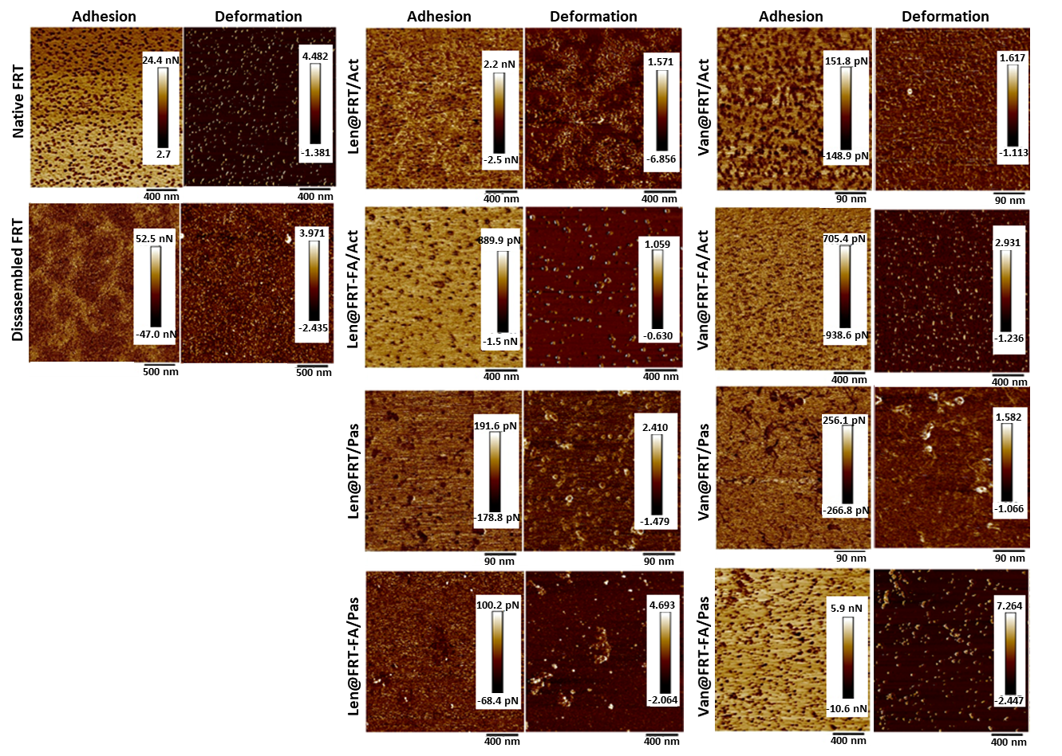
Supplementary Figure 1 AFM analyses showing adhesion and deformation of native FRT, pH-disassembled FRT and TKIs-loaded FRTs.
Abbreviations: AFM, atomic force microscopy; FRT, ferritin; TKIs, tyrosine kinase inhibitors.

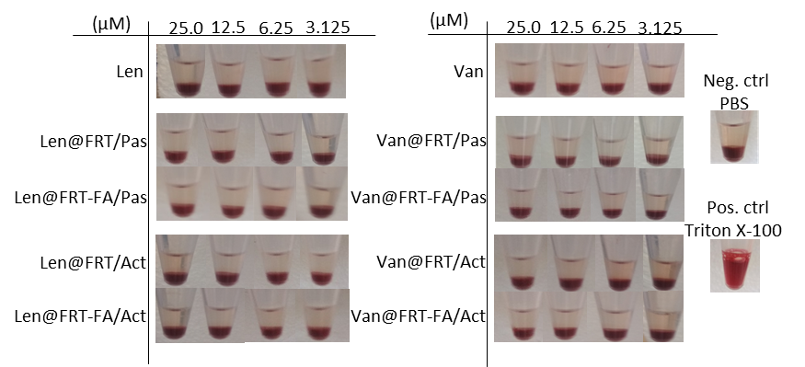
Supplementary Figure 2 Representative photographs of hemolysis examination assayed on human RBCs. PBS (pH 7.4) and Triton X-100 are shown as negative and positive controls, respectively.
Abbreviations: RBCs, red blood cells; PBS, phosphate-buffered saline.

Flow cytometry of FR, TfR1 and SCARA5
Quantitation of expression of FA and TfR1 and SCARA5 (ferritin-targeted receptors) was carried out using flow cytometry. For this purpose, the cells were detached from culture flask by Accutase® and counted using automated cell counter Countess II FL (Thermo Fisher Scientific, Waltham, MA, USA). Suspension of 400,000 cells was centrifuged (2×, 10 min, 200× rcf) and washed by cold phosphate-buffered saline (PBS). After that, the resulting pellet was resuspended in 50 μL of 10% fetal bovine serum (FBS) in PBS, and 50 μL of primary antibody [anti-FR dilution 1:100 (ab3361, Abcam, Cambridge, UK) anti-SCARA5 dilution 1:12 (ab118894, Abcam) and anti-TfR1 dilution 1:1000 (ab38171, Abcam)] in 10% FBS in PBS. Then, the suspension was incubated for 60 min at 8°C. After incubation, the unbound antibodies were washed with PBS by centrifugation (2×, 5 min at 400× rcf). The resulting pellet was resuspended in 100 μL of 3% FBS in PBS followed by addition of fluorophore-labelled secondary antibody (anti-mouse CFL-647 for FR and TfR1, c362287, Santa Cruz Biotechnology, Dallas, TX, USA and anti-rabbit Alexa Fluor-647 for SCARA5, Abcam, both diluted 1:500). Then, the cells were incubated (30 min, 8°C) and the unbound antibodies were washed with PBS by centrifugation (2×, 5 min at 400× rcf). After the last centrifugation, the pellets were resuspended in 300 μL of 3% FBS in PBS. Receptor expression was quantified using 640 nm laser and 675/25 standard filter on the flow cytometer BD Accuri C6 Plus (BD Biosciences, Franklin Lakes, NJ, USA). The flow rate was 35 μL/min and a minimum of 50,000 events was analysed per each group

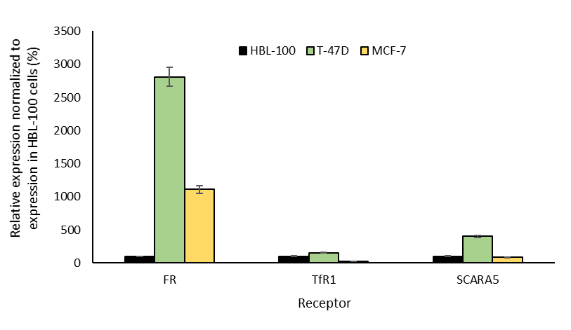
Supplementary Figure 3 Expression of FRT-targeted receptors (TfR1 and SCARA5) and FR serving as a targeted receptor after TKIs-loaded FRTs surface-functionalized with FA in three tested cell lines used in this study.
Abbreviations: FRT, ferritin; TKIs, TfR1, transferrin receptor 1; SCARA5, scavenger receptor class A member 5; FR, folate receptor; TKIs, tyrosine kinase inhibitors; FA, folic acid.

