Supporting Information
Hybrid nanoparticles modified by hyaluronic acid loading an Hsp90 inhibitor as a novel delivery system for subcutaneous and orthotopic colon cancer therapy

Chen-Wei Pan^{1#}, Tiao-Tiao Zhang^{2,5#}, Shao-Xun Li^{1,5#}, Zhi-Hua Xu^{2,5}, Bin-Hui Pan^{2,5}, Sheng Xu^{2,5}, Shuang-Hong Jin^{1,5}, Guang-Rong Lu², Shou-Xing Yang², Zhan-Xiong Xue², Ping Chen⁶, Xian Shen³*, Fang-Yan Wang⁴* and Chang-Long Xu^{2,7}*

Affiliations:
¹ Department of Infectious Disease, The Second Affiliated Hospital and Yuying Children’s Hospital of Wenzhou Medical University , Wenzhou, Zhejiang, 325000, China
² Department of Gastroenterology, The Second Affiliated Hospital and Yuying Children's Hospital of Wenzhou Medical University, Wenzhou, Zhejiang, 325000, China
³ Department of Gastrointestinal Surgery, The Second Affiliated Hospital and Yuying Children's Hospital of Wenzhou Medical University, Wenzhou, Zhejiang, 325000, China
⁴ Department of Pathophysiology, School of Basic Medicine Science, Wenzhou Medical University, Wenzhou, Zhejiang, 325000, China
⁵ The Second School of Medicine, Wenzhou Medical University, Wenzhou, Zhejiang, 325000, China
⁶ Department of Infectious Disease, Shulan Hospital, Hangzhou, Zhejiang, 310012, China
⁷ Center for Diagnostics & Therapeutics, Institute for Biomedical Sciences, Georgia State University, Atlanta, GA 30302, USA

#These authors contribute equality to this work.

*corresponding author: Chang-Long Xu
Address: 109 College west road, Wenzhou, Zhejiang, 325000, China
Tel: +86-(0577)88002715; Fax: +86-(0577)88002715
E-mail: xchlong@163.com
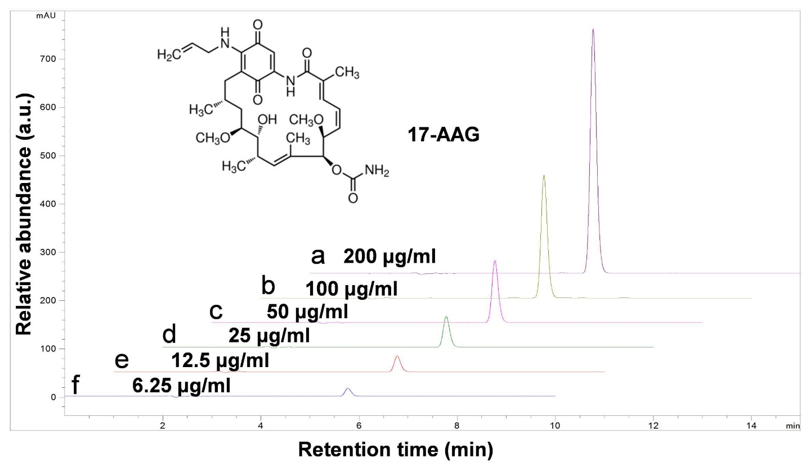
Figure S1. The encapsulated efficiency of 17-AAG was quantified by HPLC using an Agilent® 1100 LC System (Agilent Technologies Inc., CA, USA). The detection wavelength was set at 254 nm.

Figure S2. The co-localization of NPs/DiL and HA-NPs/DiL with the endocytosis marker, Tf-FITC, in HT-29 cells were investigated. Cells cultured on slides were incubated with DiL-labeled HA-DOTAP/PLGA NPs for 4 h at 37°C, and then incubated with Tf-FITC for 15 min, after fixing with 4 % PFA, cells were examined under fluorescence microscopy. Yellow color (arrow) shows co-localization of HA-DOTAP/PLGA NPs/DiL and Tf-FITC. Scale bar: 10 μm.

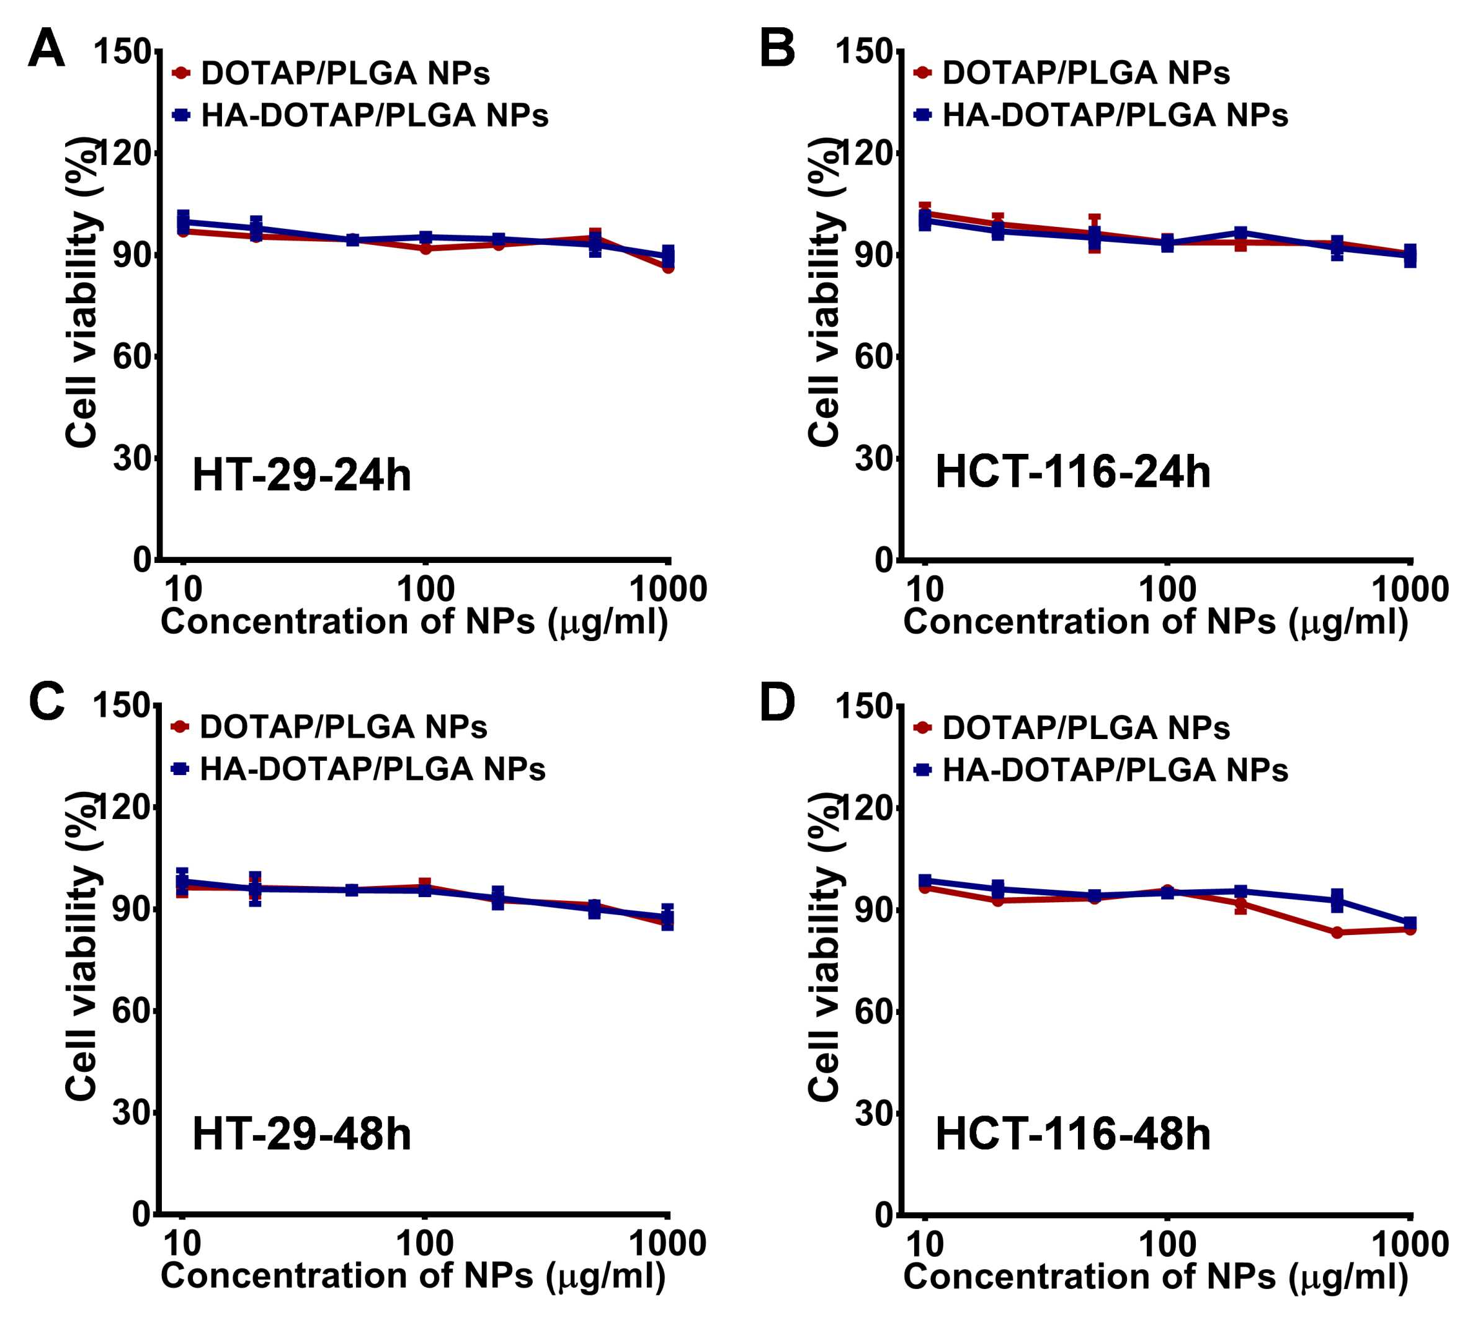
Figure S3. In vitro biocompatibility was evaluated using the MTT assays. A: HT-29 cells were incubated with DOTAP/PLGA and HA-DOTAP/PLGA NPs for 24 h, and viability was evaluated. B: HCT-116 cells were incubated with DOTAP/PLGA and HA-DOTAP/PLGA NPs for 24 h, and viability was evaluated. C: HT-29 cells were incubated with DOTAP/PLGA and HA-DOTAP/PLGA NPs for 48 h, and viability was evaluated. D: HCT-116 cells were incubated with DOTAP/PLGA and HA-DOTAP/PLGA NPs for 48 h, and viability was evaluated, (n=5).

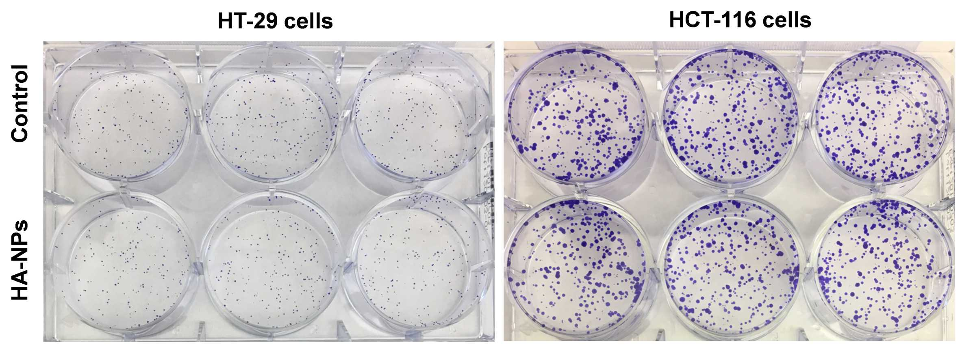
Figure S4. In vitro biocompatibility of HA-DOTAP/PLGA NPs (HA-NPs) was also evaluated by colony formation assays.

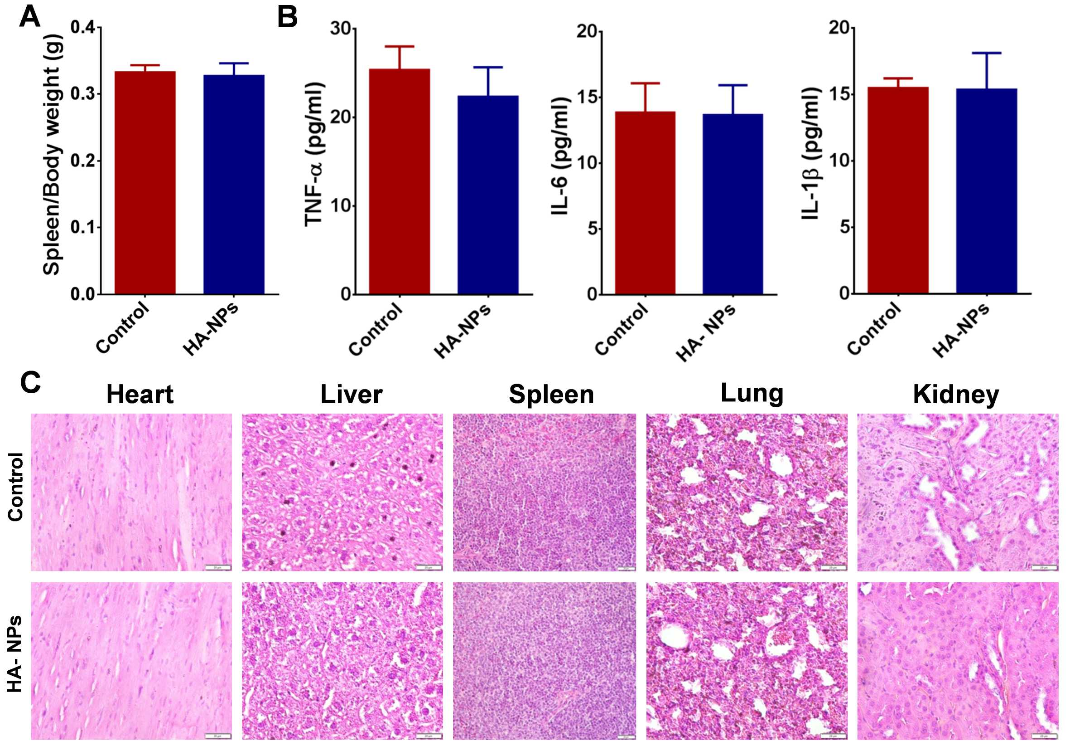
Figure S5. The in vivo biocompatibility of HA-DOTAP/PLGA NPs (HA-NPs) was evaluated in mice by daily i.v. injection for 7 days. A. The spleen/body weight was compared at the end of the experiment (n=5). B. Pro-inflammatory cytokines (TNF-α, IL-6 and IL-1β) levels in serum were compared. C. Representative H＆E-stained sections of heart, liver, spleen, lung, and kidney from the control and HA-NPs-treated mice were obtained.

Figure S6. Evaluation of apoptosis induced by HA-NPs/17-AAG in HCT-116 cells. (A) Fluorescence imaging of HCT-116 cells treated with free 17-AAG or HA-NPs/17-AAG for 8 h and then co-stained with Annexin V-FTIC and PI. Scale bar: 10 μm. (B) Flow cytometric analysis of apoptosis in HCT-116 cells treated with free 17-AAG or HA-NPs/17-AAG for 8 h. (C) Quantification of the Annexin V⁻FTIC/PI⁻ cells from panel B, ***p<0.001 (n=5).

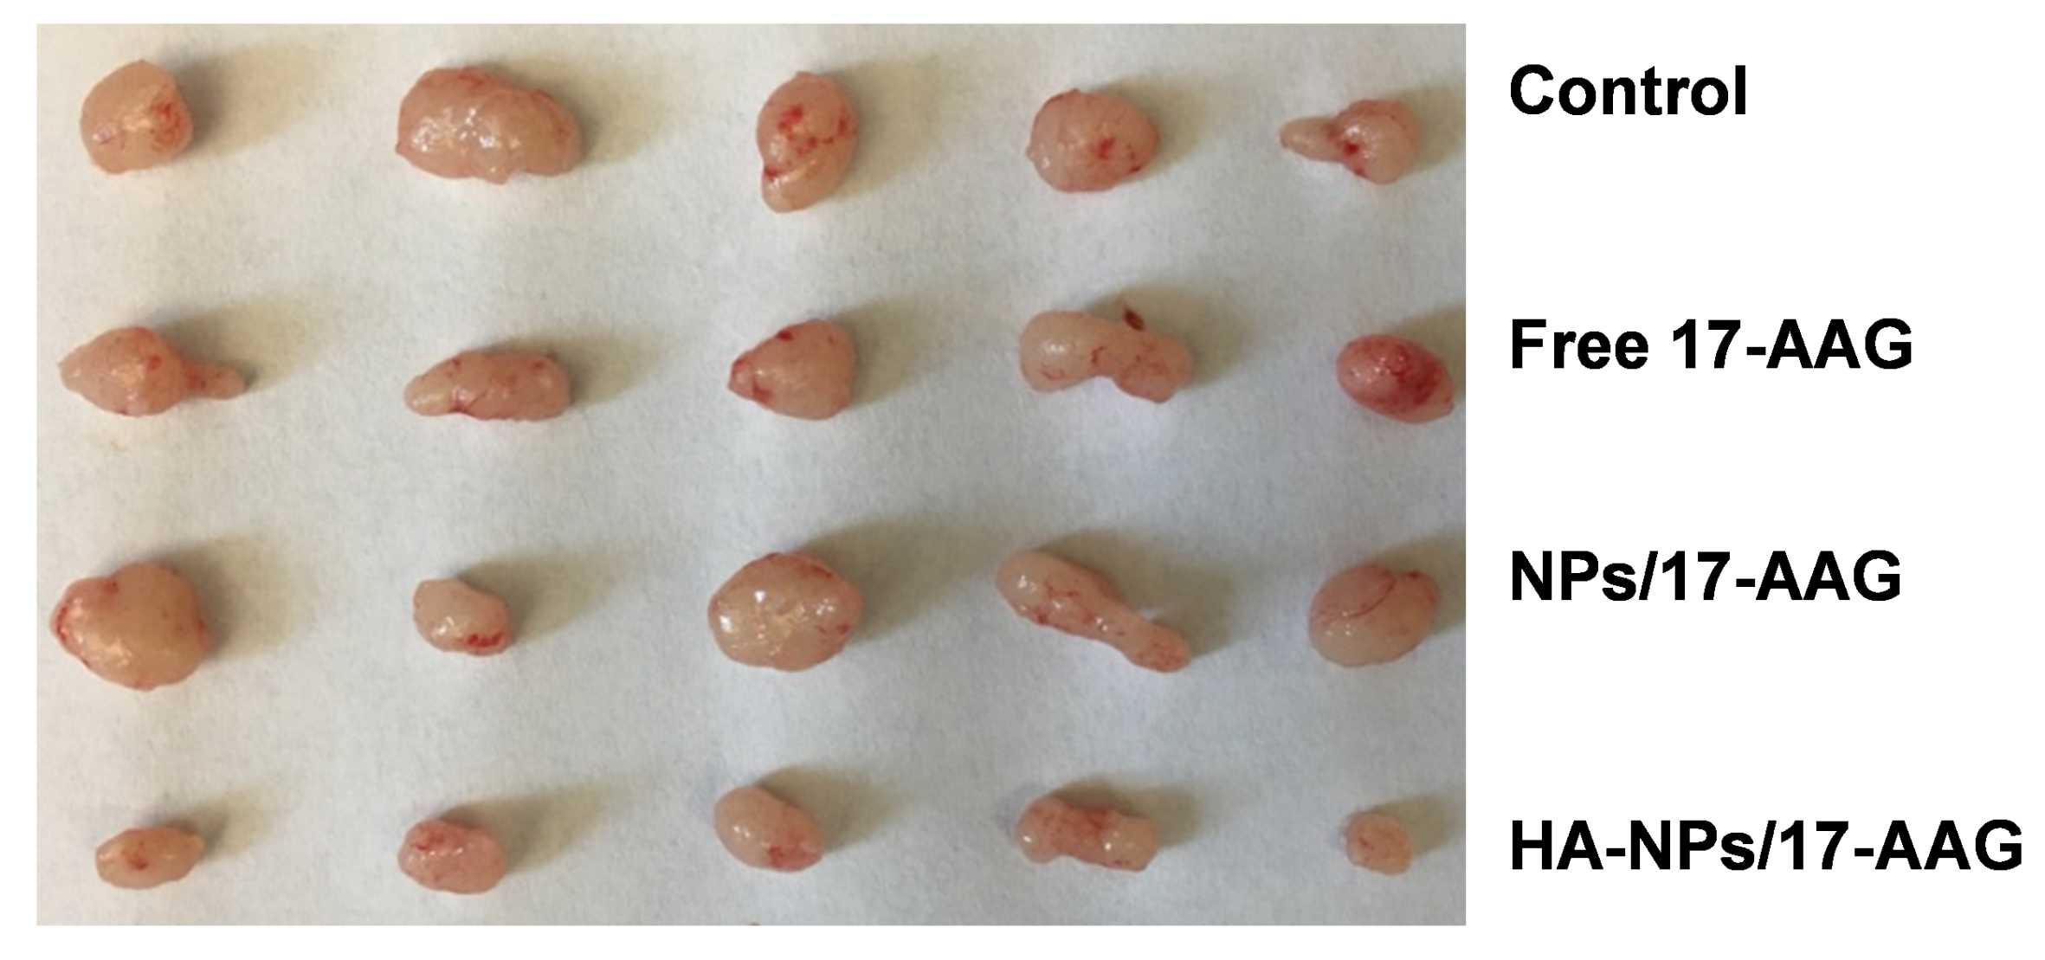
Figure S7. In vivo therapeutic efficacy of HA-NPs/17-AAG in Luc-HT-29 tumor-bearing mice. Xenograft tumors in each group were captured (n=5).

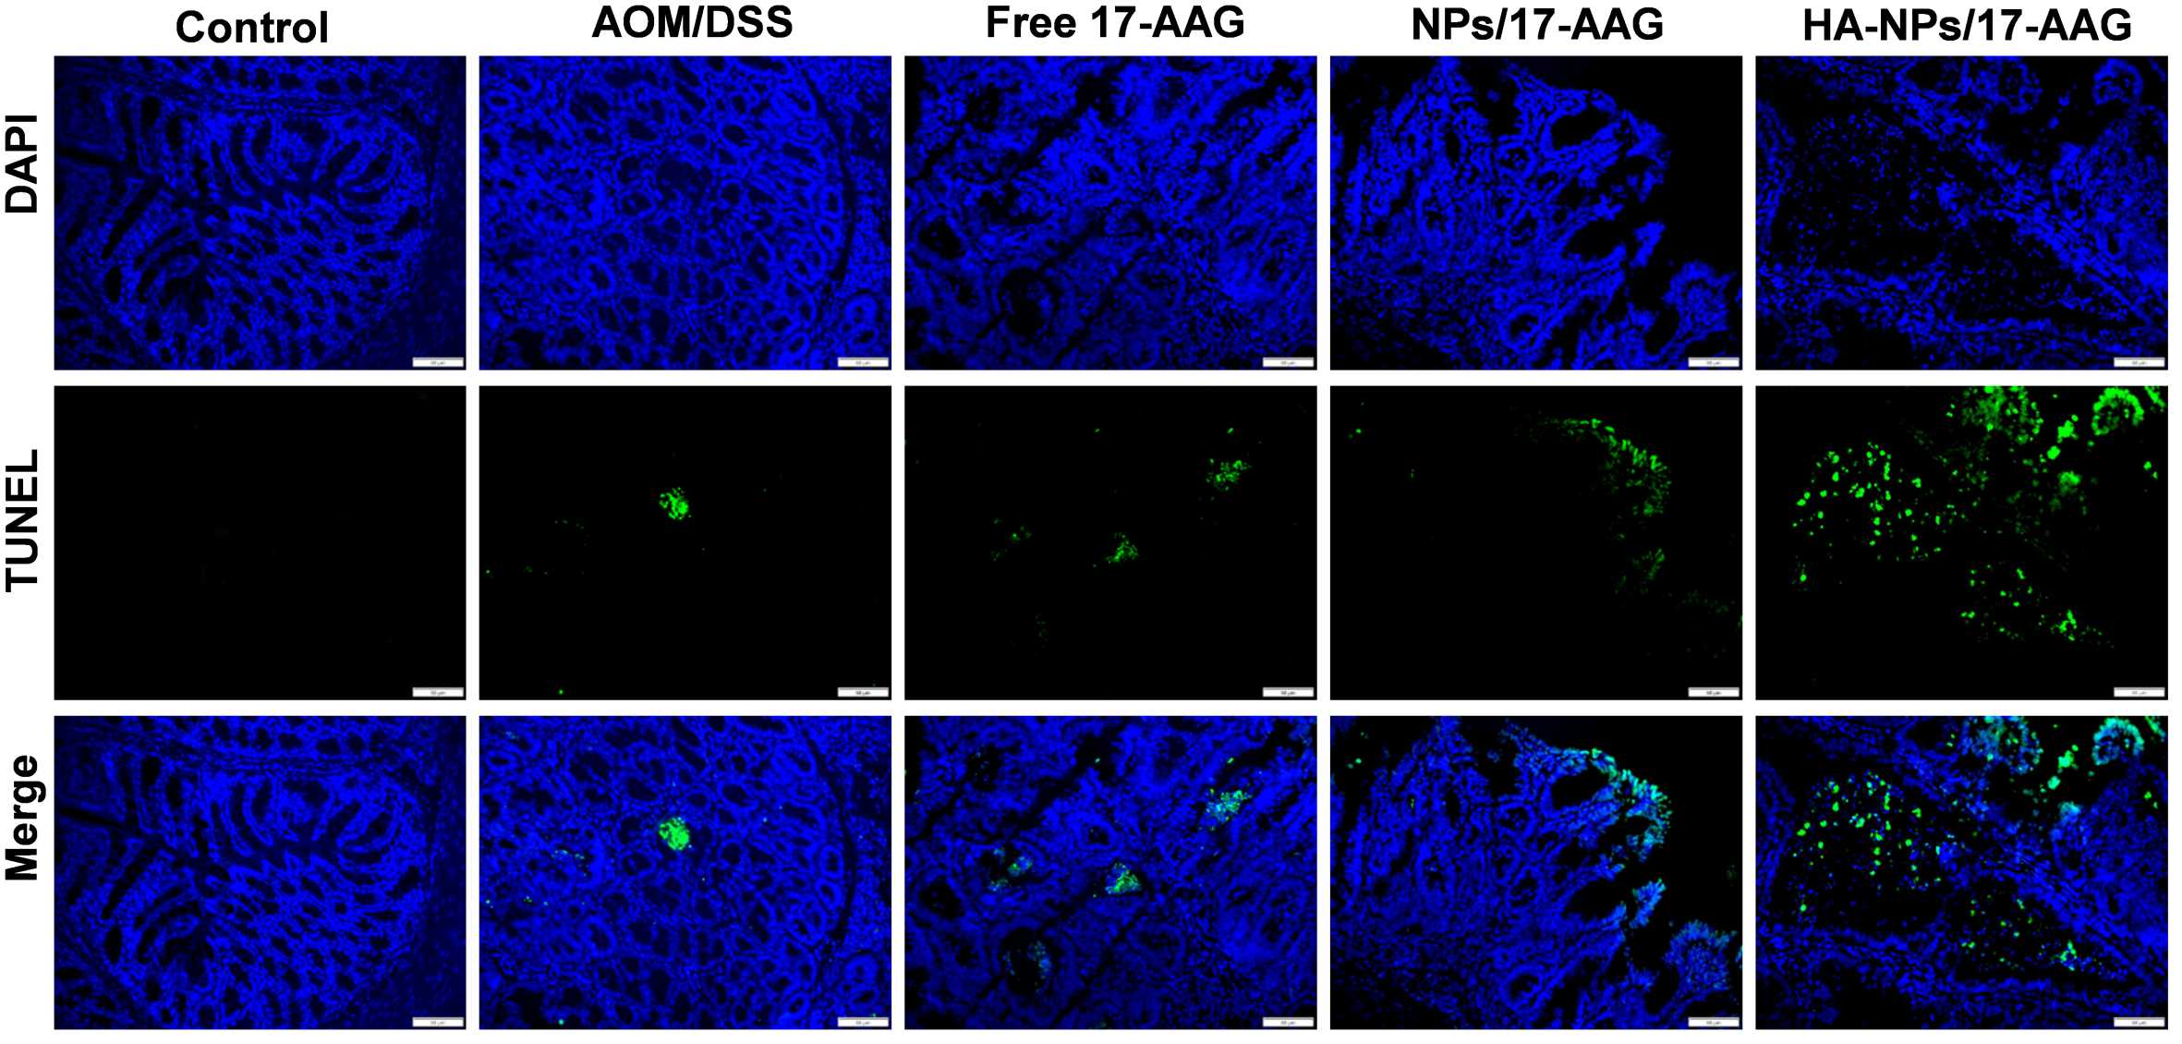
Figure S8. HA-NPs/17-AAG increases cell apoptosis in AOM/DSS-induced CAC. Apoptosis was quantified by TUNEL assay (green) and nuclei were stained with DAPI (blue), Scale bar: 20 µm.

Table S1. Safely evaluation of HA-DOTAP/PLGA nanoparticles (NPs) in vivo was evaluated by analyzing hematology and biochemistry parameters. (mean ± S.D., n=5).
Analytes | PBS group | NPs group
WBC (×10⁹/L) | 7.66 ± 1.96 | 6.97 ± 0.45
LYM (×10⁹/L) | 7.43 ± 1.90 | 6.68 ± 0.38
MON (×10⁹/L) | 0.10 ± 0.04 | 0.10 ± 0.05
NEU (×10⁹/L) | 0.14 ± 0.07 | 0.13 ± 0.07
RBC (×10¹²/L) | 9.31 ± 0.35 | 9.87 ± 0.23
HGB (×g/dL) | 14.07 ± 0.32 | 14.90 ± 0.36
PLT (×10⁹/L) | 500.33 ± 17.01 | 538.67 ± 24.58
ALT (×U/L) | 35.67 ± 3.51 | 38.00 ± 1.73
ALB (×g/dL) | 3.47 ± 0.12 | 3.60 ± 0.26
ALP (×U/L) | 67.33 ± 11.55 | 70.00 ± 9.00
AMY (×U/L) | 1032.67 ± 47.12 | 1140.67 ± 96.13
CA (×mg/dL) | 10.60 ± 0.44 | 10.47 ± 0.45
CRE (×mg/dL) | 0.2 ± 0.00 | 0.20 ± 0.00
GLOB (×g/dL) | 2.03 ± 0.06 | 2.10 ± 0.20
GLU (×mg/dL) | 228.67 ± 51.38 | 208.00 ± 12.17
PHOS (×mg/dL) | 7.57 ± 0.40 | 7.10 ± 0.70
K⁺ (×mmol/L) | 7.97 ± 0.23 | 7.73 ± 0.35
NA⁺ (×mmol/L) | 156.67 ± 3.06 | 154.33 ± 0.58
TBIL(×mg/dL) | 0.30 ± 0.00 | 0.33 ± 0.06
TP (×g/dL) | 5.47 ± 0.21 | 5.73 ± 0.12
BUN (×mg/dL) | 22.33 ± 2.08 | 22.33 ± 1.53
Hematology parameters: WBC: Total white blood cell; LYM: Lymphocyte; MON: Monocyte; NEU: Neutrophil; RBC: Red blood cells; HGB: Hemoglobin; PLT: Platelet.
Biochemistry parameters: ALT: Alanine aminotransferase; ALB: Albumin; ALP: Alkaline phosphatase; AMY: Amylase; CA: Calcium; CRE: Creatinine; GLOB: Globulin; GLU: Glucose; PHOS: Phosphorus; TBIL: Total bilirubin; TP: Total protein; BUN: Urea nitrogen.

